Winter Wellness Guide
Health and wellbeing advice for you
and your family this winter
www.shropshire.carers@shropshire.gov.uk

Protect yourself and your family and friends from flu
It’s easy to pass on flu viruses without knowing.

The flu vaccine is a safe and effective vaccine. It’s offered every year on the NHS to millions of people, including children and those at risk of getting seriously ill from flu.

Why should you get a flu jab?

- We may be more likely to get flu this winter as fewer people have built up natural immunity during COVID-19.

- If you get flu and COVID-19 at the same time, research shows you’re more likely to become quite ill.

- Getting vaccinated against flu and COVID-19 will provide protection for you and those around you for both serious illnesses.
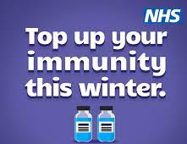
Some people will be invited to have both flu and COVID-19 booster vaccines. If you are offered both vaccines, it’s safe to have them at the same time or at different times.

If you receive carers allowance or are the main carer for an older or disabled person who may be at risk if you are ill, you are eligible for a free vaccine from the NHS. The flu vaccine is available at GP practices and pharmacies.

Find out more about winter vaccinations, including who can get one for free at:
www.nhs.uk/wintervaccinations

Support for long-term effects of COVID-19
For some people, COVID-19 can cause lasting symptoms long after the infection has gone, sometimes known as ‘long COVID’.

There are many symptoms you can have after COVID such as:  - Difficulty sleeping  - ‘Brain fog’  - Dizziness  - Loss of appetite  - Others  If symptoms are having an impact on your life, contact your GP who may give you advice on how to manage and monitor your symptoms at home or refer you for some tests such as a blood test.  For more information on long COVID, visit Long-term effects of COVID  For helpful advice on COVID recovery, please visit: Your COVID Recovery  Supporting your immunity will help to protect not only yourself, but your family, friends, and community.  Take care and stay well this winter! | COVID-19 Autumn booster  Vaccinations began on 11 September 2023 for those most at risk and people who are immunosuppressed.  From 18 September, NHS will start to invite people in priority order of risk.  To check if you are eligible, you and to book please visit:  WWW.NHS/C19 Vaccination services/book
Through a visit carried out by operational firefighters, you’ll receive guidance on staying  healthy and active, including how  to prevent falls.  A handbook is given, providing vital fire safety guidance and much more. If you’re not eligible for a home visit, you have the option of an online home safety check, you can also download the Safe and Well handbook.  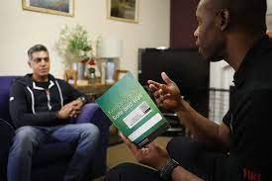  For full information, please visit:  https://www.wmfs.net/our-services/safe-and-well/ | Indoor Checks  Check your home is ready by installing insulation.  Ensure letterbox shuts securely to avoid losing heat.  Use draught excluders.  Clean out gutters and repair roof leaks. Keep chimneys swept.  Use thermal linings on curtains.  Have heating appliances services.  If you can’t heat all the rooms, heat the most used room in the day and the bedroom before you go to sleep.  Consider a Smart Meter to give you more control over energy bills. to request a smart meter free of charge or visit Smart Meters  Keep a supply of warming drinks and foods in.
Plan Ahead - Stay safe at home
Did you know, if you are eligible, you can book a free Safe and Well visit to have your home checked for hazards and get fire safety advice?

Prepare

Have your car serviced, maintain antifreeze, check tyres/tread and replace as necessary.

Car
- Have your car serviced, check tyres/tread and replace if needed.
- Check the battery.
- Keep fuel tank at least half full to avoid ice in the tank.
- Keep a can of antifreeze and a scraper in the car.
- Prepare a winter emergency kit to keep in the care to include:

- Blankets
- Spare Tyre
- A shovel
- Hi-visibility vest
- Screen wash
- Emergency Contact Numbers
- Portable phone charger
- Torch
- First aid kit
- Food and drink

Outdoor Precautions
- Wear appropriate outdoor clothing, inner layers of light, warm clothing. Gloves, hats, scarves, waterproofs. 40% of body heat is lost from the head. Tight fitting mittens are better than gloves.

- Sprinkle salt, cat litter or sand on icy patches.
- Walk slowly if doing outside tasks.
- Carry a mobile phone.
- Carry emergency contact numbers.
- Check latest weather forecasts either by radio, TV, mobile app or website.

Read Here about how to beat the cold.

Urgent health care that isn’t an emergency? Think 111 first

The NHS 111 service does not diagnose but directs you to the best place to get help for your symptoms.

You can call 111 or visit 111.nhs.uk to be triaged (via a series of questions), based on your answers, you will be directed to a range of local services.

NHS 111 can book you an appointment with your GP, Pharmacist or Urgent Treatment Centre or arrange for an ambulance to be sent if you need one.

The online system and health advisers have all the healthcare service information within the local community at their fingertips suing the NHS Pathway triage system, they know the best place for you, or the person you are calling on behalf of, to receive care.
NHS 111
Need help in other languages? Call 111 and ask for an interpreter

You can also use the NHS 111 service for help with your mental health - call and select option 2 to be put straight through to someone who can advise you.
For less urgent health needs during normal opening hours, you should still contact your GP or visit or talk to your local pharmacist.

In an emergency, call 999

Cost of living

No one should be hungry or cold this winter.

If you need help paying the bills, are worried about the cost of food or cannot afford to heat your home, you may be able to get support.

Depending on circumstances, you may be eligible for Winter Fuel or Cold Weather Payments automatically. If not, visit: gov.uk/winter-fuel-payment or call 03459 15 15 15 to see if you’re eligible.

To read about affordable warmth and energy efficiency, see latest offers in Shropshire Here

If you are struggling to make ends meet, there is advice available to you.

Read Worry about Money - Shropshire to find out more about what options are available. Link contains a few short questions, poster and useful leaflet to download.

Shropshire Larder provides a wide range of information/advice on mazimising income, budgeting, debts, and household bills

Sources of financial advice
Citizens Advice Service: https://www.cabshropshire.org.uk/ Call free on 0808 278 7894
National debt line:
www.nationaldebtline.org
0808 808 4000
Shropshire Council Advice, Advocacy and Welfare Benefits Welfare Provision
Barnabus Money Advice (Shrewsbury) 01743 364114

Are you one of Shropshire’s unpaid and or adult family carers?

If you are an unpaid family carer providing vital support to someone who needs your care in Shropshire, we are on hand to try and make life a little easier.

Whether it’s making sure you are getting all the financial help you are entitled to, helping you get a break from caring, looking into employment and learning opportunities, planning for the future or even how to get support as a carer, help is at hand.

Shropshire Carers Support Team
A dedicated team providing information, advice, and support to carers over the age of 18. Our vision is to enable carers to live their best lives. Find out more at Shropshire Choices, I Care for Someone Else

Carers Assessments
An opportunity for you to speak to someone about your caring role and the impact it can have on your life.

To book a carers assessment, telephone: First Point of Contact on 0345 678 9044. To find out more contact Shropshire Carers, 01743 341995 or shropshire.carers@shropshire.gov.uk

GP Awareness
Let your GP know about your caring role. Read about the benefits here

Emergency Planning
It is important for all carers to make contingency plans with the person they care for to use in circumstances where help from other people to deliver care may be required. More information on carer emergency plans and a template to complete can be accessed here

Hospital Carer Support Worker
Hospital admissions can be a stressful and worrying time for you and the whole family.
Most of Shropshire’s unpaid family carers begin their caring role for the first-time following hospital admission of the person they care for. For support call, Tel: 01743 256879 or email:
hospitalcarers@shropshire.gov.uk

Shropshire Carers Register
Have you signed up?

As an unpaid carer, it can be difficult to know where to find information that is current and correct. Shropshire Carers Team have a developed carers register which holds carers details so we can share information relevant to you, the carer in a way that suits you best.

With enrolment to the register, you will receive a carers ID card/emergency card, emergency plan template and a free 5-part email course delivered by Mobilise online support for carers. Carers can de-register at any time by notifying Shropshire Carers.
Carers can sign up by completing our form Carers Register form

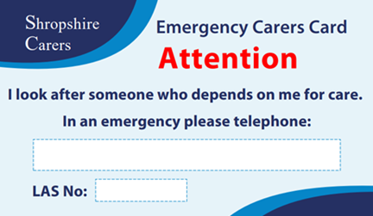

Carers ID Card

Signing up to the carers register you’ll receive a carers identification card, a small credit card size that let’s others know in an emergency that the person you care for relies on you.

Carry the card in your purse/wallet for reassurance that the person you care for, won’t be left without support.

Find out how Shropshire Carers can help you:
shropshire.carers@shropshire.gov.uk or call 01743 341995

Do you need help to use a computer
or smart phone?
There’s a lot of support available in Shropshire to give you the skills you need to get online and stay connected to family and friends.

You can attend a weekly one-hour session to learn (free) and staff/volunteers are on hand to help you. Digital Support - Shropshire Council

Try Learn my way for courses on internet safety, online shopping
and video calling.

Digital Skills for Shropshire Citizens - Help to get online and use the internet safely for over 65’s.

Mobilise Shropshire is an online service for unpaid carers, which brings together the collective knowledge, wisdom and expertise of unpaid carers. Mobilise offers a range of

information and facilitated
opportunities to join them,
carers can support each other, Face book, where Virtual cuppas, 1:1 support via a phone call and website live chat. Take a look and see how they may help you.

If you or someone you know needs help to get online, contact Shropshire Carers 01743 341995 or visit: shropshire.carers@shropshire.gov.uk

Protect yourself from scams and fraud

Getting educated and taking a few basic steps may keep you from becoming a victim of scams and fraud.

Scam crimes appear in many different forms, such as emails, post, social media, phone calls, text messages or someone at your door.

To find out what to look for and what to do, visit: Action Fraud
Shropshire Council also have information, visit: How do I protect myself

If you need help, contact Citizens Advice on 0808 223 1133 or visit: Citizen's Advice Consumer Service

Managing your Mental Health
Equally as important as our physical health.

Winter can be very isolating for many people. Bad weather, shorter days, lack of support, depressing news, all contribute to lowering our mental health.

If you would like some practical tips and advice about ways to boost your mood, a place to feel heard, please visit: Shropshire MHS

Whether you’re concerned about your own mental health or that of someone else, Shropshire Council has information to hand, please visit: Mental Health and wellbeing or contact First Point of Contact on 0345 678 9044.

Support for children and young people
Resources and advice to help young people manage their emotional wellbeing are available at Shropshire Council, please visit: Bee U

Are you experiencing domestic abuse?

If you, or someone you know, is experiencing domestic abuse, such as violence or controlling behaviour, then advice, support and services are available.

Contact West Mercia Women’s Aid on 0800 783 1359. More information at Domestic Abuse

In an emergency, always call
999
For full information, visit:
Healthy Shropshire
Healthy Shropshire
There are free resources locally with friendly staff who will help you find the right advice and support to stay healthy and well; from looking after your mental health or stopping smoking to managing your weight or simply being more active.
‘Social prescribing’ is a free service withing GP practices in Shropshire which helps you find enjoyable activities in your local area. For more information, visit: Social Prescribing in Shropshire

Shropshire Choices
First stop for information on a variety of health and social care needs support. Full information at: Shropshire Choices - I care for someone else

Support in your community
Keeping active and connected can increase our sense of belonging, which in turn improves wellbeing.

Informational and Emotional Support in your community
If you are feeling low this winter, please reach out and speak to someone.

Shropshire Carers Support team – we offer a listening ear. By talking through your situation, we can establish your needs and help you to reach solutions that assist you to move forward. Tel: 01743 341995 Mon-Fri 9.00am till 5.00pm

Mobilise Shropshire
we offer free call
with our carer support team. A friendly ear, the opportunity to get clarity around muddled thoughts, or simply just to connect.

SHOUT
You don’t need to hide behind a smile.... you can talk with SHOUT over text 24/7, it’s a free service available to everyone in the UK and it won’t show up on your phone bills.

When you text there’s a trained volunteer at the other end to talk with you – silently, by text message – until you feel calmer. Why not look at SHOUT’s
Little Book of Coping Skills booklet with plenty of tips or visit: Give us a shout.

Samaritans Self-help
Keep track of how you’re feeling, get tips on what you can do to help yourself cope, visit: Samaritans Self-help App

Community Directory
Gives information on where you can find help including benefits, groups, community transport….
Community Directory

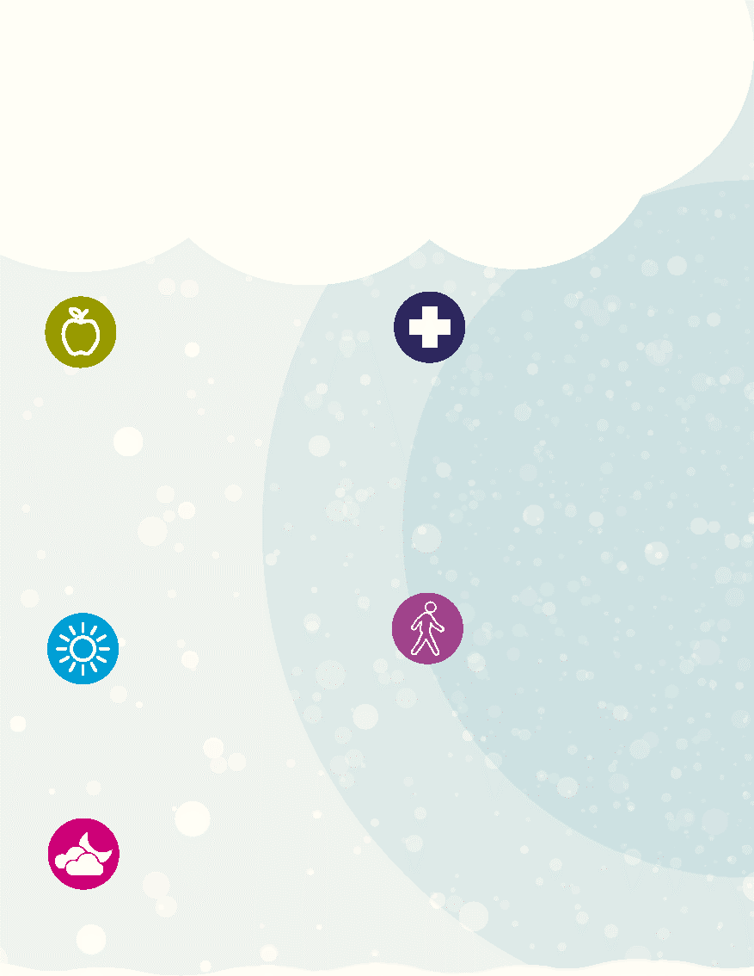
Keep a well-
stocked medicine cabinet
You can buy useful remedies for lots of minor illnesses from your local pharmacist or supermarket, often at very little cost. Own-brand versions are often cheaper but just as effective.

Eat a balanced diet
and stay hydrated
Good nutrition is vital to help keep us healthy and well. Eat meals with a mix of protein, dairy, carbohydrates, fruit and vegetables. Drink lots of water (and warm drinks or soup in cold weather) and try not to exceed recommended alcohol limits.

Be Winter Ready
Boost your vitamin levels
Get outside in the sunshine for 15-20 minutes a day and take a vitamin D supplement to avoid vitamin D deficiency.
Our top 10 tips to help you stay safe and well this winter
Stay active
30 minutes a day,
including strengthening exercises, can help you to stay strong and independent.
Shropshire’s health walks are a free, fun and sociable way to be active. You can search for local walks at Walking for Health

Sleep well
Establish a bedtime
routine and use relaxation exercises to improve sleep. Tips at: Sleep Foundation

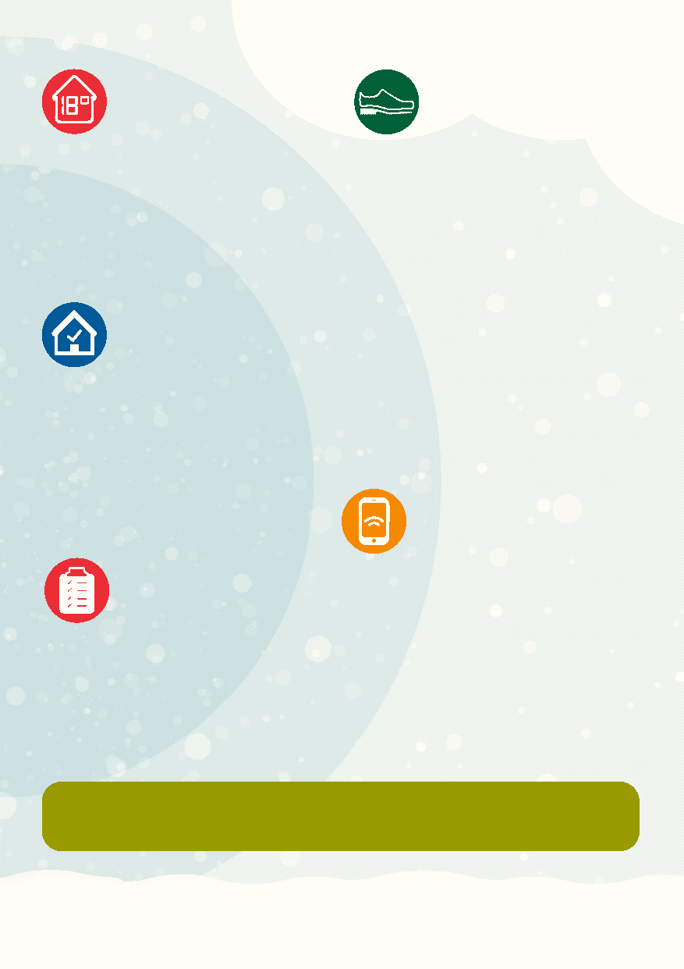
Keep warm
Heat your home to at
least 18 degrees – if
you can’t heat the whole house, heat the room you are in. Help to carry out energy efficiency improvements may be available. Visit: Energy Savings Trust
Prevent falls
Move around regularly and use
gentle exercises to stay strong and supple. Wear slip-resistant shoes with good grip and replace worn slippers. Secure rugs and mats and move obstacles. There’s lots of information to help prevent falls at: Falls Therapy Service

Keep your home
safe Check your home for trip hazards or electrical concerns and ensure you have a working smoke alarm - a free Safe and Well visit can help with this (see page 4 for details).

Stay connected
Keep in touch with
people, keep a list of
useful contacts in or by your phone in case of emergencies and please look out for friends and neighbours. There are good neighbor schemes across the county. For information, visit: Community Resource
Be prepared
Keep your car
Winter read’ with an
emergency kit in the boot. Keep a few extra store cupboard items i.e., tins/long-life milk at home, in case you can’t get out for a few days.
Further information and support on these tips are available at www.shropshire.gov.uk

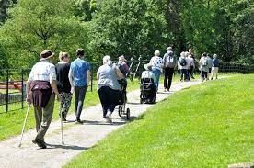
For Advice on any of the information in this booklet, or if you’re not sure where to go for help, contact Shropshire Carers Team.

For information, guidance, and support, contact Shropshire Carers on 01743 341995, shropshire.carers@shropshire.gov.uk
Visit:
www.shropshire.choices@shropshire.gov.uk

For the latest health and wellbeing information in Shropshire, visit:
Healthy Shropshire

For all news and all other information, visit: www.shropshire.gov.uk

We are here to listen and help you find the independent support, guidance, and information you need to live your best life.

*Please print off
EMERGENCY CONTACT LIST | Supplier/Company/Contact | Name and Telephone Number
 | First Point of Contact  (Shropshire Council) | 03456 789044
 | Emergency Contact
 | Emergency Contact Gas supplier
 | Gas Supplier
 | Electricity Supplier
 | Water Supplier
 | Plumber
 | Local Pharmacy
 | GP practice
 | NHS | 111

In an emergency, always dial 999

