 | JOINT TRAINING APPLICATION FORM | 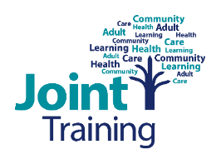

The preferred method of applying for a course is online at: www.shropshire.gov.uk/jointtraining

Course Title
Course Date
Delegate information | Names | Job title | NHS and Shropshire Council staff only: Personal / Employee No.
Please state any support needed e.g. hearing loop or other specialist equipment

Agency (please select the area you work within)
SHROPSHIRE
☐ Shropshire Council |  | ☐ Independent sector (social care/health)
☐ Shropshire Community Health NHS Trust |  | ☐ Independent sector (non-social care)
☐ Shropshire CCG |  | ☐ Voluntary sector (paid workers - social care)
☐ Midland Partnership NHS Foundation Trust |  | ☐ Unpaid volunteer, family carer or service user
☐ Acute Hospital (RSH &PRH)
OTHER
☐ Telford & Wrekin | ☐ Other, please state:

Where did you hear about us? ☐ Word of Mouth ☐ Website ☐ Social Media ☐ Internet ☐ Booklet ☐ Gov delivery ☐ Marketing event ☐ Press ☐ Skills For Care ☐ Other

Workplace/  contact details | Address:
 | Team name:
 | Tel number:
Invoice address (if different from above)

Invoice email address
(mandatory)

Purchase order No.
If used by your organisation

Line Manager name | Name:
 | Email:
Details of person completing this form | Name:
 | Email:
 | Tel No:

On completion, please email this form to: joint.training@shropshire.gov.uk
Tel: (01743) 254731 or 254732 or 254734

Data protection - records will be held in accordance with current Data Protection legislation and the Joint Training Retention Policy. Joint Training will use the data you provide for the sole purpose of training management.

