Cost of Living Help campaign
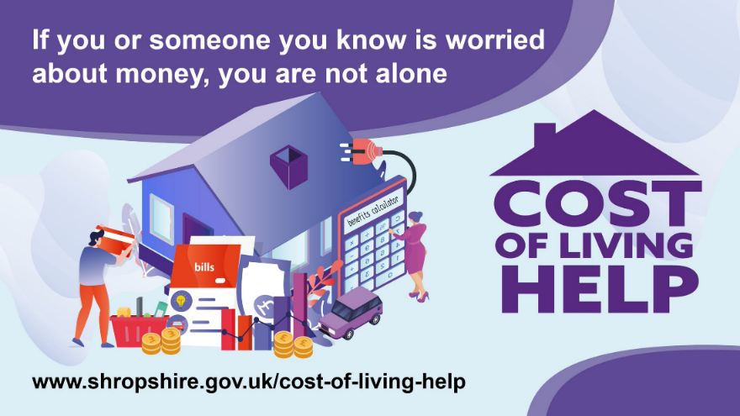

Engagement and Communication Toolkit

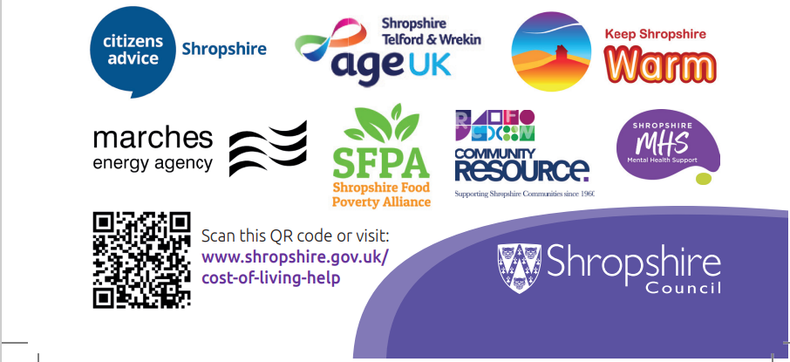

Content Page

About the campaign 3
About this toolkit 4

Key Resources 5

Engaging with residents 6

Key messages 7

Article 8 to 9

Printed and digital material 10

Social media 11 to 15

About the campaign

Background

Inflation rose to 10.1% in the year to September 2022, a 40-year high, leading to significant rises in retail prices. Some of the largest increases have been seen in our supermarkets, with the ONS reporting that some of the lowest priced food items rising 40% since September 2021. Residents have seen an increase in average household energy prices from £1277 at the beginning of the year, to £2500 in October. The FCA has reported that one in four adults are now reported to be in financial trouble or at the brink of difficulty. The Food Foundation reports that 9.7 million adults (18.4% of households) and one in four households with children were reported to have experienced food insecurity in September.

Many residents in Shropshire are struggling to cope with the increase in prices, leaving many households in a negative budget as the amount of money coming in each month is not enough to cover their essential costs. Organisations in Shropshire have been working together to support residents through the cost-of-living crisis through a social taskforce, chaired by Executive Director for Public Health Rachel Robinson. This Social taskforce brings together organisations to work in partnership to create a joint response to the cost-of-living crisis. Our partners include Citizens Advice Shropshire, Age UK, Marches Energy Agency, Community Resource, Shropshire Food Poverty Alliance, and many other key organisations who have been contributing via the taskforce and its subgroups. We have been working with partners to develop joint communications around the cost of living since the spring.

Cost of Living help campaign

Our aim is to work with partners to ensure residents have access to the help and support they need to fight the cost of living. Recognising that worrying about money and having to cut back on life’s essentials comes with a high risk of individuals feel ashamed, reluctant to come forward for help and will take a significant toll on their mental and physical well-being.

To help people cope with the cost of living, organisations across Shropshire are working together to develop communications to assist residents to find the help they need. Working together we can maximise the reach of the key messages, so as many residents as possible, are informed of the advice and support available.

About this toolkit

Thank you for supporting Shropshire’s Cost of Living Help campaign.
This toolkit provides advice and information on how to raise awareness and promote the campaign to your local community.
The toolkit provides you with a range of communication materials including
- Key messages,
- Resources where you can find up to date information on the Cost of Living campaign
- Article for newsletters or webpages
- Promotional material, for you to use and cascade to local residents and organisations.
- Social media messages

Cost of Living online training video
In addition to this toolkit, to help you support residents with the Cost of Living crisis, we worked with partners to develop an online training session.
This session was developed in partnership with Community Resource, the Shropshire Food Poverty Alliance, Age UK, Marches Energy Agency, and Shropshire Citizens’ Advice.
The training video will help you understand the key issues faced by residents, the key groups likely to be impacted and the likely impact on health inequalities.
It will also take you through the key resources you can use to support residents and outlines the support available both nationally and from local organisations. Over 500 frontline staff and volunteers have watched the session so far.
You can watch the session here: https://youtu.be/oDQaCScx5p4.

It’s important to note that we are not asking you to directly advise people on financial issues, a lot of this type of advice is very highly regulated. It is about knowing the best places to point people towards for local support and advice.

Key Resources

- Cost of living website www.shropshire.gov.uk/cost-of-living-help
- Self Help checklist for residents. We are encouraging that residents check if they are missing out on any benefits or other financial support, see if there are ways they can cut costs, borrow money safely and get support with debt, and talk to someone if they are worried about their mental health. https://shropshire.gov.uk/cost-of-living-help/cost-of-living-checklist/
- Shropshire Council Cost of living leaflets and Worrying about Money signposting leaflet (see below and attached with this toolkit)
- Shropshire Council Newsroom –This is where all the latest news on the Cost of Living campaign is published. Please do share these updates with your local residents via your communications channels.
- Social media - We will post regular messages on our Shropshire Council Twitter, Shropshire Council Facebook and Next Door accounts, please retweet or share via your social media accounts

Engaging with residents
A note on stigma
When talking to residents it is important to bear in mind that many people experiencing difficulty with rising costs will not have previously needed to come forwards for support. Many people who are struggling financially are in work or on fixed incomes. Food banks are increasingly supporting people in work. Three key things to remember when talking to residents:
- People often find it difficult to come forward for support
- The language we use the preconceptions we bring to these discussions are hugely important.
- There are a wide range of benefits that support people in varying situations. Benefits provide a lifeline, helping people maintain a reasonable quality of life in difficult circumstances.
Managing demand and expectations
The Social Taskforce has been working together to understand both the potential impact on residents and the capacity available across the system to support those who are struggling. We are aware that organisations where people turn to for help are likely to be very stretched. There are a limited number of qualified advisors across the system, and we need to mindful of not overwhelming these services.
To help mitigate pressures on these services, our initial focus will be to encourage residents who are able to refer to the self-help resources on the cost of living webpage.
For those residents who you engage with and ascertain they need support but don’t have access to a computer or online, then you can encourage them to contact the relevant helplines detailed in the long version of the two new leaflets attached to this toolkit.
A message about funding
You need to be mindful you may be approached by residents who may ask why we don’t have the same funding as maybe some neighbouring local authorities.

As you are aware we have no additional funding to support our Cost of Living programme, only the Household Support Fund from government which is predominantly targeted and ringfenced to our most vulnerable households.
A note on supporting residents in Crisis
Shropshire Council have received further money from the government’s Household Support Fund for the period 1 October 2022 to 31 March 2023. This money is to support low-income households who are most in need of help with food, energy and water bills and with other wider essential costs.
Some of this money has been given to our Local Welfare Support Team so that they can use it alongside other funds they have available to help.
The team are also able to make referrals to local food banks and link residents to support around energy debt. Details of the Council’s Welfare Support offer is here: https://shropshire.gov.uk/cost-of-living-help/what-help-can-i-claim-from-the-council/household-support-fund/

Key messages

The three key messages from the Social Taskforce
We have identified 3 key messages with a strong call to action that we want all residents to know about.
Many people in Shropshire are worried about the rising cost of living. There are three key things we want everyone to know:

- If you or someone you know is worried about money or is struggling right now, you are not alone.
- There may be simple steps you can take to cut costs or maximise your income
- If you are getting into debt or your mental health is suffering, do not wait to get help.

Article
We’ve put together an article to support families and individuals both young and old, across Shropshire.
Please use this copy in your newsletters, local community websites, town and parish notices and any other appropriate communication channels you use when communicating to your local residents.
Advice and support on hand to help with cost of living this winter
Help and support is on hand for those who are worried about money or struggling with day to day living this winter.
Shropshire Council has been working with partners to bring together key resources into one place, to help residents across Shropshire affected by the cost of living crisis.
The Cost of Living Help website offers a wide range of information and advice on:
- Money
- Energy costs and advice
- Food
- Information and support for those who care for others
- Help getting work
- Mental health and wellbeing
- What benefits/financial support you could claim from your council
- Warm welcome locations – nearly 60 locations where residents can just turn up for a chat and find out what support there is in their local area.
In addition to the above support, there is a handy 16 point cost of living checklist that can help you focus on the things that can help reduce costs and increase your income as well as supporting your mental health.
Gwilym Butler, Shropshire Council’s Cabinet member for finance and corporate resources, said:
“We know people across Shropshire are struggling and many are really worried about how they will cope with rising costs of energy, food and fuel.
“This is a top priority for us, and we are working closely with our partners in the voluntary sector to ensure residents know how to access the help and support they need.
“Since 2021 the council has helped to get millions of pounds to those who need it most, and this targeted support will continue throughout this year and into 2023.
“If you or someone you know is worried about money or is struggling right now, you are not alone. It is important to know that; There may be simple steps you can take to cut costs or maximise your income; and if you are getting into debt or your mental health is suffering, do not wait to get help.
“Together with our Social Taskforce partners we have also created a webpage full of valuable advice, tips and guidance to help people keep warm, safe and well this winter.”

Rachel Robinson, chair of the taskforce, and Shropshire Council’s executive director of health, wellbeing and prevention, added:
“If you or someone you know is worried about the cost of living, you are not alone. There is a wide range of support on offer. and through the taskforce we have been able to bring all that help and information together in one place for residents to access.
“Even if you’ve never needed support before, I really encourage everyone to take a look.
“We’ve put together a really handy checklist of things everyone can do to maximise their incomes and reduce costs, whatever your circumstances; including what financial support is available. There is also expert advice and tips from our partners on things like the energy price cap/guarantee, pre-payment meters, protecting yourself against scams; and more, where you can get further specialist advice and support.”
To find out what support is on offer, visit our Cost of Living Help webpage here.
Further information:
Since October 2021, Shropshire Council has helped to deliver more than £30 million to support residents with the rising cost of living.
The money has supported a wide range of people, including pensioners and families with young children, with food costs, fuel grants, energy bills and other essential living costs.
Thanks to Government grants, Shropshire Council has been able to identify and provide much needed financial support to those who need it most.
Grants have included:
- Three separate grants of £2.089m by the Department for Works and Pensions under the Household Support Fund (HSF) – a total of £6.266m. This has enabled the council to target low-income families, single parents, pensioners in receipt of council tax support and has also provided around 7,500 children meal vouchers for the school holidays. It has also seen the welfare support team help award around £789,000 to Shropshire households in crisis. More information on round 3 of the fund will soon be available.
- The £150 council tax rebate to support residents with their energy bills, totalling more than £16m; and the Holiday Activities and Food scheme, which saw more than 3,500 children and young people have access to free food and activities during the school holidays.
- Affordable Warm and Energy Efficiency support which has delivered a huge range of support to residents throughout the ongoing cost of living crisis. 300 households have received grants of up to £90,000 to carry out energy efficiency works totalling £1.65m.

Printed and digital material
As mentioned earlier, we have developed several leaflets as well as digital media to use on social media to help support the campaign. The leaflets include.
- Cost of Living help Short leaflet. This leaflet is designed for general circulation, and points residents to our Cost of living website, where we have brought together a range of help and advice. We have developed a Cost of Living checklist which takes residents through 16 things which may help them in the face of increased costs.
- Cost of Living help Long leaflet. PLEASE NOTE This leaflet is designed for residents who are unable to access information online. It includes the telephone numbers of the key organisations who can offer advice and support. It also includes the number for Shropshire Council’s Cost of living helpline, which provides residents with signposting information about the support which is available. Call centre staff will be making targeted outbound calls to the most vulnerable households, alongside dealing with incoming enquiries. This longer leaflet is primarily being distributed to the most vulnerable households via the Revenues and Benefits team.
- Worrying about Money signposting leaflet which help residents to identify which local organisation to contact for help. https://www.worryingaboutmoney.co.uk/shropshire. There is also an online interactive version of the leaflet: https://www.worryingaboutmoney.co.uk/shropshire which takes you through the local cash first support and advice step by step. This resource is available in 17 languages. Printed copies of the leaflet can be ordered from SophiePadgett@cabshropshire.org.uk.
- Keep Shropshire Warm leaflet – This leaflet signposts to advice on, how to Keep warm at home, financial support and discounts, Energy bills, tariffs & suppliers as well as Heating and insulation grants and support during power cuts – You can find out more here: Affordable warmth and energy efficiency | Shropshire Council

Digital media
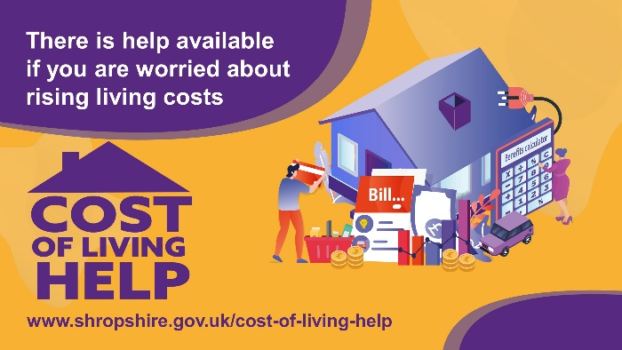
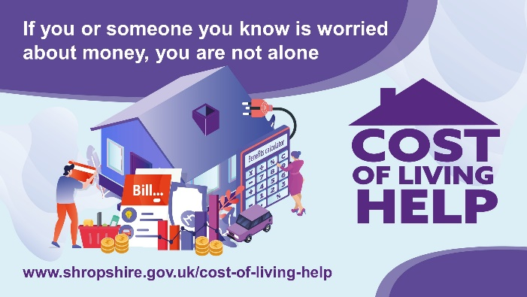

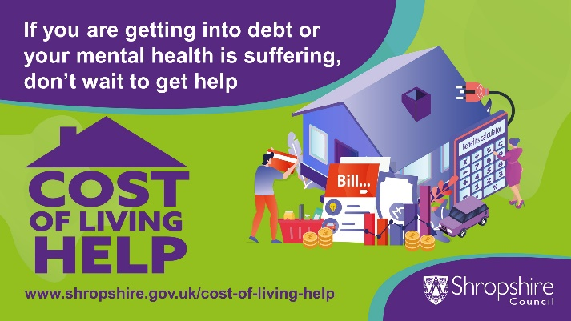

Social media messages

Please see below messages for you to publish via your social media channels. Alternatively you can share our messages by following us at @shropcouncil (Twitter) @shropshirecouncil (Instagram) and Shropshire Council on Next Door Facebook and LinkedIn. Please also share messages from our partner organisations via their social media accounts below.
Citizens Advice Shropshire @CABshropshire
Shropshire Food Poverty Alliance @Shropfoodpov
Marches Energy Agency @MarchesEnergy
Age UK Shropshire Telford and Wrekin @AgeUK_STW
Community Resource - @Comm_Resource
Recommended hashtags #costofliving #costoflivinghelp

Twitter | Facebook/Nextdoor | Instagram | Image | Link
💜We all need a helping hand sometimes.  Alongside our partners  @CABshropshire @Shropfoodpov @MarchesEnergy @AgeUK_STW @Comm_Resource we’ve put together information that could help you or someone you know who is struggling with living costs️  👉https://shropshire.gov.uk/cost-of-living-help/ | 💜We all need a helping hand sometimes.  Alongside our partners:  Citizens Advice Shropshire  Shropshire Food Poverty Alliance  Marches Energy Agency  Age UK Shropshire Telford and Wrekin  Community Resource  We’ve put together information that could help you or someone you know who is struggling with living costs️.  👉Find out more here: https://shropshire.gov.uk/cost-of-living-help/ | 💜We all need a helping hand sometimes.  Alongside our partners:  Citizens Advice Shropshire  Shropshire Food Poverty Alliance  Marches Energy Agency  Age UK Shropshire Telford and Wrekin  Community Resource  We’ve put together information that could help you or someone you know who is struggling with living costs️.  👉 Find out more by clicking the link in @shropshirecouncil bio | 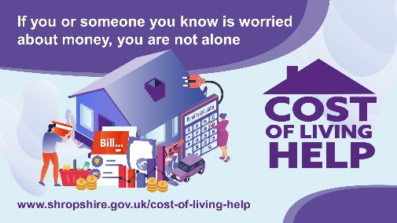 | https://shropshire.gov.uk/cost-of-living-help/
We know that it’s not easy to keep up with rising costs of living.  We want you to know that:  You’re not alone  There are steps you can take  Don’t delay seeking support  👀Read about 16 things that could help if you or someone you know is struggling with living costs.  👉🏻https://shropshire.gov.uk/cost-of-living-help/ | We know that it’s not easy to keep up with rising costs of living.  We want you to know that:  You’re not alone  There are steps you can take  Don’t delay seeking support  👀Read about 16 things that could help if you or someone you know is struggling with living costs  👉🏻https://shropshire.gov.uk/cost-of-living-help/ | 💜We know that it’s not easy to keep up with rising costs of living  We want you to know that:  You’re not alone  There are steps you can take  Don’t delay seeking support  👀Read about 16 things that could help if you or someone you know is struggling with living costs  👉 Find out more by clicking the link in @shropshirecouncil bio |  | https://shropshire.gov.uk/cost-of-living-help/
👇🏻 16 things that could help if you, or someone you know, is struggling with day to day living costs!  💜You are not alone if you are worried about the cost of living crisis. We have put together an online checklist which may help your situation.  👉🏻https://shropshire.gov.uk/cost-of-living-help/ | 16 things that could help if you, or someone you know, is struggling with day to day living costs!  You are not alone if you are worried about the cost of living crisis. We have put together an online checklist which may help your situation.  Follow the steps to see if you can:  Maximise your income  Reduce your costs  Borrow money safely or get debt support  Improve your mental health  Cost of living checklist | Shropshire Council | 16 things that could help if you, or someone you know, is struggling with day to day living costs!  You are not alone if you are worried about the cost of living crisis. We have put together an online checklist which may help your situation.  Follow the steps to see if you can:  Maximise your income  Reduce your costs  Borrow money safely or get debt support  Improve your mental health  👉 Find out more by clicking the link in @shropshirecouncil bio | 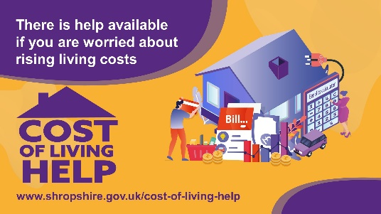 | https://shropshire.gov.uk/cost-of-living-help/
👍Getting support is a good thing!  😟Sadly, the stigma of money worries has a strong grip causing many to feel embarrassed and ashamed to seek support.  We want you to know that you’re not alone.  Find out information and advice on support available in Shropshire  👉https://shropshire.gov.uk/cost-of-living-help/ | 👍Getting support is a good thing!  😟Sadly, the stigma of money worries has a strong grip causing many to feel embarrassed and ashamed to seek support.  We want you to know that you’re not alone  Find out information and advice on support available in Shropshire  👉https://shropshire.gov.uk/cost-of-living-help/ | 👍Getting support is a good thing!  😟Sadly, the stigma of money worries has a strong grip causing many to feel embarrassed and ashamed to seek support.  We want you to know that you’re not alone  👉 Find out more by clicking the link in @shropshirecouncil bio | 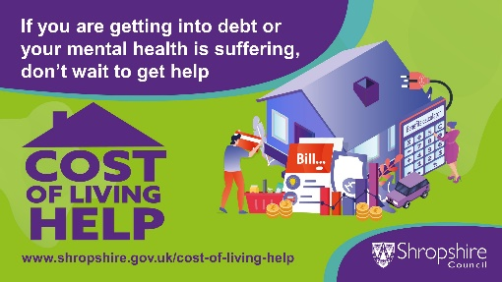 | https://shropshire.gov.uk/cost-of-living-help/

