Highways & Transport Highways Act 1980
Section 178

Application for consent to erect a banner or bunting or Christmas lights over a public highway, footway or grass verge

Important: Please complete this form in full using block capitals – failure to complete all sections may result in unnecessary delays or refusal

Information about the latest roadworks and road closures in Shropshire can be found on: http://www.shropshire.gov.uk/streetworks

Name of applicant:

Address:

Telephone numbers:

Office hours: …………..………………. Outside office hours: ………….………………..…….
Email:

Name of contractor or organisation erecting and removing the banner or bunting or lights

Address:
(enter name and address if different from above)

Telephone numbers:

Office hours: …………………………………….……. Outside office hours: ………..……………………………….

Name of event to be advertised:

Date of event: |  |  |  |  |  |  |  |  |  |  |  | Time of event:
Type of event: (please tick)

Sporting Cultural Charity Recreational

Precise location of banner or bunting or lights: (including building name, house number or name, and street name)

O.S. 12 number grid reference:

Dates for which consent is required:

Both dates inclusive From: ………………………………..………….. To: ……………………………….………….

Public liability insurance details:

Name of Insurer:…………………………………………………………………………………………………………………….

Policy number: …………………………………………………... Expiry date: ……………………………………………..

Cover (£5m minimum) …………………………………………

Important note: Your attention is drawn to the General Conditions, attached to this form, which will apply if consent is given. Special Conditions may be required in certain circumstances – please read your permit fully – any Special Conditions will be shown.

Signed: …………………………………………………… Date: ……………………………………….…………………..

Print name: ………………………………………………. Position within company: …………………….……………….

Please return this form to the postal or email address as listed below:

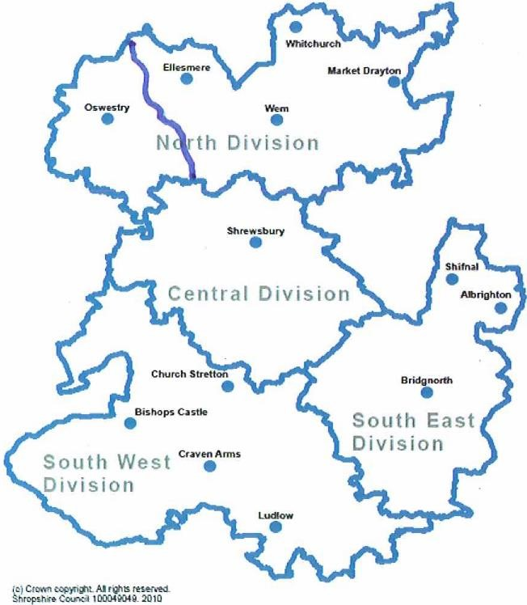
Street Works
Highway & Transport Team
Shropshire Council
107 Longden Road
Shrewsbury
Shropshire SY3 9EL

streetworks@shropshire.gov.uk
0345 678 9006

Highways & Transport

Please read this sheet and the attached specification carefully:

Conditions and regulations for the erection of banners, bunting and Christmas lights over footpaths and carriageways

- Persons desiring to erect banners, bunting or Christmas lights must apply directly to the Street Works Team for such permission, and give a guarantee that the works will be carried out to his satisfaction in accordance with the following conditions:

- That the banner, bunting or Christmas lights shall be erected in approved suitable positions, and in every case during the progress of the work, traffic must not be impeded. Proper provision must be made for pedestrians to walk the footway under the banner, bunting or Christmas lights and no part should project over the carriageway at a height of less than twenty feet (six metres). Traffic flow should not be impeded in any way.

- Banner size and design should be as per the attached specification.

- Where this consent applies to the erection of festive decorations on Shropshire Council’s street lighting columns, you will comply with the County Surveyors Society (now known as ADEPT) document, "Code of Practice for the Installation, Operation and Removal of Seasonal Decorations" (2nd edition).

- Please ensure that during erection of the banner, bunting or Christmas lights that the needs of pedestrians, especially visually handicapped and disabled people and persons with prams or wheelchairs, are borne in mind.

- The banner, bunting or Christmas lights must not obscure any traffic signs or signals, interfere with illumination from a street light or restrict motorists’ visibility.

- The persons executing such works shall be responsible for all accidents and damages to either property or persons occasioned by or resulting from their operations.

- The applicant shall indemnify Shropshire Council and provide insurance in the sum of £5,000.000 against any accidents or claims which may arise or be attributable to the presence of the banner, bunting or Christmas lights in the public highway either during the time they are being erected or taken away and while the banner, Bunting or Christmas lights are in position.

- Banners shall not be erected or removed between the hours of 8.00 am and 6.00 pm Monday to Saturday inclusive.

- Banners can only be permitted for approximately one week before the event and for the duration of the event only.

- In the event of the applicant breaking any of the aforementioned conditions or, if the Street Works Team directs on the grounds of safety to users of the public highway, the applicant will remove all banners upon receipt of a request to do so from the Street Works Team (either verbally or in writing) within such time limit as the Street Works Team may direct.

- Shropshire Council reserves the right to remove any unauthorised banners from the public highway. (If the Shropshire Council is called out to do this or to remove damaged banners in an emergency the applicant will be charged the appropriate rate for their removal.)

- In the event of the applicant breaking any of the aforementioned conditions or, if the Street Works Manager directs on the grounds of safety to users of the public highway, the applicant will remove all banners upon receipt of a request to do so from the Street Works Team (either verbally or in writing) within such time limit as the Street Works Team may direct.

Shropshire Council reserves the right to alter or amend these conditions at any time. over …/

BANNER DESIGN / SIZES

- Banners
4 metres
Max length 4 metres

Max height 0.85 metres
0.85 metres

- Eyelets

Max 0.5 metres apart To be at top and bottom of
○

○

○

○

○

○

○

○

○

○

○

○

○

○

○

○

banner

Eyelets 0.5 metres apart

- Edges

Edges of banners to be folded over and stitched This prevents the banner
ripping at the edges

Edges folded over and
stitched to strengthen
banner

Please Note: Banners that do not meet the above requirements will not be accepted by Shropshire Council

