Highways & Transport

Highways Act 1980 – Section 171

Application for consent to excavate in the highway

Important: Please complete this form in full using block capitals – failure to complete all sections may
result in unnecessary delays or refusal

Information about the latest roadworks and road closures in Shropshire can be found on: http://www.shropshire.gov.uk/streetworks

Name of applicant:

Address:

Telephone numbers:

Office hours: …………..………………. Outside office hours: ………….………………..…….
Email:

Name of accredited contractor: (your contractor must be accredited)
Address:
(enter name and address
if different from above)

Telephone numbers:

Office hours: …………………………………..….……. Outside office hours: ………..……………………………….
Contractor’s accreditation number: ……………………………………………………………………………………………
(Please attach a photocopy of the contractor’s accreditation to this application form)

Precise location of site:
(including house number
and street name)

O.S. 12 number grid reference:

Position of excavation: footway verge carriageway (tick as appropriate)
Is planning permission required? Yes No

If yes please give the planning reference number: …………………………………………………….…………………..

Purpose of excavation:
…………………………………………………………………………………………………………………………………………

…………………………………………………………………………………………………………………………………………

Dates for which consent is required:

Both dates inclusive From: ………………………………..………….. To: ……………………………….………….

Please note that at least one month’s notice is required

Public liability insurance details:
Name of Insurer: …………………………………………………………………………………………………………………….

Policy number: …………………………………………………... Expiry date: ……………………………………………..

Cover (£5m minimum) …………………………………………
A fee of £400 is required and must accompany this application
over …/

Page 2

Important note: Your attention is drawn to the General Conditions, attached to this form, which will apply if consent is given. Special Conditions may be required in certain circumstances – please read your permit fully – any Special Conditions will be shown.

Applicants, via their contractor, shall indemnify Shropshire Council against all losses or claims arising out of the execution of the works and shall insure against any damage, loss or injury which may occur to any property or to any person by, or arising out of, the execution of the works. The contractor shall have third party insurance for a minimum liability of £5,000,000 for any one claim.

I hereby apply for permission to open up the County Road for the purpose stated above and agree to carry out the work in accordance with the Council’s conditions for temporary excavations. I understand that this is not an application for planning permission and that planning permission may also be necessary for the work I am proposing.

Applicants should be aware that certain verges within Districts and Parishes are not maintained by the Highway Authority. This should be checked by the applicant with the relevant Parish and written confirmation of their approval submitted with this application.

I enclose an inspection fee of £400.00.

(Cheques made payable to Shropshire Council).

There may be additional costs if the Defect Inspection system has to be implemented as detailed in The New Roads and Street Works Act 1991.

Signed: …………………………………………………… Date: ……………………………………….…………………..

Print name: ………………………………………………. Position within company: …………………………………….

A fee of £400 is required – please indicate in the box below if you wish to pay by credit card

You will be contacted upon receipt of your application by Shropshire Council for your credit card details
I wish to pay by credit card

over …/
Page 3

Please return this form to the postal or email address as listed below

Streetworks
Highway & Transport Team
Shropshire Council
107 Longden Road
Shrewsbury
Shropshire
SY3 9EL

streetworks@shropshire.gov.uk
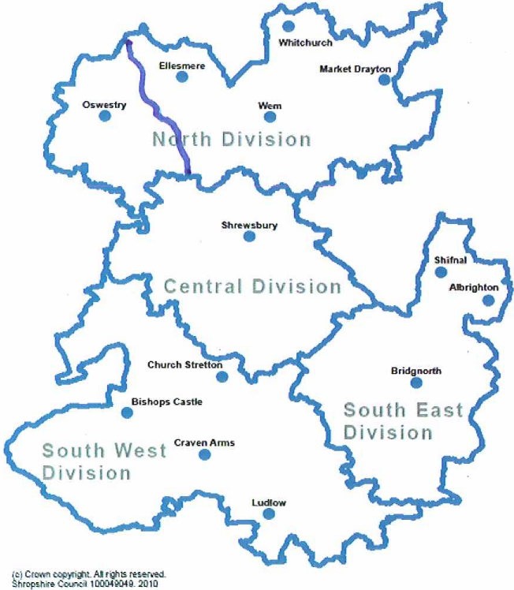

If you would like to hand deliver your form and payment to the local streetworks office or you have any other queries please call our Customer Service Centre on: 0345 678 9006

over …/

Page 4

Highways & Transport

Temporary excavations in the highway

- The following specifications of work to be undertaken when temporarily excavating in the highway. It is important to note that no works shall be commenced before the approval of the Council’s Street Works Team is given to the specification to be adopted in the particular case. Applicants must arrange, therefore, for the Street Works Team (address overleaf) to give his approval for the temporary excavation in the highway. It is pointed out that service provider’s apparatus (e.g. underground pipes, cables, etc.) may be affected by the temporary excavation and require alteration. The cost of any alterations, and/or damage to service provider’s apparatus must be borne by the frontager and the responsibility for notifying the service providers rests with the frontager.

- Commencement of work

Before commencing work the person/firm undertaking the work must obtain from the Street Works Team a Street Works Licence, the application for which must be accompanied by the inspection fee.

Please note that planning permission may be required for the works. Applicants should therefore consult their Council’s Planning Department to establish whether or not planning permission is required for the works. Applicants must also obtain the written permission of third party landowners e.g. Housing Associations, whose land is required for any excavation outside the highway.

- Materials and workmanship

All materials shall conform to the appropriate British Standard and the workmanship shall be to the satisfaction of the Street Works Team whose decision in every case shall be final and binding.

- Maintenance period

Upon completion of the works the owner shall, for a period of two years, be responsible for the rectification of any constructional faults which may appear.

- Signing of works

During the progress of the works the applicant and/or the contractor shall be responsible for the maintenance of signs in accordance with Chapter 8 of the Traffic Signs Manual 1991 and any amendment or re-enactment thereof.

- Service providers (utility companies) equipment

Frontagers should be aware that service providers apparatus may be present in the footway or verge. This may not be apparent on the surface. In some situations service providers apparatus (e.g. underground pipes, cables, inspection covers etc.) may be affected by the construction of the access crossing and require alteration. The costs of any alterations and/or damage to the service provider’s apparatus must be borne by the frontager. Under Section 184(9) of the Highways Act 1980 the highway authority may authorise the frontager to carry out the works. The highway authority will only permit the construction of the access upon receipt of evidence that the frontager has notified the service providers and obtained approval for apparatus to be altered where required. The frontager must place the order and make payment to the service provider in accordance with their requirements.

over…/

Page 5

- Temporary traffic lights

The provision of any temporary traffic lights which may be necessary will require the separate
prior written approval of Shropshire Council, such approval to be obtained by application on a
form obtained from the local Street Works Team’s office at the previously mentioned
address.

- Contractors

Frontagers should note that only accredited personnel with public liability insurance cover are permitted to carry out works on the highway. All contractors must hold a City and Guilds Certificate for “New Roads and Street Works Act 1991 Qualification of Supervisors and Operatives” or equivalent.

