Highways & Transport

Highways Act 1980 – Section 139

Application for permission to place a builder’s skip on the highway

Important: Please complete this form in full using block capitals – failure to complete all sections may
result in unnecessary delays or refusal

Information about the latest roadworks and road closures in Shropshire can be found on: http://www.shropshire.gov.uk/streetworks

Name of applicant:

Address:

Telephone numbers:

Office hours: ……………………………………………. Outside office hours: ………………………………………….
Email:

Name of skip hire company:

Address:
(enter name and address
if different from above)

Telephone numbers:

Office hours: …………………………………….……. Outside office hours: ………..……………………………….

Precise location of site:
(including house number and street name)

O.S. 12 number grid reference:

Position of skip: footway verge carriageway (tick as appropriate)

Available width for pedestrians: …..………. metres Width of verge: …..………. metres

Available width for traffic: …..………. metres

Dates for which permission is required:

Both dates inclusive From: ………………………………..………….. To: ……………………………….………….

Please note that at least 10 working days notice is required

You are required to provide Public Liability Insurance details:

Name of Insurer: …………………………………………………………………………………………………………………………….

Policy number: …………………………………………………... Expiry date: ……………………………………………..

Cover (£5m minimum) …………………………………………

A fee of £115 per month is required and must accompany this application
Skip permit extension = £100 and Unlicensed skip permit = £260

Important note: Your attention is drawn to the General Conditions, attached to this form, which will apply if permission is granted. Special Conditions may be required in certain circumstances – please read your permit fully – any Special Conditions will be shown.

Signed: …………………………………………………… Date: ……………………………………….…………………..

Print name: ………………………………………………. Position within company: …………………………………….

A fee of £115 per month is required – please indicate in the box below if you wish to pay by credit card

I wish to pay by credit card

You will be contacted upon receipt of your application by Shropshire Council for your credit card details

Please return this form to the postal or email address as listed below:

Streetworks
Highway & Transport Team
Shropshire Council
107 Longden Road
Shrewsbury
Shropshire
SY3 9EL

streetworks@shropshire.gov.uk 0345 678 9006

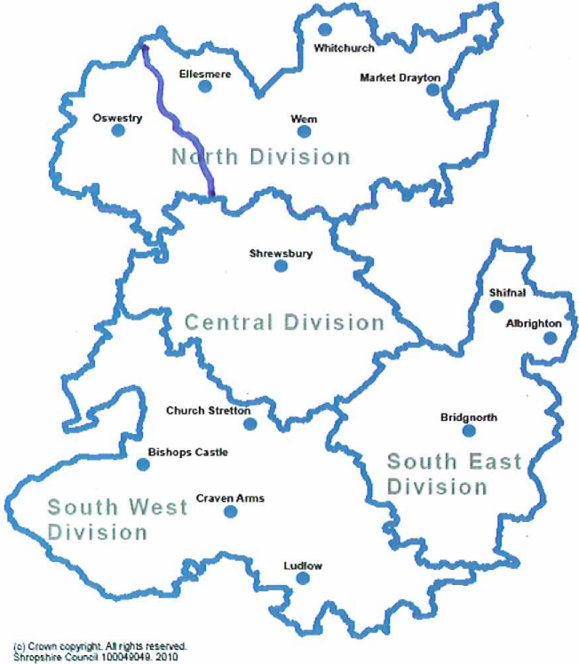

Highways & Transport

Please read this carefully:
Conditions & Regulations

To deposit a Builder’s skip on the Public Highway
Highways Act 1980, Section 139, 140 and 140a,
Road Traffic Regulations Act 1984, Section 65

Builder’s Skip (Markings) Regulations 1984, (S.I. 1984 No. 1933)
Environmental Protection Act 1990, Section 34

Part One: Conditions to be met by the owner of a Builder’s Skip when placed on the highway
1. Each skip shall be deposited on the carriageway/verge* (only in exceptional circumstances will skips be permitted on a footway) and shall be positioned:

(a) so that its longer sides are parallel to the edge of the carriageway and as near to the edge of the carriageway as is reasonably practicable and
(b) so that it does not impede the surface water drainage of the highway nor obstruct access to any manhole or the apparatus of any statutory undertaker or the Council and
(c) subject to the following special conditions:

2. Where the skip(s) occupy highway space upon which there is a traffic regulation order relating to on street parking, the skip owner must reimburse Shropshire Council for loss of income.

3. It is a requirement when carrying out any work on the highways that the works are adequately signed, guarded and lit during the hours of darkness as stipulated in “Chapter 8 of the Traffic Signs Manual” and the “Safety at Street Works and Road Works Code of Practice”.

To meet these standards each company must have an employee, registered with the Council and trained and accredited in the “Signing, Lighting and Guarding” module as prescribed in the New Roads and Street Works Act 1991, an approved module for skip installers is also acceptable.

Where the signing and lighting requirement stipulated for an individual is more onerous than the standard layout (shown in these regulations) then the person delivering the skip must be an accredited operative or the company’s accredited operative, who must be present during the installation to ensure the appropriate signing is correctly positioned to safeguard the public.

4. No skip shall be deposited in or partly in the carriageway of the road such as to prevent the free passage of vehicles or pedestrians along the carriageway in at least one direction; nor shall it prevent the free passage of pedestrians when deposited in a pedestrian precinct.

5. No skip shall be deposited in or partly in the carriageway of the road such as to prevent the free passage of vehicles and or pedestrians to any premises unless the consent of the occupier of those premises has been obtained.

6. Each skip shall not exceed 5 metres in length by 2 metres in width.

7. Each skip or group of skips shall while on the highway; be marked, guarded and
lit in accordance with the following requirements:

(a) The ends of each skip (that is to say, the sides of the skip facing traffic in both directions when the skip is positioned as mentioned in condition 2 above) shall be painted yellow and must be fitted with vertical markings in accordance with the “Builders’ Skips

(Markings) Regulation 1984”, (SI 1984 No. 1933), in having broad red fluorescent and yellow reflecting diagonal stripes (see section A in part two of this document). The painting and stripes of material shall be at all times kept clean. Damaged skips are not acceptable and may result in a skip being required to be removed.

(b) Each skip shall be guarded by a line of at least 4 traffic cones complying with B.S.873: Part 8 1985, placed on the carriageway at 1.2m centres on the approach side of the skip, at 45’ to the edge of the carriageway (see section B in part two of this document). Where 2 or more skips are deposited in a row, so that the distance between adjacent skips does not exceed 2 metres, the row shall be guarded as if it were one skip.

(c) At night (that is to say, between half-an-hour after sunset and half-an-hour before sunrise); A lamp should be placed against or attached to each corner of the skip or the end corners of the row of skips where two or more skips are deposited in a row and the distance between adjacent skips does not exceed 2 metres and shall also be placed between each cone and the next (see section B in part two of this document).

Lamps shall comply with the Traffic Sign Regulations and General Directions. Each shall have an illuminate power of not less than 1 candle and shall remain lit throughout the night.

(d) It is a condition of this permission that all necessary cones and lamps are provided for the customer’s use by the skip owner and all are in good working order.

(e) The skip owner must ensure that the necessary cones and lights are placed in position immediately the skip is deposited on the highway.

(f) Each skip or container shall be clearly and legibly marked with the owner’s name, address, and telephone number including out of hours emergency contact number.

8. No skip when standing in the highway shall contain any inflammable, explosive, noxious or dangerous material or any material which is likely to putrefy or which otherwise is, or is likely to become, a nuisance to users of the highway.

9. No skip shall be used in such a way that any of its contents fall on to the highway, or there is an escape of dust from the contents of the skip when standing on the highway.

10. Each skip shall be removed for emptying as soon as is practicable and in any case not later than 2 working days after it has been filled.

11. No skip shall remain on the highway pursuant to this permission after the period of the permission specified has expired.

12. All materials placed in each skip shall be properly disposed of and the highway where the skip or skips have been deposited shall be left in a clean and tidy condition on the expiration of this permission.

13. In accordance with the Highways Act 1980, the skip owner shall secure compliance’s with these requirements whilst the skip is on the highway.

14. The Licensee is responsible for ensuring that the skip is kept free from fly posting and graffiti. Any occurrences must be removed within 48 hours. Failure to do so will result in the licence being revoked, the Council removing the fly posting or graffiti and recharging the cost to the Licensee

15. If an unlicensed skip is found on the public highway Shropshire Council will impose additional charges on the skip company.

16. The licensee (the Company or person) intending to deposit a builder’s skip) must be covered by Public Liability Insurance which should be available for inspection; minimum cover to be £5m. Such insurance must indemnify the highway authority from and against all actions, claims, losses and expenses whatsoever in respect of loss of life, or personal injury or damage to property, howsoever caused, arising out of or in anyway attributable to the presence of the builders skip.

Part Two: Builder’s Skips conditions and regulations

A. Department of Transport's Builder’s Skips (Markings) Regulations 1984

Schedule 1 (Regulation 3) Specifications about design

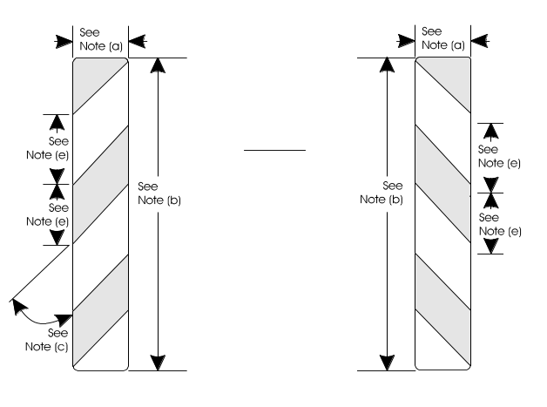

Notes:

(a) The width of each half of the markings shall be not less than 140 millimetres nor more than 280 millimetres.

(b) The length of each half of the marking shall be not less than 350 millimetres nor more than 700 millimetres.

(c) The angle of each stripe shall be not less than 40 degrees to the vertical nor more than 50 degrees to the vertical.

(d) Each half of the markings shall have a minimum area of 980 square centimetres.

(e) The breadth of each stripe shall be not less than 133 millimetres nor more than 147 millimetres.

Schedule 2 (Regulation 3) Requirements as to Markings

1. The markings specified in Schedule 1 shall consist of two plates of equal size and the same shape as one another.

- Each such plate shall comply with the requirements specified in the British Standard Specifications for Rear Marking Plates for Vehicles issued by the British Standards Institution and published on 1 April 1970 under number BS AU152: 1970 and shall be marked as provided in paragraph 5 of that Standard.

- The two plates comprising the marking shall be securely attached to the end of the builder's skip in such a manner that:

(a) each plate is as near to an outer edge of the skip as the construction of the skip allows, so, however, that no part of any plate projects beyond an outer edge of the end of the skip;

(b) the innermost edge of each plate is parallel to and the same distance from the vertical plane passing through the longitudinal axis of the skip;

(c) the upper edge of each plate is parallel to and the same distance from the upper edge of the end of the skip;

(d) no part of either plate is attached to;

- any lid, or

- any door except in a case where a door is the only place to which the plate can possibly or conveniently be fixed; and

- the upper edge of each plate is:

- not more than 1.5 metres from the ground, and

(ii) not lower than the upper edge of the skip save in so far as this may be necessary on account of the construction of the skip, the provisions of Regulations 4 or the provisions of sub-paragraph (i) above.

4. The stippled areas in the diagram in Schedule 1 shall be of red fluorescent material, and the un-stippled areas in that diagram shall be of yellow reflex reflecting material.

B. Requirements for Guarding and Lighting Builder’s Skips

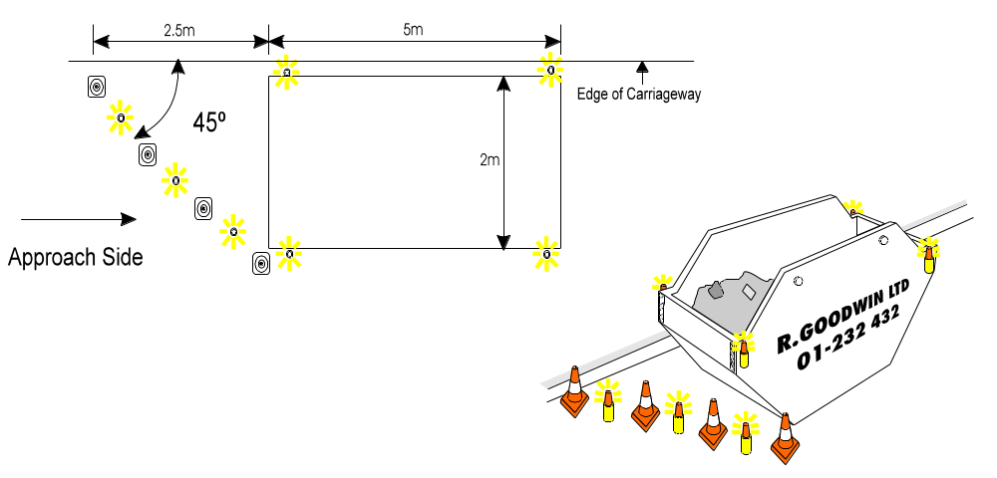
Take note that:

(a) Section 139(4) of the Highways Act 1980 requires the owner of a builder’s skip which has been deposited on the highway to secure that the skip is properly lighted during the hours of darkness, that it is clearly and indelibly marked with the owner’s name and with his telephone number or address, that the skip is removed as soon as is practicable after it has been filled and that each of the conditions of the highway authority’s permission is complied with. If the owner or customer is convicted of an offence under the subsection, he may be liable to a fine.
(b) Section 139(10) of the Highways Act 1980 provides that nothing in the section shall be taken as authorising the creation of a nuisance or of a danger to users of a highway or as imposing on a highway authority by whom a permission has been granted under the section any liability for injury, damage or loss resulting from the presence on a highway of the skip to which the permission relates.
Section 140 of the Highways Act 1980 empowers the highway authority or a police officer to require the removal or repositioning or to remove or reposition a builder’s skip deposited on the highway, even though it was deposited in accordance with the highways authority’s permission, to recover from the owner the cost of such removal or repositioning, and to dispose of a skip which is not collected by its owner. Failure to comply with a request to remove or reposition a skip under the section may result in a fine.

