Apply for a Blue Badge (Child under 3)  Apply for someone else. A Blue Badge costs up to £10 in England.  You’ll need to provide proof of the child’s identity and their address. Along with a recent photograph of their face including shoulders.  The local authority may refuse to issue a badge if you do not provide adequate evidence that the child meets the eligibility criteria.  You can apply online via gov.uk/apply-blue-badge  For more information phone the Blue Badge Team 0345 678 9014  Return the completed application to the Blue Badge Service at:  The Shirehall, Abbey Foregate, Shrewsbury, SY2 6ND | 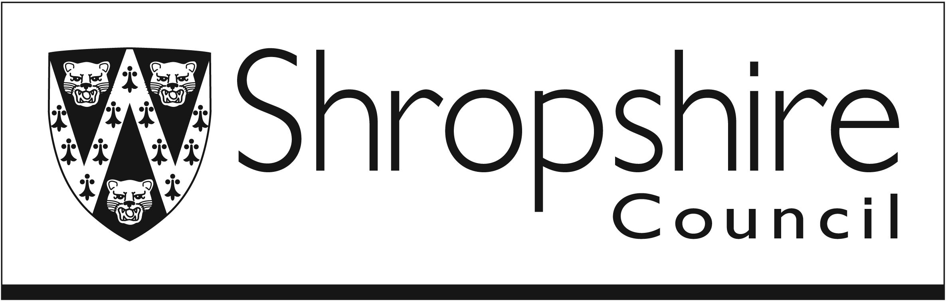
Who are you applying for?  Someone else (A relative or somebody you care for)  Fill in the answers and sign the form on their behalf. Where the form says “you”, it is referring to the applicant.  An organisation (Which transports disabled people) | If you’re applying for somebody else, we’ll ask for your name and your relationship to the applicant.  For organisations, you only need to fill in the organisation section.
Full name (First name and Last name)  Has your name changed since birth?  Yes  Enter full name at birth  No | Should be the full name of the person the badge is for.
Gender
Man (or Boy)
Woman (or Girl)
Identify in a different way
Enter gender identified with

Date of birth (Day / Month / Year)

National insurance number  (Leave blank if you don’t have one) | This helps us to find your details if you call up about your application.
Postal address
(This is where the badge will be posted to)
Postcode:
Email address (optional) | This will be used for updates about the application.
Main phone number

Alternative phone number (optional)

If you are applying on behalf of somebody else
Who should be contacted about this application?
(If you’re the contact, put your full name here)

Your relationship to the applicant

For you or the person you’re applying for  Which of these are you providing as proof of identity?  (Choose one, to attach as a copy)  Child’s Birth or adoption certificate  Child’s Passport | Attach a copy of the proof of identity to this application.
Do you give the local authority permission to check records to prove your address?  Yes  Which records should we check? (Choose one)  Council tax / Electoral roll / School records  No  You must provide a copy of your proof of address | If you don’t give us permission. You must attach a copy of either:  - Council tax  - Utility bill  - Driving licence  - Child Benefit letter
Recent photograph of the applicant  You’ll need a photo to be printed on the back of the Blue Badge. The requirements are similar to a passport photo.  Make sure it:  - Has a plain, light, background  - Includes face and shoulders  - Shows the face clearly  - Is a true likeness or taken within the last 6 months | It’s best to get somebody else to take the photo.  The photo should have the applicant’s name and a signature on the back.  Sections 2, 3, 4 & 5 are not required.
Badge issue fee
The local authority will explain how payment should be made, if the application is successful.
Section 6 – Children under 3 years old
This section is for people applying on behalf of a child that is under 3 years old.
Are you applying for a child under 3 years old?
Yes
Continue answering the questions in this section
No
Go to Section 7

Which of these applies to the child under 3?
They need to be accompanied by bulky medical equipment
They need to be near a vehicle to receive or be taken for treatment
Neither of these

Name any health conditions or disabilities that affect the child  (Try to use the correct medical terms, if you know them) | You should enclose a letter from any healthcare professionals that are involved in the child’s treatments, which confirms the details of the condition.
Section 7 – Treatments, medication, associated professionals & documents  This section is for if you have answered any of the questions in section 6.  Treatments  Has your condition required any treatments?  These could have been in the last 10 years, ongoing or any treatment you have booked in the next 3 years. List any surgeries, treatments or clinics that are to do with your condition.  Yes  Add the treatment details below  No  Go to “Medication” | Remember, when we are referring to “you” this is the applicant. If you’re applying for somebody else, answer the questions on their behalf.
Treatments
Describe the treatment  Anything relevant to your condition that you've seen (or are due to see) a professional for. For example, hip replacement operation, physiotherapy or pain clinic. | Date of the treatment  If it’s in the future – Do you expect the condition to improve afterwards?

Medication
Do you take any medication for your condition?
(Any medication or pain relief you currently take for your condition)
Yes
Add the medication details below
No
Go to “Associated professionals”

Medication
Name of this medication or pain relief  And is it prescribed? | How much do you take at a time? (Dosage) | How often do you take this?

Associated or healthcare professionals
Do you currently see any professionals for your condition?
(Or if you have seen any in the last 3 years)
Yes
Add their details below
No
Go to “Supporting documents”

Associated or healthcare professionals
Name and role of the professional  (This cannot only be your GP) | Where do they work?  (Include contact details if possible)

Supporting documents  Are you attaching supporting documents to this application?  Yes  List the documents you are attaching below.  No  Go to Section 9 | It’s especially important to attach documents where we’ve asked for you to provide proof or verification. For example, diagnosis letters.
What documents are you attaching?
(Attach copies of the documents, where possible)
Diagnosis letter
Prescriptions
Appointment letters
Other
List the documents you are attaching to this application

Applying on behalf of somebody else  By submitting this application you agree on behalf of the applicant that:  - the rules for using a Blue Badge have been read and understood  - you have the authority to submit this application  - the details provided are complete and accurate  - they won't hold more than one Blue Badge at any time  - your local authority will be told about any changes that may affect their eligibility  You also agree that your local authority may:  - contact the person whose details have been provided if there are any issues with this application or to prevent badge misuse  - if required, arrange a phone-based or in-person assessment for the applicant  - check their eligibility with the information they hold  - suggest other benefits or services that they may be eligible for  I agree to this declaration  Signed  Date of signature  Shropshire Council will decide if your child is eligible for a badge. They cannot start the assessment process until they have all the necessary evidence. An application will normally be assessed within 4 weeks of receipt but may take up to 12 weeks to assess their eligibility.  If Shropshire Council decides that your child is not eligible and you think that they did not take account of all the facts, you can ask Shropshire Council to review the application. | Section 8 is not required.  Read the declaration carefully and only sign it once you are clear.

