Apply for a Blue Badge (Organisation)  Apply or renew your Organisation’s Blue Badge(s). Each badge costs up to £10 in England.  The local authority may refuse to issue/re-issue a badge if you do not provide adequate evidence that your organisation meets the eligibility criteria.  You can apply online via gov.uk/apply-blue-badge  For more information phone the Blue Badge Team 0345 678 9014  Return the completed application to the Blue Badge Service at:  The Shirehall, Abbey Foregate, Shrewsbury, SY2 6ND | 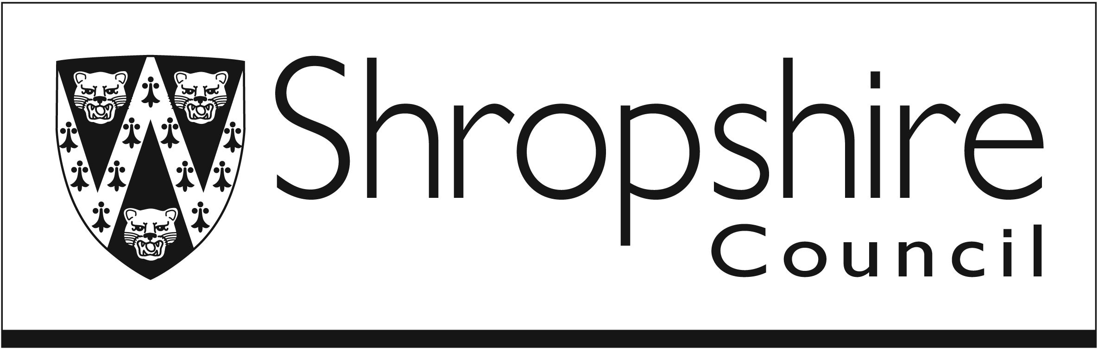
Who are you applying for?  An organisation (Which transports disabled people) | Please complete all relevant sections.
Do you already have a Blue Badge(s)?  Yes  Enter the badge number(s) (6 digits)  No | If you don’t know the badge number(s), leave it blank and your local authority should be able to find the badge using your details.  Sections 2, 3, 4, 5, 6, & 7 are not required.
Section 8 – Organisation badges  Does your organisation care for people who need a Blue Badge?  Yes  No  Does your organisation transport the people you care for?  Yes  No | If you answer “No” to either of these questions, it is unlikely your organisation is eligible for a Blue Badge.
What’s the name of your organisation?

Charity number (if applicable)

Postal address
(This is where the badge will be posted to)
Postcode:
Who should be contacted about this application?
(If you’re the contact, put your full name here)

Email address (optional) | This will be used for updates about the application.
Main phone number

Alternative phone number (optional)

List the vehicles the badge will be used in
Vehicle registration number | How often is the vehicle used?

Section 9 – Declaration  By submitting this application you agree that:  - you're authorised to complete this application on behalf of your organisation  - the details you have provided are complete and accurate  - you will tell your local authority about any changes that will affect your organisation's Blue Badge entitlement  - your local authority can check any information they already have about you so that they can process your application  I agree to this declaration  Signed  Date of signature  Shropshire Council will decide if your Organisation is eligible for a badge. They cannot start the assessment process until they have all the necessary evidence. An application will normally be assessed within 4 weeks of receipt but may take up to 12 weeks to assess your eligibility. | Read the declaration carefully and only sign it once you are clear.

