Shropshire Council
Passenger Transport Group
Coronavirus (Covid-19) Emergency - Guidance for School Transport Provision from 1st June 2020
In response to the global Coronavirus/Covid-19 pandemic emergency, apart from key worker pupils, the UK Government closed all UK schools from 20th March 2020.
In preparation for a phased re-opening of schools, and subject to further guidance from the UK Government, Shropshire Council’s school transport network will begin re-activation based on the guidance below.
Specifically, the UK Government announced on 10th May 2020 that Primary School Reception Class and Year Group 1 and 6 pupils will return to school on 1st June 2020, with other year groups returning later. Additionally the Government have asked secondary schools, sixth form colleges and further education colleges to offer some face-to-face support to supplement the remote education of Year 10 and year 12 students who are due to take exams next year, alongside the full time provision they are offering to priority groups (i.e. vulnerable and critical worker children).
From September 2020 it is possible that most primary and secondary pupils will return. The Government have emphasised that these plans are conditional on progress in containing the coronavirus and may be changed.
The plans outlined below set out how provided school transport in Shropshire is to resume and these plans will be updated and re-circulated as the return to school programme progresses. This guidance should be read and adopted by all Council passenger transport contractors/operators. Clearly, it is intrinsically relevant to schools and parents/carers. The principles set out here are also relevant to Council contractors transporting adults (ASC).
Operators should be aware of general UK Government advice stating that we should keep our distance from people outside our households. Public Health England recommends keeping a distance of 2 metres where possible. They say that the key thing is to not be too close to other people for more than a short amount of time, as much as you can. The risk of infection increases the closer you are to another person with the virus and the amount of time you spend in close contact: you are very unlikely to be infected from just walking past another person, they add.
They also state that if you need to be near other people you should avoid physical contact, try to face away from other people, and keep the time you spend near other people as short as possible. And be aware of the surfaces you or others touch.
Operators should also note that on the 12th May 2020 the UK Government issued updated guidance “Coronavirus (COVID-19): transport and travel guidance” which included links to “Safer travel guidance for passengers” and “Safer travel guidance for operators”, and these can be found at: https://www.gov.uk/government/collections/coronavirus-covid-19-transport-and-travel-guidance?utm_source=061b498b-d08e-400d-a447-5b59202d8b6e&utm_medium=email&utm_campaign=govuk-notifications&utm_content=immediate
Further UK government advice is that staff employed by operators should avoid mixing with each other where possible and that operators should support individual workers who choose to use face coverings in situations where social distancing is not possible.
Shropshire Council greatly appreciates all the support and effort from school transport operators and our other partners in these difficult times and we are always here to support you.
So, for any queries please contact the Council’s Passenger Transport Group (PTG), using the contact details shown at the foot of this guidance.

Shropshire Council, Passenger Transport Group (PTG)
28th May 2020

General Guidance to School Transport Operators re Coronavirus (Covid-19)
- In addition to the links above, school transport operators and transported pupils will follow issued general Government Covid-19 advice at this link: https://www.gov.uk/government/collections/coronavirus-covid-19-list-of-guidance#transport
- Safety of staff, pupils and the public will be paramount
- Operators should be aware of advice from the UK Government on ‘social distancing in the workplace during coronavirus (COVID-19): sector guidance’ which can be found at: https://www.gov.uk/guidance/social-distancing-in-the-workplace-during-coronavirus-covid-19-sector-guidance
- Drivers, Passenger Assistants and pupils should not travel on transport if they are feeling unwell, particularly if they have symptoms of coronavirus (COVID-19) which include a new, continuous cough, high temperature, or loss of taste or smell, or if they live in a household with someone showing any of these symptoms – they should self-isolate and stay at home. Any pupils becoming ill at school should be taken home by their parents (NB parents should have transport contingency arrangements in place to do this)
- For staff who live in the same household as someone who is at ‘High risk (clinically extremely vulnerable)’, Public Health England say that the rest of the household do not need to start shielding themselves, but they should stay at home as much as possible - operators and drivers need to consider this advice and their own circumstances before deciding how, when and if they are deployed
- Children who are considered extremely clinically vulnerable and shielding should continue to shield and are not expected to attend school; parents of children clinically vulnerable (but not clinically extremely vulnerable) of severe illness from coronavirus should follow medical advice about attendance
- The Government’s specific Covid-19 advice for staff in the transport sector should be followed and is at this link: https://www.gov.uk/government/publications/coronavirus-covid-19-safer-transport-guidance-for-operators/coronavirus-covid-19-safer-transport-guidance-for-operators
- Operators should ensure that all touch points on school transport vehicles have been cleaned to protect against Coronavirus/Covid-19 prior to and after every new journey – this includes door handles, keys, handrails, armrests, seat backs, seatbelts, driver controls, etc. [NB operators should contact PTG if they have any difficulties in sourcing appropriate cleaning supplies/PPE]
- Social distancing inside vehicles means that they will carry no more than 25% of their capacity from 1st June 2020 – on buses, only one seat must be used per row (green dots), with alternate nearside/offside window seats occupied, as per the diagram below; bus operators should mark seats accordingly; siblings from the same household can sit next to each other as long as they are socially distanced from other pupils. On taxis only the rear seat diagonally opposite the driver should be used [NB unless two siblings from the same household are transported, when both rear seats can be occupied, subject to taxi operator agreement]
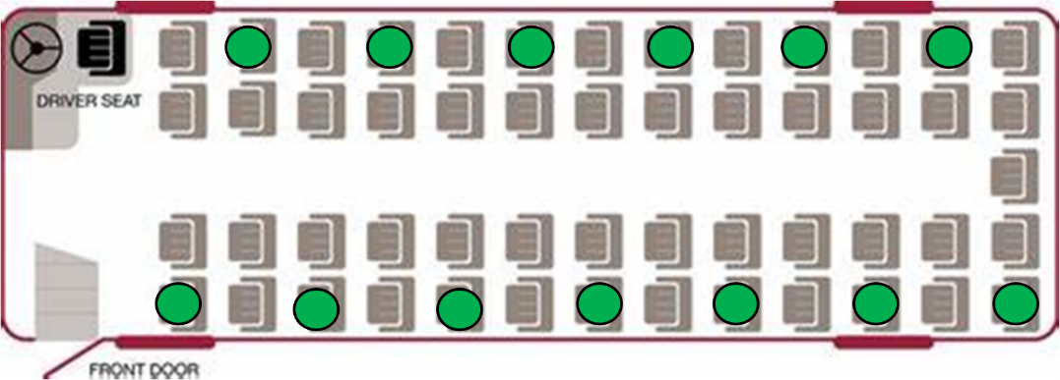
- Schools should let the Council’s Passenger Transport Group (PTG) know which entitled pupils will require provided transport from 1st June 2020, returning this information on the form provided to ptscontracts@shropshire.gov.uk. PTG also need to know which key worker entitled pupils from other year groups will require transport. PTG will then contact transport operators about providing the required transport. It’s appreciated that not all pupils from designated year groups may require transport. Schools also need to confirm their transport arrival/departure times at the school site, as we understand that some schools may stagger these to reduce site congestion
- Where the anticipated number of pupils is greater than 25% capacity, PTG will arrange with operators that they deploy a larger vehicle - where this is not possible, operators may be asked to provide additional vehicles, or in liaison with schools, ‘double trip’ so long as they can clean vehicles between trips – where an operator incurs additional costs over and above Suppler Relief payments/standard contract rate payments, they need to talk to PTG about this on a case by case basis
- Whilst we cannot be sure how the Covid-19 emergency will unfold, if most pupils return to school in September 2020, a 25% loading capacity would mean that we would be unable to deliver any meaningful home to school transport service for entitled pupils in Shropshire. So contingent on Covid-19 developments, we would be minded to initially raise the capacity to 50% from September 2020 as per the seating diagram below (with additional seats marked blue to be used), with face coverings recommended for pupils. A mixture of deploying larger vehicles, extra vehicles, ‘double tripping’, payment of parental travel expenses and/or revised pupil attendance patterns at schools may provide additional means of helping the delivery of the home to school transport service. It’s important to note that none of these things can be certain and there exists a clear risk to the integrity of our service delivery.
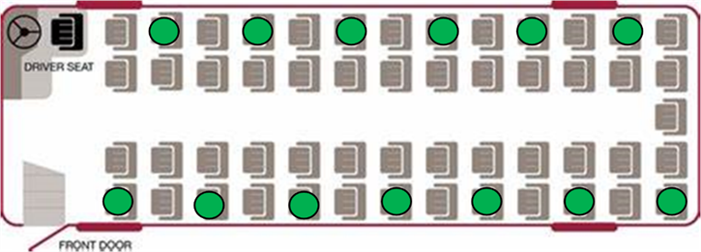

- Pupils waiting for buses should do so safely and 2 metres apart, and this is a parental responsibility. Boarding buses should be done one at a time and 2 metres apart - the vacant seat nearest the rear of the bus must you used first; disembarking buses should be undertaken one at a time, from the most forward seats first, with pupils staying 2 metres apart, working back in turn to the rear seats (i.e. so that pupils walking down the aisle do not pass any other seated pupils). These rules apply for both inbound and outbound journeys.
- Where a bus has a middle door, this should be used in preference to a front bus door – middle door boarding should see pupils using front and rear seats first, to avoid pupils passing seated pupils when using the aisle.
- Where primary school pupils have difficulty fitting seat belts themselves, the driver should offer verbal guidance and support from a safe distance – seat belts should be pre-adjusted for pupil use
- Use social distancing where possible in a transport hub/school site where multiple vehicles may be present where loading and unloading is required – when boarding at a hub, drivers may stand off the bus 2 metres away from boarding pupils/passengers; drivers should not congregate; schools may wish to supervise on-site unloading/loading
- Where school ‘link’ or ‘feeder’ transport is provided, operators should contact PTG about possible revised arrangements, one of which may be to provide the transport directly to the end destination, and the reverse of this on the return journey
- Operators should provide good vehicle ventilation when carrying passengers
- On-board disposable cleaning fluids/cloths/disposal gloves and a suitable secure on-board bin for disposal of any cleaning items, tissues or PPE, for in-journey use, should be provided
- All staff and pupils should maintain good hand hygiene (e.g. washing hands with soap and water or alcohol hand sanitiser, particularly straight before and straight after journeys), avoid direct hand contact with eyes, nose and mouth, and use tissues to catch coughs and sneezes (or at least to cough/sneeze into the crook of their elbow) disposing of tissues in a bin as soon as possible
- To maintain on-vehicle social distancing protocols, only entitled pupils whose parents have notified their school that transport will be required will be allowed to travel on the school bus/taxi;
- Where pupils/passengers do not behave in accordance with transport guidance and/or generate an unacceptable safety risk to staff, they will be refused transport without notice
- Given the restriction on carrying capacities, regrettably it is unlikely that the Council’s Temporary Seats Payment Scheme for non-entitled pupils will be able to operate for the time being.
- Safely dispose of any PPE if it is contaminated and straight after use
- At the end of their shift, drivers and Passenger Assistants (PAs) should minimise possible contamination before entering their own home – key things to do include washing with soap and water, and isolating clothes and personal effects in a box prior to cleaning
- Agreed contractual rates will replace ‘Supplier Relief’ payments from the date of a reactivation of an individual contracted route – ‘Supplier Relief’ is currently payable until at least 30th June 2020; inactive routes may be re-tasked/re-scheduled by the Council within the ‘Supplier Relief’ scheme
- Whilst our new arrangements for providing home to school transport comply with Government guidance, where parents of pupils entitled to free school transport decide to make alternative arrangements out of personal preference, parental travelling expenses as an alternative to travelling on the school bus/taxi may be paid or not depending on the local circumstances, until the end of the Summer Term 2020 in the first instance.

Additional Coronavirus (Covid-19) Guidance for Adult Social Care/Special Education Needs Disability Transport
- Government guidance for specialist schools and special post-16 establishments is to work towards a phased return of more children and young people without a focus on specific year groups and informed by risk assessments. It is particularly important that PTG is informed by schools which pupils are returning and requiring provided transport. It should be noted that given the social distancing restrictions on transport discussed elsewhere in this guidance, delivering the required transport maybe difficult or not possible; close liaison between schools and PTG is critical
- Where there are vehicle capacity problems, larger or extra vehicles may offer some solution, but their supply is limited; also, ‘double tripping’ is unlikely to be viable on longer distance routes
- Where taxi transport is provided for one pupil with a Passenger Assistant, it will be difficult to maintain social distancing protocols, so this transport may not operate; in these circumstances, alternative arrangements will be made where possible
- The Passenger Assistant (PA) should be allocated one of the seats in the seating plan outlined below and not sit beside a pupil/passenger. If there is a specific physical, behavioural or medical need the PA should sit close to, but not next to the relevant pupil/passenger. The PA may need to intervene if there is a specific in-journey incident. Appropriate PPE should be worn
- At pick up points, where staff receive passengers from their parents/carers, social distancing guidance must be adhered to and PPE, alcohol hand sanitiser and cleaning deployed appropriately straight before and after passenger handover has occurred; keep a maximum distance from and minimum time with parents/carers - there should be no physical contact with their doors, gates or parent/carer property or belongings
- An additional risk assessment should be carried out where circumstances change or where there are additional issues present
- For pupils/passengers who may require rescue medication it is unlikely that transport can be provided because of the potential infection risks that this may cause.
- If the PA needs to fasten a passenger’s seat belt/harness, this should be done with minimal physical contact, wearing appropriate PPE
- When applying or removing fluid resistant face masks or other PPE, it is important that the wearer’s hands are washed/cleansed before and after each use
- If drivers or PAs have to manoeuvre wheelchairs, they should clean the wheelchair handles and brake levers prior to pushing the wheelchair. Likewise, if installing car seats or booster seats, clean the hard surface areas (e.g. outer shell, buckles) before installing in the vehicle and clean them after use – for these tasks PPE should be worn, and this should include disposable gloves and fluid resistant face masks/face visors
- Adult Social Care/Special Education Needs Disability Transport (whether by taxi or accessible bus) should take account of the ambulance trusts’ procedures for transporting someone without covid-19 symptoms where social distancing is not possible (i.e. particularly, please see ‘Table 4’ infection control) shown at: https://www.gov.uk/government/publications/covid-19-guidance-for-ambulance-trusts/covid-19-guidance-for-ambulance-trusts
- Proper planning and the use of appropriate PPE will be needed for wheelchair users and those with disabilities where handling and sustained contact may be required for getting on and off vehicles, as in the ambulance procedure
- Transport will only be provided if it is the only option for the pupil’s/passenger’s needs and is the right mode of transport for the person being transported
- Any unnecessary moving and handling or close sustained contact with the pupil/passenger will be avoided
- If pupils or passengers present an unacceptable safety risk to staff or other pupils/ passengers, the Council reserves the right to withdraw transport without notice
- Seating arrangements should be in accordance with the principles outlined above, and specifically for smaller minibus type vehicles from June 2020, the following diagrams indicate how seating arrangements should be provided, with the yellow dots indicating the only seats to be occupied:
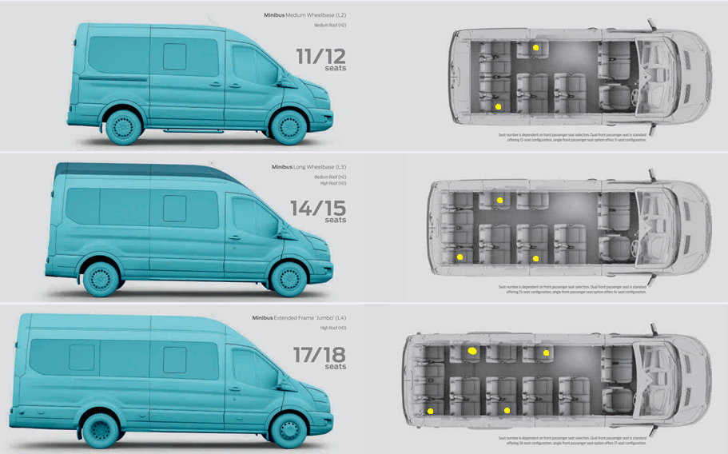

- The UK Government have issued advice in respect of ‘COVID-19: infection prevention and control (IPC)’and operators and staff should be aware of this. It can be found at this link: https://www.gov.uk/government/publications/wuhan-novel-coronavirus-infection-prevention-and-control
- Operators should also be aware of ‘Guidance for Ambulance Trusts’ at: https://www.gov.uk/government/publications/covid-19-guidance-for-ambulance-trusts/covid-19-guidance-for-ambulance-trusts

Local Bus Services (public bus) Covid-19 Guidance
- Whilst the general principles above will apply, the Government have provided specific guidance for the use of public transport and this should be adhered to. The guidance can be found at the following link: https://www.gov.uk/guidance/coronavirus-covid-19-safer-travel-guidance-for-passengers#public-transport

Community Transport Groups
- The general principles above apply to community transport but if Groups have any queries, they should contact PTG.

Shropshire Council, Passenger Transport Group (PTG), 107 Longden Road, Shrewsbury, SY3 9DS
Telephone: 01743 253031 or 01743 253044 or 01743 253042
Email: ptscontracts@shropshire.gov.uk
Web: www.shropshire.gov.uk
Date: 28nd May 2020

@ ‘H’ / Imp_Div/ Tran_Serv / Shared / TL Docs / Fleet / TR / Corona Operator Guidance 110520

