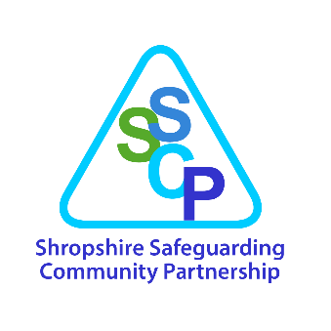
Shropshire Safeguarding Community Partnership
Strategic Plan and Priorities
2020 – 2023

Date Completed | July 2020
Status | Final
Review Date | April 2023
Approving Body/Group | Shropshire Safeguarding Community Partnership
Date of Approval | 09.10.20

CONTENTS
Foreword from the Independent Chair 3
What is the Shropshire Safeguarding Community Partnership? 4
Local Strategy 4
The Vision for Shropshire 5
Background 5

Statutory Duties of the Partnership 6

Our Business as Usual Activity 7
Our Strategic Priorities 7-12

Appendix 1. Shropshire Safeguarding
Community Partnership Structure 14

Appendix 2. Shropshire Safeguarding
Community Partnership Business Plan Template 15-16

Foreword from the Independent Chair

Thank you for your interest in wanting to understand the detail of our strategic plan and priorities to promote the welfare of children, safeguard adults who are at risk of abuse and to keep our communities safe across Shropshire. It is our ambition to empower and work with individuals and communities to jointly achieve the plan.
In responding to change, the safeguarding partners along with local agencies and organisations are committed to the transformational journey to improve local safeguarding arrangements and outcomes for children, adults and communities.
We will work together in a system where:
- the views and experiences of children, young people, families and adults are at the centre of all we do
- excellent practice is what we do
- partner agencies hold one another to account effectively
- ‘new’ safeguarding issues are identified early
- learning is promoted and embedded
- information is shared effectively
- the public feel confident that Shropshire citizens are protected from harm

This multi-agency, integrated, safeguarding and community safety partnership reflects Shropshire’s ambition to work collaboratively across local agencies and organisations and with individuals and communities to develop an equitable and robust partnership. The arrangements set out an innovative new way of working across the safeguarding system ensuring that contextual, place-based responses are modelled and facilitated by the strategic senior leadership. The Shropshire Safeguarding Community Partnership is a key driver of change as it brings partners together at a strategic and operational level, ensuring a proactive and responsive approach to the needs of children, adults and communities. It drives opportunities to shape and influence policy development leading to improved practice by our professionals and improved outcomes for our citizens.

Ivan Powell Independent Chair

What is the Shropshire Safeguarding Community Partnership?

The Shropshire Safeguarding Community Partnership (with leadership and scrutiny of the Independent Chair) is the strategic group bringing together the senior representatives from each of the statutory organisations required by the legislation above. You can find the Constitution here.

Each statutory partner organisation retains its own existing lines of accountability and responsibility.

The Shropshire Safeguarding Community Partnership acts to seek assurance, scrutinise, challenge and ensure agencies are enabled to work together to achieve the aims of the Partnership.

A Local Strategy

Whilst the production of a strategic plan is a statutory requirement, a local strategy is key to supporting our aim to work with Shropshire people and with partners to ensure that children, adults with care and support needs and the community of Shropshire are:

- living as safely as they can
- fully involved in the safeguarding and criminal justice process and the development of any ongoing protection plans if required
- receiving effectively coordinated services

A strategic priorities review day was held on 13th February 2020 in which agencies from across the wider community safety and safeguarding partnership came together to contribute to the development of the priorities and measures of success set out in this document.

The Vision for Shropshire

The Shropshire Safeguarding Community Partnership (hereafter referred to as the Partnership) is committed to increasing the safety and resilience of people in Shropshire (including children and adults with care and support needs) and their communities; in order to reduce harm caused by abuse, neglect or other crime.

Background

In 2017 following the “Review of the role and functions of Local Safeguarding Children Boards”, the Government Response and in anticipation of the changes to legislation (Children and Social Work Act 2017), Shropshire Council and its partners commissioned a review of the Local Safeguarding Children Board and its relationship with other partnership boards.

The review considered:
- The function and effectiveness of the Shropshire Safeguarding Children Board (SSCB).
- The function of all the partnership boards within Shropshire. This took into account cross cutting issues, shared understanding, and the opportunities for improved efficiency through joined up and complimentary working and business and administrative support.
The review led to the proposal of the establishment of the Shropshire Safeguarding Partnership (SSP) which would have strategic oversight of the safeguarding arrangements for adults and children. This has been considered and approved by both the Children’s and Adults Boards. Since that time, the proposal to include Community Safety has been considered and approved by the Community Safety Partnership.

On 29th April 2020, Shropshire Council’s Cabinet approved the amalgamation of the partnership arrangements and the respective Boards for Community Safety, Children and Adult Safeguarding. Shropshire Safeguarding Community Partnership now fulfils the statutory functions of the Safeguarding Adults Board, Children’s Safeguarding Partnership and the Community Safety Partnership.

Statutory Duties of the Partnership

Our Community Safety statutory duties are to:
- To formulate and implement:
  - a strategy for the reduction of crime and disorder in the area (including anti-social and other behaviour adversely affecting the local environment)
  - a strategy for combatting the misuse of drugs, alcohol and other substances in the area
  - a strategy for the reduction of re-offending in the area
- To have regard to the police and crime objectives set out in the Police and Crime Plan
- To undertake Domestic Homicide Reviews

The statutory duties of the Children’s Partnership are to:
- Publish arrangements for agencies to work together to explain how they are safeguarding and promoting the welfare of children
- Set out arrangements for scrutiny by an independent person
- Publish an annual report
- Conduct Local Child Safeguarding Practice Reviews

Our Safeguarding Adult Board statutory duties are to:
- Publish a strategic plan each financial year
- Publish an annual report
- Conduct Safeguarding Adult Reviews

Shropshire Council has two further related statutory duties which are to:
- To agree risk and co-ordinate Prevent activity
- Establish a Safeguarding Adults Board

Our “Business as Usual Activity”

The following areas are identified as “business as usual activities” for the Partnership and there are three “system” groups (see appendix 1.) set up to oversee the work:

  - Assurance and challenge between Partners
  - Ensure the effective undertaking of safeguarding enquires and investigations for adults with care and support needs and children.
  - Ensure the provision of a training programme that equips people with the knowledge and skills required to prevent and respond to harm as a result of abuse and crime.
  - Undertaking statutory case reviews and changing practice as a result of what we learn from them
  - Audit and performance (including identifying trends from our communities and using our experience to constantly improve what we do)

Our strategic priorities

In addition to our business as usual activity, to deliver our vision we have identified strategic priority areas to work on. A successful strategy and priority setting day was held with partners on 13th February 2020 and the following priorities were identified for the next three years:

- Joint priorities are Domestic Abuse, Exploitation and Transitional Safeguarding (the period of moving from Children’s Services into adulthood)
- The Adult priority is Self-Neglect
- The Children’s priority is Neglect
- The Community Safety priorities are Preventing Offending and Drug and Alcohol Misuse

The priorities identified in this document do not instruct organisations who are part of the Shropshire Safeguarding Community Partnership to only respond to these areas of work in their day-to-day activity. This document outlines the areas of particular interest to the partnership over the next three years that will be monitored through the completion of the Business Plans (by each multi-agency group) placed at the end of this document.

- DOMESTIC ABUSE
We’ll know we’ve been successful when we:

- Increase the number of domestic abuse crime/incidents reported (because we know 76% of incidents are not reported)
- Increase the number of victims who seek support from a range of partner agencies
- Are increasing positive actions against people posing a risk and/or who are perpetrating domestic abuse
- Reduce homelessness due to domestic abuse
- Decrease the repeat domestic abuse incidents being reported
- Review and re-commission a programme for those not convicted but are or pose a risk to others, of domestic abuse
- Have developed a multi-agency profile of Domestic Abuse that:
- Identifies what types of abuse are happening
- Who is harmed by domestic abuse
- Who is posing a risk of domestic abuse
- Identifies where in Shropshire domestic abuse is happening
- How Shropshire performs against other authorities

- EXPLOITATION
We’ll know we’ve been successful when we have:

- Developed a multi-agency profile of exploitation that identifies:
- What types of exploitation are happening
- Who is harmed by exploitation
- Who is posing a risk of exploitation
- Where in Shropshire exploitation is happening
- Benchmarks Shropshire against other authorities

- Increase the “disruption” of perpetrators of exploitation
- Know that partners have a clear understanding of and contribute to plans that reflect the contextual nature of the harm experienced when individuals or groups are being exploited

- Clarified the referral process into Channel Panel
- Reviewed the effectiveness of the Child Exploitation Pathway
- Increased public and parent awareness of exploitation
- Increased community involvement in tackling exploitation
- Identified children and adults with care and support needs at risk of exploitation and refer them to the appropriate safeguarding support
- Evaluated the impact of learning activity to demonstrate workforce knowledge and understanding
- Reported on the different types of exploitation being experienced within the safeguarding and community safety system
- Have a reduction in exclusions from education, employment and training
- Have a reduction in children who are Not in Education, Employment or Training
- Have a reduction in children who are being exploited entering the care system

- TRANSITIONAL SAFEGUARDING (including Adverse Childhood Experiences/Trauma Informed Responses)
We’ll know we’ve been successful when:

- Partners in Shropshire have a plan in place to explain how they will demonstrate they are “trauma informed” in their organisational practice

- There is a multi-agency aligned approach (supported by learning and development activities) to working with those who are going to need support into adulthood

- We have a clear and transparent offer in Adult Services to offer support to young people at risk of exploitation once they are 18

- SELF-NEGLECT
We’ll know we’ve been successful when we:

- Can prove that agencies are applying the Keeping Adults Safe in Shropshire Network guidance on working with people who are experiencing self-neglect

- Have developed a multi-agency profile of self-neglect that identifies:
- What types of self-neglect are happening
- Who is experiencing self-neglect
- Where in Shropshire self-neglect is happening
- How Shropshire performs against other authorities

- We have published a tool kit to support staff and the public in responding to self-neglect

- NEGLECT
We’ll know we’ve been successful when we:

- Have a reduction in referral and re-referral rates to social care, where neglect is the primary concern

- Have a reduction in the number of children having child protection plans for a subsequent time where neglect is a primary concern

- Have an increase in Early Help multi-agency activity to tackle Neglect

- Have developed a multi-agency profile of Neglect that identifies:
- What types of Neglect are happening
- Who is experiencing Neglect
- Other risk factors for Children and families
- Where in Shropshire Neglect is happening
- How Shropshire performs against other authorities

- Have re-introduced a basic Neglect module into the training schedule

- Receive a completed Partnership approved neglect screening tool as part of a referral to Children’s Social Care

- Understand the lived experience of the child and improve outcomes for children and families

- Demonstrate effective use of a whole family approach to assessing neglect and planning interventions

- Effectively measure the impact of parenting programmes and other interventions

- Demonstrate an increase in public awareness of child neglect

PREVENTING OFFENDING
We’ll know we’ve been successful when we have:

- Developed a suite of multi-agency crime and disorder profiles for Anti-Social Behaviour, Offending Behaviour and Hate Crime that identifies:
- What types of Anti-Social Behaviour, Offending Behaviour and Hate Crime are happening
- Who is experiencing Anti-Social Behaviour, Offending Behaviour and Hate Crime
- Who is causing Anti-Social Behaviour, Offending Behaviour and Hate Crime
- Where in Shropshire Anti-Social Behaviour, Offending Behaviour and Hate Crime is happening
- How Shropshire performs against other authorities

- Written, published and implemented our reduction in reoffending business plan, which is informed by the multi-agency profile

- Written, published and implemented our crime and disorder business plan, which is informed by the multi-agency profile.

- DRUG AND ALCOHOL MISUSE
We’ll know we’ve been successful when we have:

- Developed a multi-agency drug and alcohol misuse profile that identifies:
- What types of drug and alcohol abuse are happening
- Who is experiencing this
- Where in Shropshire this is happening
- Where in Shropshire services are provided
- How Shropshire performs against other authorities

- Reviewed, published and implemented the Drug and Alcohol Strategy 2020-2023.

- Increased the number of families in drug and alcohol treatment receiving support from Early Help

- Implemented a framework to support the management of drug and alcohol incidents in schools to reduce exclusions

- Increase the rate of drug and alcohol successful treatment completions

- Reduce alcohol related hospital admissions

- Reduced alcohol related road traffic accidents

- Increase the proportion of people leaving prison and accessing community treatment drug and alcohol treatment to reduce re-offending,

- Agreed and implemented a framework for working with people with co-occurring mental health and drug and alcohol conditions.

Shropshire Safeguarding Community Partnership Business Plan 2020-2023

In order to fulfil our Strategic Priorities, the groups as set out in the partnership structure (Appendix 1 below) will be expected to develop a three yearly business plan (template in Appendix 2 below) reviewable on a yearly basis, that clearly demonstrates how the priorities will be met. The profiles, performance dataset, audit programme and other associated learning and improvement activity will enable the Partnership to evaluate the impact of its priorities. The priorities and the impact of the business plan will be reported in the relevant Annual Reports.

It is to be recognised that this is a starting point for much of the work that lies ahead and some of the priorities will need to be developed further as additional information comes to light and statutory guidance is issued.

Appendix 1.

Shropshire Safeguarding Community Partnership Structure

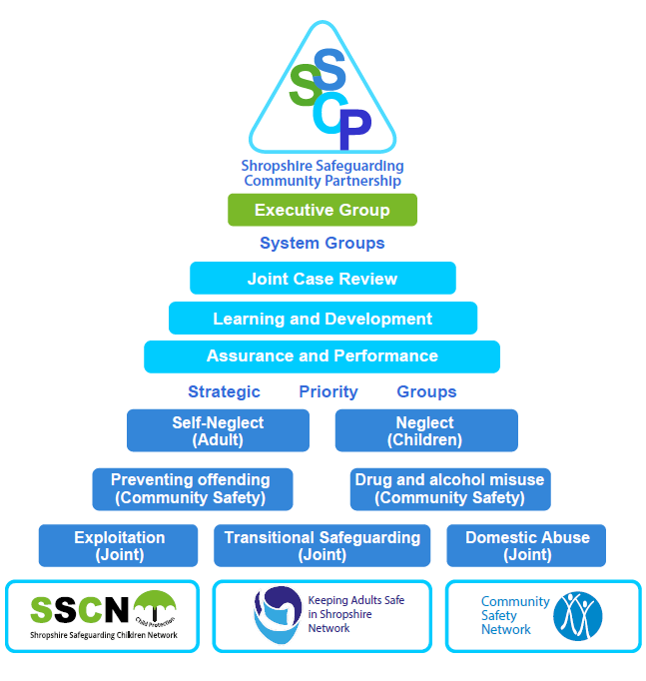
Appendix 2.

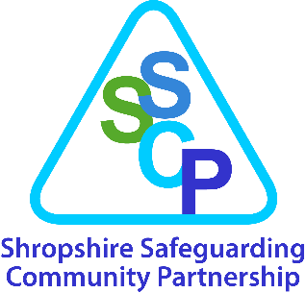

[INSERT GROUP] Annual Business Plan Template (2020-2023)
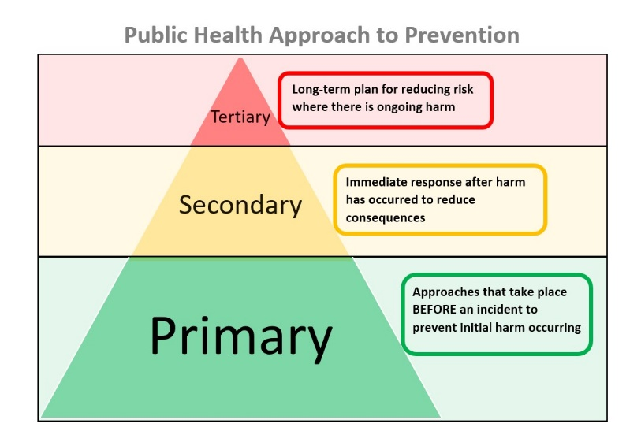
This group will focus on achieving the following statements of success by 2023:

We are using a public health model of prevention in order to ensure most effective preventative action at the earliest possible point.

Groups should complete at least one multi-agency case file audit per period to be allocated under the relevant heading below.

This is a flexible plan which should be updated by the group with progress at each meeting and formally reviewed annually. Priority Group Chairs should provide an update on the plan’s progress with any additional actions identified as part of their Executive Group report.

What action needs to be taken (specific, achievable, realistic)? | What will be the positive impact of achieving this action? |  | What are the risks/challenges to achieving this action? | Who is responsible for making it happen? | Milestone/  Timescale | Progress with RAG rating and evidence  Not Started  In Progress  Completed  Embedded
Preventing the problem before it primarily occurs.
Understanding what is happening in Shropshire.
Ensuring the system is able to protect and pursue (include secondary and tertiary prevention activity, resources: processes, services, staff etc).
Thinking widely about learning, development and improving practice.
Understanding the experience for individuals, their families and communities.

