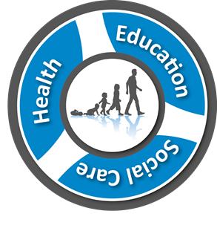

**ANNUAL REVIEW** of an

Education, Health and Care Plan (EHCP)

**AGENDA**

1. Introductions/Update on professionals involved
2. Child’s/Young Person’s/Parent’s views
3. Educational Attainment & Achievement
4. Review of provision
5. Review of needs
6. Review of outcomes
7. Transition/Moving On Arrangements
8. Additional Comments
9. Personal Budgets/Direct Payments
10. Summary/Setting Recommendation
11. Actions