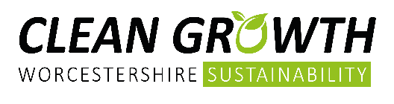
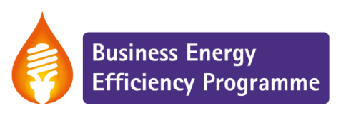
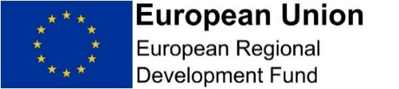

Energy Efficiency Assessment Registration Form

Please look at the guidance notes or call us to discuss if your business is eligible for support.
Then complete this form to apply for an energy and resource efficiency assessment of your business.

The assessment will assess your energy and resource usage, providing you with recommendations on how to reduce your costs and improve your environmental credentials. An assessment should be carried out before you apply for a grant. Please refer to the guidance notes before completing this form.

Please post the original copy of this form to the address specified on page 4 and ensure you complete all sections and sign both the Company and State Aid Declarations of this form.

Programme |  |  |  | Business Energy Efficiency Programme
SME Details
Company Name |  |  |  |  |  |  | Contact Name
Address |  |  |  |  |  |  | Tel No
 |  |  |  |  |  |  | Year Business Started
Number of Employees |  | Post Code |  |  |  |  | Company Registration Number
Email |  |  |  |  |  |  | Sector
To which local authority do you pay your business rates?
Do you trade majority Business to Business (B2B)? |  |  |  |  |  | What percentage of your trade is B2B?
Brief description of your business activities

Small Medium Enterprise Status

In order to receive support from the European Union you must meet certain requirements, please confirm the following about your organisation: (mark box as appropriate)
Has fewer than 250 employees (full time equivalent) | Yes No
Annual turnover is less than €50 million  Please complete box with the most recent annual turnover.  Current balance sheet is less than €43 million | Yes No  Yes No
In your business, does a separate enterprise own 25% or more of the capital or the voting rights?  If Yes, is this enterprise a SME? | Yes No  Yes No

Is your business involved with any governmental Organisations or supply government organisations or provide functions which are a statutory government responsibility?  If yes, please give details: | Yes No

Additional questions
Are you responsible for paying your energy bills? |  |  |  |  | Yes No
Please estimate your annual energy costs (include electricity, gas, other)
Are there any areas where you are already aware that you could reduce your energy usage/waste/water? (i.e. lighting, heating)
If known, please let us know the approximate size of your property in square metres
Where did you hear about the Business Energy Efficiency Programme?
Monitoring

By receiving an assessment you are agreeing to participate in monitoring activities to assess how the project is meeting targets such as reducing energy bills and CO₂ emissions, and contributing to increased profitability. If you do not provide this information you will be liable for the full cost of the assessment.
Are you willing to provide us with future monitoring information? |  |  |  | Yes No
Company declaration (Signed by a person with authority to sign for this organisation)
I certify that the information contained within the application declaration is true and accurate and agree to the terms and conditions below.
** IMPORTANT PLEASE ALSO COMPLETE AND SIGN THE SECOND DECLARATION ON PAGE 4**
Name: |  | Signature:
Position: |  | Date:

Privacy Notice & Marketing
Privacy Notice

For information on how your information is used, how Worcestershire County Council maintain the security of your information, and your rights to access information held on you, please view the Privacy Notice for the Growth & Investment and Sustainability Team on WCC's Privacy webpage: http://www.worcestershire.gov.uk/privacy

Marketing

We will automatically keep you up to date with information about your grant or business assist, but in order to process your application, we require a response to confirm whether you wish to opt-in or opt-out to receive marketing updates and how you wish to be contacted:

Yes, I consent to receive occasional newsletters and updates regarding services and products that I might be interested in, such as grants, funding, business support and events, from the Growth & Investment and Sustainability Teams and the contractors working on their behalf.

I consent to being contacted via the following methods:

Post Email Telephone

No, I do not consent to receive occasional newsletters and updates regarding services and products that I might be interested in, such as grants, funding, business support and events, from the Growth & Investment and Sustainability Teams and the contractors working on their behalf.

If you have consented to receive marketing, you may opt out at a later date. If you no longer wish to be contacted for marketing purposes, please contact: businesssupportmarket@worcestershire.gov.uk

To receive an Energy Efficiency assessment you will need to sign the declaration below.
We are more than happy to talk you through this.

De Minimis State Aid Declaration

You are being offered assistance under De Minimis State aid regulation.
Under World Trade Organisation agreements and European regulations, any assistance from the public sector towards trading operations must be strictly controlled and fall within agreed limits. De minimis aid is assistance from a public source for a trading activity which is below the threshold of aid requiring prior notification and approval from the Commission.
These levels have been revised since 1st of January 2007. This now allows a company to receive up to €200,000 of De Minimis aid over a three-year period for most sectors.
Both of these last two sectors are subject to special procedures and require the permission of Defra. Please note that the limits are in Euros, therefore when measuring the level of aid given, the official Commission Euro / £ exchange rate at the time that the assistance is granted must be used to determine the amount of aid given.
To confirm that you are able to receive this assistance you must declare the full amount of aid, from any public source, and in any format, you have already received over the last 3 financial years. You must declare whether or not it was De minimis aid. All aid received whether De minimis aid or exempted aid, must now be declared. Please note that this is a change from the requirements of previous regulations. Please be explicit in your explanation of what the aid you received has been used for.
The following is not a comprehensive list of the possible forms of aid. However it should give an indication of the most common forms of aid, which you may have been given over the past three years. Potentially any assistance from a public body might be an aid. Should you have any doubts on this matter, please contact the body from which the assistance was received:
- Grants from public bodies
- Loans from public bodies at favourable rates
- Loan guarantees from public bodies
- Differential tax benefits
- Grants from an investment trust (including charities) which may themselves have received the funds from a public body
- Investment from a part publicly funded venture capital fund
- Publicly administered funds, even if the funds were originally not public such as the national lottery
- Landfill tax
- Waiving or deferral of fees or interest normally due to a public body such as the waiving or deferral of rent or waiver of interest normally due on late payment of taxation or other costs to a public body
- Monopoly licences or guarantees of market share
- Advertising via a public channel such as a tourist board or state owned television
- Consultancy advice provided either free or at a reduced rate
- Training provided either free or at a reduced rate
- Aid for investment in environmental projects
- Provision of a free or reduced rate feasibility study for research and development or other assistance with research and development
- Purchase of public land or property at a less than market rate
- Benefiting from the provision of infrastructure where your organisation was identified as a beneficiary
These types of aid may have been provided under De Minimis (as De Minimis aid) or under another State Aid regulation. If you are in any doubt whether aid received was De Minimis aid or about its value, check with the organisation, which provided it. If they are unable to say or there is any uncertainty, assume that it was De Minimis aid.
Any De Minimis aid awarded to you under this project will have to be declared if you apply, or have applied, for any other public funding. Therefore, if successful, the offer letter must be retained and shown to any other public body to whom you apply for funding for the three years following the offer.

The use of public funding is subject to checks and audits. False declarations will lead to the recovering of the value of the assistance offered plus interest.

I declare the amount of State aid received by the company / organisation over the last three years is:

Date aid awarded | Value of the aid in Euros. | From which organisation and which scheme | What activity or item was the aid given for
 |  | ERDF – Growth Development Fund

State Aid Declaration (Signed by a person with authority to sign for this organisation)
Name: |  | Signature:
Position: |  | Date:

Note this is an officer of the company with the authority to bind the organisation in legal agreements.
Company/Organisation
(full legal name)

What you need to do next?
Have you completed all the boxes? | Yes No
Have you completed and included the De Minimis State Aid Declaration with this form? (at the end of this form) | Yes No
Please post the signed original hard copy of the registration form and any supporting documentation including the De Minimis State Aid Declaration to:

Business Energy Efficiency Programme, SustainabilityTeam, E&I, Worcestershire County Council, County Hall, Spetchley Road, Worcestershire, WR5 2NP

Please also submit your registration form by email to: sustainability@worcestershire.gov.uk

Guidance Notes

Are you eligible? To qualify, your business must:
- Be situated in and trading from Worcestershire or Herefordshire or Telford & Wrekin or Shropshire.
- Employ fewer than 250 employees
- Have a turnover of less than the equivalent of 50 million Euros per annum or a balance sheet of less than 43 million Euros
Some industries such as primary agriculture and retail are not eligible. Retail is defined as the provision of goods and services to the general public. This support is aimed at businesses who primarily serve other businesses. Other activities are excluded such as social welfare and education facilities, banking and insurance. Priority will be given to businesses that help meet the projects aims. Support is subject to the availability of funding.
What happens next?

- We will assess whether your organisation is eligible and suitable for support under the European Regional Development Fund, State Aid and programme criteria and how it help meets the programmes objectives, and the availability of funding.

- You will be contacted within 10 working days of receipt, to confirm the completed application has been received and that you are eligible for an assessment.

- An Energy & Resource Efficiency Advisor will then contact you to arrange to visit your premises and undertake a technical assessment.

- You will receive a report and you will receive an action plan with recommendations for improvement.

- The Advisor will discuss the report with you and help you to decide what actions to take.

- If you would then like to apply for a grant, the Advisor will help you complete the application form.

- By undertaking an Energy & Resource Efficiency assessment you are agreeing to participate in future monitoring activities to assess how the programme is meeting targets such as reducing energy bills and CO₂ emissions, and contributing to increase profitability. Please note, if you do not provide this information you will be liable for the full cost of the assessment.

Funders
The Business Energy Efficiency Programme is part-financed by the European Regional Development Fund Programme as part of the European Structural and Investment Funds Growth Programme 2014-2020. The Department for Communities and Local Government is the Managing Authority for European Regional Development Fund. Established by the European Union, the European Regional Development Fund helps local areas stimulate their economic development by investing in projects which will support innovation, businesses, create jobs and local community.

Assessment Terms and Conditions

The applicant declares that:-

- It satisfies all the eligibility criteria as set out in the Registration Form previously completed and submitted to Worcestershire County Council.
- It undertakes to advise the Council of any change of address, if it ceases to trade, changes in circumstances that result in the business no longer fitting the SME criteria set out in the Registration Form or of any other circumstances that may affect its right to assistance through the European Regional Development Fund (ERDF).
- In receiving an Assessment, it is agreeing to allow an Advisor access to property, processes, people, documentation, utility meters, records and resources relating to the project and provide contact details for suppliers where applicable.
- It declares that it meets any legal requirements or other regulations, which relate to the operation of its business.
- It understands that support from the Business Energy Efficiency Programme is subject to the availability of funding and the aims of the project.
- It understands that false declarations may invalidate its application and consequently the value of any assistance awarded must be repaid on request.
- It understands that it will be contacted in the future to assess the impact of the Assessment. It understands that this could be by way of a visit to the company, telephone, mail or electronically.
- It is aware of its obligation to participate in monitoring activities and supply any requested evidence such as energy bills and business accounts.
- If there is a change of ownership within the business the new owner/s must be made aware of the monitoring requirements.
- It understands that in processing this application, information will be shared with members of the Business Energy Efficiency Programme Board. Commercially sensitive information will be maintained as ‘commercial - in confidence’ subject to the Freedom of Information Act 2000.
- It agrees to sign the Advisor's time sheet on request as a true and accurate record.

- It will adhere to ERDF Publicity regulations set out in the document National Publicity Requirements, European Regional Development Fund (ERDF) Programme 2014-20.

- Any promotion by the business, of participation in Business Energy Efficiency Programme must be approved by the programme manager.

- The Business Energy Efficiency Programme team and its contracted providers will contact businesses applying to the programme directly, regarding the free energy and resource efficiency assessment and grants.

Any engagement with a Third Party outside of these arrangements is between the business and the Third Party. All communications will be direct between the Business Energy Efficiency Programme and the applying business and any Third Party will not be included in these communications.

It will ensure that any documentation in relation to the assessment is stored and retained until a date that is three years beyond the closure of the ERDF programme which currently stands at 31 December 2033. This should be available if the company were subject to an audit by the ERDF.
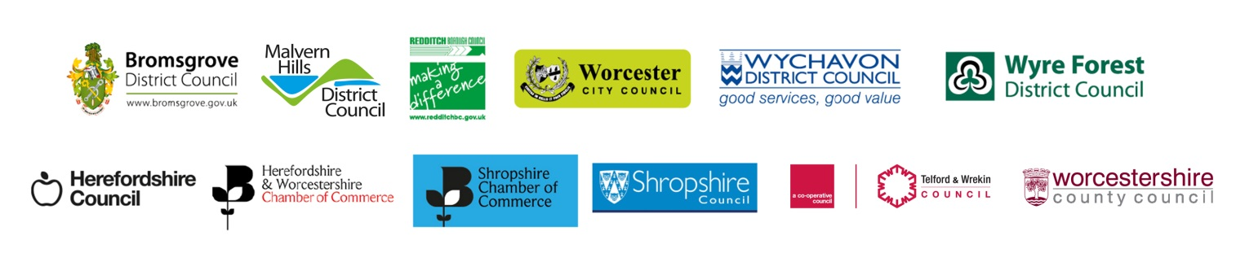

The limit applies to aid received by your company in the UK or if you are part of a group to your parent company. If this is the case it may be more practical for you to get this form completed by your parent company. If your own company is a parent to subsidiary companies then you must include the De Minimis aid received by your subsidiaries in the UK in this declaration.
DEFRA Department for Farming and Rural Affairs
European Exchange Rates accessible from http://ec.europa.eu/budget/inforeuro/index.cfm?fuseaction=currency_historique&currency=GBP&Language=en

