

**Licensing Act 2003**

**Statement of Licensing Policy**

**2024 to 2029**

**Date policy adopted:**

**Policy adopted by: Council**

**Date policy formally published:**

**Date policy implemented:**

**Next review period: 2028**

# Executive Summary

Shropshire Council (‘the Council’) is the Licensing Authority for the county of Shropshire (excluding the area that is the responsibility of Telford & Wrekin Council) and is fulfilling its legal duty to prepare a statement of licensing policy (‘the Policy’) through this document.

The Policy describes the geographical and local area profiles of the area. It broadly sets out the requirements of the Licensing Act 2003 (‘the Act’) to guide relevant stakeholders through the licensing regime and to facilitate compliance with the provisions of the Act.

The Act regulates licensable activities through premises licences, club premises certificates, temporary event notices and personal licences. The licensable activities are the sale by retail of alcohol, the supply of alcohol by or on behalf of a club to, or to the order of, a member of the club, the provision of regulated entertainment and the provision of late night refreshment

The Act contains four licensing objectives which must be addressed when licensing functions are undertaken. These objectives are central to the Act and are the prevention of crime and disorder, public safety, the prevention of public nuisance and the protection of children from harm. The Policy makes it clear that the Council will proactively promote these licensing objectives through the adoption, implementation and enforcement of this Policy.

The Policy forms the Council’s mandate for managing local licensable activities and sets out how the Council’s position on local risks, and therefore its expectations, in relation to applicants/licence holders. The Policy is not a stand-alone document and must be read in conjunction with relevant legislation and guidance. Whilst the Policy sets out the Council’s position with respect to the Act, the legal interpretation and application of the Act is ultimately a matter for the Courts.

The Council’s aim is to establish responsibly managed and safe licensed premises. The Policy aims to support the Council’s high level outcomes by creating an environment through the promotion of the licensing objectives that encourages people to be healthy, communities to be resilient and to develop a prosperous economy.

The Council is committed to supporting a vibrant, balanced and safe licensed trade and evening and night time economy. It is recognised that the Council has a key role in shaping and manging the growth that is occurring across a number of Shropshire’s market towns and, whilst such growth can lead to the licensing objectives being undermined, the Council recognises it is important to simultaneously understand the positive contribution that well managed licenced premises bring in support of local businesses and the growth and prosperity of Shropshire’s economy, which, in turn, makes Shropshire’s towns and communities exciting and attractive places to live, learn, work and visit.

The Council is seeking to curtail the negative elements of the licensed economy through supporting licence holders, prospective licence holders, personal licence holders and those with temporary authorisations to eliminate, through rigorous and enforceable licences, the potential negative outcomes.

The Policy is inextricably linked to a number of strategic objectives that underpin the Council’s high level outcomes. These will not only be delivered through the licensing regime. It will require partnership working with other Council services and/or agencies and organisations e.g. with applicants, licence/notice holders, responsible authorities, other local businesses and communities.

The Policy identifies the functions that the Council undertakes and the principles the Council will follow when administering applications and, where relevant, setting fees. The Council expects compliance with these principles to assist applicants and licence/notice holders to satisfy the statutory licensing objectives when undertaking licensable activities that are regulated by the Council.

The roles and duties of the Strategic Licensing Committee, the Licensing Act Sub-Committee and officers of the Council are explained, including the mechanism for authorising the delegation of the licensing functions and the manner in which decisions are made.

The Policy highlights the responsibility that everyone has to promote the welfare of children, young people and adults with care and support needs and to protect them from harm and exploitation. In this regard, the organisations/bodies deemed to be competent to advise on such matters are clearly referenced.

The Policy lists the organisations/bodies that are ‘responsible authorities’ under the Act and provides practical guidance to help define ‘other persons’. Guidance is offered to these parties on how to make representations in respect of licence applications and reviews, as well as setting out the Council’s position on licensing hearings, the exchange of information, freedom of information, and the setting of fees.

The main body of the Policy focusses on the practical processes and procedures that must be followed in order for the Council to be in a position to determine an application and authorise an applicant to undertake one or more of the licensable activities.

The Policy also sets out the principles that will be applied when the Council carries out the inspection of premises and when it institutes criminal proceedings in respect of specified offences under the Act. This includes the principles that will be applied in respect of general compliance, enforcement and the manner in which complaints will be dealt with. The Council’s focus is on ensuring the promotion of the licensing objectives and compliance with licence conditions.

The details and outcome of the consultation process that was undertaken prior to the adoption of the Policy is clearly set out, including a list of consultees. There are also six appendices to the Policy, the information contained in each further supports the overall aims and objectives of the Policy.

**CONTENTS**

**Policy Page**

**Part 1 Introduction 6**

**Part 2 Licensing Principles, Process and Delegation 14**

**Part 3 Activities Subject to Authorisation 28**

**Part 4 Inspection, Compliance, Enforcement and Complaints 72**

**Part 5 Consultation 76**

**Part 6 Licensing Contact Details 81**

**Appendices**

**Appendix A Map of Geographical Area of the Administrative Area 84**

**of Shropshire Council**

**Appendix B Local Area Profile 86**

**Appendix C Safeguarding of children, young people and adults with 117**

**care and support needs. Modern slavery and human**

**trafficking**

**Appendix D Evening and Night Time Economy Guidance – Licensing 122**

**and Planning Considerations**

**Appendix E** **Extract from the Shropshire Council Constitution Setting 132 out Delegations**

**Appendix F List of Documents that Demonstrate Entitlement to Work 136 in the UK**

# PART 1

**INTRODUCTION**

# PART 1 – INTRODUCTION

**1.0 Background**

1.1 Under Section 5 of the Licensing Act 2003 (‘the Act’), licensing authorities are required to prepare a statement of licensing policy in relation to the exercising of their licensing functions. Shropshire Council (‘the Council’) is the Licensing Authority for the county of Shropshire (excluding the area that is the responsibility of Telford & Wrekin Council) and is fulfilling its legal duty to prepare a statement of licensing policy (‘the Policy’) through this document. References to ‘the Council’ in this Policy refer to the Council in its capacity as the Licensing Authority, unless otherwise specified.

1.2 The Council is required to publish the Policy at least every five years. It will also keep the Policy under review and revise it when appropriate to do so. Any amendments to the Policy must be the subject of further consultation and the Policy, or relevant parts of the Policy, must then be re-published.

**2.0 County area**

Geographical profile

2.1 The geographical area to which this Policy applies is the administrative area of Shropshire Council as outlined in the map produced at **Appendix A**.

2.2 Shropshire is a diverse, predominantly rural, inland county, situated on the far western edge of the West Midlands region.  Shropshire borders Wales to the West, Telford and Wrekin and Staffordshire to the North East, Worcestershire and Herefordshire to the South and Cheshire to the North.

2.3 Based on the Mid 2016 Population Estimates published by the Office for National Statistics, the population of Shropshire is 313,400 and has 0.98 persons per hectare (319,730.32 hectares), compared to a national figure for England of 4.24 persons per hectare (13,027,843 hectares).  The County is one of the most sparsely populated local authorities in the country with approximately 540 settlements widely dispersed and only five settlements have a population of over 10,000 (Shrewsbury, Oswestry, Ludlow, Bridgnorth and Market Drayton).

2.4     The Sub-National Population Projections (2014) published by the Office for National Statistics show that the population of Shropshire continues to grow and is projected to rise to 335,700 by 2035 (a 7% rise 2016-2035).  The number of households is projected to rise to 152,900 by 2035 (a 13% rise 2016-2035).  The Shropshire Core Strategy 2011 has planned for 25,700 new homes in Shropshire between 2006 and 2026.  Shropshire Council is currently undertaking a Partial Review of the Local Plan which will determine the future housing requirement in Shropshire to 2036.

Local area profile

2.5 The Council has undertaken an assessment of the local area and produced a local area profile. This is produced at **Appendix B**. The local area profile aims to summarise existing national research regarding alcohol-related harm, as well as providing a local evidence base regarding actual and future emerging risks relevant to the licensing objectives and geographical areas of potential risk.

2.6 The profile will continue to be reviewed and updated to reflect changes to the local landscape and environment. Formal consultation will be undertaken where changes to the profile are likely to have a significant impact on stakeholders and the areas of concern and risks associated with the local area; otherwise changes will be highlighted on an ongoing basis on the Council’s website. The risks identified in the local area profile are evidence (not perception) based.

2.7 The profile takes account of a range of factors, data and information held by the Council and a wide range of partners and has been brought together through proactive engagement with both responsible authorities and other relevant organisations.

2.8 The profile aims to increase awareness of local risks and improve information sharing in order to facilitate constructive engagement with licensees and a more coordinated response to local risks. The Council encourages applicants to use the local area profile to help inform them of specific risks that need to be considered prior to submitting any new or variation to all licence applications/notices.

2.9 The profile aims to:

* enable the Council to better serve the Shropshire community by more accurately reflecting the community and the risks within it;
* provide greater clarity for licensees/applicants as to the relevant factors in the Council’s decision making process;
* improve premises licence applications as licensees/applicants will be able to incorporate necessary controls and measures to mitigate relevant risks in their applications;
* enable licensing authorities to make robust and fair decisions, based on a clear, published set of factors and risks, which are therefore less susceptible to challenge; and
* encourage a proactive approach to risk that is likely to result in an increase in compliance and a reduction in enforcement action.

2.10 The Council has considered the local area profile. Given the current position demonstrated by the profile there are wards within the Shropshire Council administrative area where it may be considered necessary to include specific conditions in relation to applications. Applicants must be particularly mindful of the key findings and recommendations set out within the Local Area Profile and ensure a risk assessment has been undertaken to allow applicants to properly address the risks through the operating schedule in order to sufficiently promote the licensing objectives.

**3.0 Consultation and communication**

3.1 In determining the Policy the Council has consulted as set out in Part 5 of this Policy.

3.2 In order to deliver a transparent, accountable and efficient licensing service the Council is committed to proactive engagement, ongoing communication and consultation with all stakeholders. The Council wants to facilitate an open and constructive partnership with all stakeholders in order to improve compliance and reduce regulatory costs.

3.3 In particular, the Council welcomes the opportunity to communicate and consult with relevant stakeholders to enable and encourage the exchange of views and information in relation to the Policy, to mitigate risks to the licensing objectives, to ensure conditions are relevant, proportionate and necessary, to ensure changes in the law are widely communicated and understood and the need for licence reviews are reduced to a minimum. The specific methods to achieve this communication and consultation will be determined as required.

**4.0 Licensing Act 2003**

4.1 The Act regulates licensable activities[1] through premises licences, club premises certificates, temporary event notices and personal licences. The licensable activities are:

* The sale by retail of alcohol
* The supply of alcohol by or on behalf of a club to, or to the order of, a member of the club
* The provision of regulated entertainment
* The provision of late night refreshment

4.2 It contains four licensing objectives which must be addressed when licensing functions are undertaken. These objectives are central to the Act and are:

* The prevention of crime and disorder
* Public safety
* The prevention of public nuisance
* The protection of children from harm

4.3 The Council will proactively promote these licensing objectives through the adoption, implementation and enforcement of this Policy.

**5.0 Scope**

5.1 This Policy supersedes all previous statements of licensing policies. Any application determined on or after the date that this Policy takes effect will be administered under the requirements set out in this Policy irrespective of the date the application was submitted to or received by the Council.

5.2 The Policy forms the Council’s mandate for managing local licensable activities and sets out how the Council’s position on local risks, and therefore its expectations, in relation to applicants/licence holders in the administrative area of Shropshire Council.

5.3 The Policy does not override the right of any person to make an application and to have that application considered on its own merits. In addition, it does not undermine the right of any person to make representations on an application or to seek a review of a licence where a legal provision is made for them to do so.

5.4 The Policy does NOT attempt to explain all the requirements of the Act for each type of licence/notice and the associated licensable activities. The requirements of the Act are detailed and complex; consequently, to ensure the provisions are fully understood, potential applicants and existing licence/notice holders are strongly encouraged, with respect to the type of premises and activity being considered to:

* make themselves familiar with the relevant provisions of the Act, regulations and orders;
* make themselves familiar with any other relevant legislation, for example the Anti-Social Behaviour, Crime and Policing Act 2014;
* consult the Guidance issued under Section 182 of the Licensing Act 2003 (‘Section 182 Guidance’) issued by the Home Office and any other appropriate guidance, particularly where it is produced by a responsible authority ;
* seek advice from appropriate legal experts; and
* discuss specific requirements with the Council’s licensing team.

5.5 The Policy is not a stand-alone document and must be read in conjunction with relevant legislation and guidance. Whilst the Policy sets out the Council’s position with respect to the Act, the legal interpretation and application of the Act is ultimately a matter for the Courts.

**6.0 Purpose**

6.1 The Council’s aim is to establish responsibly managed and safe licensed premises. The Policy acts as the primary vehicle for setting out the Council’s approach to licensing regulation under the Act. It aims to support the Council’s high level outcomes by creating an environment through the promotion of the licensing objectives that encourages people to be healthy, communities to be resilient and to develop a prosperous economy.

6.2 The Council is committed to supporting a vibrant, balanced and safe licensed trade and evening and night time economy. It is unfortunate that this type of activity can have undesirable and unintended side effects, which can undermine the four licensing objectives and lead to negative public health outcomes.

6.3 The Council is seeking to curtail the negative elements of the licensed economy through supporting licence holders, prospective licence holders, personal licence holders and those with temporary authorisations to eliminate, through rigorous and enforceable licences, the potential negative outcomes. It is also crucial through the licensing regime to support the elements of this economy which make Shropshire’s towns and communities exciting and attractive places to live, learn, work and visit.

6.4 The Policy is inextricably linked to a number of strategic objectives that underpin the Council’s high level outcomes. These will not only be delivered through the licensing regime. It will require partnership working with other Council services and/or agencies and organisations e.g. with applicants, licence/notice holders, responsible authorities, other local businesses and communities.

6.5 There is a recognition that the Evening and Night Time Economy[2] is growing across a number of Shropshire market towns and that this Policy has a key role in shaping and managing this growth. It is recognised that such growth can lead to the licensing objectives being undermined; however, it is important to simultaneously understand the positive contribution that well managed licenced premises bring in support of local businesses and the growth and prosperity of Shropshire’s economy.

6.6 The Policy provides guidance to any person with an interest in licensing under the Act; in particular, but not restricted to:

* persons who wish to apply for premises licences, club premises certificates, temporary event notices and personal licences;
* persons who hold existing licences and notices, including those that are the subject of review;
* the Council, in its capacity as the licensing authority, including licensing officers and members of the relevant licensing committees;
* licensing consultants, solicitors and barristers advising and/or representing applicants and licence/notice holders;
* the responsible authorities under the Licensing Act 2003, and
* magistrates and judges hearing appeals against Council decisions.

**7.0 Review of the Policy**

7.1 The Policy will be prepared and published every five years. However, it will be the subject of continuous evaluation and reviewed, revised and published before any revision is given effect. At the time of review all relevant stakeholders will again be consulted. Any person may request a review of the Policy at any time.

**8.0 Regulatory, policy framework and integrated strategies**

8.1 The operation of the Council’s licensing service, as it relates to the licensing of licensable activities, is undertaken primarily in accordance with:

* the Licensing Act 2003, as amended;
* regulations and orders made under the Act;
* guidance issued by the Home Office; and
* the principles of better regulation, particularly as set out in the Regulators’ Code (BRDO 14/705 April 2014)[3].

8.2 In addition, the service is provided in accordance with all relevant Council policies, duties and responsibilities; in particular, those relating to:

* Protection of children, young persons and adults with care and support needs
* Better regulation and enforcement
* Data protection including access to information
* Public sector equality duty
* Human rights[4]

8.3 So far as is reasonably practicable the Council will avoid duplication with other regulatory regimes. In particular, this Policy and associated conditions do not address health and safety at work, fire safety or planning requirements. Applicants, licence/notice holders are required to ensure all relevant provisions are satisfied in these respects.

8.4 The key integrated strategies that have relevance to the Policy include:

* + Shropshire Health and Wellbeing Strategy 2016 – 2021
  + Shropshire Strategy to Reduce Alcohol Related Harm 2016 – 2019
  + Shrewsbury Big Town Plan
  + Shropshire Local Development Framework: Adopted Core Strategy to 2026
  + Shropshire Council Economic Growth Strategy 2017 – 2021
  + Child Sexual Exploitation Strategy 2016 – 2018
  + Shropshire Council Modern Anti-Slavery and Human Trafficking Statement and Policy (March 2018)
  + West Midlands Regional Adult Safeguarding Multi-Agency Policies and Procedures, as agreed and adopted by the Keeping Adults Safe in Shropshire Board

**PART 2**

**LICENSING**

**PRINCIPLES, PROCESS AND DELEGATION**

**PART 2 – LICENSING PRINCIPLES, PROCESS AND DELEGATION**

**9.0 Introduction**

9.1 This part of the Policy focusses on the functions that the Council undertakes and the principles the Council will follow when administering applications and, where relevant, setting fees. The Council expects compliance with these principles to assist applicants and licence/notice holders to meet the statutory licensing objectives when undertaking licensable activities that are regulated by the Council.

9.2 This part also explains the roles and duties of the Strategic Licensing Committee, the Licensing Act Sub-Committee and officers of the Council.

9.3 The Council seeks to ensure that licensable activities are suitable and are conducted in such a manner that promotes the licensing objectives and minimises the risks that undermine the objectives. The specific regulatory functions of the Council are:

* licensing premises where licensable activities take place by issuing premises licences, club premises certificates and provisional statements
* receiving and issuing personal licences
* receiving and endorsing temporary event notices
* administering licence reviews
* maintaining registers of the licences and notices issued
* collecting licence/notice fees
* inspection, compliance and enforcement locally in relation to licences/notices
* providing information for any statutory return requirements

9.4 With respect to premises licences/notices, the Council also has the regulatory responsibility for dealing with full and minor variations, interim authority notices, provisional statements, change of name and address, transfers, reinstatements and producing copies of lost, stolen, damaged or destroyed licences and dealing with surrendered licences in accordance with specific regulatory provisions that relate to each licence or notice type.

9.5 The Council recognises that promoting the welfare of children, young people and adults with care and support needs and protecting them from harm and exploitation is everyone’s responsibility. In so far as it relates to applicants, licensees, employees in licensed premises, responsible authorities, elected members, other local businesses and communities, everyone who has dealings with children, young people and adults with care and support needs have a duty to report matters of concern to the relevant authorities. In addition, the wider safeguarding context (see **Appendix C** for further information) must be considered when prospective and existing applicants submit applications, during the assessment and determination process and the ongoing use of the licence/notice.

9.6 In order to support the outcomes and objectives above Licensing will:

* promote the four licensing objectives;
* ensure that the premises are appropriate for their proposed use;
* ensure the premises layout and condition is acceptable for the proposed use;
* ensure that the premises are being managed responsibly,
* the protection of young people and adults with care and support needs from harm and exploitation

9.7 For the purposes of this Policy, any reference to ‘licence’ will include premises licence, club premises certificate and personal licence unless otherwise specified.

**10. Overarching licensing principles**

10.1 The Council aims to provide a clear, consistent and responsive service to prospective and current licence/notice holders, members of the public and other relevant stakeholders.

10.2 The Council will seek to build and maintain good liaison and working relationships with the Responsible Authorities, including sharing relevant information and, where appropriate, investigating offences.

10.3 The Council aims to ensure that all relevant Responsible Authorities give full consideration to applications and that the most appropriate Responsible Authority provides advice to the applicant and, where necessary, take the opportunity to submit formal representations to the Council. The Licensing Team will provide guidance and assist Responsible Authorities to submit representations.

10.4 Shropshire Council, as the Licensing Authority, is also a Responsible Authority. The Licensing Team, acting as a Responsible Authority will, when necessary, make representations to applications to ensure that all four licensing objectives are being properly promoted.

10.5 Licensing is not bound by decisions made by Planning and vice versa. There is no legal basis for Licensing to refuse a licence application because it does not have planning permission. While the two services consider different (albeit related) matters, Licensing must only address the licensing objectives to ensure that the licensing process does not lead to a re-run of any planning hearing. To avoid duplication and inefficiency, planning permission, building control approval and licensing regimes will be properly separated. In practice, this means that Licensing will ensure that they enter into discussion with planning counterparts prior to determination with the aim of agreeing mutually acceptable operating hours and scheme designs. This will include sharing the positive and adverse impacts relating to the licensing objectives and enabling each respective regime to determine applications separately.

10.6 The Council, in terms of both the licensing and planning regimes, will consider carefully any conflict that may exist between licence applications and planning/building regulation restrictions and will work with applicants and licence holders to resolve such conflicts. In addition, with respect to applications that may impact on the evening and night time economy, the Council will have regard to the guidance set out in **Appendix D.** It is ultimately the responsibility of the applicant/licence holder to ensure that operations at a premises are compliant with both planning permissions and licensing authorisations. Licensing and planning are separate regimes and ultimately decisions on permissions or authorisations under each regime are made independently.

10.7 The Council will be mindful of the needs of the applicant but this will be balanced against the clear duty that the Council has to ensure that the licensing objectives are promoted and the Council’s desire to ensure the overall purpose of this Policy is delivered.

10.8 In all cases, licence/notice applications will be considered and determined on their own individual merits.

10.9 The Council will make general advice, relating to its functions under the Act, available through its website. In addition, on request, the Council will provide specific advice about compliance to prospective and actual licence/notice holders and will advise the public on what activities they may undertake without the need for specific licences/notices.

10.10 The Council will employ or otherwise source staff with the necessary skills and knowledge and will delegate to them the necessary powers they need to carry out licensing, compliance and enforcement functions.

**11. Delegation of Council licensing functions**

11.1 Licensing carried out under the Act is a Council function that is delegated to the Strategic Licensing Committee. The Strategic Licensing Committee has delegated this function to the Licensing Act Sub-Committee and to officers of the Council who will determine all applications in accordance with this Policy.

11.2 The specific delegations are set out in the Council’s Constitution, which is available at <https://shropshire.gov.uk/committee-services/ecCatDisplay.aspx?sch=doc&cat=13331&path=0%20>. The relevant extract from the Constitution is produced at **Appendix E** of this Policy.

11.3 Officers and the Licensing Act Sub-Committee may elect not to exercise their delegated decision making authority in respect of any particular licence/notice application. This is likely to be the case where delegation may give rise to a risk of judicial review challenge, particularly on the basis of appearance of bias.

11.4 Whilst officers and the relevant committees will, in the majority of cases, follow the Policy, there may be specific circumstances where the Council believes it is right to depart from the Policy. This may also be the case in relation to the Section 182 Guidance. In either case, the Council will take account of the implications of any departure from the Policy and/or the Guidance and shall ensure there are strong reasons for such departure. In all cases, these reasons will be clearly expressed, explained and documented.

**12.0 Committees**

Strategic Licensing Committee

12.1 This Committee is made up of 15 members of the Council. It deals with policy issues, including the setting of licence fees where this is permitted by the legislation.

Licensing Act Sub-Committee

12.2 This Committee is made up of a selection of three Members from the Strategic Licensing Committee.

12.3 Members on the Sub-Committee, when determining applications, will have regard to relevant licensing legislation, in particular the Licensing Act 2003 and associated regulations and orders, this Policy, the Section 182 Guidance, the Human Rights Act 1998, the Equality Act 2010, any relevant legal case law, other relevant Council policies and any other relevant guidance that may from time to time be made available by other appropriate organisations or stakeholders.

**13.0 Decisions**

13.1 The Council will ensure that licensing and regulatory decisions are properly reasoned and evidence-basedand taken at the appropriate level. The Council will adopt a presumption in favour of decisions being made at the lowest appropriate level within the Council so that decisions of similar complexity and impact are generally made at similar levels within the Council.

13.2 The decisions that the Council can take, either by way of a Licensing Act Sub-Committee hearing, including where the hearing is for the purposes of a premises licence review, or by an officer under delegated authority, are dependent on the type of licence or notice being considered and the specific circumstances associated with the licence/notice.

13.3 However, broadly, the Council has the power to:

* grant or reject/refuse new and renewal applications
* grant or reject/refuse applications for variations and transfers
* revoke or cancel existing licences/notices under certain circumstances, including for the non-payment of fees
* suspend a premises licence
* add, remove, amend and exclude licence/notice conditions
* review premises licences

13.4 In addition, the Council may choose to issue written warnings and prosecute (including offering a simple caution) in respect of specified criminal offences. Further details, in this regard, are provided in Part 4 of this Policy.

13.5 As part of any decision to grant, reject/refuse, revoke, cancel or suspend a licence/notice, the officer and/or Licensing Act Sub-Committee will take into consideration the facts of the application, any information and evidence provided by the responsible authorities, any information and evidence from other persons, together with the options set out in the licensing officer’s report. The licensing officer will not normally make a specific recommendation, but may do so in exceptional circumstances.

13.6 In order to provide applicants with the opportunity to consider and respond by way of written and/or verbal representations, as appropriate, the Council will provide the relevant details that have given rise to the need for an officer decision and/or hearing.

13.7 Following the determination of an application by the Council (or any other regulatory enforcement decision), the applicant or licensee and any other relevant party will receive a copy of the decision in writing. The reasons for the decision will be clearly set out and will reflect the extent to which the decision has been made with regard to the Council’s Policy and the Section 182 Guidance. It will be delivered as soon as is practicable after the decision has been made. This will include information on the right of appeal, where this is relevant.

**14.0 Appeals**

14.1 Parties aggrieved by a decision of the Council have a right of appeal to the Magistrates’ Court. Appeals must be lodged with the Court in accordance with the relevant statutory provisions. The Council strongly advises parties to promptly seek appropriate independent legal advice if they wish to consider pursuing an appeal.

14.2 Closure orders – see 13.12 of the Section 182 Guidance

14.3 Any party to a decision may apply for judicial review (although the Court may decline an application) and ask the Court to grant a particular type of order if they believe that the decision taken by the Council is:

* illegal, i.e. beyond the powers available to the Council;
* subject to procedural impropriety or unfairness with a failure in the process of reaching the decision; or
* irrational such that no sensible person could have reached that decision.

**15.0 Responsible authorities**

15.1 Responsible authorities, as listed in Section 13 of the Act, have the responsibility to review licence applications and notices (in certain circumstances) and the right to make representations in relation to those applications/notices or any licence review. They may also apply to the Council for a review of an existing licence.

15.2 The responsible authorities are:

* The Council in its capacity as the licensing authority and any other Council whose area part of the premises is situated
* The planning authority
* The authority which has functions in respect of minimising or preventing the risk of pollution of the environment or of harm to human health
* Chief Officer of Police for West Mercia Police
* Shropshire and Wrekin Fire & Rescue Authority
* Director of Public Health for Shropshire Council
* The enforcing authority (primarily either Environmental Health or the Health and Safety Executive)[5] for Health and Safety at Work
* Shropshire Council Children’s Services
* UK Border Agency (The Home Office)
* The Weights and Measures Authority (Shropshire Council Trading Standards)
* In relation to a vessel (including pleasure boats), the navigation authorities, as defined in the Water Resources Act 1991, that have statutory functions in relation to the waters where the vessel is usually moored or berthed, or any waters where it is proposed to be navigated at a time when it is used for licensable activities, namely:
* Environment Agency in England and Wales
* Canal and Rivers Trust
* Maritime and Coastguard Agency (Secretary of State for Transport)
  1. The contact details for each of the responsible authorities are available on the Council’s website at <https://shropshire.gov.uk/media/2317/responsible-authorities.pdf>

**16.0 Body competent to advise about the protection of children from harm**

16.1 The body (the ‘responsible authority’) that represents those who are responsible for, or interested in, matters relating to the protection of children from harm and is recognised by the Council (in its capacity as the licensing authority) as being competent to advise on such matters is Shropshire Council’s Children’s Services. It is recognised that such a body must not only be competent to advise on such matters, it must also have adequate resources available to take on the practical role required of the responsible authority for the purposes of the protection of children from harm, i.e. reviewing licence applications, submitting representations and applying for licence reviews, where necessary,

16.2 In addition to recognising Shropshire Council’s Children’s Services as the responsible authority for the protection of children from harm, the Council also recognises the need to utilise the expertise of the Shropshire Safeguarding Children Board (SSCB), in its capacity to provide oversight of all services that are responsible for, or interested in, matters that relate to the protection of children from harm. In this role, the SSCB is the body that the Council, in its capacity as the licensing authority, and other services or responsible authorities, will report matters of concern relating to the protection of children from harm where they are not being adequately addressed by any or all of the responsible authorities or the licensing regime as a whole.

**17.0 Body competent to advise about the protection of young persons and adults with care and support needs from harm**

17.1 The Council recognises that the Act does not legally require the designation of a body which represents those who are responsible for or interested in the protection of young persons and adults with care and support needs. However, for this purpose, the Council has deemed the Keeping Adults Safe in Shropshire Board (KASiSB) to be the competent body.

**18.0 Any other person**

18.1 An ‘other person’ is not legally defined in the Act. The Council accepts that any individual, body or business, including a member of the relevant licensing authority, is an ‘other person’.

18.2 The Council is of the view that in order for an ‘other person’ to make a relevant representation they would ordinarily be a person who:

1. lives, works or otherwise occupies space sufficiently close to the premises to be likely to be affected by the licensable activities, and/or;
2. has relevant concerns or evidence of issues which are undermining one or more of the licensing objectives;
3. represents persons who satisfy (a) or (b)

18.3 It is a matter for the Council to decide whether a representation is relevant with regard to a particular application and this will be decided on a case by case basis.

* 1. When determining whether a person ‘lives, works or otherwise occupies space sufficiently close to the premises’, the Council will consider the following non-exhaustive list of relevant factors:
* size of the premises
* nature of the premises
* distance of the premises from the location of the person making the representation
* potential impact of the premises, e.g. number of customers, routes likely to be taken by those visiting the establishment
* circumstances of the person who lives close to the premises; this is not their personal characteristics, but their interests which may be relevant to the distance from the premises
* living sufficiently close to the premises may be different for different parties, e.g. a private resident, a residential school for children with truanting problems, a residential hostel for vulnerable adults
  1. A representation, by an existing licenced business, stating that it is going to be affected by another licenced business starting up in the area will not be considered a relevant representation, unless it is supported by other specific evidence that the licensing objectives are being undermined.
  2. If any individual wishes to approach a Shropshire Council Councillor to act as their representative, care must be taken to ensure that the Councillor in question is not a member of the Strategic Licensing Committee and in particular absolutely must not be a member of the Licensing Act Sub-Committee dealing with the licence/notice application or licence review. If there is any doubt, the individual is advised to contact the Council’s Licensing Team for clarification.

**19.0 Making representations**

19.1 Representations or objections[6] to the following types of Licensing Act 2003 applications can be made by any of the Responsible Authorities or any other person:

* New premises licence
* New club premises certificate
* Full variation of a premises licence or club premises certificate
* Minor variation of a premises licence or club premises certificate
* Review of a premises licence or club premises certificate
* Provisional statement

19.2 Representations or objections to the following types of Licensing Act 2003 applications can be made by the Police and the applicant/licence holder:

* Transfer of a premises licence
* Variation of a licence to specify an individual as a designated premises supervisor
* Application for a personal licence (where the applicant has been convicted of a relevant offence)
* Hearings regarding personal licences (where the licence holder has been a convicted of a relevant offence)

19.3 Representations or objections to Temporary Event Notices may be made by the Police or Shropshire Council’s Environmental Protection Team with responsibility for Environmental Health.

19.4The Council provides a form for making representations which can be obtained from the Council’s website at [www.shropshire.gov.uk/licensing](http://www.shropshire.gov.uk/licensing). Representations must be ‘relevant’; this means that they relate to the likely effect of the grant of the licence on the promotion of at least one of the licensing objectives.

19.5 A representation must not be ‘frivolous’ or ‘vexatious’. A representation would be considered vexatious if it appeared to the Council that it was intended to cause aggravation or annoyance to another person without reasonable cause or justification, e.g. if a representation was made as a result of a dispute between rival businesses. Frivolous representations would be considered to be those that displayed a lack of seriousness, or where no remedial steps would be considered necessary or proportionate in order to address the issues raised.

19.6 It is for the Council to determine if a representation is considered frivolous or vexatious.

19.7 Representations must be made in writing, either using the form provided on the Council’s website, or following a similar format. Representations must be received either in the post or by email to the Licensing Team.

19.8 Representations can only be made during the relevant consultation period for the particular application/notice (see Part 3). The end date for application/notice consultation periods will be displayed on the site notice attached to the premises (where required), on the Council’s website (where required) and in the newspaper advert (where required). Representations received after the end of the consultation period will not be considered, the person or Responsible Authority submitting an out of time representation will be informed of this.

**20.0 Exchange of information**

20.1 The Council will share information about licensable activities with responsible authorities and other relevant stakeholders in order to enable:

* the development of an overarching view of all licensable activity;
* the identification of risks;
* information and intelligence to be fed back to the Council (and to other licensing authorities) to support it to carry out its regulatory responsibilities;
* the avoidance of duplication or over-regulation and to maximise the efficient use of resources.

20.2 The Council recognises that shared regulation depends on effective partnerships and collaboration and that the exchange of information is an important aspect of this and benefits all parties.

20.3 Where the Council is required or wishes to exchange information with other persons/bodies, the information will be relevant and it will be appropriate, necessary and proportional to do so for the purposes of carrying out its functions under the Act and to also enable those other persons/bodies to carry out their functions under the Act.

20.4 The exchange of information will be undertaken in accordance with the Data Protection Act 2018 and subsequent guidance published by the Information Commissioner’s Office (ICO), or such other guidance that may from time to time be made available.

20.5 The Council has not established any information exchange protocols specifically for the purposes of the Licensing Act and does not currently intend to do so. However, where there are existing information exchange protocols established in relation to other matters, the Council will have due regard to any relevant principles set out in such protocols and apply them as if they were established for the purposes of information exchange with other persons/bodies under the Act. If at any time during the lifetime of this Policy it becomes necessary to establish specific information exchange protocols under the Licensing Act, the Council will take appropriate steps to do so.

**21.0 Freedom of information**

21.1 As a public body, the Council is subject to the provisions of the Freedom of Information Act 2000 (FOIA). Information disclosed in relation to freedom of information requests will be disclosed in accordance with the legislation and the ‘Guide to freedom of information’ issued by the ICO or such other guidance that may from time to time be made available. The Guide is available on the ICO website.

21.2 The information submitted to the Council in pursuance of applications will be kept confidential unless it is necessary to share it for the purposes of the Council exercising its functions under the Act. The Council will undertake to keep personal names and addresses confidential, unless it is necessary to share it for the purposes of the Council’s statutory functions; however, the Council cannot give an assurance that this confidentiality can be maintained in all circumstances because under the FOIA, there is a statutory Code of Practice with which the Council must comply and which deals, amongst other things, with obligations of confidence.

21.3 Persons who wish to access information about themselves that the Council may hold should submit a FOIA request.

Confidentiality of those making representations

21.4 Representations, including personal information, will be subject to publication in accordance with the necessary regulatory processes associated with the processing of applications and reviews. In addition, representations, including personal information, may be subject to release to other parties or to disclosure in accordance with the access to information regimes (these are primarily the Freedom of Information Act 2000 (FOIA), the Data Protection Act 2018 (DPA) and the Environmental Information Regulations 2004).

21.5 If persons making representations want information, including personal data that they have provided to be treated as confidential, they must be aware that, under the FOIA, there is a statutory Code of Practice with which the Council must comply and which deals, amongst other things, with obligations of confidence. The Act also stipulates that the names and addresses of those making representations will be published unless there are circumstances, of which the Council is made aware, that would present a serious risk to the individual making the representation if their details were published.

21.6 In view of this, where persons want information and personal data to be treated as confidential, the Council expects persons making representations to explain why they regard the information and/or personal data they have provided as confidential. The Council will take full account of the explanation provided but cannot give an assurance that the requested confidentiality can be maintained in all circumstances. An automatic confidentiality disclaimer generated by an IT system will not, of itself, be regarded as binding on the Council.

**22.0 Working in partnership**

22.1 The Council aims to work in partnership when dealing with matters relating to the licensing establishments and activities, including the adoption of a partnership approach to address problems that may arise. Such partnerships will include (but are not restricted to) the Responsible Authorities, Community Safety Partnership, relevant licensing trade associations, other local authorities, West Mercia Police and consumer groups.

22.2 The Council will work cooperatively with local businesses to reduce the risk to the licensing objectives to acceptable levels. However, it must be recognised that the Council, as the primary local regulator, will ensure that all relevant provisions relating to the effective administration of the licensing functions are robustly enforced to take account of the licensing objectives and the fundamental purpose of this Policy.

**23.0 Cumulative Impact, Early Morning Restriction Orders and Late Night**

**Levy**

23.1 Currently no cumulative impact assessments have been undertaken and there are no plans to do so. Similarly, the Council has no plans to introduce any Early Morning Restriction Orders or Late Night Levies. However, should the Council choose to undertake such an assessment, or introduce such orders or levies, during the lifetime of this Policy, full consultation will be undertaken and the details will be published on the Councils website.

**24.0 Sale of alcohol at community events and ancillary business sale of alcohol**

24.1 The Council acknowledges that Part 5A of the Act relating to the sale of alcohol at community events and ancillary business sale of alcohol has not yet been enacted. The Council will have consideration for the provisions of this part of the Act if, and when, it is enacted, and amend the Policy accordingly.

**25.0 Fees**

Fee setting

25.1 The administration of licences and compliance, enforcement and the costs of dealing with unlicensed licensable activities under the Act is covered by licence fees.

25.2 The majority of fees are set nationally and the Council has no control over these.

25.3 The Council is permitted to set a fee for producing a copy of an entry in the licencing public register and for this purpose the Council determines the fee. The Council ensures that the income from this fee, as nearly as possible, equates to the costs of providing the copy. The Strategic Licensing Committee reviews and sets the fee annually under delegated authority from the Council.

Annual Fees

25.4 Premises licenses are subject to an annual fee which is due each year on the anniversary of the date of original grant of the premises licence. Annual fees are determined by the non domestic rateable value of the premises.

25.5 To assist premises licence holders to remember when their annual fee is due, reminder letters will be issued at the beginning of the month prior to the fee being due. It is not a legal requirement for the Council to issue this reminder and the responsibility for ensuring payment of annual fees is made on time lies entirely with the premises licence holder.

25.6 If payment of the annual fee is not made on time, a further reminder letter will be issued at the beginning of the month after the fee was due. This will give the premises licence holder 14 days to make payment from the date the letter was issued and warn them that if payment is not made, their premises licence will be suspended.

25.7 Where, following the second reminder letter, payment has still not been received the premises licence holder will be issued with a final letter giving them seven days to make payment from the date of the letter. If at the end of this seven days the fee has not been paid, the licence will be suspended and will cease to have effect until the fee has been paid in full. The police and the fire service will be notified of the suspension of the licence.

25.8 Premises with suspended licences will be monitored by the Council. Any premises found to be carrying on licensable activities with a suspended licence will be subject to enforcement action in accordance with the Council’s Better Regulation and Enforcement Policy.

25.9 Premises licences will remain suspended until full payment of the annual fee is received and, in the case of payment by cheque or BACS, the payment has cleared. Once payment is received the licence holder, police and fire service will be informed the licence is no longer suspended.

25.10 Where annual fees are paid by BACS the licence holder must also inform the Licensing Team directly of the payment. Failure to do so may result in further reminder or suspension letters being sent to the premises licence holder.

25.11 Annual fees paid by cheque will not be considered paid until such time as the cheque has cleared.

25.12 Payment of the annual fee is the responsibility of the current premises licence holder. Any unpaid annual fees that may have accrued will be the responsibility of the current licence holder and not any previous licence holder(s).

25.13 Invoices will not be issued for annual fee payments.

Refunds

25.14 All fees for applications/notices are payable at the time the application/notice is submitted. Where an application/notice is withdrawn or not granted the fee will not be refunded except in exceptional circumstances at the discretion of the Council.

25.15 Annual fees are non-refundable. Outgoing premises licence holders will not be eligible for a refund of any part of an annual fee paid by them. Similarly, if a premises licence is surrendered or lapses, no part of the annual fee will be refundable.

**PART 3**

**ACTIVITIES SUBJECT TO AUTHORISATIONS**

**PART 3 – ACTIVITIES SUBJECT TO AUTHORISATIONS**

**26.0 Licensable Activities**

Sale by retail of alcohol

26.1 The retail sale of alcohol is the sale of alcoholic products to the general public from a retail setting such as a supermarket, restaurant, pub or off-licence. This does not include the sale of alcohol from wholesalers.

26.2 Alcohol means products where the alcohol content at the time of sale exceeds 0.5%. There are some very specific exemptions where certain products are not classed as alcohol for the purposes of sale by retail of alcohol, such as liqueur confectionery.

Provision of Regulated Entertainment

26.3 Regulated entertainment is:

* a performance of a play which takes place in front of an audience of more than 500 people and/or between the hours of 23:00 and 08:00
* an exhibition of a film
* an indoor sporting event which takes place in front of an audience of more than 1000 people and/or between the hours of 23:00 and 08:00
* a boxing or wrestling entertainment (not including Greco-Roman wrestling or freestyle wrestling between two participants) which takes place in front of an audience of more than 1000 people and/or between the hours of 23:00 and 08:00 and/or where both the activity and the spectators are not wholly accommodated within a building
* performance of live music (or entertainment of a similar description) in front of an audience of more than 500 and/or between the hours of 23:00 and 08:00
* any playing of recorded music (or entertainment of a similar description) in front of an audience of more than 500 people and/or between the hours of 23:00 and 08:00
* a performance of dance (or entertainment of a similar description) in front of an audience of more than 500 and/or between the hours of 23:00 and 08:00[7].

26.4 There are a number of circumstances in which a premises licence, or other authorisation under the Act, for regulated entertainment is not required. The Act and Section 182 Guidance issued under the Act provide further detail on this[8].

Provision of Late Night Refreshment

26.5 Late night refreshment is the sale of hot food or drink between the hours of 23:00 and 05:00.

26.6 ‘Hot’ means food or drink supplied above the ambient air temperature at the time of supply, intended for consumption either on or off the premises. This includes supply of hot food or drink from premises like restaurants or pubs and takeaways.

26.7 There are certain circumstances in which the licensing authority can designate specific areas or types of premises to be exempt from the requirement to hold a licence to provide late night refreshment. The licensing authority can choose to apply these designations in specific circumstances where they think it will be helpful to business and there are no likely problems with anti-social behaviour, disorder associated with the night time economy or illegal working in licensed premises. The Council has chosen not to designate any specific area or premises type to be exempt from the requirement to hold a late night refreshment licence. The Council has no plans to introduce any such designations, should it choose to do so during the life of this Policy it will publish any such intentions[9].

26.8 There are a number of circumstances in which a premises licence, or other authorisation under the Act, for licensable activities is not required. The Act and Section 182 Guidance issued under the Act provide further detail on this[10].

**27.0 Overarching principles relating to licence applications**

27.1 The Council will aim to visit all premises prior to granting new applications. The Council expects applicants to work with it in an open and cooperative way and to disclose anything which the Council would reasonably expect to know.

27.2 The matters to be considered by the Council in relation to each of the licensing objectives are not legally defined. However, the Council is particularly concerned to ensure that all applicants fully address the following matters:

* how they and/or their staff have sufficient expertise in the business roles relevant to the licence application which demonstrates an ability to understand and promote the licensing objectives;
* clear evidence that there is appropriate training for all staff with regard to their responsibilities under the Act and the adoption of industry wide good practice, which is supported by adequate management and supervision practices;
* detailed descriptions of the nature of all activities/business, including non-licensable activities, and how the business will operate, e.g. business plan including number of people attending the premises, customer profile (including age of patrons and the potential for underage drinking) and hours of operation and hours of opening;
* clear evidence specifying the staffing structure, including details of key personnel and the Designated Premises Supervisor (DPS) and sufficient information to confirm that the DPS is actively the person in charge of the business and is sufficiently experienced for this role;
* information that demonstrates that the physical characteristics (condition, design and layout) of the premises are suitable for the general operation of the premises and compatible with the licensable activities, e.g. detailed floor plans, photographs and technical specifications relating to fixtures and of fittings;
* evidence of the location of the premises and the nature of the surrounding area, including what is around the premises and the wider impact that the licensable and non-licensable activities may have, e.g. physical environment, crime and disorder hotspots, proximity to residential premises, proximity to areas where children may congregate, potential for the misuse of drugs and abuse of alcohol including drunkenness and the potential for anti-social behaviour (this is not about proving demand for or lack of a particular type of premises or activity in an area, rather demonstrating that licensable activity at the premises will not undermine any of the licensing objectives);
* sufficient information to demonstrate that the impact on the wider location has been properly considered to take account of the movement of people into and out of the area, including the potential impact on the transport network and provisions made to take account of this;
* evidence of steps that will be taken that will have a positive impact on health and wellbeing for groups such as local residents, those who will participate in the licensable activities and on the environment, e.g. litter and refuse collection times and clean-up costs;
* identify all relevant local initiatives that may assist in promoting the four licensing objectives and mitigate potential risks, e.g. taxi marshals, purple flag, pub watches, street pastors and local crime reduction initiatives;
* a clearly set out operating schedule that provides positive proposals that adequately addresses the anticipated impacts and risk posed to the local area and identifies the necessary conditions enabling appropriate control of the licensable activities, demonstrating that all of the licensing objectives are being promoted;
* how their business priorities will enhance the wider community interest.
  1. Once applicants understand the risks associated with their premises (having given full consideration to the above points) further guidance to assist with the development of an effective operating schedule is set out in the Council’s ‘Premises Licences – Operating Schedule and Plans Guidance’ available on the Council’s website.

27.4 Applicants who follow the above guidance are less likely to attract representations from Responsible Authorities.

**28.0 Application for a New Premises Licences**

Description

28.1 A premises licence authorises the use of any premises (which is defined in the Act as a vehicle, vessel or moveable structure or any place or part of any premises) for licensable activities.

* Vehicle means a vehicle intended or adapted for use on roads
* A vessel includes a ship, boat, raft or other apparatus constructed or adapted for floating on water
* A moveable structure is any structure capable of being moved
* Any place includes areas such as parks, playing fields or streets
* A premises is a building or other permanent structure

28.2 A premises licence is required if any of the licensable activities are carried out on or from one of the above types of premises. The licensable activities are:

* Sale by retail of alcohol
* Provision of regulated entertainment
* Provision of late night refreshment

Duration of Licence

28.3 A premises licence has effect until:

* the licence is revoked as a result of a licence review
* it is suspended as the result of a licence review
* the licence is surrendered by the licence holder
* the licence holder dies
* the licence holder lacks mental capacity
* the licence holder becomes insolvent
* the licence holder is a company which is dissolved
* the licence holder ceases to have the right to work in the UK
* the end of any specified limited period for which it was granted

28.4 The Council will suspend a premises licence where the relevant annual fee has not been paid (see paragraph 25.4). A premises licence does not have effect whilst it is suspended.

Application process

28.5 A premises licence may be applied for by any person[11] (person includes individual, sole trader, partnership and company) who uses, or intends to use, a premises for any licensable activity.

28.6 Where the applicant is an individual, or individuals, they must:

* be aged 18 or over
* be entitled to work in the UK (see **Appendix F** for list of documents which may be provided to demonstrate entitlement to work in the UK), if they are applying for the sale/supply of alcohol and/or the provision of late night refreshment

28.7 The prescribed application form, which is available on the Council’s website ([www.shropshire.gov.uk/licensing](http://www.shropshire.gov.uk/licensing)) must be fully completed and be accompanied by a plan of the premises to which the application relates in the prescribed form, and the appropriate fee. If any part of the application form is incomplete or the relevant information or supporting documentation is not provided, the application will be rejected and returned to the applicant. The applicant will be informed of what the missing information/documentation is and requested to formally resubmit the whole application with that information included.

28.8 No application will be processed until such a time as all the required information/documentation is provided. The full fee for the licence is payable at the time the application is submitted. In the event that an application for a licence is paid by cheque the application will not be valid, and the consultation period will not begin, until such time as the cheque has cleared. In the event that the cheque does not clear, the application will be considered invalid and returned to the applicant. The applicant will be notified.

28.9 An officer will review the operating schedule of the application and liaise with the applicant to ensure that information provided within it is suitably worded to be applied to the licence as conditions if the application is granted. The intention of the proposed steps within the operating schedule will not be changed. Assistance will be provided to develop conditions consistent with the proposed operating schedule to ensure that any conditions, on a granted licence, are clear and can be effectively enforced where necessary.

28.10 Licence applications must be submitted to Shropshire Council’s Licensing Team, and can be submitted either by email or paper copy.

28.11 Where a licence application is submitted by email, the Council will consider the application to have been submitted by relevant electronic facility, and the responsibility for giving notice of the application to each of the Responsible Authorities therefore lies with the Council. This must be done no later than the first working day after the application was given to the Council.

28.12 Where a paper copy licence application is submitted, the applicant must give notice of the application to each responsible authority by giving each a copy of the application together with its accompanying plan, document and other information on the same day the application is submitted to the Licensing Authority.

28.13 The 28 day consultation period for a licence application begins on the first working day after a valid application is given to the Council. From this day, and for a period of no less than 28 consecutive days following this, the applicant must display a notice (“site notice”) prominently at or on the premises to which the application relates, where it can be conveniently read from the exterior of the premises. The notice must comply with the following format:

* be of a size equal to or larger than A4
* be pale blue in colour
* printed legibly in black ink
* be in a font size equal to or larger than 16
* where the premises covers an area of more than 50 meters square the same notice must be displayed every 50 meters along the external perimeter of the premises abutting any highway

28.14 The applicant must also publish a notice (“newspaper notice”) in a local newspaper, or if there is none, in a local newsletter, circular or similar document, circulating in the vicinity of the premises. This notice must appear on at least one occasion during the period of 10 working days starting on the day after it was given to the Council.

28.15 The Council provides a template for the site notice within the premises licence application pack. This can be completed and used as both the site notice and newspaper notice. If the public notice template provided in the application pack is not used, the applicant must ensure that their site notice and newspaper notice contain the information prescribed within the relevant legislation[12].

28.16 The Council will also advertise the application for a period of no less than 28 consecutive days starting the day after a valid application is received by publishing the required details on the Council’s website[13].

28.17 The Responsible Authorities, or any other person, may make representations to the Council about the application at any time during the 28 day consultation period. Representations made about premises licence applications must be ‘relevant’. See paragraph 19.0 about making representations.

28.18 When relevant representations are received about an application the Act requires that a hearing of the Licensing Act Sub Committee will be held in order to determine the application, unless all parties are in agreement that this is not necessary. The Council proactively encourages and supports all parties to attempt to negotiate and mediate during the consultation period in order to remove the need for a hearing. A hearing is not necessary when relevant representations are withdrawn and the application remains unchanged (see paragraph 53.0 on hearings and the Council’s Hearing Guidance on the website)

28.19 The Responsible Authorities, and any other person, may suggest additional conditions they wish to be applied to the licence to mitigate concerns they have. The acceptance of additional suggested conditions by the applicant will remove the requirement for the Responsible Authority, or other person, to object to the application. If agreement can be reached between the parties on the addition of extra conditions no hearing will be required. If the applicant does not agree to the addition of conditions suggested by other parties a hearing will be required (see paragraph 53.0 on hearings and the Council’s Hearing Guidance on the website).

28.20 Where no relevant representations are received the licence will be automatically granted on the day after the end of the 28 day consultation period, with the agreed operating schedule and mandatory conditions attached. A paper copy of the premises licence and summary of the premises licence will be issued to the applicant as soon as reasonably practicable after this. The Council will notify the Chief Officer of Police that the licence has been issued, and provide a copy of the licence to them.

**29.0 Change of licence holder’s name/address and stolen, lost, damaged or destroyed premises licence or summary**

29.1 There are specific provisions under the act which permit a licence holder to make changes to their name and/or address or to obtain a copy of a lost, stolen, damaged or destroyed licence providing the correct application or notification is submitted. The Council provides a form on their website (www.shropshire.gov.uk/licensing) for making both of these requests, which must be accompanied by the required documentation, as detailed on the form, and the relevant fee.

**30.0 Surrender of a premises licence**

30.1 Where a premises licence holder wishes to surrender their premises licence, they must give written notice to the Council which must be accompanied by the premises licence. If the premises licence is not available, the notice to surrender must be accompanied by a statement of reasons for failure to provide the licence. From the date the Council receives a notice to surrender a premises licence, the licence will lapse and will not be effective.

**31.0 Reinstatement of a premises licence**

31.1 A premises licence may be reinstated where a premises licence has been surrendered, and in the following circumstances where no interim authority notice has effect:

* the licence holder dies
* the licence holder lacks mental capacity
* the licence holder becomes insolvent
* the licence holder is a company which is dissolved
* the licence holder ceases to have the right to work in the UK

31.2 A premises licence may be reinstated by any person who would be eligible to apply for a premises licence (see paragraph 28.6 above) within 28 days of the premises licence being surrendered or one of the above points having effect. The transfer of a premises licence process should be followed (see paragraph 35.0).

**32.0 Application for a Provisional Statement**

Description

32.1 An application for a provisional statement may be made where a premises is being, or is about to be, constructed, extended or altered for the purpose of being used for licensable activities, and the applicant is unable to complete the operating schedule of the premises licence application. This may be due to unknown factors regarding the operation of the premises in the early stages of the construction, extension or alteration.

32.2 A provisional statement does not authorise licensable activities if issued. It exists to provide some assurance to investors, who may otherwise be unwilling to commit funds to the development, that a premises licence covering the requested licensable activities is likely to be granted once the building was complete.

32.3 Where an applicant is able to satisfy all the requirements of a premises licence application, but the premises is not yet built, the Council strongly encourages applications for a premises licence to be made, rather than a provisional statement.

Application process

32.4 A provisional statement may be applied for by any person[14] (person includes individual, sole trader, partnership and company) who is interested in the proposed premises. Where the applicant is an individual, or individuals, they must be aged 18 or over.

32.5 A provisional statement cannot be sought or given for a vessel, vehicle or moveable structure (as defined in paragraph 28.10 above)

32.6 The prescribed application form, which is available on the Council’s website ([www.shropshire.gov.uk/licensing](http://www.shropshire.gov.uk/licensing)), must be fully completed and be accompanied by plans of the premises to which the application relates in the prescribed form, and the appropriate fee. If any part of the application form is incomplete or the relevant information or supporting documentation is not provided, the application will be rejected and returned to the applicant. The applicant will be informed of what the missing information/documentation is and requested to formally resubmit the whole application with that information included.

32.7 No application will be processed until such a time as all the required information/documentation is provided. The full fee for the licence is payable at the time the application is submitted. In the event that an application for a licence is paid by cheque the application will not be valid, and the consultation period will not begin, until such time as the cheque has cleared. In the event that the cheque does not clear, the application will be considered invalid and returned to the applicant. The applicant will be notified.

32.8 Provisional statement applications must be submitted to Shropshire Council’s Licensing Team, and can be submitted either by email or paper copy.

32.9 Where a provisional statement application is submitted by email, the Council will consider the application to have been submitted by relevant electronic facility, and the responsibility for giving notice of the application to each of the Responsible Authorities therefore lies with the Council. This must be done no later than the first working day after the application was given to the Council.

32.10 Where a paper copy provisional statement application is submitted, the applicant must give notice of the application to each responsible authority by giving each a copy of the application together with its accompanying plans, documentation and other information on the same day the application is submitted to the Licensing Authority.

32.11 The 28 day consultation period for a provisional statement application begins on the first working day after a valid application is given to the Council. From this day, and for a period of no less than 28 consecutive days following this, the applicant must display a notice (site notice) prominently at or on the premises to which the application relates, where it can be conveniently read from the exterior of the proposed premises. The notice must comply with the following format:

* be of a size equal to or larger than A4
* be pale blue in colour
* printed legibly in black ink
* be in a font size equal to or larger than 16
* where the premises covers an area of more than 50 meters square the same notice must be displayed every 50 meters along the external perimeter of the premises abutting any highway
  1. The applicant must also publish a notice (newspaper notice) in a local newspaper, or if there is none, in a local newsletter, circular or similar document, circulating in the vicinity of the premises. This notice must appear on at least one occasion during the period of 10 working days starting on the day after it was given to the Council.

32.13 The Council provides a template for the site notice within the provisional statement application pack. This can be completed and used as both the site notice and newspaper notice. If the public notice template provided in the application pack is not used, the applicant must ensure that their site notice and newspaper notice contain the information prescribed within the relevant legislation[15].

32.14 The Council will also advertise the application for a period of no less than 28 consecutive days starting the day after a valid application is received by publishing the required details on the Council’s website[16].

32.15 The Responsible Authorities, or any other person, may make representations to the Council about the application for a provisional statement at any time during the 28 day consultation period.

32.16 Representations made about provisional statement applications must be ‘relevant’. Responsible Authorities, and any other person, must take the opportunity of the application for a provisional statement to make any relevant representations. Where they do not take this opportunity, and there is no material change in circumstances relating either to the premises or the area in the vicinity of the premises, when the premises licence application is made, and there is no good reason that they didn’t, any representation they make at the time will not be relevant and will be excluded. See paragraph 19.0 about making representations.

32.17 When relevant representations are received about an application, the Act requires that a hearing of the Licensing Act Sub Committee will be held in order to determine the application, unless all parties are in agreement that this is not necessary. The Council proactively encourages and supports all parties to attempt to negotiate and mediate during the consultation period in order to remove the need for a hearing. A hearing is not necessary when relevant representations are withdrawn and the application remains unchanged.

32.18 The Responsible Authorities, and any other person, may suggest additional conditions they wish to be applied to the provisional statement to mitigate concerns they may have. The acceptance of additional suggested conditions by the applicant will remove the requirement for the Responsible Authority, or other person, to object to the application. If agreement can be reached between the parties on the addition of extra conditions no hearing will be required. If the applicant does not agree to the addition of conditions suggested by other parties a hearing will be required.

32.19 Where no relevant representations are received the provisional statement will be automatically issued on the day after the end of the 28 day consultation period. A paper copy of the provisional statement will be issued to the applicant as soon as reasonably practicable after this. The Council will notify the Chief Officer of Police that the licence has been issued, and provide a copy of the provisional statement to them.

**33.0 Variation of a Premises Licence (Full Variation)**

Description

33.1 A full variation of a premises licence allows the premises licence holder to make an application to vary or change what an existing premises licence authorises, where the proposed change may have an adverse impact on one or more of the licensing objectives. Full variation applications must be made where the licence holder wishes to:

* extend the period the licence has effect
* make substantial changes to the premises the licence relates to
* add the supply of alcohol as a licensable activity
* increase the amount of time on any day during which alcohol may be sold or supplied

Application process

33.2 The prescribed application form, which is available on the Council’s website ([www.shropshire.gov.uk/licensing](http://www.shropshire.gov.uk/licensing)) must be fully completed and be accompanied by a plan of the premises to which the application relates in the prescribed form, and the appropriate fee. If any part of the application form is incomplete or the relevant information or supporting documentation is not provided, the application will be rejected and returned to the applicant. The applicant will be informed of what the missing information/documentation is and requested to formally resubmit the whole application with that information included.

33.3 No application will be processed until such a time as all the required information/documentation is provided. The full fee for the full variation is payable at the time the application is submitted. In the event that an application for a full variation is paid by cheque the application will not be valid, and the consultation period will not begin, until such time as the cheque has cleared. In the event that the cheque does not clear, the application will be considered invalid and returned to the applicant. The applicant will be notified.

33.4 An officer will review the application and liaise with the applicant to ensure that information provided within it is suitably detailed to explain the requested variation. Where variations, additions or removal of conditions are requested, an officer will review the wording to be applied to the licence as conditions if the application is granted. The intention of the proposed steps within the operating schedule will not be changed. Assistance will be provided to develop conditions consistent with the proposed operating schedule to ensure that any conditions, on a granted licence, are clear and can be effectively enforced where necessary.

33.5 At the time of making a full variation application, the Council expects licence holders to review the conditions attached to the licence and ensure they are fit for purpose. If a licence holder finds that there are conditions attached to their licence which could be updated, amended or improved they are encouraged to propose changes to these conditions as part of their application. The Council will also take the opportunity to do this to ensure that premises licenses contain relevant, fit for purpose and enforceable conditions. Where the Council finds that there are conditions attached to a licence which require updating, amendment or improvement, or that there are important elements missing from the conditions, an officer will liaise with the licence holder and propose amended or new conditions.

33.6 Full variation applications must be submitted to Shropshire Council’s Licensing Team, and can be submitted either by email or paper copy.

33.7 Where a full variation application is submitted by email, the Council will consider the application to have been submitted by relevant electronic facility, and the responsibility for giving notice of the application to each of the Responsible Authorities therefore lies with the Council. This must be done no later than the first working day after the application was given to the Council.

33.8 Where a paper copy variation application is submitted, the applicant must give notice of the application to each responsible authority by giving each a copy of the application together with its accompanying plan, document and other information on the same day the application is submitted to the Council.

33.9 The 28 day consultation period for a full variation application begins on the first working day after a valid application is given to the Council. From this day, and for a period of no less than 28 consecutive days following this, the applicant must display a notice (site notice) prominently at or on the premises to which the application relates, where it can be conveniently read from the exterior of the premises. The notice must comply with the following format:

* be of a size equal to or larger than A4
* be pale blue in colour
* printed legibly in black ink
* be in a font size equal to or larger than 16
* where the premises covers an area of more than 50 meters square the same notice must be displayed every 50 meters along the external perimeter of the premises abutting any highway

33.10 The applicant must also publish a notice (newspaper notice) in a local newspaper, or if there is none, in a local newsletter, circular or similar document, circulating in the vicinity of the premises. This notice must appear on at least one occasion during the period of 10 working days starting on the day after it was given to the Council.

33.11 The Council provides a template for the site notice within the full variation application pack. This can be completed and used as both the site notice and newspaper notice. If the public notice template provided in the application pack is not used, the applicant must ensure that their site notice and newspaper notice contain the information prescribed within the relevant legislation[17].

33.12 The Council will also advertise the application for a period of no less than 28 consecutive days starting the day after a valid application is received by publishing the required details on the Council’s website[18].

33.13 The Responsible Authorities, or any other person, may make representations to the Council about the application at any time during the 28 day consultation period. Representations made about full variation applications must be ‘relevant’. See paragraph 19.0 about making representations.

33.14 When relevant representations are received about a full variation application the Act requires that a hearing of the Licensing Act Sub Committee will be held in order to determine the application, unless all parties are in agreement that this is not necessary. The Council proactively encourages and supports all parties to attempt to negotiate and mediate during the consultation period in order to remove the need for a hearing. A hearing is not necessary when relevant representations are withdrawn and the application remains unchanged.

33.15 The Responsible Authorities, and any other person, may suggest additional conditions they wish to be applied to the licence to mitigate concerns they may have. The acceptance of additional suggested conditions by the applicant will remove the requirement for the Responsible Authority, or other person, to object to the application. If agreement can be reached between the parties on the addition of extra conditions no hearing will be required. If the applicant does not agree to the addition of conditions suggested by other parties a hearing will be required.

33.16 Where no relevant representations are received the licence will be automatically granted on the day after the end of the 28 day consultation period, with the agreed operating schedule and mandatory conditions attached. A paper copy of the premises licence and summary of the premises licence will be issued to the applicant as soon as reasonably practicable after this. The Council will notify the Chief Officer of Police that the licence has been granted, and provide a copy of the licence to them.

**34.0 Variation of a Premises Licence (Minor Variation)**

Description

34.1 A minor variation of a premises licence allows the premises licence holder to make an application to vary or change what an existing premises licence authorises, where the proposed change will not have an adverse impact on one or more of the licensing objectives. Minor variation applications must be made where the licence holder wishes to:

* make minor changes to the structure of layout of the premises
* make small adjustments to licensing hours
* remove out of date, irrelevant or unenforceable conditions
* add volunteered conditions
* add certain licensable activities

34.2 The Council considers that significant risk of undermining the licensing objectives can be created through minor variation applications if they are considered to be little more than an administrative process. Whilst it is accepted that minor variations exist in order to reduce the burden on licensed premises looking to make less risky changes to their licence, the Council will still carefully scrutinise minor variation applications. Applicants will be approached for further details where it is considered that adequate detail has not been provided in the application.

Application process

34.3 The prescribed application form, which is available on the Council’s website ([www.shropshire.gov.uk/licensing](http://www.shropshire.gov.uk/licensing)), must be fully completed and accompanied by the relevant supporting documentation and appropriate fee. If any part of the application form is incomplete or the relevant information or supporting documentation is not provided, the application will be rejected and returned to the applicant. The applicant will be informed of what the missing information/documentation is and requested to formally resubmit the whole application with that information included.

34.4 No application will be processed until such a time as all the required information/documentation is provided. The full fee for the minor variation is payable at the time the application is submitted. In the event that an application for a minor variation is paid by cheque the application will not be valid, and the consultation period will not begin, until such time as the cheque has cleared. In the event that the cheque does not clear, the application will be considered invalid and returned to the applicant. The applicant will be notified.

34.5 An officer will review the application and liaise with the applicant to ensure that information provided within it is suitably detailed to explain the requested variation. Where variations, additions or removal of conditions are requested, an officer will review the wording to be applied to the licence as conditions if the application is granted. The intention of the proposed steps within the operating schedule will not be changed. Assistance will be provided to develop conditions consistent with the proposed operating schedule to ensure that any conditions, on a granted licence, are clear and can be effectively enforced where necessary.

34.6 At the time of making a minor variation application, the Council expects licence holders to review the conditions attached to the licence and ensure they are fit for purpose. If a licence holder finds that there are conditions attached to their licence which could be updated, amended or improved they are encouraged to propose changes to these conditions as part of their application. The Council will also take the opportunity to do this to ensure that premises licenses contain relevant, fit for purpose and enforceable conditions. Where the Council finds that there are conditions attached to a licence which require updating, amendment or improvement, or that there are important elements missing from the conditions, an officer will liaise with the licence holder and propose amended or new conditions.

34.7 Minor variation applications must be submitted to Shropshire Council’s Licensing Team, and can be submitted either by email or paper copy. The responsibility for giving notice of the application to the relevant Responsible Authorities lies with the Council. The Council will decide which Responsible Authorities they consider it appropriate to share the application with.

34.8 The 10 working day consultation period for a minor variation application begins on the first working day after a valid application is given to the Council. From this day, and until the end of the ninth consecutive working day after that day, the applicant must display a notice (site notice) prominently at or on the premises to which the application relates, where it can be conveniently read from the exterior of the premises. The notice must comply with the following format:

* be of a size equal to or larger than A4
* be white in colour
* printed legibly in black ink
* be in a font size equal to or larger than 16
* where the premises covers an area of more than 50 meters square the same notice must be displayed every 50 meters along the external perimeter of the premises abutting any highway

34.9 The Council provides a template for the site notice within the minor variation application pack. This can be completed and used as both the site notice and newspaper notice. If the public notice template provided in the application pack is not used, the applicant must ensure that their site notice contains the information prescribed within the relevant legislation[19].

34.10 The Responsible Authorities, or any other person, may make representations to the Council about the application at any time during the 10 working day consultation period. Representations made about minor variation applications must be ‘relevant’. See paragraph 19.0 about making representations.

34.11 The Responsible Authorities, and any other person, may suggest additional conditions they wish to be applied to the licence to mitigate concerns they may have. The acceptance of additional suggested conditions by the applicant will remove the requirement for the Responsible Authority, or other person, to object to the application.

34.12 The Council must take account of any relevant representations received when determining a minor variation application. Where the Council considers that a relevant representation has been received, and one or more of the licensing objectives could be undermined by the proposed variation(s), the application will be rejected.

34.13 Where no relevant representations are received the licence will be granted, with the agreed operating schedule and mandatory conditions attached. A paper copy of the premises licence and summary of the premises licence will be issued to the applicant as soon as reasonably practicable after this. The Council will notify the Chief Officer of Police that the licence has been granted and provide a copy of the licence to them.

34.14 The Council has a period of 15 working days from the first working day after a valid application is given to the Council to determine the application.

**35.0 Transfer of a Premises Licence**

Description

35.1 Any person who would be eligible to apply for a premises licence (as described in paragraph 28.6 above) may apply to the Council for the transfer of a premises licence to them. There are various circumstances in which a transfer of a premise licence may be required, a typical example would be where a business has been sold and the previous licence holder will no longer be responsible for the premises.

Application process

35.2 The prescribed application form, which is available on the Council’s website ([www.shropshire.gov.uk/licensing](http://www.shropshire.gov.uk/licensing)) must be fully completed and be accompanied by the appropriate fee. If any part of the application form is incomplete or the relevant information or supporting documentation is not provided, the application will be rejected and returned to the applicant. The applicant will be informed of what the missing information/documentation is and requested to formally resubmit the whole application with that information included.

35.3 No application will be processed until such a time as all the required information/documentation is provided. An application to transfer a premises licence will only be accepted where:

* the applicant has requested that the transfer has immediate effect, and they are in a position to use the premises during the application period for the licensable activity or activities authorised by the licence (see Section 43 of the Licensing Act 2003);
* the existing premises licence holder has given their consent to transfer the licence;
* the applicant has shown, to the Council’s satisfaction, that they have taken all reasonable steps to obtain consent from the existing premises licence holder and they haven’t been able to, and they are in a position to use the premises during the application period for the licensable activity or activities authorised by the licence (see Section 43 of the Licensing Act 2003).

35.4 The full fee for the transfer is payable at the time the application is submitted. In the event that an application for a transfer is paid by cheque the application will not be valid, and the consultation period will not begin, until such time as the cheque has cleared. In the event that the cheque does not clear, the application will be considered invalid and returned to the applicant. The applicant will be notified.

35.5 Where a transfer application is submitted by email, the Council will consider the application to have been submitted by relevant electronic facility, and the responsibility for giving notice of the application to the relevant Responsible Authorities therefore lies with the Council. This will be done the next working day after the application was given to the Council, and the 14 day consultation period for the relevant Responsible Authorities will be considered to start on this day.

35.6 Where a paper copy transfer application is submitted, the applicant must give notice of the application to the relevant Responsible Authorities by giving each a copy of the application together with its accompanying documentation on the same day the application is submitted to the Licensing Authority. The Council will consider the 14 day consultation period for the relevant Responsible Authorities to begin the day the application is received by the Council.

35.7 Where the Chief Officer of Police believes that the transfer may undermine the prevention of crime and disorder objective, or the Home Office (Immigration Enforcement) considers the transfer would be prejudicial to the prevention of illegal working in licensed premises, they may object by giving notice to the Council at any time within the 14 day consultation period.

35.8 The details of any objection received will be shared with the applicant, who may wish to discuss the content with the relevant Responsible Authority. If agreement can be reached between the two parties, any objection may be withdrawn. If any objection remains at the end of the consultation period a hearing of the Licensing Act Sub Committee will be required to determine the application.

35.9 Where no objections are received the transfer will be automatically granted on the day after the end of the 14 day consultation period. A paper copy of the premises licence and summary of the premises licence will be issued to the applicant as soon as reasonably practicable after this. The Council will notify the Chief Officer of Police that the licence has been issued, and provide a copy of the licence to them. The previous licence holder will also be notified that the transfer has been granted.

35.10 It is the responsibility of the applicant to inform the designated premises supervisor that an application to transfer the premise licence has been made, and if it is granted.

**36.0 Variation of a premises licence to specify an individual as Designated Premises Supervisor (Vary DPS)**

Description

36.1 Premises licenses which authorise the sale of alcohol must also specify a Designated Premises Supervisor (DPS). There can only be one DPS specified on a premises licence, this should be the person who has day to day responsibility for running the premises. A DPS may supervise more than one premises, as long as they are able to ensure each premises complies with the requirements of the Licensing Act 2003, the conditions of their premises licence and that the licensing objectives are properly promoted. A premises licence holder may apply to the Council to vary or specify the Designated Premises Supervisor.

Application process

36.2 The prescribed application form, which is available on the Council’s website ([www.shropshire.gov.uk/licensing](http://www.shropshire.gov.uk/licensing)) must be fully completed and be accompanied by the appropriate fee. If any part of the application form is incomplete or the relevant information or supporting documentation is not provided, the application will be rejected and returned to the applicant. The applicant will be informed of what the missing information/documentation is and requested to formally resubmit the whole application with that information included.

36.3 No application will be processed until such a time as all the required information/documentation is provided. The full fee for the vary DPS is payable at the time the application is submitted. In the event that an application for a vary DPS is paid by cheque the application will not be valid, and the consultation period will not begin, until such time as the cheque has cleared. In the event that the cheque does not clear, the application will be considered invalid and returned to the applicant. The applicant will be notified.

36.4 Unless otherwise specified by the applicant, the application to specify an individual as the DPS will have immediate effect during the application period, as if it were granted. The application period begins on the day the application is received by the Council.

36.5 Where a vary DPS application is submitted by email, the Council will consider the application to have been submitted by relevant electronic facility, and the responsibility for giving notice of the application to the Chief Officer of Police therefore lies with the Council. This will be done the next working day after the application was given to the Council, and the 14 day consultation period for the Chief Officer of Police will be considered to start on this day.

36.7 Where a paper copy vary DPS application is submitted, the applicant must give notice of the application to the Chief Officer of Police by giving a copy of the application, together with its accompanying documentation, on the same day the application is submitted to the Licensing Authority. The Council will consider the 14 day consultation period for the Chief Officer of Police to begin the day the application is received by the Council.

36.8 During the 14 day consultation period the Council will check the status of the personal license held by the proposed DPS, if not issued by Shropshire Council, with the home licensing authority to ensure it is current and valid.

36.9 In any circumstances it is the responsibility of the applicant to notify the existing DPS of the application to vary the DPS.

36.10 Where the Chief Officer of Police believes that the application to vary the DPS may undermine the prevention of crime and disorder objective, they may object by giving notice to the Council at any time within the 14 day consultation period.

36.11 The details of any objection received will be shared with the applicant, who may wish to discuss the content with the police. If agreement can be reached between the two parties, any objection may be withdrawn. If any objection remains at the end of the consultation period a hearing of the Licensing Act Sub Committee will be required to determine the application.

36.12 Where no objections are received the vary DPS will be automatically granted on the day after the end of the 14 day consultation period. A paper copy of the premises licence and summary of the premises licence will be issued to the applicant as soon as reasonably practicable after this. The Council will notify the Chief Officer of Police that the licence has been issued, and provide a copy of the licence to them.

36.13 It is the responsibility of the applicant to inform the previous DPS that the application has been granted.

**37.0 Request to be removed as a designated premises supervisor**

37.1 Where an individual no longer wishes to be the designated premises supervisor they must inform the premises licence holder. It is the responsibility of the licence holder to then either make an application to vary the designated premises supervisor, or return the premises licence to the Council within 14 days of receiving notification from the outgoing DPS. If they licence holder is unable to return the premises licence, they must inform the Council in writing that the DPS has left and provide an explanation for why they cannot return the licence.

37.2 The Council would prefer that, at the same time as notifying the licence holder, the outgoing DPS also informs the Licensing Team that they no longer wish to be the DPS of the premises. This may be done in writing or by email.

**38.0 Interim Authority Notice**

Description

38.1 Interim authority notices can be given following the lapse of a premises licence as a result of the death, incapacity or insolvency of the licence holder, or change of their immigration status and where no application to reinstate the licence though transfer has been made.

38.2 Any person who is a freeholder or leaseholder of the premises, or who has a connection to the former holder of the premises licence may, during the first 28 days from the day after the licence lapsed, give the Council an interim authority notice:

* where the former licence holder has died, their personal representative is most likely to be the executor of their estate
* where the former licence holder lacks capacity to hold the licence, their personal representative is most likely to be the person who has enduring or lasting power of attorney
* where the former licence holder has become insolvent, their personal representative is their insolvency practitioner

38.3 The person giving the notice must have the right to work in the UK. Only one interim authority notice may be given in respect of any premises licence.

Application process

38.4 The prescribed form, which is available on the Council’s website ([www.shropshire.gov.uk/licensing](http://www.shropshire.gov.uk/licensing)), must be fully completed and accompanied by the appropriate fee. If any part of the notice form is incomplete or the fee is not paid, the notice will be rejected and returned to the notice giver. The notice giver will be informed of what the missing information is and requested to formally resubmit the whole notice with that information included.

38.5 No notice will be processed until such a time as all the required information is provided. The full fee is payable at the time the notice is submitted. In the event that an interim authority notice is paid by cheque the notice will not be valid until such time as the cheque has cleared. In the event that the cheque does not clear, the notice will be considered invalid and returned to the notice giver. The notice giver will be notified.

38.6 Interim authority notices must be submitted to Shropshire Council’s Licensing Team, and can be submitted either by email or paper copy.

38.7 Where an interim authority notice is submitted by email, the Council will consider the notice to have been submitted by relevant electronic facility, and the responsibility for giving a copy of the notice to the Chief Officer of Police, and the Home Office where the licence includes the supply of alcohol and/or late night refreshment and the notice giver is an individual, therefore lies with the Council. This will be done no later than the first working day after the notice was given to the Council.

38.8 Where a paper copy interim authority notice is submitted, the notice giver must give a copy of the notice the Chief Officer of Police, and the Home Office where the licence includes the supply of alcohol and/or late night refreshment and the notice giver is an individual, no later than 28 days after the day the notice was received by the Council.

38.9 Where the Chief Officer of Police believes that the interim authority notice may undermine the prevention of crime and disorder objective, they may object by giving notice to the Council at any time before the end of the second working day following the day they received the copy notice.

38.10 Where the Home Office believes that the interim authority notice may be prejudicial to the prevention of illegal working in licensed premises, they may object by giving notice to the Council at any time before the end of the second working day following the day they received the copy notice.

38.11 The details of any objection received will be shared with the notice giver, who may wish to discuss the content with the objector. If agreement can be reached between the two parties, any objection may be withdrawn. If, following an objection being made, the applicant no longer wishes to pursue the notice, the Council will cancel it by giving the notice giver notice, stating the reasons for its cancellation. The Council’s notice will be given to the police and the Home Office and the premises licence will lapse.

38.12 If any objection remains at the end of the second working day following the day the Chief Officer of Police or Home Office received the copy notice, a hearing of the Licensing Act Sub Committee will be required to determine the application.

38.13 Where no objections are received the notice will stand and the premises licence will be reinstated. The notice giver becomes the premises licence holder and the notice has effect for a period of three months from the day it is received by the Council. A paper copy of the premises licence and summary of the premises licence will be issued to the notice giver as soon as reasonably practicable after this. The Council will notify the Chief Officer of Police and the Home Office that the licence has been issued, and provide a copy of the licence to them.

38.14 Unless a valid application is received to transfer the premises licence within the three month period the notice has effect, the premises licence will lapse again and will no longer have effect. An interim authority notice may be terminated by the person who gave it at any time during the three month notice period by notifying the Council. It is the notice givers responsibility to notify the Designated Premises Supervisor of the interim authority notice.

**39.0 Club Premises Certificate**

Description

39.1 A club premises certificate is intended to permit licensable activities in a premises used by a club (see below description). Where a premises is used for club purposes, and also has areas where general public admission is permitted, or areas are available for hire to the general public, the Council strongly encourages applications to be made for a single premises licence to cover the entire premises, rather than a club premises certificate to cover members areas and a premises licence to cover non-member areas. This avoids the cost of two annual licence fees for the premises and consolidates the licensable activities under one authorisation.

39.2 A club premises certificate authorises the use of any premises (which is defined in the Act as a vehicle, vessel or moveable structure or any place or part of any premises) occupied by, and habitually used for the purposes of, a qualifying club for licensable activities.

* Vehicle means a vehicle intended or adapted for use on roads
* A vessel includes a ship, boat, raft or other apparatus constructed or adapted for floating on water
* A moveable structure is any structure capable of being moved
* Any place includes areas such as parks, playing fields or streets
* A premises is a building or other permanent structure

39.3 In order to be a ‘qualifying club’ the following conditions must be met:

* There must be a period of at least two days between new members applying for, or being nominated for, membership and their admission to the members only facilities of the club;
* Where there is no application or nomination process to become a member, there must still be two days between a person becoming a member and being given admission to the facilities of the club;
* The club is established and conducted in good faith as a club;
* The club has at least 25 members;
* Alcohol is not supplied, or intended to be supplied, to members on the premises otherwise than by or on behalf of the club.

39.4 Where a qualifying club applies for a club premises certificate to authorise the supply of alcohol, the following further conditions must also be met:

* The purchase of alcohol for the club and the supply of alcohol by the club are managed by committee whose members are elected members of the club and are aged 18 and over;
* No individual person, directly or indirectly, may receive or derive any financial, or other, benefit from the supply of alcohol.

39.5 In order to determine that a club is established and conducted in good faith, the Council requires the following evidence to accompany an application for a club premises certificate:

* Details of the arrangements for purchasing alcohol – there must be no restrictions placed on the club’s freedom of purchase
* Details of the rules or arrangements under which money, property or any gain arising from the operation of the club is for the benefit of the club or charitable, benevolent or political purposes and does not benefit any other individual or organisation
* Detail of arrangements in place for giving member information about the finances of the club, and any accounts and/or other records kept to ensure the accuracy of that information
* Details of the nature of the premises occupied by the club

39.6 The above qualifying criteria also apply to registered societies, friendly societies[20] and relevant miners’ welfare institutes[21]. A proprietary club, which is a for profit group such as a health club, is not a qualifying club and any premises occupied by them, where licensable activities are carried out, would require a premises licence, and not a club premises certificate.

**40.0 Licensable Activities and Qualifying Club Activities**

40.1 A club premises certificate is required if any of the licensable activities are carried out by any of the above clubs, on or from one of the above types of premises. The licensable activities are:

* Supply of alcohol
* Provision of regulated entertainment

Supply of alcohol

40.2 The supply of alcohol is the provision of alcoholic products by a qualifying club to a member of a club (see paragraph 39.4), and the sale by retail of alcohol to guests of members of the club for consumption on the premises.

40.3 Alcohol means products where the alcohol content at the time of sale exceed 0.5%. There are some very specific exemptions where certain products are not classed as alcohol for the purposes of sale by retail of alcohol, such as liqueur confectionery.

Provision of Regulated Entertainment

40.4 Regulated entertainment provided by or on behalf of the club for members of the club and their guests. Regulated entertainment is:

* a performance of a play which takes place in front of an audience of more than 500 people and/or between the hours of 23:00 and 08:00
* an exhibition of a film
* an indoor sporting event which takes place in front of an audience of more than 1000 people and/or between the hours of 23:00 and 08:00
* a boxing or wrestling entertainment (not including Greco-Roman wrestling or freestyle wrestling between two participants) which takes place in front of an audience of more than 1000 people and/or between the hours of 23:00 and 08:00 and/or where both the activity and the spectators are not wholly accommodated within a building
* performance of live music (or entertainment of a similar description) in front of an audience of more than 500 and/or between the hours of 23:00 and 08:00
* any playing of recorded music (or entertainment of a similar description) in front of an audience of more than 500 people and/or between the hours of 23:00 and 08:00
* a performance of dance (or entertainment of a similar description) in front of an audience of more than 500 and/or between the hours of 23:00 and 08:00[22].

40.5 There are some circumstances in which a club premises certificate, or other authorisation under the Act, for regulated entertainment is not required. The Act and Section 182 Guidance issued under the Act provide further detail on this[23].

Duration of Club Premises Certificate

* 1. A club premises certificate has effect until:
* it is withdrawn because the club ceases to be a qualifying club
* the licence is revoked as a result of a licence review
* it is suspended as the result of a licence review
* the licence is surrendered by the licence holder
* the end of any specified limited period for which it was granted

40.7 The Council will suspend a club premises certificate where the relevant annual fee has not been paid. A club premises certificate does not have effect whilst it is suspended.

Application process

40.8 A club premises certificate may be applied for by any qualifying club (see paragraph 39.3) for a premises which is occupied by and habitually used for the purposes of the club carrying out qualifying club licensable activities (see paragraph 40.1).

40.9 The prescribed application form, which is available on the Council’s website ([www.shropshire.gov.uk/licensing](http://www.shropshire.gov.uk/licensing)) must be fully completed and be accompanied by a plan of the premises in the prescribed form, a copy of the rules of the club to which the application relates and the appropriate fee. If any part of the application form is incomplete or the relevant information or supporting documentation is not provided, the application will be rejected and returned to the applicant. The applicant will be informed of what the missing information/documentation is and requested to formally resubmit the whole application with that information included.

40.10 No application will be processed until such a time as all the required information/documentation is provided. The full fee for the club premises certificate is payable at the time the application is submitted. In the event that an application for a club premises certificate is paid by cheque the application will not be valid, and the consultation period will not begin, until such time as the cheque has cleared. In the event that the cheque does not clear, the application will be considered invalid and returned to the applicant. The applicant will be notified.

40.11 An officer will review the operating schedule of the application and liaise with the applicant to ensure that information provided within it is suitably worded to be applied to the club premises certificate as conditions if the application is granted. The intention of the proposed steps within the operating schedule will not be changed. Assistance will be provided to develop conditions consistent with the proposed operating schedule to ensure that any conditions, on a granted club premises certificate, are clear and can be effectively enforced where necessary.

40.12 Club premises certificate applications must be submitted to Shropshire Council’s Licensing Team, and can be submitted either by email or paper copy.

40.13 Where a club premises certificate application is submitted by email, the Council will consider the application to have been submitted by relevant electronic facility, and the responsibility for giving notice of the application to each of the Responsible Authorities therefore lies with the Council. This must be done no later than the first working day after the application was given to the Council.

40.14 Where a paper copy club premises certificate application is submitted, the applicant must give notice of the application to each responsible authority by giving each a copy of the application together with its accompanying plan, documents and other information on the same day the application is submitted to the Council.

40.15 The 28 day consultation period for a club premises certificate application begins on the first working day after a valid application is given to the Council. From this day, and for a period of no less than 28 consecutive days following this, the applicant must display a notice (site notice) prominently at or on the premises to which the application relates, where it can be conveniently read from the exterior of the premises. The notice must comply with the following format:

* be of a size equal to or larger than A4
* be pale blue in colour
* printed legibly in black ink
* be in a font size equal to or larger than 16
* where the premises covers an area of more than 50 meters square the same notice must be displayed every 50 meters along the external perimeter of the premises abutting any highway

40.16 The applicant must also publish a notice (newspaper notice) in a local newspaper, or if there is none, in a local newsletter, circular or similar document, circulating in the vicinity of the premises. This notice must appear on at least one occasion during the period of 10 working days starting on the day after it was given to the Council.

40.17 The Council provides a template for the site notice within the club premises certificate application pack. This can be completed and used as both the site notice and newspaper notice. If the public notice template provided in the application pack is not used, the applicant must ensure that their site notice and newspaper notice contain the information prescribed within the relevant legislation[24].

40.18 The Council will also advertise the application for a period of no less than 28 consecutive days starting the day after a valid application is received by publishing the required details on the Council’s website[25].

40.19 The Responsible Authorities, or any other person, may make representations to the Council about the application at any time during the 28 day consultation period. Representations made about club premises certificate applications must be ‘relevant’. See paragraph 19.0 about making representations.

40.20 When relevant representations are received about an application the Act requires that a hearing of the Licensing Act Sub Committee will be held in order to determine the application, unless all parties are in agreement that this is not necessary (See paragraph 53.0 about hearings and the Councils Hearings Guidance on the website). The Council proactively encourages and supports all parties to attempt to negotiate and mediate during the consultation period in order to remove the need for a hearing. A hearing is not necessary when relevant representations are withdrawn and the application remains unchanged.

40.21 The Responsible Authorities, and any other person, may suggest additional conditions they wish to be applied to the club premises certificate to mitigate concerns they may have. The acceptance of additional suggested conditions by the applicant will remove the requirement for the Responsible Authority, or other person, to object to the application. If agreement can be reached between the parties on the addition of extra conditions no hearing will be required. If the applicant does not agree to the addition of conditions suggested by other parties a hearing will be required.

40.22 Where no relevant representations are received the club premises certificate will be automatically granted on the day after the end of the 28 day consultation period, with the agreed operating schedule and mandatory conditions attached. A paper copy of the club premises certificate and summary of the club premises certificate will be issued to the applicant as soon as reasonably practicable after this. The Council will notify the Chief Officer of Police that the club premises certificate has been granted, and provide a copy of the licence to them.

**41.0 Change of club premises certificate holder’s name, notification of alteration of club rules and stolen, lost, damaged or destroyed club premises certificate or summary**

41.1 There are specific provisions under the act which permit a club premises certificate holder to make changes to their name, notify the Council of alterations to the club rules, or to obtain a copy of a lost, stolen, damaged or destroyed certificate providing the correct application or notification is submitted. The Council provides a form for making both of these requests, which must be accompanied by the required documentation, as detailed on the form, and the relevant fee.

**42.0 Surrender of a club premises certificate**

42.1 Where a club premises certificate holder wishes to surrender the certificate, they must give written notice to the Council which must be accompanied by the club premises certificate. If the certificate is not available, the notice to surrender must be accompanied by a statement of reasons for failure to provide the certificate. From the date the Council receives a notice to surrender a club premises certificate, the certificate will lapse and will not be effective.

**43.0 Withdrawal of a Club Premises Certificate**

43.1 Where it appears to the Council that a club which holds a club premises certificate is no longer a qualifying club (as defined in paragraph 40.0 above) the Council will give a notice to the club notifying them that the club premises certificate no longer has effect. Where a notice of withdrawal is given because it appears to the Council that the club has fewer than 25 members, the notice will have effect after a period of three months from the date the notice is given. Where the club has increased its members in the three-month notice period to the required number, the notice will not take effect.

**44.0 Variation of a Club Premises Certificate (Full Variation)**

Description

44.1 A full variation of a club premises certificate allows the certificate holder to make an application to vary or change what an existing club premises certificate authorises, where the proposed change may have an adverse impact on one or more of the licensing objectives. Full variation applications must be made where the licence holder wishes to:

* extend the period the licence has effect
* make substantial changes to the premises the licence relates to
* add the supply of alcohol as a licensable activity
* increase the amount of time on any day during which alcohol may be sold or supplied

Application process

44.2 The prescribed application form, which is available on the Council’s website ([www.shropshire.gov.uk/licensing](http://www.shropshire.gov.uk/licensing)) must be fully completed and be accompanied by a plan of the premises to which the application relates in the prescribed form, and the appropriate fee. If any part of the application form is incomplete or the relevant information or supporting documentation is not provided, the application will be rejected and returned to the applicant. The applicant will be informed of what the missing information/documentation is and requested to formally resubmit the whole application with that information included.

44.3 No application will be processed until such a time as all the required information/documentation is provided. The full fee for the full variation is payable at the time the application is submitted. In the event that an application for a full variation is paid by cheque the application will not be valid, and the consultation period will not begin, until such time as the cheque has cleared. In the event that the cheque does not clear, the application will be considered invalid and returned to the applicant. The applicant will be notified.

44.4 An officer will review the application and liaise with the applicant to ensure that information provided within it is suitably detailed to explain the requested variation. Where variations, additions or removal of conditions are requested, an officer will review the wording to be applied to the certificate as conditions if the application is granted. The intention of the proposed steps within the operating schedule will not be changed. Assistance will be provided to develop conditions consistent with the proposed operating schedule to ensure that any conditions, on a granted certificate, are clear and can be effectively enforced where necessary.

44.5 At the time of making a full variation application, the Council expects club premises certificate holders to review the conditions attached to the certificate and ensure they are fit for purpose. If a certificate holder finds that there are conditions attached to their club premises certificate which could be updated, amended or improved they are encouraged to propose changes to these conditions as part of their application. The Council will also take the opportunity to do this to ensure that club premises certificates contain relevant, fit for purpose and enforceable conditions. Where the Council finds that there are conditions attached to a club premises certificate which require updating, amendment or improvement, or that there are important elements missing from the conditions, an officer will liaise with the certificate holder and propose amended or new conditions.

44.6 Full variation applications must be submitted to Shropshire Council’s Licensing Team, and can be submitted either by email or paper copy.

44.7 Where a full variation application is submitted by email, the Council will consider the application to have been submitted by relevant electronic facility, and the responsibility for giving notice of the application to each of the Responsible Authorities therefore lies with the Council. This must be done no later than the first working day after the application was given to the Council.

44.8 Where a paper copy variation application is submitted, the applicant must give notice of the application to each responsible authority by giving each a copy of the application together with its accompanying plan, document and other information on the same day the application is submitted to the Council.

44.9 The 28 day consultation period for a full variation application begins on the first working day after a valid application is given to the Council. From this day, and for a period of no less than 28 consecutive days following this, the applicant must display a notice (site notice) prominently at or on the premises to which the application relates, where it can be conveniently read from the exterior of the premises. The notice must comply with the following format:

* be of a size equal to or larger than A4
* be pale blue in colour
* printed legibly in black ink
* be in a font size equal to or larger than 16
* where the premises covers an area of more than 50 meters square the same notice must be displayed every 50 meters along the external perimeter of the premises abutting any highway

44.10 The applicant must also publish a notice (newspaper notice) in a local newspaper, or if there is none, in a local newsletter, circular or similar document, circulating in the vicinity of the premises. This notice must appear on at least one occasion during the period of 10 working days starting on the day after it was given to the Council.

44.11 The Council provides a template for the site notice within the full variation application pack. This can be completed and used as both the site notice and newspaper notice. If the public notice template provided in the application pack is not used, the applicant must ensure that their site notice and newspaper notice contain the information prescribed within the relevant legislation[26].

44.12 The Council will also advertise the application for a period of no less than 28 consecutive days starting the day after a valid application is received by publishing the required details on the Council’s website[27].

44.13 The Responsible Authorities, or any other person, may make representations to the Council about the application at any time during the 28 day consultation period. Representations made about full variation applications must be ‘relevant’. See paragraph 19 about making representations.

44.14 When relevant representations are received about a full variation application the Act requires that a hearing of the Licensing Act Sub Committee will be held in order to determine the application, unless all parties are in agreement that this is not necessary. The Council proactively encourages and supports all parties to attempt to negotiate and mediate during the consultation period in order to remove the need for a hearing. A hearing is not necessary when relevant representations are withdrawn and the application remains unchanged See paragraph 53.0 about hearings and the Council’s Hearing Guidance on the website.

44.15 The Responsible Authorities, and any other person, may suggest additional conditions they wish to be applied to the club premises certificate to mitigate concerns they have. The acceptance of additional suggested conditions by the applicant will remove the requirement for the Responsible Authority, or other person, to object to the application. If agreement can be reached between the parties on the addition of extra conditions no hearing will be required. If the applicant does not agree to the addition of conditions suggested by other parties a hearing will be required See paragraph 53.0 about hearings and the Council’s Hearing Guidance on the website.

44.16 Where no relevant representations are received the club premises certificate will be automatically granted on the day after the end of the 28 day consultation period, with the agreed operating schedule and mandatory conditions attached. A paper copy of the club premises certificate and summary of the club premises will be issued to the applicant as soon as reasonably practicable after this. The Council will notify the Chief Officer of Police that the club premises certificate has been granted, and provide a copy of the certificate to them.

**45.0 Variation of a Club Premises Certificate (Minor Variation)**

Description

45.1 A minor variation of a club premises certificate allows the club premises certificate holder to make an application to vary or change what an existing certificate authorises, where the proposed change will not have an adverse impact on one or more of the licensing objectives. Minor variation applications must be made where the licence holder wishes to:

* make minor changes to the structure of layout of the premises
* make small adjustments to licensing hours
* remove out of date, irrelevant or unenforceable conditions
* add volunteered conditions
* add certain licensable activities

45.2 The Council considers that significant risk of undermining the licensing objectives can be created through minor variation applications if they are considered to be little more than an administrative process. Whilst it is accepted that minor variations exist in order to reduce the burden on licensed club premises looking to make less risky changes to their club premises certificate, the Council will still carefully scrutinise minor variation applications. Applicants will be approached for further details where it is considered that adequate detail has not been provided in the application.

Application process

45.3 The prescribed application form, which is available on the Council’s website ([www.shropshire.gov.uk/licensing](http://www.shropshire.gov.uk/licensing)) must be fully completed and accompanied by the relevant supporting documentation and appropriate fee. If any part of the application form is incomplete or the relevant information or supporting documentation is not provided, the application will be rejected and returned to the applicant. The applicant will be informed of what the missing information/documentation is and requested to formally resubmit the whole application with that information included.

45.4 No application will be processed until such a time as all the required information/documentation is provided. The full fee for the minor variation is payable at the time the application is submitted. In the event that an application for a minor variation is paid by cheque the application will not be valid, and the consultation period will not begin, until such time as the cheque has cleared. In the event that the cheque does not clear, the application will be considered invalid and returned to the applicant. The applicant will be notified.

45.6 An officer will review the application and liaise with the applicant to ensure that information provided within it is suitably detailed to explain the requested variation. Where variations, additions or removal of conditions are requested, an officer will review the wording to be applied to the club premises certificate as conditions if the application is granted. The intention of the proposed steps within the operating schedule will not be changed. Assistance will be provided to develop conditions consistent with the proposed operating schedule to ensure that any conditions, on a granted certificate, are clear and can be effectively enforced where necessary.

45.7 At the time of making a minor variation application, the Council expects club premises certificate holders to review the conditions attached to the certificate and ensure they are fit for purpose. If a licence holder finds that there are conditions attached to their certificate which could be updated, amended or improved they are encouraged to propose changes to these conditions as part of their application. The Council will also take the opportunity to do this to ensure that club premises certificates contain relevant, fit for purpose and enforceable conditions. Where the Council finds that there are conditions attached to a certificate which require updating, amendment or improvement, or that there are important elements missing from the conditions, an officer will liaise with the certificate holder and propose amended or new conditions.

45.8 Minor variation applications must be submitted to Shropshire Council’s Licensing Team, and can be submitted either by email or paper copy. The responsibility for giving notice of the application to the relevant Responsible Authorities lies with the Council. The Council will decide which Responsible Authorities they consider it appropriate to share the application with.

45.9 The 10 working day consultation period for a minor variation application begins on the first working day after a valid application is given to the Council. From this day, and until the end of the ninth consecutive working day after that day, the applicant must display a notice (site notice) prominently at or on the premises to which the application relates, where it can be conveniently read from the exterior of the premises. The notice must comply with the following format:

* be of a size equal to or larger than A4
* be white in colour
* printed legibly in black ink
* be in a font size equal to or larger than 16
* where the premises covers an area of more than 50 meters square the same notice must be displayed every 50 meters along the external perimeter of the premises abutting any highway

45.10 The Council provides a template for the site notice within the minor variation application pack. This can be completed and used as both the site notice and newspaper notice. If the public notice template provided in the application pack is not used, the applicant must ensure that their site notice and newspaper notice contain the information prescribed within the relevant legislation[28].

45.11 The Responsible Authorities, or any other person, may make representations to the Council about the application at any time during the 10 working day consultation period. Representations made about minor variation applications must be ‘relevant’. See paragraph 19.0 about making representations.

45.12 The Council must take account of any relevant representations received when determining a minor variation application. Where the Council considers that a relevant representation has been received, and one or more of the licensing objectives could be undermined by the proposed variation(s), the application will be rejected at the end of the 10 working day consultation.

45.13 Responsible Authorities, and any other person, may suggest additional conditions they wish to be applied to the club premises certificate to mitigate concerns they may have. The acceptance of additional suggested conditions by the applicant will remove the requirement for the Responsible Authority, or other person, to object to the application. If agreement can be reached between the parties on the addition of extra conditions no hearing will be required. If the applicant does not agree to the addition of conditions suggested by other parties a hearing will be required See paragraph 53.0 about hearings and the Council’s Hearing Guidance on the website.

45.14 Where no relevant representations are received the club premises certificate will be automatically granted on the day after the end of the 10 working day consultation period, with the agreed operating schedule and mandatory conditions attached. A paper copy of the club premises certificate and summary of the certificate will be issued to the applicant as soon as reasonably practicable after this. The Council will notify the Chief Officer of Police that the club premises certificate has been granted, and provide a copy of the certificate to them.

**46.0 Temporary Event Notices (TENs)**

Description

46.1 A temporary event notice (TEN) may be given by any individual aged 18 or over wishing to carry on licensable activities (see paragraph 26.0) without the authorisation of a premises licence on a temporary basis. A TEN may be given for a premises which has a premises licence or club premises certificate to cover licensable activities not permitted by the existing authorisation, or where the permission of the licence/certificate holder to use the licence/certificate has not been given.

46.2 A temporary event notice may be given for any individual premises up to 15 times in a calendar year. ‘Premises’ can mean any place, it does not have to be a building with a formal address.

46.3 Each temporary event notice must last no longer than 7 days, or 168 hours, and there must be 24 hours between each individual temporary event notice at a premises. For the purposes of a TEN ‘a day’ is considered to be 00:00 to 23:59. The maximum total duration of events which can be authorised by TENs at an individual premises is 21 days in a calendar year.

46.4 Multiple TENs may be given at the same time, if for example an individual is planning multiple events throughout the year and is planning ahead. Each individual event must be on a separate notice and accompanied by the fee.

46.5 Personal licence holders may give up to 50 TENs in a calendar year, up to 10 of which may be late TENs. Non personal licence holders may give up to 5 TENs in a calendar year, 2 of which may be late TENs. Associates, relatives and business partners of an individual giving a TEN are considered to be the same person in relation to these restrictions. Therefore, for example, two business partners who held personal licenses could not apply for 100 TENs between them, they would be limited to 50.

46.6 The maximum number of people at any one time attending an event authorised by a TEN is 499. This includes any staff, suppliers and other services who may be in attendance.

46.7 A copy of the TEN must be on the premises whilst the event is taking place. The person who gave the notice does not need to be at the event, or on the premises, but they should nominate a person who is present at the premises whilst the event is taking place to keep and produce the notice. A notice identifying the nominated person should be on display at the premises.

Notice giving process

46.8 The prescribed form of the notice, which is available on the Council’s website ([www.shropshire.gov.uk/licensing](http://www.shropshire.gov.uk/licensing)), must be fully completed and be accompanied the appropriate fee. If any part of the notice is incomplete or the fee is not paid, the notice will be rejected and returned to the applicant. The notice giver will be informed of what the missing information is and requested to formally resubmit the whole notice with that information included.

46.9 No notice will be processed until such a time as all the required information is provided. The full fee is payable at the time the notice is submitted. In the event that a notice is paid by cheque the notice will not be valid, and the consultation period will not begin, until such time as the cheque has cleared. In the event that the cheque does not clear, the notice will be considered invalid and returned to the notice giver. The notice giver will be notified.

46.10 Temporary Event Notices must be submitted to Shropshire Council’s Licensing Team, and can be submitted either by email or paper copy.

46.11 Where a TEN is submitted by email, the Council will consider the notice to have been submitted by relevant electronic facility, and the responsibility for giving a copy of the notice to the Chief Officer of Police and Environmental Health therefore lies with the Council. This must be done no later than the first working day after the application was given to the Council.

46.12 Where a paper copy TEN is submitted, the notice giver must give notice of the TEN to the Chief Officer of Police and Environmental Health by giving each a copy of the notice on the same day the application is submitted to the Council.

46.13 There are two types of temporary event notice, standard TENs and late TENs. They are subject to different processes and may be used in specific circumstances.

46.14 Standard TENs must be submitted to the Council at least ten working days before the event, not including the day the notice is submitted, or the day of the event. The Council strongly encourages those planning events where a TEN is required to submit the notice as part of the early stages of planning of the event. The three day consultation period begins the day the notice is received by the Chief Officer of Police and Environmental Health. They may make representations to the Council about the notice at any time during the 3 day consultation period. Representations made about TENs must be ‘relevant’, and made on the basis the notice would undermine one or more of the four licensing objectives.

46.15 When relevant representations are received about a TEN, the Act requires that a hearing of the Licensing Act Sub Committee will be held in order to determine the notice, unless all parties are in agreement that this is not necessary See paragraph 53.0 about hearings and the Council’s Hearing Guidance on the website. The Council proactively encourages and supports all parties to attempt to negotiate and mediate during the consultation period in order to remove the need for a hearing. The police or Environmental Health may contact the notice giver in order to negotiate a mutually satisfactory agreement which allows the proposed licensable activities to proceed. Any proposed modification must be agreed by the police, Environmental Health and the notice giver. In these circumstances the Council will modify the TEN in accordance with the agreement made prior to issuing. A hearing is not necessary where a modification is agreed during the consultation period.

46.16 Where a TEN has been given for any part of a premises to which an existing premises licence or club premises certificate applies, and there has been an objection from the police or Environmental Health which has not been withdrawn, the Council may apply conditions from the licence or certificate if they feel it is appropriate for the promotion of the licensing objectives.

46.17 Where no relevant representations are received the notice will stand. It will be endorsed by the Council and issued to the notice giver within 24 hours of the day of the event.

46.18 Late TENs can be given in exceptional circumstances, where the reason for submitting the notice late is outside the notice giver’s control, for example a sudden need to change the venue of an event. Late TENs may be given no later than five working days, but no earlier than nine working days, before an event is due to take place, not including the day the notice is submitted or the day of the event. The application process for a late TEN is the same as a standard TEN, however if a relevant objection is received from the police or Environmental Health the notice will not be valid. A counter notice will be issued by the Council to the notice giver no later than 24 hours before the event to confirm that the TEN does not have effect and the event will not go ahead. A copy of the counter notice will also be provided to the police and Environmental Health.

46.19 Where a TEN is submitted which exceeds either the permitted number of TENs at an individual premises, or the number an individual person may apply for, the notice will not be valid and the Council will issue a counter notice to the notice giver no later than 24 hours before the beginning of the event.

46.20 Ordinarily notices will be issued in hard copy and sent in the post so they can be placed at the premises. If the notice giver has the facilities to print the notice, and would prefer to receive it electronically in PDF format, they should inform the Council of this at the time the notice is submitted.

**47.0** **Withdrawal of a Temporary Event Notice**

47.1 TENs may be withdrawn if an event is no longer going ahead. This must be done no later than 24 hours before the start of the event. If the notice is not withdrawn within this time period, the notice will count towards the premises’ and the individual’s permitted numbers of notices in that calendar year. The fee for submitting the notice will not be refunded.

**48.0** **Stolen, lost, damaged or destroyed Temporary Event Notice**

48.1 There are specific provisions under the act which allow a notice holder to obtain a copy of a lost, stolen, damaged or destroyed TEN by requesting it from the Licensing Team. This must be done within one month of the end of the event period which is specified on the notice, and be accompanied by the relevant fee. The Council will issue an endorsed copy of the notice to the notice holder.

**49.0 Personal Licences**

Description

49.1 A personal license authorises an individual to supply alcohol or authorise the supply of alcohol by others in accordance with a premises licence or club premises certificate. A personal licence must be held by any individual in order to be the Designated Premises Supervisor at a licensed premises.

49.2 An applicant for a personal licence must:

* be aged 18 or over
* have the right to work in the UK in a licensable activity
* have a licensing qualification accredited but the Secretary of State (or be a prescribed person in the Licensing Act 2003 [Personal licenses] Regulations 2005)
* not have forfeited a personal licence within five years of their application
* not have been convicted of any relevant or foreign offence or been required to pay an immigration penalty[29]
* provide a criminal conviction certificate, a criminal record certificate or the results of a subject access search of the Police National Computer by the National Identity Service which is no older than one calendar month before the date the app
* inform the Council if they are convicted of a relevant offence or foreign offence or are required to pay an immigration penalty during the application process
* provide two recent passport style photographs of themselves, one of which is endorsed with a statement verifying the likeness of the photograph to the applicant[30]

Duration of licence

49.3 A personal licence has effect indefinitely unless it is surrendered, the holder of the licence ceases to have the right to work in the UK, the licence is revoked, forfeited or suspended by order of a court.

49.4 If a personal licence holder is charged with a relevant offence[31], they have a duty to produce their personal licence to the court, or notify the court of the existence of their personal licence and the issuing Licensing Authority.

49.5 If a personal licence holder is convicted of a relevant offence they must inform the Council as soon as reasonably practicable, the details of the date and nature of the conviction and the sentence.

Application process

49.6 The prescribed application form, which is available on the Council’s website ([www.shropshire.gov.uk/licensing](http://www.shropshire.gov.uk/licensing)), must be fully completed and be accompanied by the required documentation as listed above in paragraph 49.2. If any part of the application form is incomplete or the relevant information or supporting documentation is not provided, the application will be rejected and returned to the applicant. The applicant will be informed of what the missing information/documentation is and requested to formally resubmit the whole application with that information included.

49.7 No application will be processed until such a time as all the required information/documentation is provided. The full fee for the licence is payable at the time the application is submitted. In the event that an application for a licence is paid by cheque the application will not be valid, and the consultation period will not begin, until such time as the cheque has cleared. In the event that the cheque does not clear, the application will be considered invalid and returned to the applicant. The applicant will be notified.

49.8 Personal licence applications must be submitted to Shropshire Council’s Licensing Team, and can be submitted either by email or paper copy.

49.9 Where a valid application is received by the Council which discloses any conviction for a relevant offence, foreign offence or immigration penalty, the application will be given by the Council to the Chief Officer of Police. They may raise objections to the issuing of the personal licence within 14 days of receiving the application if they believe that the granting of the licence would undermine the prevention of crime and disorder objective.

49.10 Where a valid application is received which discloses a conviction for a foreign offence, which the Council considers to be comparable to an immigration offence, an immigration offence or immigration penalty, the Council will give the application to the Home Office. They may raise objections within 14 days of receiving the application if they believe the granting of the licence would be prejudicial to the prevention of illegal working in licensed premises.

49.11 If objections are received from the Chief Officer of Police or Home Office a hearing of the Licensing Act Sub Committee will be arranged to determine the application, unless all parties agree it is not necessary See paragraph 53.0 about hearings and the Council’s Hearing Guidance on the website.

49.12 Where no relevant convictions, foreign offences, immigration offences or immigrations penalties are disclosed with a valid application, the Council will grant and issue the licence as soon as reasonably practicable. The Council will inform the Chief Officer of Police of the granting of the licence.

49.13 If it comes to light that an applicant for a personal licence did not disclose convictions for relevant offences, foreign offences, immigration offences or immigration penalties during the application period, and the personal licence has been granted, the Council will inform the Chief Officer of Police and the Home Office (where relevant). They will have 14 days to raise any objections, where objections are received a hearing of the Licensing Act Sub Committee will be required to determine if the personal licence should be revoked See paragraph 53.0 about hearings and the Council’s Hearing Guidance on the website. If no objections are received the personal licence will remain in force.

49.14 Only one personal licence application may be made at any time, an individual may not apply for another personal licence until the initial application has been determined. An individual may only hold one personal licence, a personal licence will be void if at the time it is granted the individual holds another personal licence.

Convictions after grant of personal licence

49.15 Any personal licence holder who is charged with a relevant offence must, no later than the time they first appear in the magistrate’s court, produce their personal licence to the court. If they do not have their personal licence they must still inform the court of its existence, notify them of the issuing Council and explain why it cannot be produced.

49.16 If an individual is charged with a relevant offence and appears in court during the application period, prior to the granting of a personal licence, there is no requirement to inform the court of their application. There is also no requirement to inform the Council of the charge.

49.17 If a personal licence holder is convicted of a relevant offence, foreign offence, immigration offence or receives an immigration penalty they must inform the Council as soon as reasonably practicable after the conviction of the date and nature of the conviction and the sentence imposed. They must also return the personal licence to the Council, or if that is not practical a notice stating why that is the case. The Council will record the detail of the conviction(s) and endorse them on the licence with any period of suspension. The personal licence will then be returned to the holder, unless it has been forfeited by the court, in which case the Council will keep it.

49.18 If a personal licence holder receives a conviction for a relevant or foreign offence, an immigration offence or an immigration penalty, the Council will consider whether or not it considers further action is required. This may mean revocation of the personal licence, or suspension for a period of up to six months. The Council will notify the licence holder and give them 28 days to make representations from the day they are notified. Having received the licence holder’s representation, the Council will decide whether or not they proposed to revoke or suspend the personal licence.

49.19 If the Council is minded to propose suspension or revocation of the personal licence, a hearing of the Licensing Act Sub Committee will be arranged in order to make a final decision on whether to suspend or revoke the licence. See paragraph 53.0 about hearings and the Council’s Hearing Guidance on the website.

49.20 If the Council is not minded to revoke or suspend the licence, the Chief Officer of Police will be notified and will have 14 days from the day of notification to make any representations in relation to the prevention of crime and disorder. Where the conviction is related to immigration offences, the Home Office will also be notified and can make representations in the same way as the police but with regard to ensuring that it would not be prejudicial to illegal working in licensed premises for the licence holder to retain their personal licence. A hearing of the Licensing Act Sub Committee will then be arranged to make the final decision on whether to suspend or revoke the licence. See paragraph 53.0 about hearings and the Council’s Hearing Guidance on the website.

49.21 Where the Licensing Act Sub Committee decides to suspend or revoke a personal licence, the decision will not have effect until 21 days after the licence holder is notified the decision, or if the licence holder decides to appeal the decision, until the appeal is disposed of.

49.22 The licence holder, Chief Officer of Police and Home Office (where necessary) will be notified of the decision of the Licensing Act Sub Committee.

49.23 Where the conviction is being appealed by the personal licence holder, the Council may not take any of the above action until the appeal period has ended.

**50.0** **Change of licence holder’s name/address and stolen, lost, damaged or destroyed premises licence or summary**

50.1 There are specific provisions under the act which permit a personal licence holder to make changes to their name and/or address or to obtain a copy of a lost, stolen, damaged or destroyed licence providing the correct application or notification is submitted. The Council provides a form for making both of these requests, which must be accompanied by the required documentation, as detailed on the form, and the relevant fee.

**51.0 Surrender of a personal licence**

51.1 Where a personal licence holder wishes to surrender their personal licence, they must give written notice to the Council which must be accompanied by the personal licence. If the personal licence is not available, the notice to surrender must be accompanied by a statement of reasons for failure to provide the licence. From the date the Council receives a notice to surrender a personal licence, the licence will lapse and will not be effective.

**52.0 Review of a Premises Licence or Club Premises Certificate**

Description

52.1 The Responsible Authorities, or any other person, may apply to the Council for a review of a premises licence or club premises certificate where issues associated with the premises in relation to the licensing objectives occur after the grant or variation of a licence or club certificate.

52.2 The Act does not provide a pre-defined list of issues that might prompt a licence review; however, the Council is likely to consider carrying out a review where there are reasonable concerns relating to:

* the licensing objectives being undermined or that compliance with the objectives is at risk;
* the fundamental purpose of the Council’s Policy being undermined or that compliance with the purpose is at risk;
* complaints from residents, responsible authorities of other interested parties about the operation of the premises;
* premises licence conditions not being observed; and/or,
* the premises operating outside of the principles set out in the Council’s Policy

52.3 Where a responsible authority, or any other person, intends to submit a review application, they are strongly advised to first contact the licensing team to discuss their concerns in advance of submitting their application. This is on the basis that the Council prefers to provide licence/certificate holders the opportunity to first enter into constructive discussions to secure compliance without recourse to a formal licence review where it is practical to do so. The Council will normally undertake a process of ensuring compliance by a licence/certificate holder through constructive discussions, an initial investigation by a Council officer, informal mediation and/or dispute resolution.

52.4 The above is the Council’s preferred approach, however review applications may be submitted without first doing this, although this is discouraged.

Application process

52.5 The applicant must submit the application to the Council on the required form (the relevant form is available on the Council’s website [licensing@shropshire.gov.uk](mailto:licensing@shropshire.gov.uk)) with any supporting information and/or documents. Applications for a review may be submitted to the Council in writing, either on paper or by email.

52.6 If any part of the application form is incomplete the application will be rejected and returned to the applicant. The applicant will be informed of what is missing and requested to formally resubmit the whole application with that information included. No application will be processed until such a time as all the required information/documentation is provided.

52.7 On the same day the application is submitted to the Council, notice of the application, in the form of a copy of the application, should be given to premises licence/club premises certificate holder and to all responsible authorities. Failure to do so will halt the application process until notice is received by all parties.

52.8 The 28 day consultation period for a review of a premises licence/club premises certificate application begins on the first working day after a valid application is given to the Council. From this day, and for a period of no less than 28 consecutive days following this, the premises to which the application relates must display a notice (site notice) prominently at or on the premises to which the application relates, where it can be conveniently read from the exterior of the premises. The notice will be provided by the Council to the premises. The Council will also advertise the review application at its main offices and on its website.

52.9 Representations to the application from the Responsible Authorities, or any other person, may be made at any time during the 28 day consultation period. Representations made about review of premises licence/club premises certificate applications must be ‘relevant’. See paragraph 19 for further details on making representations.

52.10 At the end of the 28 day consultation period a hearing of the Licensing Act Sub Committee will be arranged to consider the application and any representations and determine it. See paragraph 53.0 about hearings and the Council’s Hearing Guidance on the website. The purpose of the hearing will be to determine whether the Council should take any action in relation to the licence, namely:

* modify the conditions of the licence (adding, removing or amending);
* exclude a licensable activity from the scope of the licence;
* remove the DPS (for premises licenses);
* suspend the licence for a period not exceeding three months;
* revoke the licence (for premises licenses) or withdraw the certificate (for club premises certificates)

52.11 The licence/certificate holder, the applicant for review, any person who made representations and the Chief Officer of Police will be informed of the outcome of the review hearing as soon as reasonably practical. The licence/certificate holder, any person who made representations on the application and the person who applied for the review may appeal a decision in respect of a licence review. The decision of the Licensing Act Sub Committee will not have effect until the end of the 21 day appeal period which begins the day the parties are notified of the outcome of the hearing. See paragraph 14.0 in relation to appeals.

Summary Reviews

52.12 Under section 53A to 53D of the Licensing Act 2003, the Chief Officer of Police may apply for a summary review of a premises licence or club premises certificate where they believe that the premises is associated with serious crime or disorder (as defined by the Act). On receipt of an application of this kind, the Council will follow the process as set out in the Act.

**53.0 Hearings**

53.1 Where negotiation or mediation result in a mutually agreed change, which reduces or removes elements of what is requested by an original application, a hearing of the Licensing Act Sub Committee will still be required. If all parties are in agreement, there will be no need for a hearing which parties are expected to attend, but a Licensing Act Sub Committee will be appointed and a report of the mediated changes agreed to the application will be provided to them. The Committee will still be required to determine the application, but will do so in the knowledge that, based on the mediated changes, there is no challenge to the application.

53.2 Where relevant representations are made and not withdrawn, or a negotiated or mediated agreement cannot be reached (as above), a hearing of the Licensing Act Sub Committee will be required to determine the application.

53.3 Where an agreement is reached through negotiation or mediation which results in changes to the application which increases the scope of what was originally requested, the 28 day consultation period will be required to start again. Ordinarily, this will not require applicants to submit a new application, and pay the application fee again. The application will need to be re-advertised in the required manner, and sent to the Responsible Authorities again. It remains at the Council’s discretion whether a new application, accompanied by the relevant fee, will be required in these circumstances.

53.4 See the Council’s guidance on the hearing process on the website for details of how hearings are organised and take place.

**PART 4**

**INSPECTION,**

**COMPLIANCE, ENFORCEMENT AND COMPLAINTS**

**Part 4 – Inspection, Compliance, Enforcement and Complaints**

**54.0 Summary**

54.1 This part of the Policy sets out the principles that will be applied when the Council carries out the inspection of premises and when it institutes criminal proceedings in respect of specified offences under the Act.

54.2 This includes the principles that will be applied in respect of general compliance, enforcement and the manner in which complaints will be dealt with.

54.3 The focus of the Council’s inspection, compliance and enforcement role is on ensuring the promotion of the licensing objectives and compliance with licence conditions.

**55.0 Inspection, compliance and enforcement**

55.1 The Council will generally use the least intrusive regulatory tool to achieve compliance and will ensure that any regulatory action is proportionate to the importance of the matters to which it relates.

55.2 Council officers may undertake inspection, compliance and enforcement activities for the purpose of assessing compliance under the Act and to determine whether an offence is being committed. In doing so, the Council’s officers will work closely with other enforcement authorities to achieve compliance with the relevant legislation, licence/notice requirements and specific conditions of each licence/notice.

55.3 The Council will undertake all inspection, compliance and enforcement work in accordance with the Council’s Better Regulation and Enforcement Policy (or such similar policy that may from time to time be adopted) which is available on the Council’s website at <http://shropshire.gov.uk/shropshire-council/policies/>. The Better Regulation and Enforcement Policy sets out clearly the overall approach adopted by the Council towards inspection, compliance and enforcement. It also specifically sets out the principles by which the Council intends to manage all criminal investigations.

55.4 The Council recognises that combating the illegal provision of licensable activities is of significant benefit to the licensed community as the provision of illegal and unregulated licensable activities impacts upon the reputation of the licensed industry as a whole. The persistent and widespread existence of illegal licensable activities also reduces the incentive on operators to be correctly licensed.

55.5 Accordingly, where the Council uncovers evidence of illegal licensable activities taking place it will work in partnership with other enforcement authorities to undertake criminal investigations into such activity with a view to prosecuting the individuals and companies responsible.

55.6 In relation to the prevention, investigation and prosecution of offences under the Act, and other offences related to licenses/notices, the Council will give priority, based on the level of risk posed to the licensing objectives, to crimes in which there is a greater risk of harm or exploitation to children and vulnerable persons.

55.7 Whilst breaching a licence condition is a criminal offence, the Council will default, in the first instance, to its regulatory rather than criminal powers when considering such a breach. However, where there are significant breaches of licensing conditions that satisfy the criteria for invoking criminal powers in accordance with the Council’s Better Regulation and Enforcement Policy this will mean that the Council will investigate matters with a view to instituting criminal proceedings irrespective of whether it has used its regulatory powers or not.

55.8 The Council will abide by the statutory principles of good regulation and the Regulators’ Code. Inspection and enforcement activities will be carried out in a way that is transparent, accountable, proportionate, consistent and targeted, and promotes efficient and effective regulatory approaches that improve outcomes without imposing unnecessary burdens on business.

55.9 The Council will apply a risk-based approach to inspection and where relevant this will be informed by the Council’s local area profile. Overall, it is the Council’s intention to resource inspections of high-risk premises to a greater level than those deemed to be of a lower-risk. This will ensure that resources are more effectively concentrated on potential problem premises. However, inspections of lower-risk premises will be undertaken at an appropriate level in order to allow the Council to maintain a presence at such premises and to target controls on emerging risks.

**56.0 Complaints**

56.1 Where appropriate, complainants will be encouraged to raise complaints with the relevant licence holder or business concerned. However, the Council will also respond to complaints in line with its Better Regulation and Enforcement Policy and will use complaint information to assist in the determination of licensing decisions and enforcement action.

**57.0** **Publication of information relating to the Council’s regulatory functions**

57.1 The Council will not normally publish details of the information found or the conclusions reached during its inspections and investigations. An exception may be made where there is speculation in the public domain and/or where those involved have made public statements which need to be responded to in order to avoid misconceptions arising.

57.2 The Council will normally publish details of all formal regulatory action taken under the Act. Such information will be published as soon as practicable after a decision has been taken, whether or not the decision is the subject of an appeal.

57.3 When investigating criminal matters, the Council will generally consider making a public announcement when suspects are arrested, when search warrants are executed, when charges are laid and at the conclusion of any trial. A public announcement may also be made at other stages of an investigation when this is considered appropriate.

57.4 The Council will, upon request, review any compliance or enforcement-related notices that are published on the Council’s website in order to determine whether continued publication is appropriate, or whether publicity should be removed or amended.

**PART 5**

**CONSULTATION**

**PART 5 – CONSULTATION**

**58.0 Formal consultation**

58.1 Formal consultation was undertaken for a period of ten weeks between 25 June 2018 and 2 September 2018.

58.1 The consultation was publicised through the Council’s ‘Get involved’ section of its website, through a press release, on the Council’s and licensing team’s social media platforms and direct emails to all existing premises licence holders where an email address was available.

58.2 In addition, direct engagement, by email and/or face-to-face discussions, was undertaken with a range of trade representatives, responsible authorities, solicitors specialising in licensing matters that are in regular contact with the Council’s licensing team, pub companies/breweries and other relevant stakeholders. These are listed below:

* Association of Convenience Stores (ACS)
* Association of Licensed Multiple Retailers (ALMR)
* British Beer and Pub Association (BBPA)
* British Institute of Inn Keeping (BII)
* British Retail Consortium (BRC)
* British Board of Film Classification (BBFC)
* Licensed Victuallers Associations (LVAs)
* Shropshire Fire and Rescue Service
* West Mercia Police
* Environment Agency
* Environmental Health, Shropshire Council
* Trading Standards, Shropshire Council
* Community Protection, Shropshire Council
* Planning Services, Shropshire Council
* Case Management Team (Children), Shropshire Council
* Children’s Services, Shropshire Council
* Director of Public Health for Shropshire
* Home Office (Immigration Enforcement) Alcohol Licence Team
* Maritime & Coastguard Agency
* Canal and River Trust
* Poppleston Allen
* TLT
* John Gaunt
* Flint Bishop
* DWF
* Punch Taverns
* Joules
* Marston’s
* Enterprise Inns
* Admiral Taverns
* Greene King
* J D Weatherspoons
* Ludlow Brewing Company
* Mitchells and Butler
* Star Pubs & Bars
* Shropshire Association of Local Councils
* Shropshire Chamber of Trade
* County Pubwatch Chairs
* Neighbourhood Authorities Working Group for Licensing

58.3 Details of the consultation were also circulated, through a newsletter, by the Shropshire Voluntary and Community Sector Assembly (VCSA) to around 250 different voluntary groups/organisations.

58.4 As the opportunity was taken to significantly revise the format and content of the policy, the consultation welcomed and encouraged all interested parties to provide feedback in relation to the content and format of the whole policy and did not ask specific consultation questions.

58.5 There was a limited response to the consultation with only 10 responses received. Full details of the responses, together with the analysis of those responses with officer comments and explanatory notes, were considered by the Strategic Licensing Committee on the 3 October 2018 and by the Council on 13 December 2018.

58.6 Broadly, there was support for the revised policy and the opportunity to comment on what was held to be a constructive piece of work was welcomed; of particular note was the support from the Council’s planning service, which is a key responsible authority with whom the licensing team is keen to foster more effective working relationships in order to further promote the licensing objectives.

58.7 Positive comments were received to the effect that the policy is comprehensive and concise and yet comprehensible, omitting jargon and easy to read. It is considered a significant improvement on the existing policy with added clarity on roles and responsibilities. It was welcomed that the policy makes it clear that whilst the Council will aim to advise a business, it is ultimately the business’ responsibility to ensure that it meets the four licensing objectives.

58.9 The creation of a separate responsible authority role within the licensing function of Shropshire Council was also recognised as an improvement to the existing position as it will encourage links between different Council functions as well as providing additional advice and guidance to all. In addition, the fact that the Council will look to liaise with the licence holder to propose amended or new conditions in relation to licence variations was fully endorsed and recognised as a suitable way of keeping licenses relevant and up to date.

58.10 Further comments indicated the policy is to be welcomed and commended, with the procedures seen as good implementation of the legislation that actively requires applicants to provide adequate and detailed information to enable sound licencing decisions.

58.11 One village hall committee did respond indicating that it was unrealistic for such a committee to be expected to comment on such a lengthy and technically worded document. It was suggested that a digest could be produced to assist understanding that would lead to further consultation responses. An individual response was sent to the village hall committee concerned explaining the reasons for the extent of the technical detail and that legally the Council is required to consult on the whole policy. It was always the intention to include an executive summary at the beginning of the policy (this was not included in the consultation version) and this has subsequently been incorporated into the policy to aid understanding.

58.12 No major changes were made to the policy as a result of the feedback. A small number of minor clarifying amendments were made to:

* ensure any confusion over what is meant by ‘the Council’ was removed;
* clarify that the planning and licensing regimes consider different aspects and aim to protect the local environment to different levels and that, as a result, it is entirely possible that there may be conflict in respect of conditions placed through each regime;
* enhance the wording in the list of matters that the Council will consider, and expects applicants to fully address, in relation to demonstrating that each of the licensing objectives is met; and
* to strongly encourage applicants and existing licence/notice holders to consider other appropriate guidance, particularly where it is produced by a responsible authority, in order to further the understanding of the provisions of the Licensing Act 2003.

58.13 There was a suggestion that the Council may wish to consider ‘drip feeding’ the public with information, through the press, to assist in raising awareness of the responsibilities of licence holders. This will be considered on an ongoing basis through a variety of communication channels, including social media platforms.

58.14 Changes were also made to take into account of advice from both the Shropshire Safeguarding Children Board (SSCB) Business Manager and the Head of Children’s Social Care and Safeguarding with respect to determining the body competent to take on the responsible authority role in respect of the licensing objective relating to the protection of children from harm. The draft policy originally proposed the SSCB to be the body competent; however, following discussions with interested parties around the practical application and implementation of this responsible authority role, it was agreed that the body competent would be changed to Shropshire Council’s Children’s Services. However, there was a recognition that the SSCB will be the body where matters of concern, relating to the protection of children from harm, would be reported where they are not being adequately addressed by any or all of the responsible authorities or the licensing regime as a whole.

58.15 Where feedback was received that did not lead to changes to the policy, this is because the Act did not permit the changes suggested, the matter is addressed in a different paragraph within the policy, or the changes were not justified in the circumstances described; in all cases, the reasons for the position taken were made clear to the Strategic Licensing Committee and to the Council at meetings held on 3 October 2013 and 13 December 2013, respectively.

**PART 6**

**LICENSING CONTACT DETAILS**

**PART 6 – LICENSING CONTACT DETAILS**

**59.0 Contact details**

59.1 For information, advice and guidance relating to this Policy and licensing generally, please contact:

Licensing

Trading Standards and Licensing

Shropshire Council

Abbey Foregate

Shrewsbury

Shropshire

SY2 6ND

Tel: 0345 678 9026

Email: [licensing@shropshire.gov.uk](mailto:licensing@shropshire.gov.uk)

59.2 Website: <http://www.shropshire.gov.uk/licensing/>

**60.0 Licence Fee Payments**

Telephone: 0345 678 9026

Online: <http://www.shropshire.gov.uk/pay-for/>

**APPENDICES**

**APPENDIX A**

**MAP OF GEOGRAPHICAL AREA OF THE ADMINISTRATIVE AREA OF SHROPSHIRE COUNCIL**

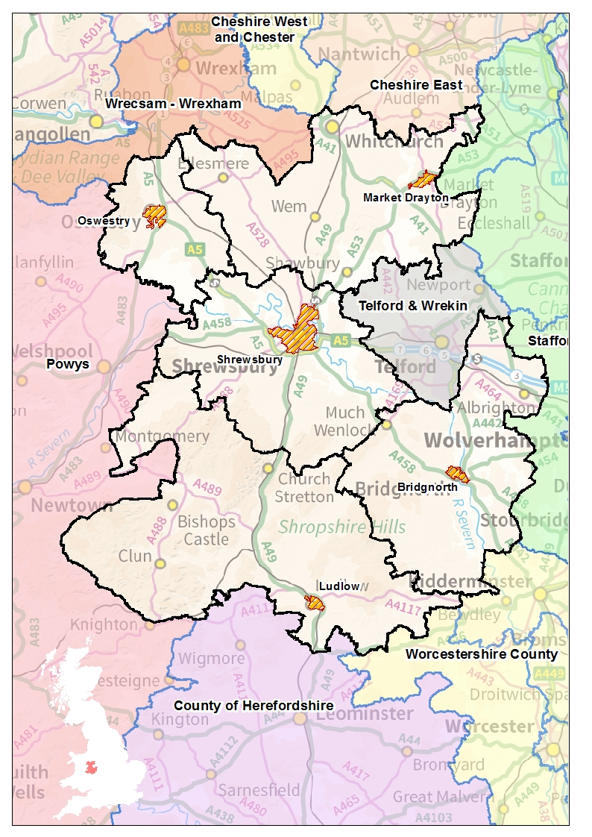

**Key**

**Yellow shaded area shows settlements of a population of over 10,000 people.**

**APPENDIX B**

**LOCAL AREA PROFILE**



**PROBLEM PROFILE:**

LOCAL AREA PROFILE – LICENSED PREMISES

**AUTHOR:**

NIKKI ARMSTRONG-SMITH

PUBLIC PROTECTION OFFICER - INTELLIGENCE

**CREATED DATE:**

15 MARCH 2018 - DRAFT

|  |  |
| --- | --- |
| **VERSION** | **DATE** |
| V1 | 15.03.18 |
|  |  |
|  |  |

*Trading Standards, Licensing and Regulatory Services*

*Public Health*

*Shropshire Council, Shirehall, Abbey Foregate, Shrewsbury, SY2 6ND. Tel: 01743 258765*

* INTRODUCTION

One of the key pieces of legislation enforced by licensing authorities in England and Wales is the Licensing Act 2003 which regulates the sale and supply of alcohol, the provision of entertainment, and the provision of late night refreshment.

The authority is divided into two parts;

* Premises Licence – includes on and off licences and details the times and conditions under which alcohol can be sold.
* Personal Licence – allows individuals to sell alcohol or authorise the sale.

The licensing process focuses on 4 key objectives of the Act, which include;

* Prevention of crime and disorder
* Promotion of public safety
* Prevention of public nuisance
* Protection of children from harm.

All applicants must serve notice on Responsible Authorities and evidence that they can satisfy these key objectives. Applications may be subject to representation, and in the event of an objection(s) to the licence that cannot be resolved through negotiation with the applicant a hearing is held to determine the outcome.

The Licensing Act 2003 requires the licensing authority to develop, consult on and publish a statement of licensing policy with respect to its licensing functions every five years in order to set out the approach to regulation and assist operators in terms of compliance. Shropshire Council are currently revising this statement ahead of implementation during 2019, and it is vital that this Policy reflects local issues in order to identify and reduce risks to the licensing objectives (outlined above). This requires an understanding of local trends and geographical areas of risk; therefore the need to develop a local area profile has been identified in order to inform and support the Statement of Licensing Policy.

* AIM OF THE REPORT

The following local area profile aims to summarise existing national research regarding alcohol-related harm, as well as providing a local evidence base regarding issues relevant to the licensing objectives and geographical areas of potential risk. Data from various sources will be utilised in order to provide an understanding of current and emerging issues in order to support the statement of licensing policy, as well as identifying issues that will need to be considered by operators during the application process.

The report will also serve to support the decision making process regarding future applications in order to minimise the risks associated with licensed premises. Ultimately the findings will assist the Licensing Authority in terms of meeting the objectives and ensuring the specific needs of local communities are considered and vulnerable groups are protected.

Please note, sensitive and confidential data has been removed from this version of the profile in order to allow for dissemination outside of Shropshire Council; therefore not all datasets referred to are included. If you require the official-sensitive version of the report please contact the author.

* BACKGROUND: EXISTING RESEARCH – ALCOHOL RELATED HARM

Addressing the harm caused by alcohol misuse is a priority for Public Health England (PHE), and a key theme of the four licensing objectives. Alcohol is a major cause of ill health and is the leading risk factor for deaths among men and women aged 15-49 years in the UK[32]. However, the harm alcohol causes is much wider than the individual drinker; alcohol misuse can have a detrimental social, emotional and economic impact on communities.

Evidence indicates that 27% of men and 13% of women (an estimated 10.4 million people) in England drink alcohol in a way that presents increasing risk to their health and wellbeing[33]. The table below displays consumption data, as well as alcohol related hospital admissions and mortality rates for Shropshire, allowing for national and regional comparisons;

|  |  |  |  |  |
| --- | --- | --- | --- | --- |
| **INDICATOR** | **Period** | **England** | **West Midlands** | **Shropshire** |
| Volume of pure alcohol sold through the off-trade | 2014 | 5.5 | 5.1 | 5.3 |
| Percentage of adults who abstain from drinking alcohol | 2011 - 2014 | 15.5 | 16.6 | 8.6 |
| Percentage of Adults drinking over 14 units of alcohol a week | 2011 - 2014 | 25.7 | 25.7 | 19.3 |
| Hospital admissions for alcohol related conditions | 2016/17 | 2185 | 2345 | 2005 |
| Hospital admissions for alcohol specific conditions | 2016/17 | 563 | 543 | 402 |
| Hospital admissions for alcohol specific conditions - Under 18's | 2014/15 - 16/17 | 34.2 | 28.5 | 26.9 |
| Alcohol Related Mortality | 2016 | 46 | 50.1 | 40 |
| Hospital admissions for mental and behavioural disorders due to use of alcohol | 2016/17 | 367 | 333 | 263 |
| Hospital admissions for intentional self-poisoning by and exposure to alcohol | 2016/17 | 46.7 | 46.8 | 36.3 |
| Hospital admissions for alcohol related unintentional injuries | 2016/17 | 141.6 | 132.8 | 130.4 |

Figure 1: Local Alcohol Profiles, Public Health England

Of note, in Shropshire during 2016/17, there were 4,457 admission episodes for alcohol related conditions involving males, as compared to 2,502 involving females. However, for females the rate of admissions per 100,000 is closer to the national rate. Overall admissions have consistently increased since 2014/15. Hospital admissions for alcohol specific conditions indicate that 842 episodes during 2016/17 involved male patients, as compared to 446 episodes involving females.

In addition to the obvious health impacts, the economic impact nationally is estimated to be £21 billion;

* £11 billion - alcohol related crime
* £7 billion – lost productivity through unemployment and sickness
* £3.5 billion – cost to the NHS

Nationally there has also been a shift in the way alcohol is consumed which presents a challenge to the Act in terms of promoting behaviour change amongst those groups who cause the most significant alcohol related harms. For example, people are visiting pubs less frequently; more than two-thirds of all alcohol sold is through the off-trade[34]. Such trends suggest more alcohol is consumed within the home which has potential implications in terms of domestic violence and child protection issues, as opposed to public place stranger violence.

Alcohol related harms are therefore impacted by both consumption patterns and social factors. In order to explore trends at a local level, the remainder of the profile will focus on key demographic and socio-economic datasets in order to provide an evidence base in support of the four key licensing objectives. High risk localities across the County will be identified regarding individuals experiencing alcohol related harm, as well as areas recording a higher rate of problematic alcohol related issues. The data has been mapped against ward boundaries, with the location of licensed premises also displayed in order to identify geographical areas of risk and correlations with specific criteria.

* LICENSED PREMISES: SHROPSHIRE OVERVIEW

Nationally, a considerable body of evidence exists to suggest that alcohol outlet density is related to alcohol consumption and alcohol-related harm. It is also an indicator of availability and exposure to alcohol[35].

Shropshire currently licence 1651 premises for the sale of alcohol and late night refreshments; this includes on and off licensed premises. The night time economy in Shropshire is predominantly centred on the main market towns of Shrewsbury, Oswestry, Whitchurch, Bridgnorth and Ludlow; areas which offer a variety of pubs, bars, restaurants, fast food outlets and nightclubs. A vibrant and diverse night time economy can provide many benefits to the community, however alcohol related issues can also prove problematic if activity is unregulated[36]. It is vital to minimise any negative impact from licensed premises whilst also encouraging economic diversity and prosperity**.**

The map below displays the location of licensed premises across Shropshire, and indicates cluster sites in the main county towns, with a higher concentration of premises in the Shrewsbury and Atcham district;

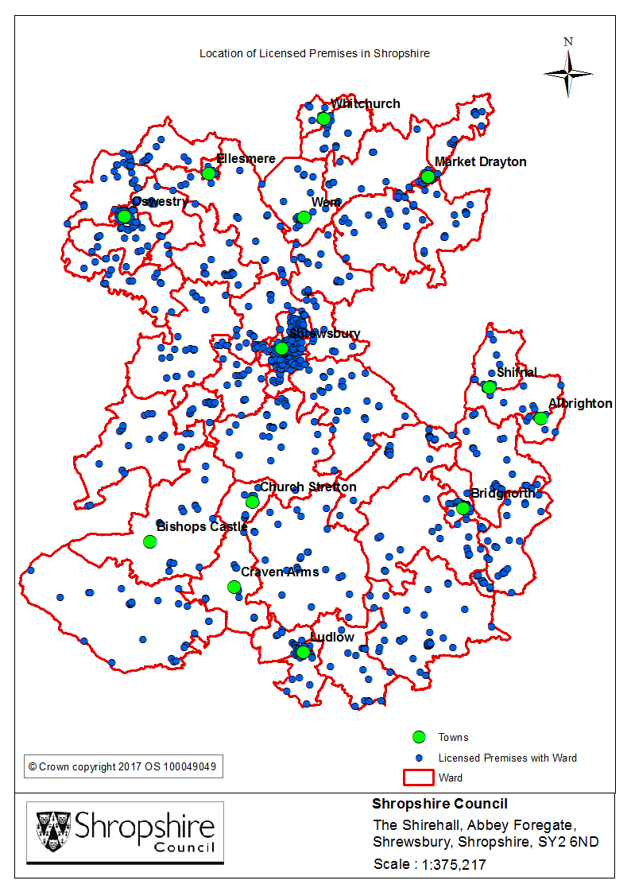

As illustrated, the highest number of premises are located in Shrewsbury which is the key centre for entertainment. At a lower geographical level, the tables below identify the number and rate of licensed premises for the top 5 hotspot wards;

|  |  |
| --- | --- |
| **WARD** | **RATE PER 1000 POPN** |
| Quarry and Coton Hill | 38.13 |
| Ludlow North | 19.08 |
| Oswestry South | 17.43 |
| Bridgnorth East and Astley Abbotts | 11.22 |
| Bishop's Castle | 10.92 |

Figure 3: Rate of premises per 1000 population

|  |  |
| --- | --- |
| **WARD** | **TOTAL** |
| Quarry and Coton Hill | 173 |
| Bridgnorth East and Astley Abbotts | 76 |
| Oswestry South | 76 |
| Ludlow North | 71 |
| Church Stretton and Craven Arms | 54 |
| Whitchurch North | 47 |

Figure 2: Number of premises per ward

**Key findings**: Both the highest number and rate of premises per 1000 population are located in Quarry and Coton Hill ward in Shrewsbury. This ward encompasses Shrewsbury town centre; it is predominantly urban in nature and densely populated. The ward provides a wide range of shops, entertainment venues and other amenities. 1,011 businesses are based in this particular ward[37], creating 7,800 jobs.

The map overleaf displays the concentration of premises licensed for the sale of alcohol and late night refreshments within the Quarry and Coton Hill ward.

Licensed premises in Shropshire are routinely monitored to ensure compliance with the four licensing objectives. Intelligence led visits are conducted at new licensed premises, or following changes to the designated premises supervisor. During 2016/17, 66% of new licensed premises were visited, and 82% of new designated premises supervisors. In addition 91 routine inspections were completed. Problems or concerns with licensed premises are identified at the earliest opportunity, and in the first instance advice is offered to the licensee in order to improve standards at the premises. If problems persist, a hearing may be held. During 2016/17, 5 hearings were held indicating the success of early intervention.

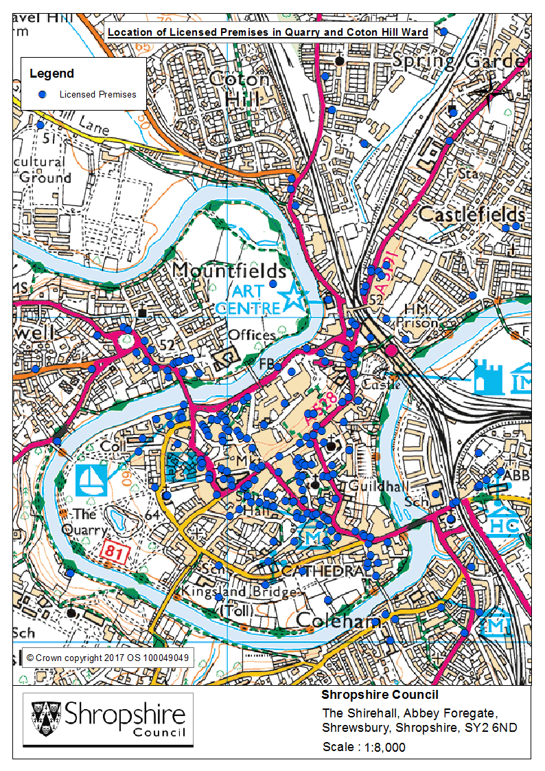

* PREVENTION OF CRIME AND DISORDER

Objective 1 of the Licensing Act focuses on the prevention of crime and disorder. Alcohol can often be a causal factor leading to crime and disorder, impacting on the safety of those in the wider community and increasing fear of crime levels. In order to identify hotspot areas, and any correlation with the location of existing licensed premises, crime and anti-social behaviour data has been analysed for the period April 2015 – March 2017.

The map below displays the location of licensed premises, alongside the rate of crimes per 1000 population by ward in Shropshire;

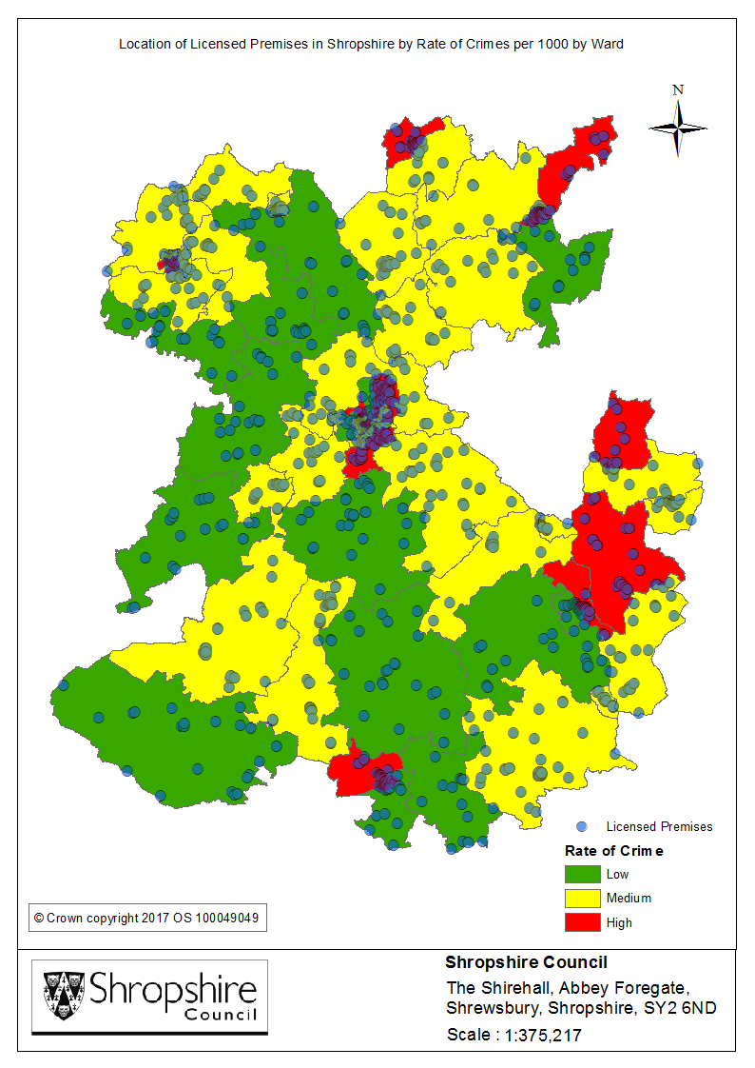

The tables below identify the top 5 hotspot wards with regard to both the number of rate of recorded crimes;

|  |  |
| --- | --- |
| **WARD** | **RATE per 1000 POPN** |
| Quarry and Coton Hill | 437.51 |
| Oswestry South | 300.85 |
| Harlescott | 188.31 |
| Ludlow North | 177.86 |
| Sundorne | 166.71 |

|  |  |
| --- | --- |
| **WARD** | **No. of CRIMES** |
| Quarry and Coton Hill | 1985 |
| Oswestry South | 1312 |
| Bayston Hill, Column and Sutton | 1212 |
| Market Drayton West | 956 |
| Harlescott | 931 |

Figure 5: Rate of crimes per 1000 population by ward

Figure 4: Number of crimes per ward

**Key findings**: Quarry and Coton Hill has been identified as the hotspot ward in relation to recorded crime. As outlined previously, this ward encompasses Shrewsbury town centre and therefore includes a wide range of amenities including retail and commercial premises. A higher number of licensed premises are also located in this particular ward, indicating a correlation with the night-time economy. Oswestry South and Harlescott also feature within the top 5 in relation to both crime volume and crime rate.

The findings of a large number of studies link violent incidents with alcohol consumption and the night-time economy. For example, the 2016/17 Crime Survey for England and Wales found that in 40% of all violent incidents the victim believed the perpetrator to be under the influence of alcohol. Alcohol related crime, and particularly violence, can have wider consequences for both personal health as well as the delivery of health services. It would be expected that alcohol related crime would be more prevalent in town centre locations with a higher concentration of licensed premises; however the consumption of alcohol is also likely to have an impact on domestic abuse trends and violence within the home. Therefore data regarding alcohol related crime, violence, and more specifically domestic abuse is also presented in order to identify higher risk localities.

The map overleaf displays the location of licensed premises, alongside the rate of alcohol related crime per 1000 population by ward. If alcohol is deemed a contributory factor leading to a crime, an alcohol marker is attached to the record, therefore trends may differ from overall crime rates. The tables below identify the top 5 hotspot wards with regard to both the number of rate of alcohol related crimes;

|  |  |
| --- | --- |
| **WARD** | **TOTAL** |
| Quarry and Coton Hill | 544 |
| Oswestry South | 251 |
| Whitchurch North | 168 |
| Bridgnorth East and Astley Abbotts | 161 |
| Market Drayton West | 161 |
| Castlefields and Ditherington | 134 |

Figure 7: Rate of alcohol related crimes per 1000 population by ward

Figure 6: Number of alcohol related crimes per ward

|  |  |
| --- | --- |
| **WARD** | **RATE** |
| Quarry and Coton Hill | 119.90 |
| Oswestry South | 57.56 |
| Ludlow North | 31.43 |
| Castlefields and Ditherington | 28.94 |
| Bridgnorth East and Astley Abbotts | 23.77 |

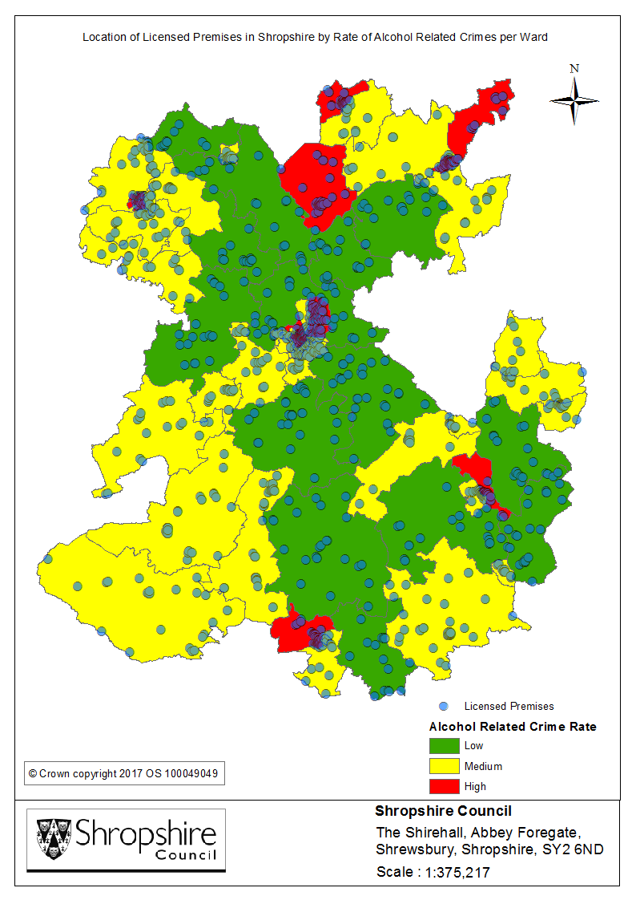

**Key findings**: Again Quarry and Coton Hill ward features as the most problematic hotspot area in terms of both the number and rate of alcohol related crimes. More than double the number of crimes were committed in this ward in comparison to those recorded in Oswestry South, which is the second hotspot area in terms of volume.

The map below displays the location of licensed premises, alongside the rate of violent crime per 1000 population by ward in Shropshire;

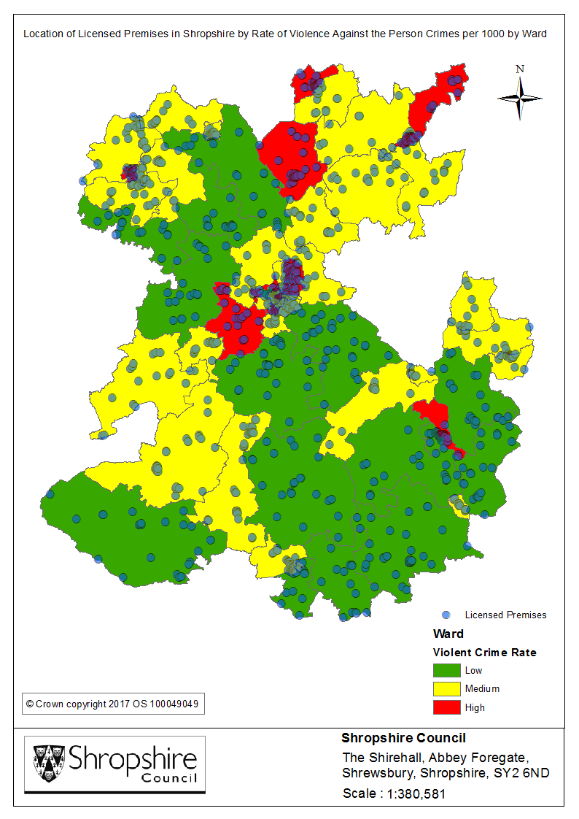

The tables below identify the top 5 hotspot wards with regard to both the number of rate of recorded violent crimes[38];

|  |  |
| --- | --- |
| **Ward** | **No. of Violent Crimes** |
| Quarry and Coton Hill | 644 |
| Harlescott | 349 |
| Oswestry South | 346 |
| Market Drayton West | 336 |
| Oswestry East | 317 |

|  |  |
| --- | --- |
| **Ward** | **Rate of Violent Crime per 1000 population** |
| Quarry and Coton Hill | 70.97 |
| Oswestry South | 39.67 |
| Sundorne | 37.02 |
| Harlescott | 35.30 |
| Castlefields and Ditherington | 30.02 |

Figure 8: Number of violent crimes per ward

Figure 9: Rate of violent crimes per 1000 population by ward

**Key findings**: Quarry and Coton Hill has again been identified as the hotspot ward in relation to violent crime, which correlates with overall crime trends. As illustrated previously, a higher number of licensed premises are also located in this particular ward. Harlescott and Oswestry South also feature in the top 5 with regard to both volume and rate.

The map overleaf displays the location of licensed premises, alongside the rate of domestic abuse offences per 1000 population by ward in Shropshire. The tables below identify the top 5 hotspot wards with regard to both the number of rate of recorded domestic abuse offences[39];

|  |  |
| --- | --- |
| **Ward** | **Rate of Domestic Abuse per 1000 population** |
| Castlefields and Ditherington | 19.44 |
| Quarry and Coton Hill | 16.75 |
| Sundorne | 15.90 |
| Harlescott | 14.97 |
| Market Drayton East | 13.63 |

|  |  |
| --- | --- |
| **Ward** | **No. of Domestic Abuse Offences** |
| Oswestry East | 95 |
| Market Drayton West | 93 |
| Castlefields and Ditherington | 90 |
| Whitchurch North | 80 |
| Quarry and Coton Hill | 76 |

Figure 11: Rate of domestic abuse per 1000 population by ward

Figure 10: Number of domestic abuse offences per ward

**Key findings**: As illustrated above, the highest number of domestic abuse offences were recorded in the Oswestry East ward; this area is predominantly urban in nature and densely populated. With regard to the rate of domestic abuse, Castlefields & Ditherington has been identified as the hotspot ward; this area is predominantly residential but in close proximity to Shrewsbury town centre. Of note, Quarry and Coton Hill ward still features in the top 5 hotspot areas in terms of both volume and rate.

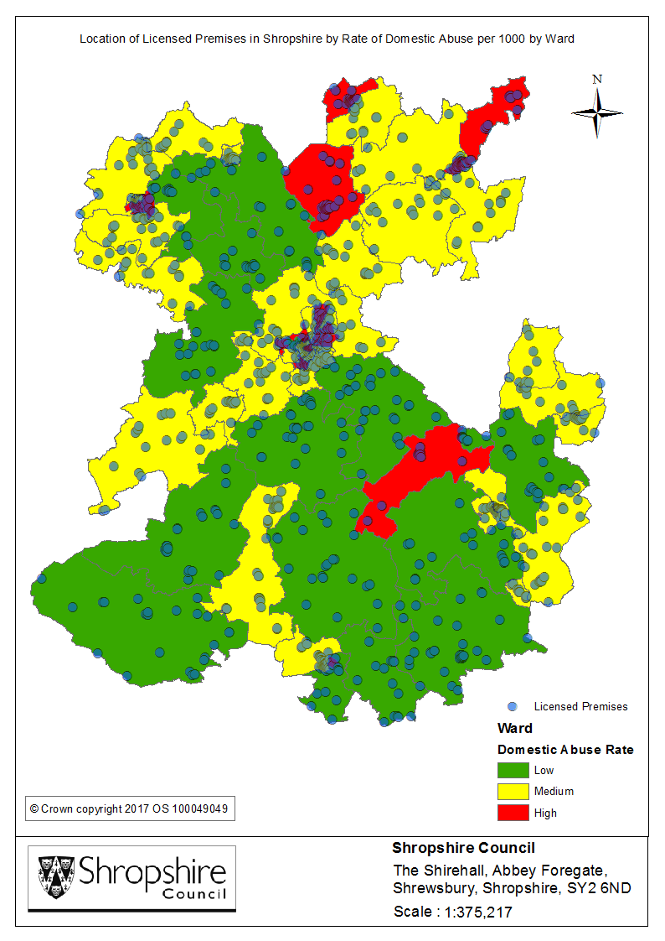

The map below displays the location of licensed premises, alongside the rate of ASB incidents per 1000 population by ward;

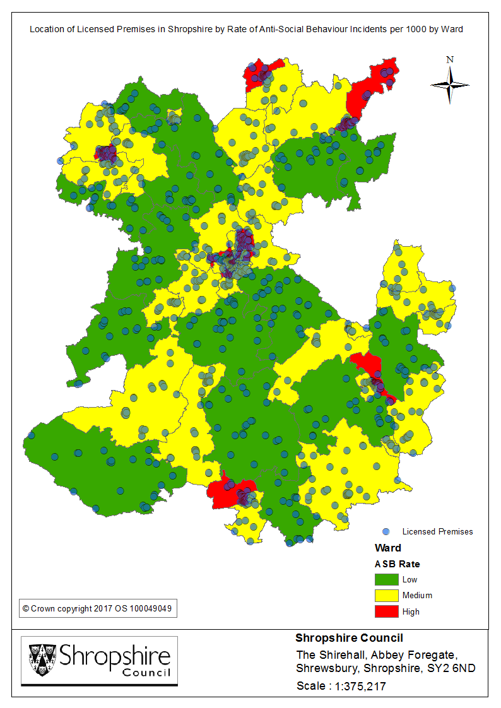

The tables below identify the top 5 hotspot wards in relation to the number and rate of ASB incidents;

|  |  |
| --- | --- |
| **WARD** | **No. of ASB INCIDENTS** |
| Quarry and Coton Hill | 1550 |
| Harlescott | 759 |
| Oswestry South | 683 |
| Oswestry East | 615 |
| Market Drayton West | 571 |

Figure 13: Rate of ASB incidents per 1000 population by ward

Figure 12: Number of ASB incidents per ward

|  |  |
| --- | --- |
| **WARD** | **RATE per 1000 POPN** |
| Quarry and Coton Hill | 170.82 |
| Oswestry South | 78.31 |
| Harlescott | 76.76 |
| Sundorne | 69.32 |
| Castlefields and Ditherington | 55.51 |

**Key findings**: Again, Quarry and Coton Hill has been identified as the hotspot ward in relation to ASB, primarily due to the nature of the town centre location. Harlescott, Sundorne, and Castlefields & Ditherington also feature within the top 5 hotspots regarding the rate of incidents per 1000 population; all areas are predominantly residential and located in the Shrewsbury and Atcham district. The map overleaf displays the Shrewsbury area in greater detail, in order to identify premises located within the hotspot wards detailed above.

**Recommendation:** With regard to future licence applications in relation to premises located in the wards identified above, ensure the required measures are in place to minimise the impact on increased crime and disorder levels; for example door supervision, adequate staffing levels, CCTV and other appropriate crime prevention tactics. Also consider the use of ASB powers to tackle any ongoing nuisance issues in the vicinity of existing licensed premises. Of note, a Public Spaces Protection Order is currently in place which covers the Quarry and Coton Hill ward and prohibits the consumption of alcohol in a public place in order to reduce alcohol related crime and anti-social behaviour.

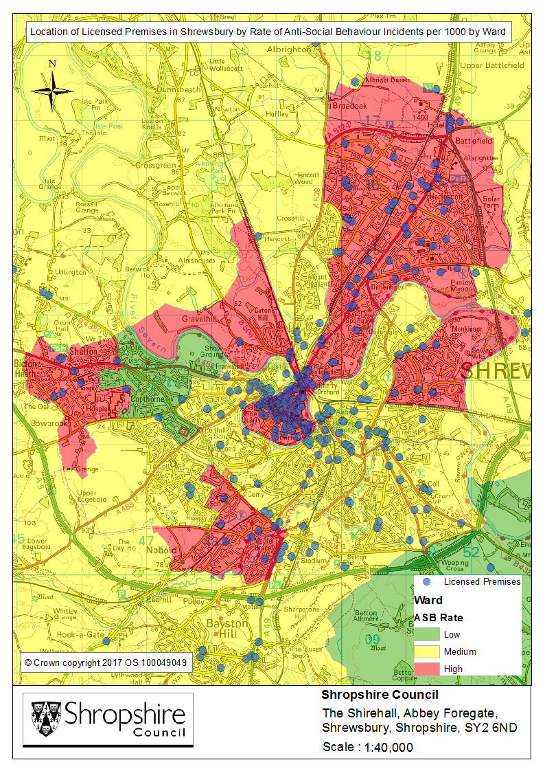

* PROMOTION OF PUBLIC SAFETY

As part of their duties under the 2003 Act, licence holders have a responsibility to ensure the safety of those using their premises. Physical safety includes the prevention of accidents and injuries and other immediate harms that can result from alcohol consumption such as unconsciousness or alcohol poisoning[40].

Shropshire has a number of schemes and initiatives in place to ensure alcohol is sold responsibly, supporting the use of existing laws, regulations and controls available to all the local partners in order to minimise alcohol related harm. For example, Pubwatch schemes are currently in place in Shrewsbury, Market Drayton, Church Stretton, Ludlow and Oswestry. In addition schemes are in development in Shifnal & Albrighton, and Bridgnorth. Of note, the Shrewsbury Pubwatch scheme currently has 60 members. Shrewsbury also has Purple Flag status for the town’s night time economy; this is a national award recognising excellence in the management of town and city centres after hours. The Purple Flag assessors described Shrewsbury as a ‘very safe and secure town’ and also commended the strong partnership approach to improving and responding to issues in town[41].

Protecting those vulnerable to alcohol related harm is complex, as there is no clear definition regarding those at risk and there is currently a lack of evidence regarding social determinants. Social factors can result in health inequalities, however there has been little research examining the link with alcohol related issues. The location of drug and alcohol treatment centres are likely to draw vulnerable people into specific locations, and have therefore been considered at a local level in terms of the proximity to areas with a higher number of licensed premises.

The map overleaf displays the location of treatment facilities[42] in Shropshire, and their proximity to licensed premises;

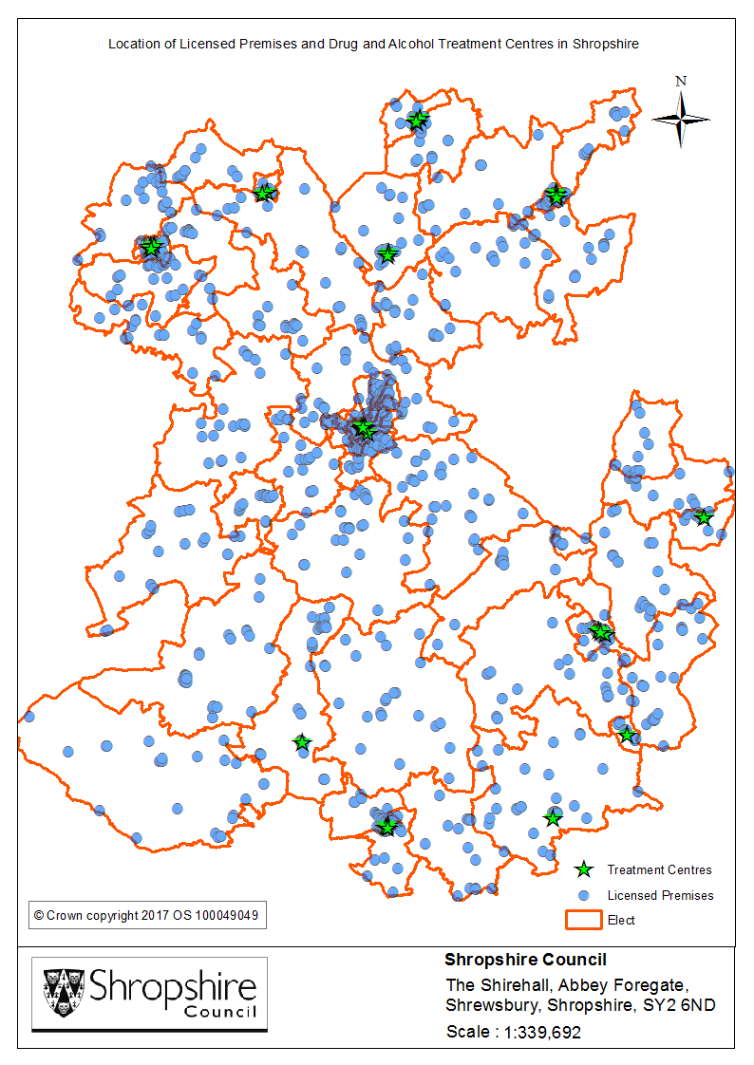

**Key findings**: Oswestry South features as a hotspot area regarding the number and rate of licensed premises, as well as the number of treatment facilities (x4). 4 facilities are also located in Quarry and Coton Hill ward, which has already been identified as a hotspot area regarding the concentration of licensed premises, and rates of crime and ASB.

**Recommendation**: Premises licence holders should have clear policies and procedures in place identifying all public safety risks, alongside measures to prevent and manage those risks. The safety of individuals leaving the premises should also be acknowledged; for example promoting safe night-time transport options. Consideration should also be given to the location of licensed premises in areas with a higher rate of individuals vulnerable to alcohol related harm; for example, preventing the sale of alcohol to those already intoxicated.

* PREVENTION OF PUBLIC NUISANCE

Public nuisance retains its broad common law meaning within Licensing Act 2003, and the relevant issues predominantly concern noise nuisance, light pollution, odour and litter. The Act enables licensing authorities and responsible authorities, through representations, to consider what constitutes public nuisance and what is appropriate to prevent it in terms of conditions attached to specific premises licences[43].

In order to identify hotspot areas and any correlation with the location of existing licensed premises, Regulatory Services noise and pollution complaints[44] have been analysed for the period April 2015 – March 2017. Noise complaints include both domestic and non-domestic reports, and pollution complaints include the following incident categories;

* Smoke
* Air Quality
* Accumulations and Deposits
* Light Nuisance
* Odour

The map overleaf displays the location of licensed premises, alongside the rate of noise complaints per 1000 population by ward in Shropshire;

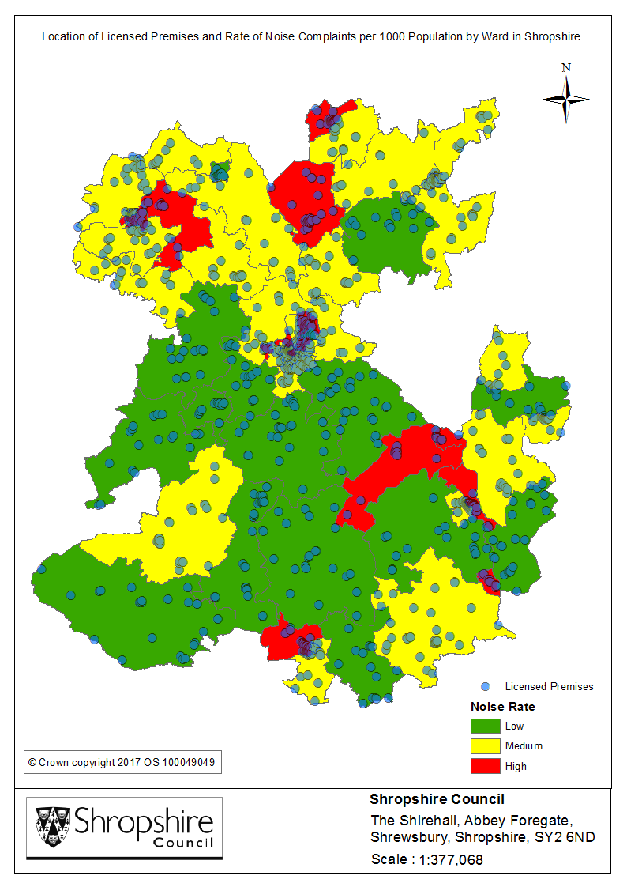

The tables below identify the top 5 hotspot wards with regard to both the number of rate of noise complaints;

|  |  |
| --- | --- |
| **WARD** | **TOTAL** |
| Quarry and Coton Hill | 92 |
| Bridgnorth East and Astley Abbotts | 61 |
| Bayston Hill, Column and Sutton | 61 |
| Oswestry East | 51 |
| Wem | 47 |
| Harlescott  Figure 14: Number of Noise complaints per ward | 44 |

Figure 15: Rate of Noise complaints per 1000 population by ward

|  |  |
| --- | --- |
| **WARD** | **RATE** |
| Quarry and Coton Hill | 20.28 |
| Oswestry South | 9.63 |
| Bridgnorth East and Astley Abbotts | 9.01 |
| Harlescott | 8.90 |
| Ludlow North | 8.87 |

**Key findings**: Quarry and Coton Hill ward has been identified as the primary hotspot area in relation to both the number and rate of noise complaints. As identified previously, this ward also contains the highest number of licensed premises and has recorded the highest rate of crime and anti-social behaviour.

The map overleaf displays the location of licensed premises, alongside the rate of pollution complaints per 1000 population by ward in Shropshire. In addition, the tables below identify the top 5 hotspot wards with regard to both the number of rate of pollution complaints;

Figure 17: Rate of Pollution complaints per 1000 population by ward

|  |  |
| --- | --- |
| **WARD** | **RATE** |
| Prees | 5.55 |
| Whitchurch South | 4.76 |
| Castlefields and Ditherington | 4.54 |
| Shifnal North | 4.44 |
| Quarry and Coton Hill | 4.19 |

|  |  |
| --- | --- |
| **WARD** | **TOTAL** |
| Prees | 24 |
| Wem | 22 |
| Castlefields and Ditherington | 21 |
| Church Stretton and Craven Arms | 21 |
| Shifnal North | 21 |
| Whitchurch South | 21 |
| Cleobury Mortimer | 20 |
| Market Drayton West | 19 |
| Quarry and Coton Hill | 19 |

Figure 16: Number of Pollution complaints per ward

**Key findings**: As illustrated above, Prees has recorded the highest number and rate of pollution complaints during the review period. This ward is predominantly rural in nature, and is sparsely populated. Of note, Quarry and Coton Hill ward does feature within the top 5 hotspot areas regarding both the number and rate of complaints.

**Recommendation**: Consideration should be given to applications for licensed premises in the identified hotspot areas already recording higher levels of noise and pollution complaints. Applicants need to evidence that additional premises will not contribute to existing issues, and cause a public nuisance for local residents.

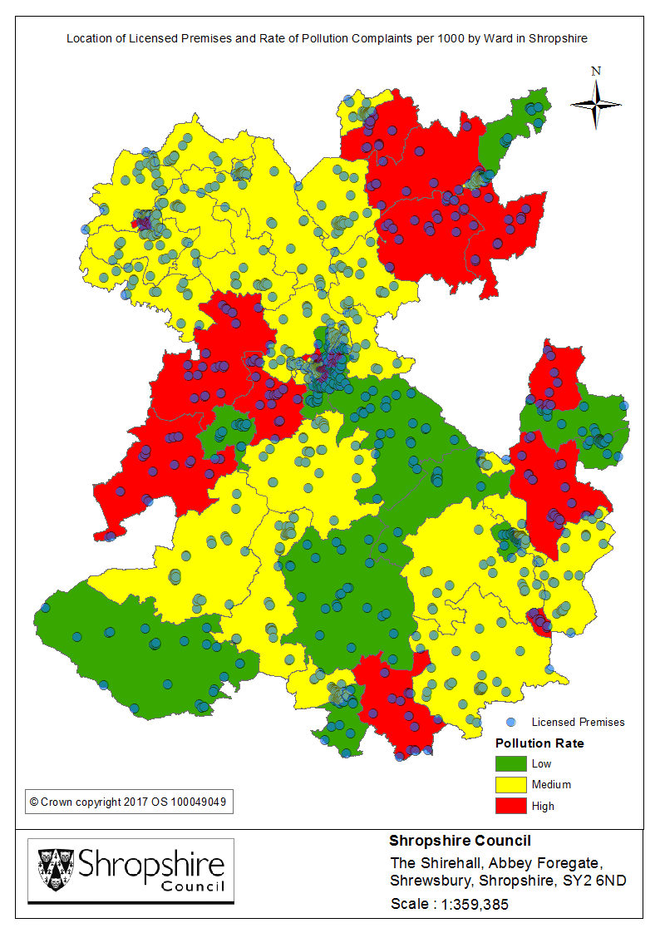

* PROTECTION OF CHILDREN FROM HARM

The fourth objective of the Licensing Act 2003 states that children should be protected from harm, and as such recognises young people as a vulnerable group. If someone is under the age of 18 it is illegal to sell them alcohol, to buy (or attempt to buy) alcohol, for an adult to buy (or attempt to buy) alcohol for them, or to drink alcohol in licensed premises. Premises licence holders must ensure that an age verification policy applies to the premises in relation to the sale or supply of alcohol. In addition, a number of licensed premises in Shropshire also adhere to best practise schemes such as ‘Challenge 25’ which require individuals who appear to be under the age of 25 to also provide ID.

According to the What About YOUth survey conducted in 2014:

* 68.1% of 15 year olds surveyed in Shropshire stated that they had an alcoholic drink
* 7.1% reported having an alcoholic drink at least once a week.
* 16.4% reported that they had been drunk in the last four weeks.
* For all three drinking measures above, Shropshire’s figures were higher than both the West Midlands and National averages.

Intelligence led test purchase exercises are conducted across Shropshire in order to prevent the underage sale of alcohol from licensed premises. During 2017/18, 31 off licensed premises were visited which resulted in 5 sales, and 4 on licensed premises resulting in 2 sales.

Further consideration should be given to interventions which will ensure the prevention of underage drinking. Again the location of premises should be taken into consideration; for example the proximity to schools. In order to identify locations where younger people will be present in greater numbers at certain points of the day the maps overleaf display the location of all Shropshire schools and colleges alongside licensed premises, as well as the hotspot area in Shrewsbury at a lower geographical level.

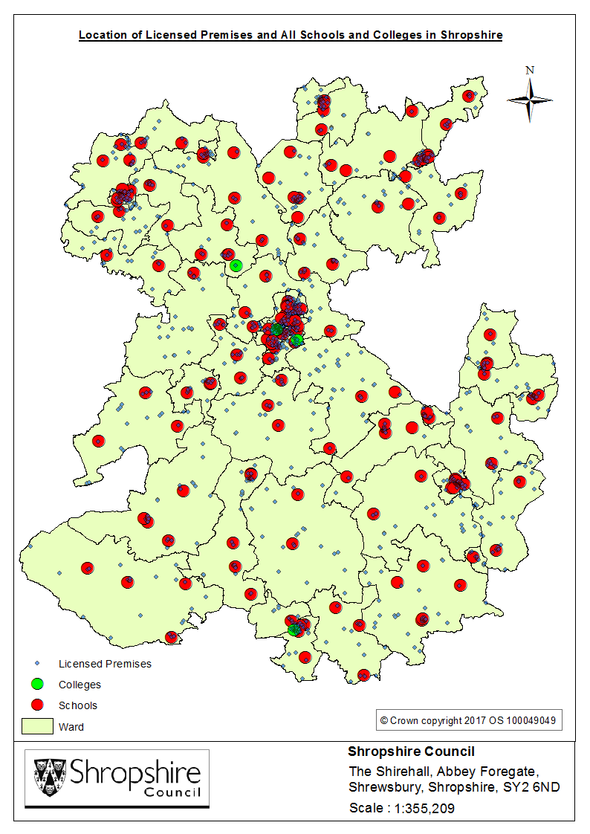

The map below displays the location of premises within the Shrewsbury cluster site;

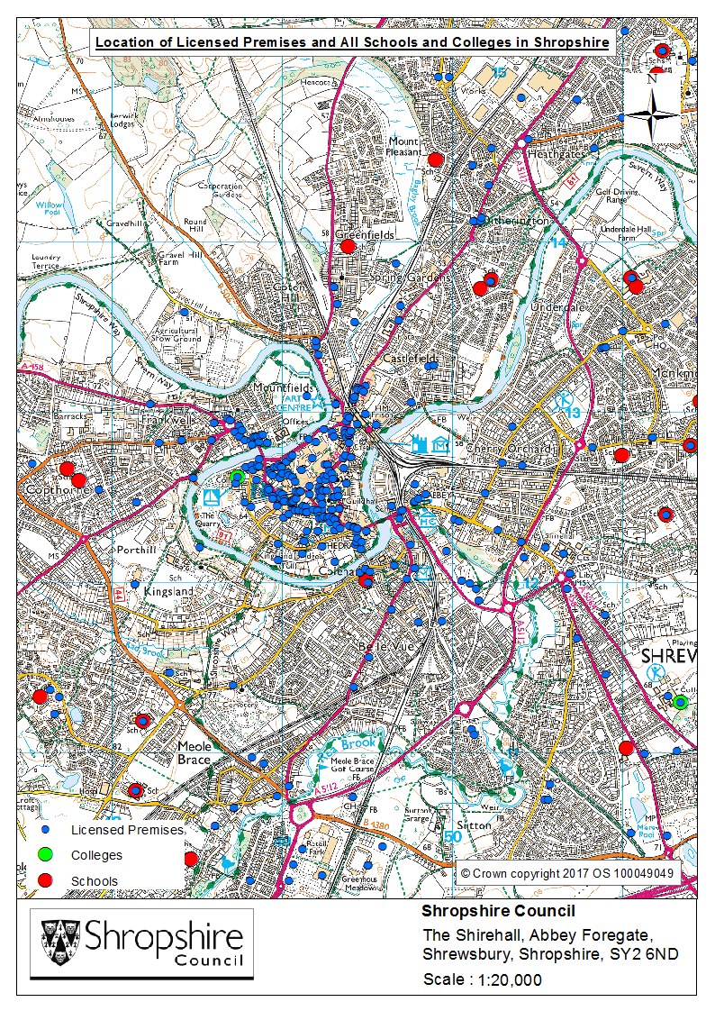

20% of the population in Shropshire are under 18, and 13% are of school age (aged 5-16 years). The table below displays the top 10 areas in relation to the rate of school children per 1000 population[45]. The number of children by age is also provided;

|  |  |  |  |  |  |  |  |  |  |  |  |  |  |  |
| --- | --- | --- | --- | --- | --- | --- | --- | --- | --- | --- | --- | --- | --- | --- |
| **AREA** | **Age 5** | **Age 6** | **Age 7** | **Age 8** | **Age 9** | **Age 10** | **Age 11** | **Age 12** | **Age 13** | **Age 14** | **Age 15** | **Age 16** | **TOTAL 5-16** | **RATE per 1000 POP** |
| Porthill | 47 | 53 | 48 | 50 | 55 | 44 | 42 | 46 | 57 | 142 | 125 | 118 | 827 | 172.90 |
| Sundorne | 78 | 60 | 50 | 56 | 52 | 68 | 60 | 52 | 55 | 53 | 53 | 57 | 694 | 170.89 |
| Copthorne | 50 | 60 | 55 | 75 | 53 | 47 | 59 | 63 | 57 | 53 | 58 | 56 | 686 | 163.80 |
| Underdale | 55 | 65 | 55 | 74 | 67 | 42 | 61 | 48 | 58 | 53 | 61 | 68 | 707 | 160.35 |
| Cheswardine | 65 | 74 | 65 | 75 | 54 | 51 | 48 | 49 | 48 | 47 | 61 | 65 | 702 | 158.04 |
| The Meres | 49 | 52 | 58 | 52 | 48 | 58 | 37 | 62 | 67 | 67 | 99 | 124 | 773 | 156.00 |
| Harlescott | 67 | 78 | 69 | 74 | 69 | 56 | 60 | 67 | 67 | 49 | 63 | 54 | 773 | 155.47 |
| Meole | 38 | 49 | 48 | 45 | 57 | 61 | 66 | 54 | 73 | 58 | 61 | 53 | 663 | 154.15 |
| Burnell | 42 | 49 | 45 | 46 | 54 | 66 | 55 | 38 | 61 | 78 | 84 | 108 | 726 | 151.28 |
| Monkmoor | 61 | 69 | 52 | 62 | 48 | 43 | 51 | 59 | 57 | 55 | 55 | 55 | 667 | 149.42 |

Figure 18: Top 10 Areas - Rate of school aged children per 1000 population

**Key findings**: Porthill has the highest rate of school age children across Shropshire; the area is adjacent to the licensed premises cluster site in Quarry and Coton Hill ward and as such should be considered a risk area. Monkmoor has the highest number of schools across the County; however this ward does not feature within the top 5 hotspot areas regarding the number and rate of licensed premises. As outlined previously, the highest number of licensed premises are located in Quarry and Coton Hill ward; this area also contains Shrewsbury Sixth Form College, and Coleham Primary School is located just outside the ward border.

**Recommendation:** With regard to future licence applications in relation to premises located in the wards identified above, ensure the required measures are in place to prevent underage drinking and to protect young people from alcohol related harm; for example age restricted sales policies and door supervision.

* SOCIO-ECONOMIC FACTORS

INDEX OF MULTIPLE DEPRIVATION 2015

The Index of Multiple Deprivation (IMD 2015) is a nationally recognised measure of deprivation at the Super Output Area level. It measures deprivation in its broadest sense by assessing indicators relating to income, employment, health and disability, education, skills and training, barriers to housing and services, crime and the living environment[46]. The IMD score is a measure of relative deprivation indicating socio-economic status, and therefore an important tool for identifying the most disadvantaged areas. This provides a useful indicator in terms of highlighting potential areas of risk in relation to alcohol-related harm, as greater deprivation is associated with higher rates of alcohol dependency.

The 2014 What About YOUth survey found deprivation was associated with rates of drinking amongst young people. However, in England, young people from the least deprived areas who were surveyed were more likely to have ever drunk alcohol compared with those surveyed who were from the most deprived backgrounds (70% compared with 50% respectively)[47].

The map overleaf displays the level of deprivation per ward across Shropshire, alongside the location of licensed premises. In addition the table below identifies the 5 wards across the County with the highest deprivation score;

|  |  |
| --- | --- |
| **WARD** | **DEPRIVATION SCORE** |
| Harlescott | 28.01 |
| Market Drayton East | 27.77 |
| Monkmoor | 26.33 |
| Oswestry South | 25.34 |
| Castlefields and Ditherington | 24.93 |

Figure 19: Top 5 Wards – Deprivation Score

**Key findings**: 3 of the top 5 wards are located in Shrewsbury; as outlined previously Shrewsbury has the greatest concentration of licensed premises. Harlescott has the highest deprivation score, although this ward does not feature as a hotspot in relation to the number and rate of licensed premises it has been identified as a risk area regarding alcohol treatment rates. Oswestry South should be considered a risk area as this ward features in the top 5 hotspot wards in relation to number and rate of licensed premises, as well as deprivation score.

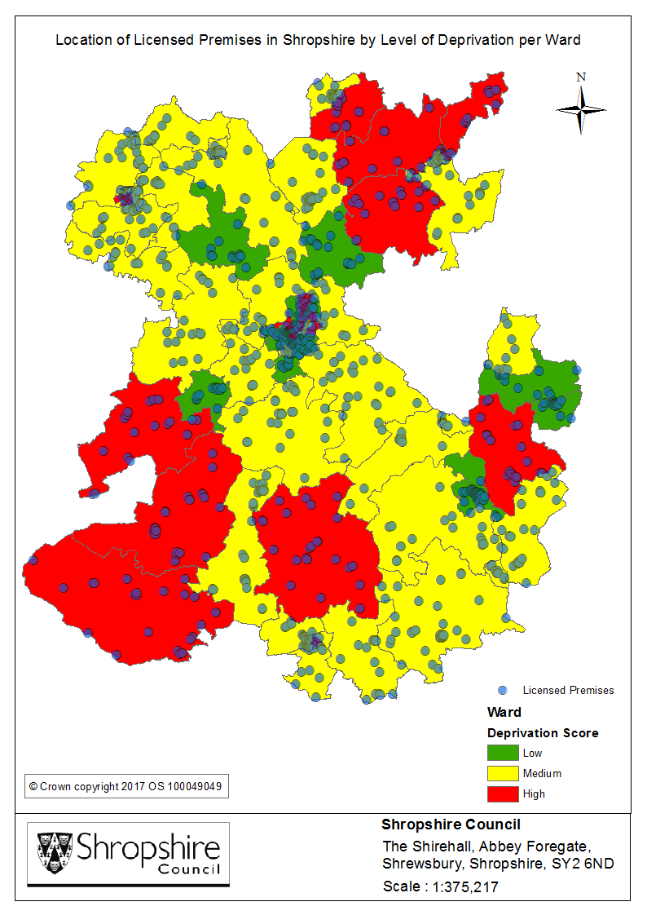

UNEMPLOYMENT

Significant negative health impacts can arise as a result of unemployment, both for the individual and their families. This impact worsens when it involves alcohol misuse**[48]**. Harmful drinking and the associated increased risk of mental health problems can make it harder for people with alcohol dependence issues to find work again.

Data regarding the number of economically active unemployed residents has been considered in order to indicate unemployment levels among resident populations. This data is based on the 2011 UK Census, therefore timeliness does pose a limitation, however used alongside the additional criteria provides a useful indicator. The table below displays the top 5 hotspot areas regarding the number of unemployed residents;

|  |  |
| --- | --- |
| Ward | **Unemployed** |
| Oswestry East | 304 |
| Market Drayton West | 246 |
| Whitchurch North | 221 |
| Bayston Hill, Column and Sutton | 198 |
| Wem | 197 |

Figure 20: Top 5 wards – number of residents unemployed (2011 Census)

**Recommendation:** Research indicates that those living in deprived areas are more likely to experience health inequalities and as such are potentially more vulnerable to alcohol related harm. Consideration should therefore be given to future license applications for premises located in the areas posing a greater risk as identified above.

* CONCLUSION

Findings indicate that the highest number of risk areas are located within the Shrewsbury and Atcham district, which would be expected as this is the most densely populated area in Shropshire. At a lower geographical level Quarry and Coton Hill ward poses the greatest risk primarily due to the concentration of licensed premises, crime (including violence against the person) and ASB rates, as well as noise nuisance. Outside of Shrewsbury, a higher number of identified risk areas are located in Oswestry; of note, Oswestry South has the third highest number and rate of licensed premises across Shropshire.

The risk matrix displayed in appendix 1 details the ward areas across Shropshire posing the greatest risk, alongside the specific indicator. This allows for the identification of risk type; this maybe the location of certain premises, or the location of groups vulnerable to alcohol related harm. However, all areas outlined within the profile should be considered risk areas and future applications for licensed premises located in these wards should be evaluated in line with the findings of this report in order to effectively manage and minimise the impact of alcohol in line with the 4 key objectives of the Licensing Act 2003.

* RECOMMENDATION

This profile provides a starting point in terms of identifying local risk factors requiring consideration in order to aid compliance with the 4 key licensing objectives. However, it is important to build on this profile via engagement with other partner organisations in order to enhance the range of local risk factors considered.

**APPENDIX** **C**

**Safeguarding of children, young people and adults with care and support needs**

**Modern slavery and human trafficking**

**Introduction**

Set out below is information for licence holders to help them report, to the relevant authorities, matters of concern that could relate to the safety of children, young people and adults with care and support needs, particularly as it relates to child sexual exploitation, abuse, modern slavery and human trafficking.

**General information**

1.1 Shropshire Council’s Licensing Service is helping to tackle child sexual exploitation, abuse, modern slavery and human trafficking by working together with key partners particularly West Mercia Police, Children and Adult Services within the Council, the Safeguarding Children Board and the Keeping Adults Safe in Shropshire Board. The Boards also work with the police, children’s and adults social care, schools, health services and the youth offending team, as well as specialist child sexual exploitation organisations such as the child sexual exploitation National Working Group (NWG) Network.

1.2 Through agencies working together and sharing information, we aim to identify and prevent sexual exploitation, modern slavery and human trafficking to protect children, young people and adults with care and support needs and disrupt the activities in order to prosecute perpetrators of abuse.

1.3 Sharing information with West Mercia Police and Children’s and Adults Social Care helps to protect children, young people and adults with care and support needs from harm.

**How licence holders can help tackle child sexual exploitation, abuse and modern slavery**

1.4 Licence holders may become aware of or come into contact with children, young persons and adults with care and support needs, or people who are victims of modern slavery or human trafficking. This may be in hotels, bars and restaurants, late night takeaways, off licenses or other licensed premises. Licence holders, and staff employed in licensed premises are in an ideal position to help protect people.

1.5 Safeguarding children, young people and adults with care and support needs is everyone’s business and everyone’s responsibility.

**Child sexual exploitation**

1.6 Sexual exploitation of children and young people involves exploitative situations, contexts and relationships where young people (or a third person or persons) receive something, e.g. food, accommodation, drugs, alcohol, cigarettes, affection, gifts, money, etc. as a result of them performing, and/or another or others performing on them, sexual activities. Violence, coercion and intimidation are commonly involved in such exploitative relationships.

1.7 Child sexual exploitation involves perpetrators grooming youngsters and using their powers to sexually abuse them. Sexual exploitation of children and young people can take many forms, whether it occurs through a seemingly ‘consensual’ relationship with an older boyfriend, or a young person having sex in return for attention, gifts, alcohol or cigarettes.

1.8 Child sexual exploitation is a crime that can affect any child, anytime, anywhere – regardless of their social or ethnic background.

1.9 In particular, licence holders and staff in licensed premises should ask themselves the following types of questions:

* Does your customer appear to be under 18 years old?
* Are they with a much older person and appear to be in a relationship?
* Do you think that they are under the influence of alcohol or drugs?
* Are children, young people or adults with care and support needs regularly being dropped off/picked up or collected and taken elsewhere from licensed premises such as a hotel, B&B or late night takeaway?
* Is a child, young person or adult with care and support needs regularly being brought to a licensed premises such as a hotel or B&B where you work? If so, ask yourself why?

1.10 **If the answers to any of the questions above gives you even the slightest cause for concern, these concerns should be reported**

1.11 **If you have reason to suspect that a child is being abused or at risk of abuse it is your responsibility to report your concerns to and share information with West Mercia Police (Tel: 101) and Children’s Social Care (Tel: 0345 678 9021).**

1.12 Further information about Shropshire’s Safeguarding Children Board can be found at: <http://www.safeguardingshropshireschildren.org.uk/>

**Adults with care and support needs**

1.13 An adult with care and support needs is someone who is in need of community care services due to disability, age or illness. They may be unable to take care of or protect themselves against significant harm or exploitation.

1.14 In particular, licence holders and staff who work in licensed premises should ask themselves the following questions when coming into contact with children, young people or adults with care and support needs:

* Has your customer got any physical signs of abuse or neglect?
* Are they a regular customer? Do you see changes in their behaviour or mood?
* A customer tells you they are having difficulties with someone else
* A customer tells you they have a worry about someone
* A customer tells you they have hurt a person
* A customer tells you something they have seen or heard
* Do you know something that causes concern about someone else’s welfare?
* You see worrying behaviour towards someone

1.15 **If the answers to any of the questions above gives you even the slightest cause for concern you may need to take urgent action to protect the adult.**

1.16 Your first priority is with the adult, to make them safe (including reporting to the police if immediate action is required). Ideally, support the adult to take action to stop the abuse, if they need to raise a concern with Shropshire Council to help them stop the abuse support that person to contact the [**First Point of Contact team**](https://shropshire.gov.uk/adult-social-care/where-can-i-get-help/first-point-of-contact/) **on 0345 678 9044 Monday to Thursday, 9am to 5pm, and Friday 9am to 4pm.**

1.17 **If you have urgent adult safeguarding concerns outside of these hours, please phone the** [**Emergency Social Work Duty Team**](https://shropshire.gov.uk/emergency-duty-team/) **on 0345 678 9040**

1.18 **In an emergency contact the police (999) or non-emergency 101.**

**Modern slavery and human trafficking**

1.19 Modern slavery is a crime and a violation of fundamental human rights and can take various forms such as slavery, servitude, forced and compulsory labour and human trafficking.

1.20 In particular, licence holders and staff who work in licensed premises should ask themselves the following questions when coming into contact with children, young people or adults with care and support needs:

* Is the victim in possession of a passport, identification or travel documents? Are these documents in possession of someone else?
* Does the victim act as if they were instructed or coached by someone else? Do they allow others to speak for them when spoken to directly?
* Was the victim recruited for one purpose and forced to engage in some other job? Was their transport paid for by facilitators, whom they must pay back through providing services?
* Does the victim receive little or no payment for their work? Is someone else in control of their earnings?
* Was the victim forced to perform sexual acts?
* Does the victim have freedom of movement?
* Has the victim or family been threatened with harm if the victim attempts to escape?
* Is the victim under the impression they are bonded by debt, or in a situation of dependence?
* Has the victim been harmed or deprived of food, water, sleep, medical care or other life necessities?
* Can the victim freely contact friends or family? Do they have limited social interaction or contact with people outside their immediate environment?

1.21 Report something suspicious you spot to police or other authorities - it could be at licensed premises where you work, where workers seem reticent to engage, not appropriately dressed for their work or increasingly ill fed and unkempt. Or a young person repeatedly being brought to a hotel by another person for short periods of time.

1.22 If there is an immediate danger to the suspected victim or if you think that the suspected victim is under 18, inform the police and call 999 as a matter of urgency.

1.23 **Modern Slavery Helpline**: 0800 0121 700

1.24 For **England and Wales**, please call our **24-hour confidential Referral Helpline** on **0300 303 8151** anytime of the day or night to refer a victim of trafficking or receive advice.

**APPENDIX D**

**EVENING AND NIGHT TIME ECONOMY GUIDANCE**

**LICENSING AND PLANNING CONSIDERATIONS**

**Evening and Night Time Economy – Guidance**

**Licensing and Planning Considerations**

**Introduction**

This guidance has been produced to explain how the regulatory licensing and planning regimes are applied in Shropshire in relation to the evening and night time economy.

The document is for guidance purposes only as it currently has no formal status in either regime.

For the purposes of this document, the Evening and Night Time Economy is the provision of retail facilities, entertainment, food and drink usually in a social setting. This includes the ‘retail offer’ of:

* retail development (including shops, warehouse clubs and factory outlet centres);
* leisure facilities;
* entertainment facilities (including cinemas, restaurants, cafes, drive-through restaurants, bars and pubs, night-clubs, betting shops, bingo halls, casinos, health and fitness centres, and indoor bowling centres;
* offices;
* arts, culture and tourism development (including theatres, museums, galleries and concert halls, hotels and conference facilities) and;
* mixed-use within existing and new premises (e.g. combined book shop, library and cafés).

This guidance considers two regulatory processes which together impact on the night time and evening economy. The use of land or buildings is considered through the planning system and licensable activities on land or in buildings are considered through the licensing system.

For the purposes of this guidance the licensing regime refers to the authorisation or permission given under the Licensing Act 2003 (the Act) for the:

* the sale of alcohol;
* the supply of alcohol in relation to ‘private members clubs’;
* the provision of regulated entertainment (plays, films, indoor sporting events, boxing or wrestling, live music, recorded music, dance); and
* supply of hot food/drinks from takeaway food outlets and night cafes (late night refreshment).

This takes the form of a premises licences, club premises certificates, temporary event notices and personal licences.

For the purposes of this guidance the planning regime (policy and permissions) is determined under the Town and Country Planning Act 1990 (as amended) and associated legislation and planning policy including the development plan and other material considerations.

The two regimes are legally distinct from one another but may have regard to similar issues. Consequently in applying for a licence or planning permission it is important to be aware of and comply with any restrictions imposed by the other regime.

This guidance does not, in any way, give a presumption that any licence or planning permission will be granted for any of the activities or uses identified.

**Aims of this guidance**

To inform those interested in both planning and licencing regimes of the scope of controls under each regulatory regime having regard to the following key matters:

* town centres and rural settlements are the heart of our communities;
* health and wellbeing of the people who live, learn, work and visit Shropshire;
* the transition between day, evening and night-time trading with shop opening hours increasing;
* responsible trading that takes account of the hours during which licensable activities operate;
* the provision for a cohesive environment;
* customer choice through a diverse range of recreational activities;
* a diverse retail offer which reflects the individuality of our communities;
* a reduction in traffic congestion/ pollution;
* cultural and social events to help entice workers to remain in the centre a little longer;
* the principle of mitigation so that the residual impacts of a proposal are acceptable in planning and licencing terms.

**Licensing and planning process**

|  |  |
| --- | --- |
| Licensing | Planning |
| **The purpose**  To promote the four licensing objectives:   * the prevention of crime and disorder * public safety * the prevention of public nuisance * protection of children from harm   which collectively seek to protect the quality of life for those who live and work in the vicinity of licenced premises and those who take part in the licenced activities | **The purpose**  To take decisions in accordance with the development plan policies having regard also to relevant planning considerations.  To promote sustainable development through frameworks and policies: sustainable means change for the better and development means growth  There are three dimensions to sustainable development that need to be considered together through the planning system:   * an economic role * a social role * an environmental role   These are described in further detail through national policy in the National Planning Policy Framework |
| **Primary policy/guidance documents**   * Shropshire Council’s Statement of Licensing Policy 2019 to 2024 * Home Office guidance issued under section 182 of the Licensing Act 2003 | **Primary policy/guidance documents**   * The Local Plan which comprises:-Core Strategy Development Plan) Document (DPD) – adopted in March 2011 with key strategic policies to maintain the vitality and viability of market towns across Shropshire (CS1, CS2,CS3); * The Site Allocations and Development Management (SAMDev) Plan this has specific policies for Town centre Development , Leisure, Tourism and Culture: * Neighbourhood Plans ( to date Shifnal and Much Wenlock) * and; * Supplementary Planning Guidance * The Economic Growth Strategy * The Big Town plan (Shrewsbury) * National policy and guidance including the National Planning Policy Framework(NPPF) and the National Planning Practice Guidance (NPPG) |
| **Key principles associated with the application**  **The onus is on the applicant to demonstrate:**   * how they and/or their staff have sufficient expertise in the business roles relevant to the licence application which demonstrate an ability to understand and promote the licensing objectives * clear evidence that there is appropriate training for all staff with regard to the responsibilities under the Act and the adoption of industry wide good practice, which is supported by adequate management and supervision practices * detailed description of the nature of all activities/business, including non licensable activities, and how the business will operate e.g. business plan including number of people attending the premises, customer profile (including age of patrons and the potential for underage drinking) and hours of operation and hours of opening * clear evidence specifying the staffing structure, including details of key personnel and the Designated Premises Supervisor (DPS) and sufficient information to confirm that the DPS is actively the person in charge of the business * information that demonstrates that the physical characteristics (condition, design and layout) of the premises are suitable for the general operation of the premises and compatible with the licensable activities e.g. detailed floor plans, photographs and technical specifications relating to fixtures and of fittings * evidence of the location of the premises and the nature of the surrounding area, including what is around the premises and the wider impact that the licensable and non-licensable activities may have e.g. physical environment crime and disorder hotspots, proximity to residential premises, proximity to areas where children may congregate potential for the misuse of drugs and abuse of alcohol including drunkenness and the potential for anti-social behaviour (This is not about proving demand for or lack of a particular type of premises or activity, rather demonstrating that licensable activity at the premises will not undermine any of the licensing objectives.) * sufficient information to demonstrate that the impact on the wider location has been properly considered to take account of the movement of people into and out of the area, including the potential impact on the transport network and provisions made to take account of this * evidence of steps that will be taken that will have a positive impact on health and wellbeing for groups such as local residents and those who will participate in the licensable activities and on the environment e.g. litter and refuse collection times and clean-up costs. * identify all relevant local initiatives that may assist in promoting the four licensing objectives and mitigate potential risks e.g. taxi marshals, purple flag, pub watches, street pastors and local crime reduction initiatives * a clearly set out operating schedule that provides positive proposals that adequately addresses the anticipated impacts and risk posed to the local area and identifies the necessary conditions enabling appropriate control of the licensable activities   how their business priorities will enhance the wider community interest  It is important that applicants sufficiently demonstrate how their business priorities will enhance the wider community interest and once a licence is granted that licensees demonstrate this in practice | **Key principles associated with the application**  **The onus in the applicant to demonstrate:**   * development is in accordance with the development plan policies and any other material planning considerations * details of the proposed development, works or change of use * existing and proposed floor and elevation plans * location of the site through relevant plans * how the proposed development is a suitable response to the site and its setting and that it can be adequately accessed by prospective users * the character and amenity of the existing area having regard to design, layout, landscape and prevailing uses |
|  | **The onus is on the Planning Service to determine the application against the Local Plan and other material planning considerations including primary policy/guidance documents (see above) and consultee responses**  **Key considerations**   * protecting, enhancing and conserving the historic built environment * protecting , enhancing and conserving the natural environment (ecology and biodiversity - green space and protected species) * transport and highways * surface and foul water drainage * size scale and mass * landscape and visual impacts * amenities of the area * market need sequential approach (subject to size/scale of the proposed development) for town centre development * Disability Discrimination Act |
| **Mandatory conditions**   * There are a significant number of mandatory conditions provided in the Licensing Act 2003, and regulations made under it, specific to the licensable activities taking place at or from a premises | **Mandatory conditions**   * Planning applications have to be commenced within 3 years of the decision. |
| **other conditions**   * Conditions relevant to the application circumstances as proposed by the applicant or responsible authorities * Licence conditions should be: * specific to the premises * necessary and proportionate * enforceable * evidenced * precise   It is acknowledged that it is desirable for Licensing and Planning conditions to align wherever practicable | **other conditions**   * Conditions relevant to the application circumstances. * Planning conditions should be:   - necessary;  - relevant to planning and to the development to be permitted;  - enforceable;  - precise and;  - reasonable in all other respects  It is acknowledged that it is desirable for Planning and Licensing conditions to align wherever practicable |
| **Informatives**  Informatives on licenses are not permitted by the Licensing Act 2003 | **Informatives**  To advise that a separate licence might also be required for licensable activity |
| **Presumptions**  The Council does not have a blanket policy on the hours licensable activities may take place; however, the Council actively encourages applicants to limit their licensable activity hours to reflect the necessities of their specific proposed business operation.  The start and finish times of licensable activities will be determined by the licensing process. | **Presumptions**  Premises opening hours will be determined by the Planning regime. |
| **Responsible Authorities**  Applicants are not required to seek the views of responsible authorities or other persons before submitting their application; however, this is actively encouraged by the Council and the application should include evidence of the outcome of these views.    The Responsible Authorities able to comment on licence applications are:   * Licensing Service (in its capacity as a Responsible Authority) * Planning Service * Environmental Health Service or Health and Safety Executive (depending on premises type) * Environmental Health for the purposes of human health and pollution * Trading Standards Service * Children’s Services * Director of Public Health for Shropshire * Chief Officer of Police, West Mercia Police * Shropshire Fire and Rescue Service * Home Office (Immigration Enforcement) Alcohol Licence Team * Maritime & Coastguard Agency (if an application is for a vessel on a waterway only) * Environment Agency * Canal and River Trust   Other persons e.g. members of the public also have the opportunity to comment on licence applications | **Consultees**  Applicants are not required to seek the views of statutory consultees or local residents/businesses before submitting their application; however, this is actively encouraged by the Council and the application should include evidence of the outcome of these views  The Planning Service will consult the following as appropriate:   * Highways * Drainage and Flooding * Public Health * Natural England * Historic England * Highways England * Environment Agency * Parish & Town Councils   Where appropriate immediate neighbours/businesses (where identifiable) will be notified by letter    This list is not exhaustive |
| **Publication and Consultation**  Premise Licences   * there is a legal requirement on the applicant to publish details of certain applications in a local newspaper and display a notice at the site immediately on or outside the premises and on the Council to place a notice on the website * other persons and responsible authorities have a prescribed number of days (dependent on and determined by the application type) to make representations with appropriate evidence   Temporary Events - there is no legal requirement for a notice to be published or displayed prior to the event taking place. Environmental Health and the Police have three working days from receipt of the notice to make any comments. | **Publication and Consultation**  Planning Application   * there is a requirement for the Council to publish details of most planning applications in a local newspaper, notify properties with a common boundary to the premises to which the application relates and display a notice at the site in a prominent position on or outside the premises and on the Council to place a notice on its online planning register * other persons and statutory consultees normally have 21 days (if additional information is received and re-consultation is required this period may be subject to change) to make representations |
| **Determining an Application**   * if no representations are received the licence will be granted in terms that relate to the operating schedule submitted by the applicant * if representations are made and are not withdrawn there will be a Licensing Act Sub-committee hearing to determine the application * the name and address of persons making representations will be disclosed to the applicant, premises licence holder and any other interested person * no new evidence can be introduced at the Licensing Act Sub-committee hearing therefore, it is important that all matters are included in the initial representation * person making the representation are encouraged to attend the hearing   Licensing Officers will liaise with Planning Officer in respect of cases under consideration on a regular basis | **Determining an Application**   * if no representations are received the planning application may be approved or refused in accordance with the legislation, policy/guidance documents after a period of not less than 21 days * applications are determined either by officers or by a planning committee in accordance with procedures set out in part 8 of the Council’s constitution the name and address of persons making representations will be made available via the Council’s online planning register * new evidence can be supplied up to the point the decision is taken and must be taken into account * anyone can attend the Planning Committee where an application is not delegated to officers for determination * there are procedures for public speaking at planning committee   Planning Officers will liaise with Licensing Officers in respect of cases under consideration on a regular basis |
| **Variation**   * An applicant or existing licence holder can apply to vary the licence * Variations can be a result of a licence review | **Variation**   * An applicant can apply to remove or amend planning conditions subsequently |
| **Maintaining Compliance**   * Governed by the Better Regulation and Enforcement Policy that promotes an escalated approach to securing compliance e.g. advice, mediation, agreed action plans, warnings, licence review and prosecution * Licence reviewsmay be sought by any responsible authority or any other person and can result in modification of the conditions, exclusion of licensable activities, removal of the Designated Premises Supervisor, suspension or revocation of the licence | **Maintaining Compliance**   * Governed by the Better Regulation and Enforcement Policy that promotes an escalated approach to securing compliance e.g. advice, mediation, agreed action plans, warnings, revocation and prosecution * The Council’s Planning Enforcement Protocol describes when it is considered expedient to take formal enforcement action. |
| **Appeals**   * to the Magistrates Court | **Appeals**   * The applicant can lodge an appeal against a refusal or non-determination of a planning application to the Secretary of State. Appeals are determined by an independent planning inspector employed by the Planning Inspectorate on his behalf.   Appeals can also be made to the Planning Inspectorate in the event of non-determination |

**APPENDIX E**

**EXTRACT FROM THE SHROPSHIRE COUNCIL CONSTITUTION SETTING OUT DELEGATIONS**

**Council Delegations**

**Licensing Act 2003**

|  |  |  |  |  |
| --- | --- | --- | --- | --- |
| **Matter to be determined** | **Full Council** | **Strategic Licensing Committee** | **Licensing Act Sub-Committee** | **Public Protection Officer (Professional)\***  **(unless otherwise specified)** |
| **Final approval of the Licensing Authority Policy Statement** | X |  |  |  |
| **Fee setting** |  | X |  |  |
| **Exemptions from fees** |  |  |  | X  (Team Manager responsible for the Licensing Function) |
| **Application for Personal Licence with no convictions or spent convictions** |  |  | X  If a police objection | X  If no objection made |
| **Application for Personal Licence with unspent convictions** |  |  | X |  |
| **Application for Premises Licence/Club Premises Certificate** |  |  | X  If a relevant representation made and not withdrawn | X  If no relevant representation made or representations have been withdrawn |
| **Application for Provisional Statement** |  |  | X  If a relevant representation made and not withdrawn | X  If no relevant representation made or representations have been withdrawn |
| **Application to vary Premises Licence/Club Premises Certificate** |  |  | X  If a relevant representation made and not withdrawn | X  If no relevant representation made or representations have been withdrawn |
| **Application to vary Designated Premises Supervisor** |  |  | X  If a police objection | X |
| **Request to be removed as Designated Premises Supervisor** |  |  |  | X |
| **Application for transfer of Premises Licence** |  |  | X  If a police objection | X |
| **Application for Interim Authorities** |  |  | X  If a police objection | X |
| **Application to review Premises Licence/Club Premises Certificate** |  |  | X |  |
| **Licensing Authority initiating a review Premises Licence/Club Premises Certificate** |  |  |  | X  (Operations Manager) |
| **Decision on whether a representation is irrelevant, frivolous, vexatious, etc.** |  |  |  | X |
| **Decision to object when Licensing Authority is a consultee and not the relevant authority considering the application** |  |  | X |  |
| **Determination of objections to a Temporary Event Notice** |  |  | X |  |
| **Determination of objections to a late Temporary Event Notice** |  |  |  | X |
| **Determination of application to vary premise licence at community premises to include alternative licence condition** |  |  | X  If a police objection | X |
| **Decision whether to consult other responsible authorities on minor variation applications** |  |  |  | X  (Public Protection Officer – Specialist) |
| **Determination of minor variation application** |  |  |  | X  (Public Protection Officer – Specialist) |
| **Acknowledgement of notices, applications and other documents** |  |  |  | X  (Public Protection Officer – Technical Support) |
| **Revocation of Personal Licence under Section 124 of the Licensing Act 2003** |  |  | X  If a police or Secretary of State (immigration) objection notice | X |
| **Review of Premise Licence following closure under Section 167 of the Licensing Act 2003** |  |  | X |  |
| **Issue of counter notice to temporary event under Section 107 of the Licensing Act 2003** |  |  |  | X |

**X indicates the lowest level to which decisions can be delegated**

**\*Or equivalent if post designations are amended**

**APPENDIX F**

**LIST OF DOCUMENTS THAT DEMONSTRATE ENTITLEMENT TO WORK IN THE UK**

**Documents that demonstrate entitlement to work in the UK**

* An expired or current passport showing the holder, or a person named in the passport as the child of the holder, is a British citizen or a citizen of the UK and Colonies having the right of abode in the UK [please see note below about which sections of the passport to copy].
* An expired or current passport or national identity card showing the holder, or a person named in the passport as the child of the holder, is a national of a European Economic Area country or Switzerland.
* A Registration Certificate or document certifying permanent residence issued by the Home Office to a national of a European Economic Area country or Switzerland.
* A Permanent Residence Card issued by the Home Office to the family member of a national of a European Economic Area country or Switzerland.
* A **current** Biometric Immigration Document (Biometric Residence Permit) issued by the Home Office to the holder indicating that the person named is allowed to stay indefinitely in the UK, or has no time limit on their stay in the UK.
* A **current** passport endorsed to show that the holder is exempt from immigration control, is allowed to stay indefinitely in the UK, has the right of abode in the UK, or has no time limit on their stay in the UK.
* A **current** Immigration Status Document issued by the Home Office to the holder with an endorsement indicating that the named person is allowed to stay indefinitely in the UK or has no time limit on their stay in the UK, **when produced in combination with** an official document giving the person’s permanent National Insurance number and their name issued by a Government agency or a previous employer.
* A **full** birth or adoption certificate issued in the UK which includes the name(s) of at least one of the holder’s parents or adoptive parents, **when produced in combination with** an official document giving the person’s permanent National Insurance number and their name issued by a Government agency or a previous employer.
* A birth or adoption certificate issued in the Channel Islands, the Isle of Man or Ireland **when produced in combination with** an official document giving the person’s permanent National Insurance number and their name issued by a Government agency or a previous employer.
* A certificate of registration or naturalisation as a British citizen, **when produced in combination with** an official document giving the person’s permanent National Insurance number and their name issued by a Government agency or a previous employer.
* A **current** passport endorsed to show that the holder is allowed to stay in the UK and is currently allowed to work and is not subject to a condition preventing the holder from doing work relating to the carrying on of a licensable activity.
* A **current** Biometric Immigration Document (Biometric Residence Permit) issued by the Home Office to the holder which indicates that the named person can currently stay in the UK and is allowed to work relation to the carrying on of a licensable activity.
* A **current** Residence Card issued by the Home Office to a person who is not a national of a European Economic Area state or Switzerland but who is a family member of such a national or who has derivative rights or residence.

* A **current** Immigration Status Document containing a photograph issued by the Home Office to the holder with an endorsement indicating that the named person may stay in the UK, and is allowed to work and is not subject to a condition preventing the holder from doing work relating to the carrying on of a licensable activity **when produced in combination with** an official document giving the person’s permanent National Insurance number and their name issued by a Government agency or a previous employer.
* A Certificate of Application, **less than 6 months old**, issued by the Home Office under regulation 17(3) or 18A (2) of the Immigration (European Economic Area) Regulations 2006, to a person who is not a national of a European Economic Area state or Switzerland but who is a family member of such a national or who has derivative rights of residence.
* Reasonable evidence that the person has an outstanding application to vary their permission to be in the UK with the Home Office such as the Home Office acknowledgement letter or proof of postage evidence, or reasonable evidence that the person has an appeal or administrative review pending on an immigration decision, such as an appeal or administrative review reference number.
* Reasonable evidence that a person who is not a national of a European Economic Area state or Switzerland but who is a family member of such a national or who has derivative rights of residence in exercising treaty rights in the UK including:-
* evidence of the applicant’s own identity – such as a passport,
* evidence of their relationship with the European Economic Area family member – e.g. a marriage certificate, civil partnership certificate or birth certificate, and
* evidence that the European Economic Area national has a right of permanent residence in the UK or is one of the following if they have been in the UK for more than 3 months:

(i) working e.g. employment contract, wage slips, letter from the employer,

(ii) self-employed e.g. contracts, invoices, or audited accounts with a bank,

(iii) studying e.g. letter from the school, college or university and evidence of sufficient funds; or

(iv) self-sufficient e.g. bank statements.

Family members of European Economic Area nationals who are studying or financially independent must also provide evidence that the European Economic Area national and any family members hold comprehensive sickness insurance in the UK. This can include a private medical insurance policy, an EHIC card or an S1, S2 or S3 form.

**Original documents must not be sent to licensing authorities.** If the document copied is a passport, a copy of the following pages should be provided:-

(i). any page containing the holder’s personal details including nationality;

(ii) any page containing the holder’s photograph;

(iii) any page containing the holder’s signature;

(iv) any page containing the date of expiry; and

(v) any page containing information indicating the holder has permission to enter or remain in the UK and is permitted to work.

If the document is not a passport, a copy of the whole document should be provided.

1. Licensable activities are further explained at Paragraph 26.0
2. **For the purposes of this Policy, The Evening and Night Time Economy is the provision of retail facilities, entertainment, food and drink in a social setting.**
3. **Regulators’ Code (previously the Regulators’ Compliance Code), Department of Business, Innovation and Skills, 2014, issued under section 23 of the Legislative and Regulatory Reform Act 2006.** 
4. **Human Rights Act 1998, in particular, Article 1, Protocol 1 – peaceful enjoyment of possessions (a licence is considered a possession in law and people should not be deprived of their possessions except in the public interest); Article 6 – right to a fair hearing; Article 8 – respect for private and family life (in particular, removal or restriction of a licence may affect a person’s private life); Article 10 – right to freedom of expression.** 
5. Section 18 Health and Safety at Work Act etc.1974
6. **Representations may be made in support of an application. They will be noted by the Council and recorded against the application. If a hearing is necessary due to objecting representations, supporting representations will be included in the information provided to the Committee, and those making supporting representations will be invited to attend the hearing.** 
7. **If the performance of dance falls within the definition of ‘relevant entertainment’ under Section 2A of the Local Government (Miscellaneous Provisions) Act 1982 a Sexual Entertainment Venue Licence under that legislation will be required, rather than a premises licence**
8. **Licensing Act 2003 Schedule 1, Part 2 and Revised Guidance issued under section 182 of the Licensing Act 2003**
9. **Licensing Act 2003, Schedule 2 and Licensing Act 2003 (Late Night Refreshment) Regulations 2015 (SI 2015/1781)**
10. **Licensing Act 2003 Part 9, section 173, 174 and 175 and Revised Guidance issued under section 182 of the Licensing Act 2003**
11. **A wide range of individuals and bodies set out in Section 16 of the Act may apply for premises licences** 
12. **Licensing Act 2003 (Premises Licenses and Club Premises Certificates) Regulations 2005 SI 2005/42 – Regulations 25 and 26**
13. **Licensing Act 2003 (Premises Licenses and Club Premises Certificates) Regulations 2005 SI 2005/42 – Regulation 26c**
14. **A wide range of individuals and bodies set out in section 16 of the Act may apply for premises licences** 
15. **Licensing Act 2003 (Premises Licenses and Club Premises Certificates) Regulations 2005 SI 2005/42 – Regulations 25 and 26**
16. **Licensing Act 2003 (Premises Licenses and Club Premises Certificates) Regulations 2005 SI 2005/42 – Regulation 26c**
17. **Licensing Act 2003 (Premises Licenses and Club Premises Certificates) Regulations 2005 SI 2005/42 – Regulations 25 and 26**
18. **Licensing Act 2003 (Premises Licenses and Club Premises Certificates) Regulations 2005 SI 2005/42 – Regulation 26c**
19. **Licensing Act 2003 (Premises Licenses and Club Premises Certificates) Regulations 2005 SI 2005/42 – Regulations 25 and 26**
20. Licensing Act 2003 Part 4, section 65
21. Licensing Act 2003 Part 4, section 66
22. **If the performance of dance falls within the definition of ‘relevant entertainment’ under Section 2A of the Local Government (Miscellaneous Provisions) Act 1982 a Sexual Entertainment Venue Licence under that legislation will be required, rather than a premises licence**
23. **Licensing Act 2003 Schedule 1, Part 2 and Revised Guidance issued under section 182 of the Licensing Act 2003**
24. **Licensing Act 2003 (Premises Licenses and Club Premises Certificates) Regulations 2005 SI 2005/42 – Regulations 25 and 26**
25. **Licensing Act 2003 (Premises Licenses and Club Premises Certificates) Regulations 2005 SI 2005/42 – Regulation 26c**
26. **Licensing Act 2003 (Premises Licenses and Club Premises Certificates) Regulations 2005 SI 2005/42 – Regulations 25 and 26**
27. **Licensing Act 2003 (Premises Licenses and Club Premises Certificates) Regulations 2005 SI 2005/42 – Regulation 26c**
28. **Licensing Act 2003 (Premises Licenses and Club Premises Certificates) Regulations 2005 SI 2005/42 – Regulations 25 and 26**
29. **Licensing Act 2003, Schedule 4**
30. **Photograph must be endorsed by a solicitor, notary, a person of standing in the community or any other individual with a professional qualification**
31. **Licensing Act 2003, Schedule 4**
32. Adults – alcohol JSNA support pack 2017-18
33. Alcohol: applying All Our Health, PHE Feb 18
34. The Licensing Act 2003: post-legislative scrutiny, Nov 17
35. PHE Local Alcohol Profiles for England, March 17
36. Strategy to Reduce Alcohol Related Harm 2016-2019
37. MINT, 2015
38. Violence Against the Person
39. 2016/17 data
40. Amended Guidance Issued Under Section 182 of the Licensing Act 2003, October 2012
41. http://www.originalshrewsbury.co.uk/news/purple-flag
42. Includes needle exchanges
43. Amended Guidance Issued Under Section 182 of the Licensing Act 2003, October 2012
44. Service Requests extracted from Uniform
45. 2016 Population Estimates Mid-2016 National Statistics
46. The Index of Multiple Deprivation 2015 in Shropshire County; Shropshire Council
47. Substance Misuse in Shropshire Needs Assessment 2015/16
48. Health Matters: Harmful Drinking and Alcohol Dependence, PHE Jan 2016