The Three Parishes of Adderley, Norton in Hales and Moreton Say

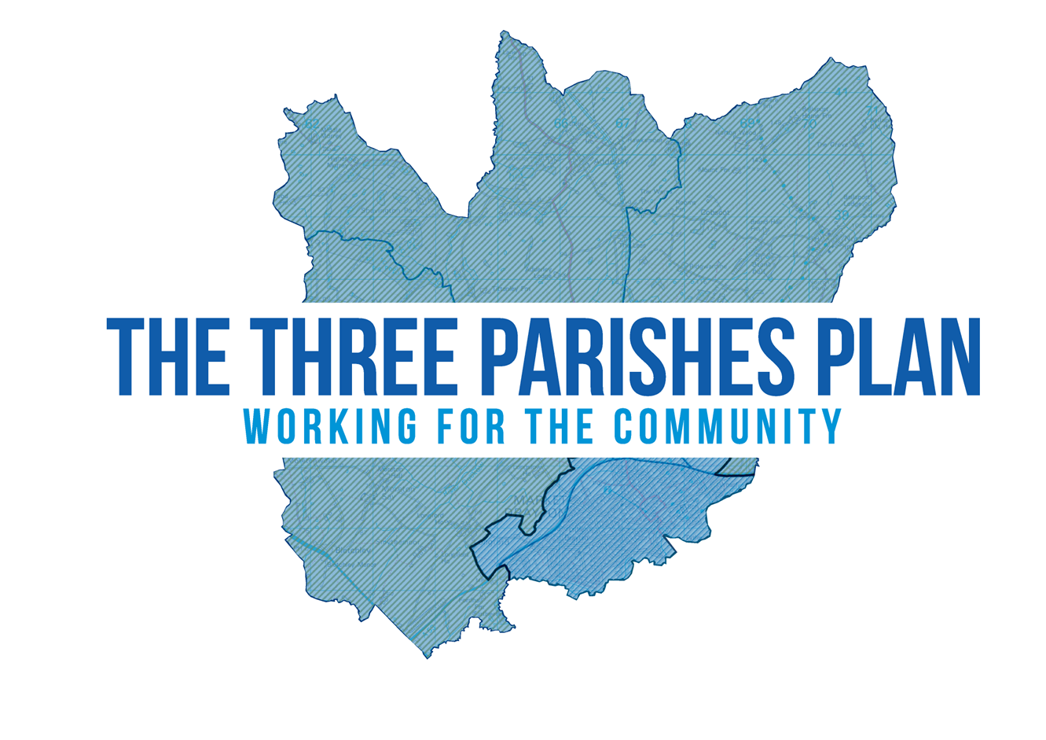

Regulation 16
Consultation Draft

Foreword
In January of 2019 the neighbouring Parishes of Norton In Hales, Adderley and Moreton Say decided to undertake a Neighbourhood Plan. For three Parishes to collaborate on a plan of such importance is a huge undertaking and it has only been possible with the support of members of the community and the parish councillors together with Shropshire Council representatives and officers. Thanks must also go to those members of the community who have attended consultation days and public meetings and have taken the time to fill in questionnaires and return them for consideration in the creation of this document.
In beginning the Neighbourhood Plan process we could not have anticipated the onset of a global pandemic. The impact of the pandemic has caused many long delays and has made it difficult to achieve as much as we would have liked. Nevertheless we have held consultation meetings in each of the three parishes. In addition every household in the three parishes has received a housing needs consultation document the response to which we have supplemented with an independent housing needs assessment. Issues which were raised during this process which could not have been addressed by the developing plan were referred through parish councils to the appropriate bodies. We have kept people informed throughout this process by reporting back at parish meetings and parish council meetings. In addition the Neighbourhood Plan website, https://threeparishplan.org/ has been regularly updated with short bulletins and has copies of the notes from each meeting.
The three parishes share common issues around development. They lie between the local market town of Market Drayton and the neighbouring counties of Cheshire and Staffordshire. Each of the neighbouring authorities have their own ambitions for development and so there was a shared desire on the part of the three parishes to have their own ambitions for development enshrined in a Neighbourhood Plan rather than be subject to the influences from surrounding bodies. We want our Neighbourhood Plan to reflect the needs and the aspirations of the local communities who recognise the needs and limitations and well as the opportunities of living in rural communities faced with the challenges of access to services. We recognise that many of the issues faced by the community lie beyond the scope of a Neighbourhood Plan but there was a determination that development in the area matched the needs and aspirations of the community.
Three Parishes Neighbourhood Plan
Contents Page
- Introduction and Stages 4
- Setting the Context 6
- Description of the Three Parishes Neighbourhood area 6
- Housing 10
- Heritage 10
- Landscape and Natural Environment 12
- Why are we preparing a Neighbourhood Plan? 14
- What is a Neighbourhood Plan 14
- Submission of application to designate the Neighbourhood area 14
- Process to date 14
- National and Local Planning Policy 15
- National Planning Policy Framework 15
- Shropshire Local Plan 16
- Emerging Shropshire Local Plan 16
- Evidence Base 18
- Consultations 18
- Technical Evidence 19
- SEA and HRA 19
- Vision and Objectives 21
- The Vision of the Neighbourhood Plan 21
- Objectives 21
- Policies 23
- Housing and Design; 23
- Employment and Business; 27
- Natural Environment; 30
- Movement and Connection; 34
- Built Environment and Heritage; and 38
- Community Facilities 40
- Monitoring and Review 42
Annexes
- Policies Map 44
- Process of Preparing a Neighbourhood Plan 45
- National Heritage List 47

Introduction
The three settlements of Adderley, Norton-In-Hales and Moreton Say (alongside Bletchley, Longford, Longslow) are proposed as a ‘Community Cluster’ in the emerging Shropshire Local Plan. Draft policy SP9 of the draft Local Plan sets out how development will be managed in Community Cluster settlements, but in general this will consist of modest levels of appropriate development in order to maintain or enhance their sustainability.
The Three Parishes hold a responsibility for their historic and environmental heritage, and as part of this Neighbourhood Plan we are seeking to ensure the continued protection of our Neighbourhood area.
There is a shared commitment to ‘future proof’ the land for future diversification of industry, amenity areas and tourism; to maximise the potential of our land and capture the vitality and vibrancy of the rural areas.
The aim of this Neighbourhood Plan is to recognise the potential for economic growth in Shropshire whilst ensuring that the Three Parishes have a role in that future.
Stages
This Neighbourhood Plan has been formulated on the basis of ensuring the community gets the right types of development in the right place. In preparation for this draft of the Neighbourhood Plan early consultation was held with the public, a further consultation was then held on the Regulation 14 draft of the document and following input from consultees and the general public a Regulation 15 draft has now been prepared which will be formally submitted to Shropshire Council.
Shropshire Council, as the Local Planning Authority, will then carry out one final check to ensure the plan and its accompanying information comply with the relevant legal requirements. If satisfied, the Local Planning Authority will place it on their website for a final six week consultation (Regulation 16), before passing it on to an Independent Examiner who will issue a report on whether or not the Neighbourhood Plan should proceed to a final referendum.
The Draft Plan at its current stage offers a vision for the future and sets out clear objectives and policies based on previous comments received regarding the Neighbourhood Area. The policies within this Plan will also be subjected to scrutiny by the statutory agencies including;
- The Environment Agency;
- Natural England; and
- Historic England
These will then be assessed by the agencies through a screening exercise relating to the environmental assessments including the Strategic Environmental Assessment (SEA) and the Habitats Regulations Assessment (HRA). If passed by examination, and then supported through referendum, the policies will then have to be taken into account by applicants, developers and the Local Planning Authority when considering development in the Neighbourhood Area. Thus giving much greater weight to the views of the Parish in the decision-making process.

How to comment
The draft plan and accompanying Environmental and Habitats Regulations Assessments Reports can be inspected on the Neighbourhood Plan website: https://threeparishplan.org/ or be emailed to residents and other interested parties on request.
Paper copies of the plan can be viewed at the following:
- Norton-In-Hales Village Hall, Norton-In-Hales, Shropshire, TF9 4AT;
- Adderley Village Hall, Market Drayton, Shropshire, TF9 3TF; and
- Moreton Say Village Hall, Moreton Say, Shropshire, TF9 3RS.
A paper copy of the SEA and HRA screening reports can be made available on request.
The Draft Plan and accompanying reports can also be viewed on the Shropshire Council website: https://shropshire.gov.uk/planning-policy/neighbourhood-and-community-led-plans/emerging-neighbourhood-plans/.
Please note that all comments must be sent to the Secretary to the Steering Group (not to Shropshire Council):
The Clerk to Adderley Parish Council Mrs Jane Evans 51 Longford Turning, Market Drayton, Shropshire, TF9 3PF.
Or by emailing to: clerk@adderleyparish.co.uk

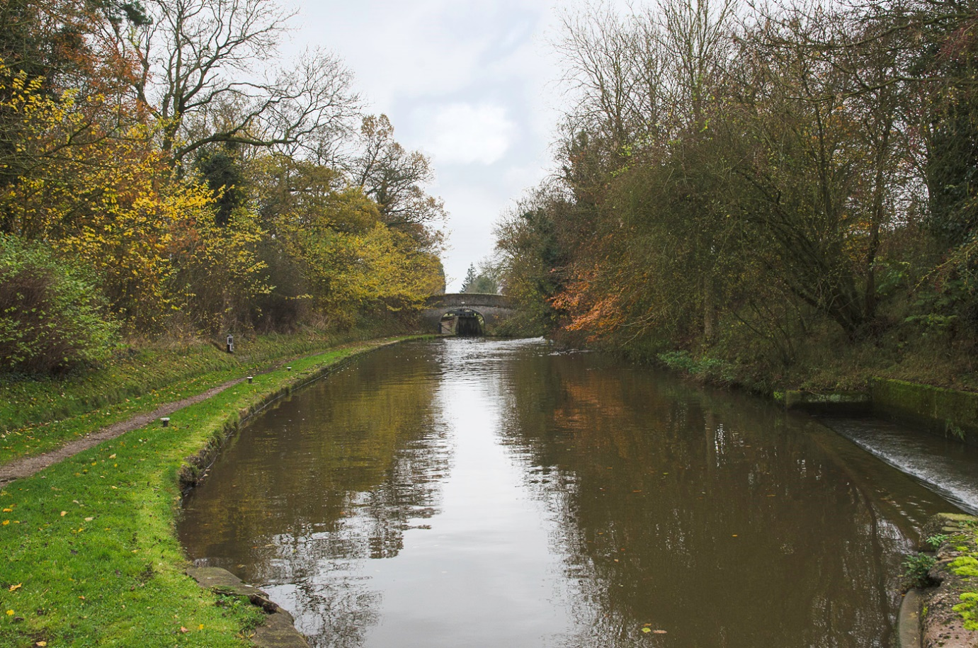
Figure 1: Canal at Adderley

Setting the Context for the Three Parishes
The Three Parishes are located to the north of Market Drayton in the administrative authority of Shropshire Council. To the north is Cheshire East Council and to the east is Staffordshire Council. The Three Parishes consist of:
- Adderley;
- Norton-In-Hales; and
- Moreton Say.
Figure 2: Three Parishes Boundary
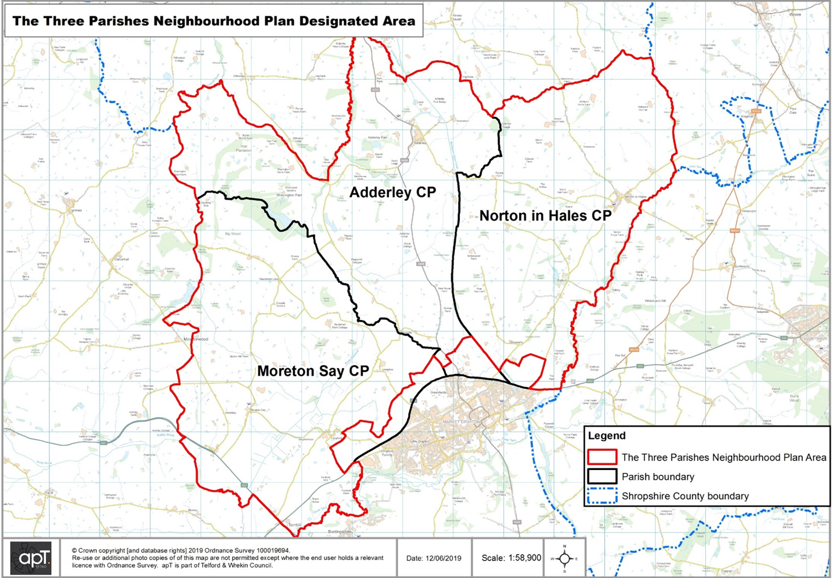
The combined area covers approximately 6, 000 hectares and as of the 2011 census has a recorded population of 1, 477 people, which equates to 0.25 persons per hectare.
The Shropshire Union Canal (running from Ellesmere Port on the River Mersey to Autherley Junction, near Wolverhampton, where it meets the Staffordshire and Worcestershire Canal) runs through the neighbourhood area in a north-south direction. The River Tern runs along the southern edge where it then rises north-east of Market Drayton.
The surrounding area consists of rolling lowland landscapes, characterised by agricultural land as well as a dense network of hedgerow trees and ancient woodland which are set within a background of winding lanes and irregular fields.

There are a range of local facilities and services within the Three Parishes. These key facilities and services are show in Table 1 below.
Table 1: List of Key Services and Facilities
Village Halls | Café
Pubs and Restaurants | Recreation Areas
Pre-School | Listed Churches
Primary Schools | Places of Retail

Local facilities and services are predominantly located in Adderley and Norton-In-Hales, with other key facilities including an on-demand bus service with concessionary travel (within Norton-In-Hales) available to residents, which is typically used by those over 60 or with an eligible disability.
Throughout the Three Parishes Neighbourhood Area the main access and transport routes are minor rural roads that cross through villages. The A529 provides a key north-south transport route between Audlem and Market Drayton and local routes also connect with the A53 and A41 which runs through the south-west of Moreton Say.
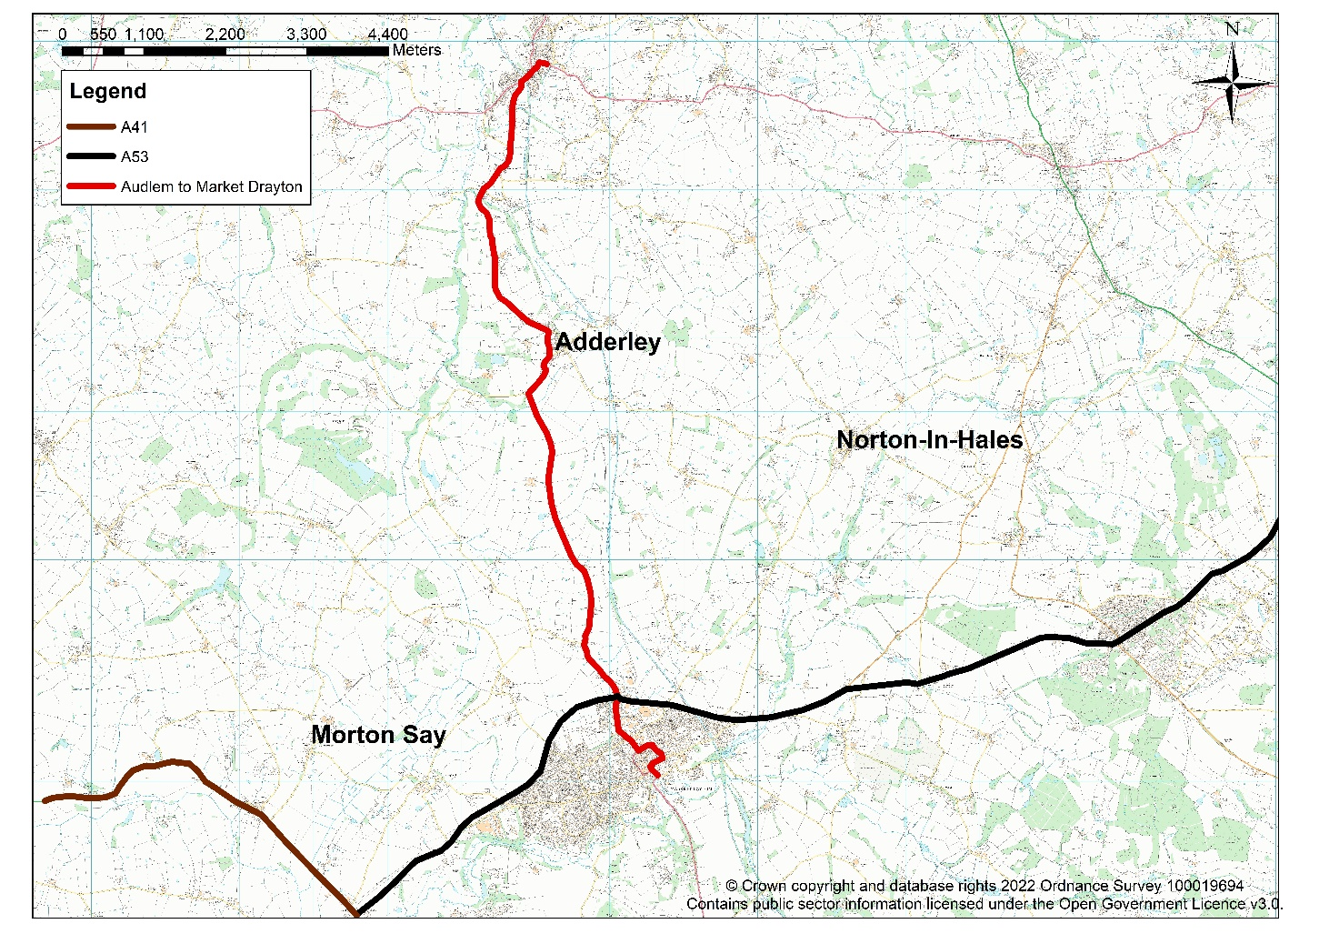
Figure 3: Main Transport Routes

In terms of flood risk most of the area is located outside of any flood risk zones. However, where the Rivers Duckow and Tern cross through the area, their river lengths are in flood zone 3, meaning that the land around the rivers has a high probability of flooding.

Adderley
Adderley is a rural parish in Shropshire, located north of Market Drayton between the town and Cheshire East county boundary. Adderley village is the principal settlement in the neighbourhood area. During the 2011 census Adderley Parish had a population of 372 residents and covered a geographic area of 1, 965.3 hectares, giving a population density of approximately 0.2 persons per hectare.
From the 2011 census, the age profile for Adderley is slightly younger than the Shropshire average but similar to the Three Parishes overall. The presence of a primary school and nursery in Adderley provides an opportunity for educating early year’s children. Given there is notable difference between the age profile for primary school age residents compared with the Three Parishes and county averages, the primary school caters to a wider catchment area beyond the parish.
Adderley has a greater proportion of working-age population at 65.9% in comparison with 62.6% and 62% for the Three Parishes as a whole and Shropshire respectively. This is a benefit to Adderley Parish in terms of having those who are contributing to the economy; however, as this population grows older, housing and lifestyle choices will influence decisions on whether to remain in the area or move elsewhere.
The key industries for residents aged 16-74 in employment can be broadly grouped into three categories. These include:
- Land-based industries such as agriculture, forestry and fishing;
- Public sector services including education, health and social care; and
- Manufacturing/trade activities.
This reflects the rural nature of the parish, and also the proximity to towns where public sector services are typically located.
The lack of public transport services and travel to work distances offer insight into the economic patterns of residents. This suggests that households are reliant on car use to travel around, especially with a lack of public transport and provision locally.
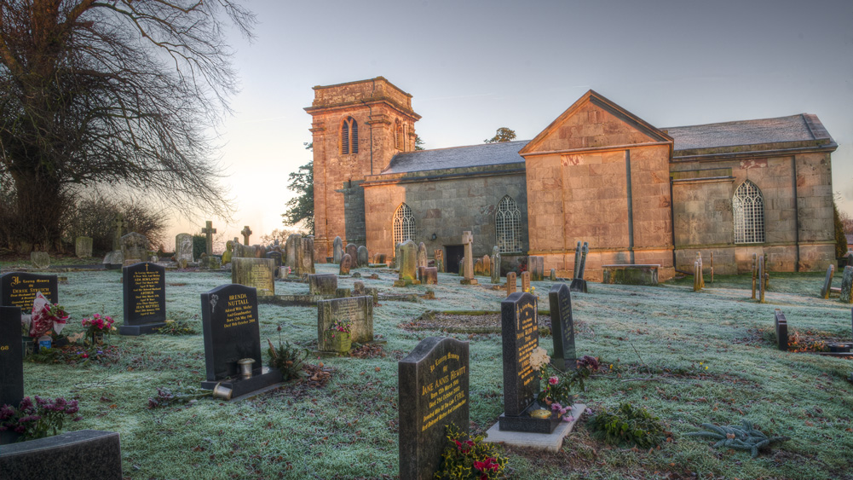
Figure 4: Adderley Church
Moreton Say
Figure 5: Aerial View of Moreton Say
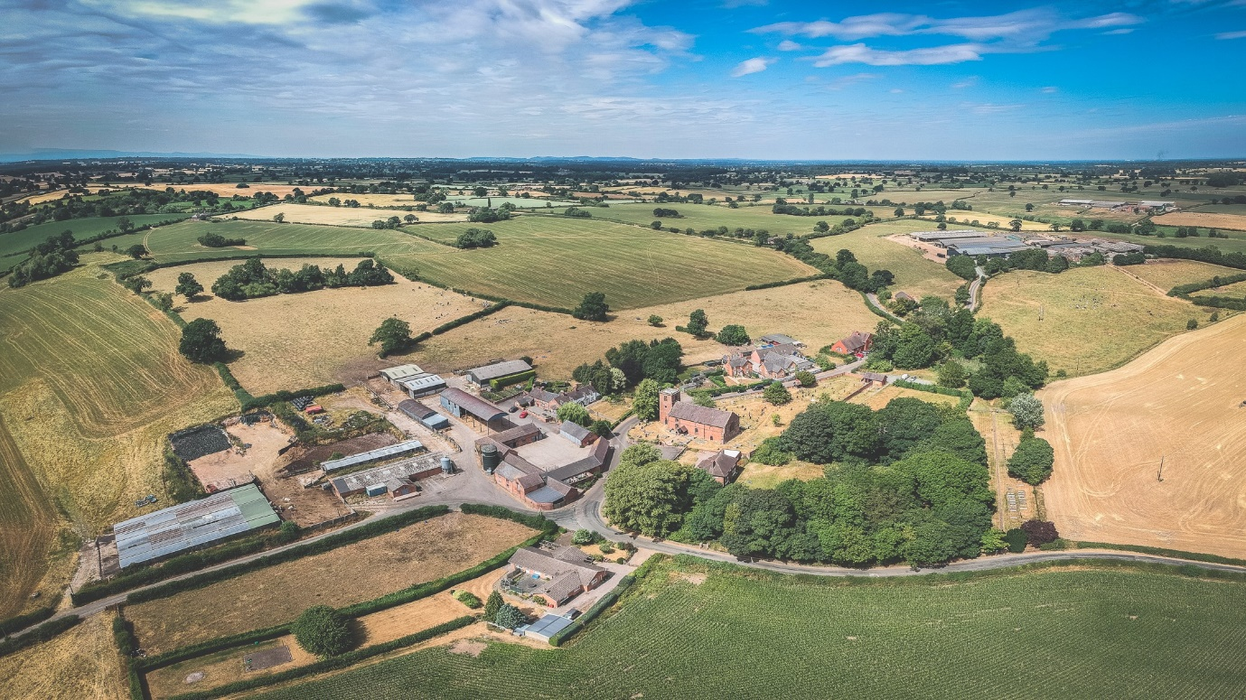
Moreton Say is a small village and sparsely populated parish in Shropshire. It is located just northwest of the town of Market Drayton. The Parish also covers the hamlets of Longford and Longslow. During the 2011 census it had a total population of 485 people and covers 2162.7 hectares providing a population density of approximately 0.2 persons per hectare.
Of the 485 residents in Moreton Say Parish, figures suggest that the population of Moreton Say skews younger than the Three Parishes and Shropshire averages. The mean age at 40.9 years is lower than both Three Parishes (43.4) and Shropshire (42.6). This is most evident in the proportionally greater working age population (66.6%) and proportionally smaller elderly and retired populations (13.3%). The presence of Moreton Say Primary School also provides an opportunity for educating children within the Parish.
The slightly larger working age population is a key asset; however, it is recognised that challenges remain with infrastructure, particularly transport. There are no bus services in Moreton Say, meaning residents must travel by car and this is reflected in the census data for high car ownership compared with the Three Parishes and Shropshire.
While the proportion of home workers in Moreton Say is greater than other categories of travel to work (likely to have increased due to the impacts of Covid-19 and increasing amounts of people working at home), the majority of workers still travel to work.
This pattern may be partly due to a high proportion of workers in the agriculture, forestry and fishing industries, or technological improvements and changing working practices enabling greater flexibility with work patterns. Nevertheless, the main regional towns still appear to draw workers on their commute resulting in greater traffic on key commuter corridors (the A41) at peak times, further worsened by the lack of public transport.

Norton in Hales
Norton in Hales is a rural parish in the north of Shropshire Council. Woore Parish adjoins the eastern boundary of Norton in Hales; Cheshire East Council adjoins the northern boundary and Staffordshire County adjoins the southern boundary. Adderley and Market Drayton are located west and south-west of the parish respectively.
The River Tern runs along the southern boundary with Staffordshire County. The western boundary follows the Shropshire Union Canal for much of its route, adjoining Adderley parish.
The parish covers a geographic area of 1, 839.35 hectares. With 620 residents (at the 2011 census) giving a population density of approximately 0.3 persons per hectare.
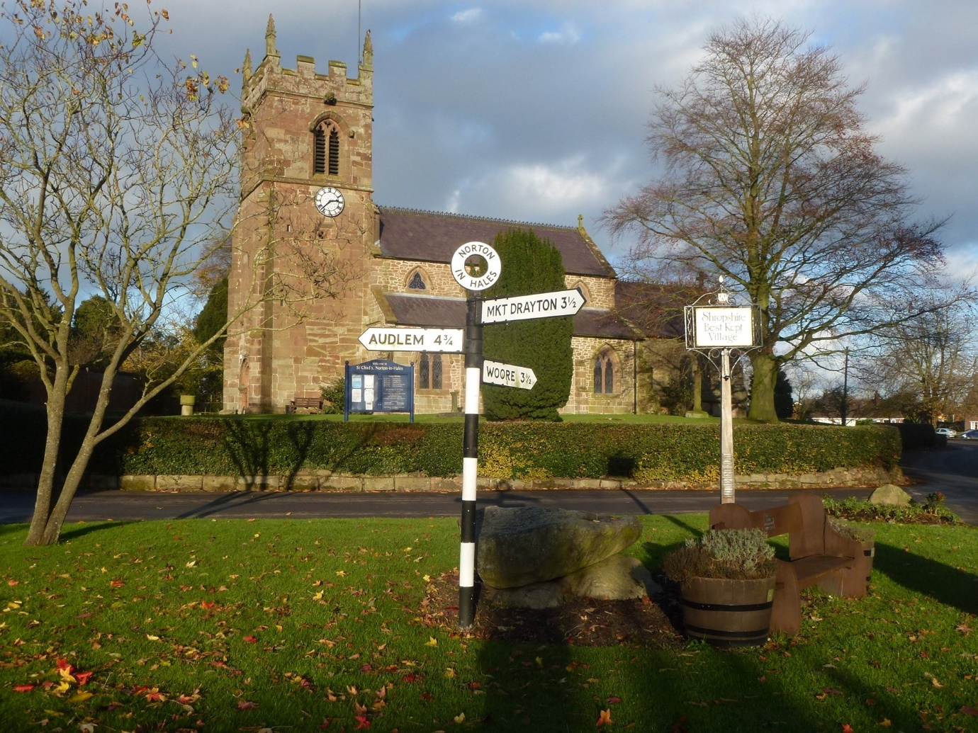
Figure 6: Norton In Hales from outside St Chad’s Church
The Norton in Hales age profile was slightly older in contrast to its neighbours in the Three Parishes. Overall the mean and median ages were older (45.6 and 47) than the Three Parishes (43.4 and 46) and Shropshire (42.6 and 44). There were however variations within the age groups.
Norton in Hales has a primary school and given the greater proportion of younger school-age pupils (5 to 9) it is assumed that they attend the primary school, although the numbers overall suggest that the school has a wider catchment area beyond the parish.
The proportion of working age population was less than the Three Parishes and Shropshire averages. However, the proportion of economically active residents was broadly consistent (71.5%) with the Three Parishes (72.6%) and Shropshire (71%).
The trends in industry sectors was broadly similar to the Three Parishes overall; the main difference was that fewer parish residents working in the agriculture forestry and fish industries (11.8%) than across the Three Parishes (15.8%). This was however offset by slightly greater proportions of Norton in Hales residents working in the wholesale and retail trade, manufacturing and education industries respectively.
Housing
During the 2011 census, the majority of dwellings (houses and bungalows) across the Three Parishes were detached (61.1%) which was significantly greater than the Shropshire average (39.5%). The proportion of semi-detached dwellings for both the Three Parishes and Shropshire were at similar levels (30.1% and 33.4% respectively). Proportionally there were more terrace properties across Shropshire, reflecting the areas’ rural character and dispersed nature of development.
In terms of housing tenure, the proportions of home ownership were similar for the Three Parishes (71.3%) and Shropshire (69.2%) averages, with more households owning their properties outright across the Three Parishes (41%) than Shropshire (38.6%).
Across Shropshire there were proportionally more social rented households (13.5%) than the Three Parishes (6.8%), with more private rent households (17.9%) across the Three Parishes than Shropshire (15%). Reflecting the rural nature of the neighbourhood area.
Heritage
There is one conservation area in the Three Parishes within Norton-In-Hales village. It was designated on 1st March 2007 and covers most of the built-up area of the village.
In addition, there are several grade II and II* listed buildings which are located throughout the Three Parishes. The greatest concentration of listed buildings can be found around the main villages of Adderley and Norton-In-Hales. Historic halls such as Brand Hall, is west of Norton-In-Hales; this includes the grade II* listed hall and several grade II and II* structures within the grounds of the hall.
A scheduled monument is located north of Adderley, approximately 75m North West of Pool House. The monument includes the earthwork and buried remains of a motte castle and an 18th century icehouse.
Figures 7, 8 and 9: Brand Hall Norton-In-Hales, St Peters Church, Adderley and Styche Moreton Say
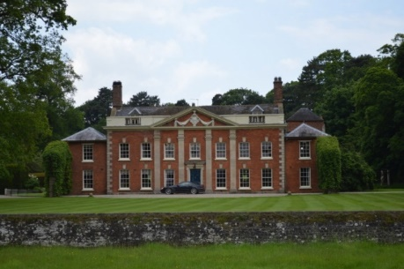
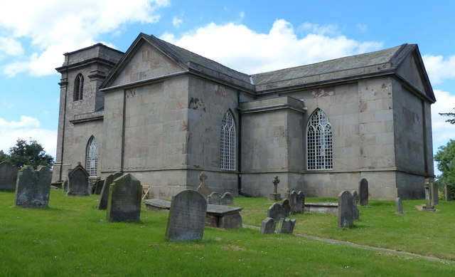

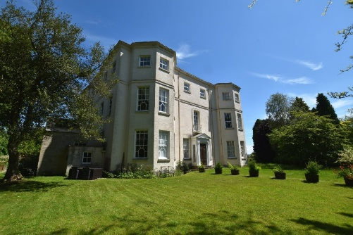

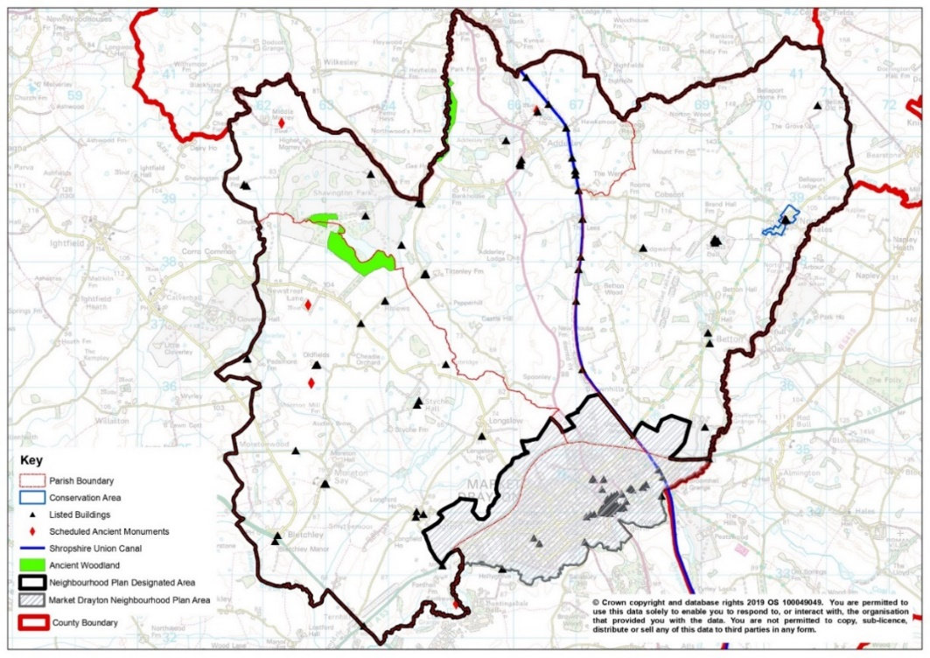
Figure 10: Heritage in the Three Parishes

Landscape and Natural Environment
The Shropshire Landscape Assessment provides an analysis of the county’s varied landscape. It looks at physical characteristics and cultural dimensions which together have been used to identify 27 different landscape types. The landscape types are defined by components that determine its character and this information can help determine the conditions to be set for new development. The Three Parishes Neighbourhood Area is characterised by the following areas with varying influences on the area as a whole:
- Principal Timbered Farmlands: This landscape type occurs throughout much of Shropshire. They are predominantly rolling lowland landscapes, with occasional steeply undulating valley sides, and are characterised by a mosaic of agricultural land. Other key characteristics include:
- Relic ancient woodland;
- Hedged fields with scattered hedgerow trees;
- Dispersed settlement pattern; and
- Small to medium scale landscapes with filtered views.
- Timbered Pastures: Occurring only in the extreme north-eastern corner of Shropshire, this is a lowland landscape of rolling glacial tills, where the heavy overlying souls support medium intensity dairy farming. Other key characteristics include:
- Dense network of trees;
- Ancient woodland character, pastoral land use; and
- Small-medium scale landscape with filtered views.
- Estate Farmlands: Estate farmlands are gently rolling lowland and valley floor landscapes that occur across large areas of Shropshire. The lower ground is usually underlain by softer, more easily eroded rocks such as shales, sometimes in sharp contrast to nearby ridges or harder rocks. Glacial drift deposits form the basis of most soils and these landscapes include some of the best agricultural land in the county, which have traditionally been associated with mixed farming. Other key characteristics include:
- Clustered settlement pattern;
- Large country houses with associated parklands;
- Planned woodland character; and
- Medium to large scale landscapes with framed views.
- Settled Pastoral Farmlands: Located mainly in the northern and western parts of the county, these are lowland agricultural landscapes. Heavy, often poorly drained soils are of the defining characteristics of this landscape type and have traditionally been associated with livestock farming. Other key characteristics include:
- Pastoral land use;
- Scattered hedgerow trees;
- Irregular field pattern; and
- Small to medium scale landscapes.
- Principal Settled Farmlands: These are prevalent throughout northern Shropshire, mainly in association with Permian and Triassic sandstones, together with the Rea Valley, the Vale of Montgomery, the northern end of Ape Dale and the areas of Ludlow and Bridgnorth. Key characteristics include:
- Mixed farming land use; and
- Varied pattern of sub-regular, hedged fields.
- Riverside Meadows: These are linear landscapes associated with the well-defined floodplains that border the major rivers in the county, the Severn, Vyrnwy, Tern and Teme, and their larger tributaries. Key characteristics include:
- Flat, floodplain topography;
- Pastoral land use;
- Linear belts of trees along watercourses;
- Hedge and ditch field boundaries; and
- Unsettled.
Figure 11: Landscape Characteristics of the Three Parishes
Principal Settled Farmlands
Timbered Pastures
Estate Farmlands
Settled Pastoral Farmlands
Principal Settled Farmlands
Riverside Meadows

Why are we preparing a Neighbourhood Plan?
What is a Neighbourhood Plan?
Neighbourhood Plans form part of the Statutory Development Plan for the area. They are prepared to promote, guide and control local development and importantly, are used to help determine local planning applications. This means that neighbourhood communities can have a direct input into the planning process and have an influence on shaping the future of their community based on the views expressed through surveys of the local population and businesses.
Submission of Application to Designate Neighbourhood Area
Not all neighbourhoods choose to produce a neighbourhood plan. However, in 2018 the Three Parishes of Adderley, Norton-In-Hales and Morton Say, decided that this was an important right to exercise, seeking to ensure the future sustainable development of their settlements by providing detailed planning policies for their area. The move was considered both sensible and appropriate, which allowed flexibility for controlling future development in the Neighbourhood Area.
The Three Parishes made the application to Shropshire Council in June the same year under the provisions of the Town and Country Planning Act 1990. Shropshire Council consulted on the proposed area for a period of 4 weeks between September and October 2018. In advertising this information comments were invited through the ‘Get Involved’ section of the Shropshire Council website and e-mails circulated to all statutory consultees, as well as to adjoining Parish and Town Council areas. Shropshire Council received three responses to this consultation, none of which objected to the principle of the proposed Neighbourhood Area.
In response, at Cabinet it was agreed that the Three Parishes Plan Area was an appropriate basis for the development of a Neighbourhood Development Plan and notified them accordingly. A formal notice confirmed that the Neighbourhood Plan area was acceptable and was published on 12th December 2018.
Process to Date
The Neighbourhood Plan has now reached the Regulation 15 (Formal Submission), this means that the current draft will be formally submitted to Shropshire Council alongside its associated documents, before proceeding to Regulation 16 (Publicising a Plan Proposal) where it will be published to the public for 6 weeks.

National and Local Planning Policy
One of the requirements of a Neighbourhood Plan is to account for both National and Local Planning Policy. If the Plan does not comply with both it will fail the basic conditions which are required to be met. This is tested through an independent examination before the neighbourhood plan can proceed to referendum.
National Planning Policy
In terms of National Planning Policy this is mostly contained within the National Planning Policy Framework (NPPF). This states that the Three Parishes Neighbourhood Plan should “support the delivery of strategic policies contained in local plans or spatial development strategies” in this case the Shropshire Local Plan. The Neighbourhood Plan will need to “shape and direct development that is outside of these strategic policies”.
Para 14 of the NPPF considers that “situations where the presumption (at paragraph 11d) applies to applications involving the provision of housing, the adverse impact of allowing development that conflicts with the neighbourhood plan is likely to significantly and demonstrably outweigh the benefits” provided the following criteria apply:
- the neighbourhood plan became part of the development plan two years or less before the date on which the decision is made;
- the neighbourhood plan contains policies and allocations to meet its identified housing requirement;
- the local planning authority has at least a three year supply of deliverable housing sites (against its five year housing supply requirement, including the appropriate buffer as set out in paragraph 73); and
- the local planning authority’s housing delivery was at least 45% of that required over the previous three years.
Para 21 considers that “Strategic policies should not extend to detailed matters that are more appropriately dealt with through neighbourhood plans or other non-strategic policies”. This means that some policies that are specific to the neighbourhood area are better placed within neighbourhood plans, this could include improvement to local transport networks or control of land within the area.
The role of Neighbourhood Plans is further expanded in Para 29 stating that “Neighbourhood planning gives communities the power to develop a shared vision for their area. Neighbourhood plans can shape, direct and help to deliver sustainable development, by influencing local planning decisions as part of the statutory development plan. Neighbourhood plans should not promote less development than set out in the strategic policies for the area, or undermine those strategic policies”.
Para 30 continues “Once a neighbourhood plan has been brought into force, the policies it contains take precedence over existing non-strategic policies in a local plan covering the neighbourhood area, where they are in conflict; unless they are superseded by strategic or non-strategic policies that are adopted subsequently”.
When considering the achievement of well-designed places para 125 states that “Neighbourhood Plans can play an important role in identifying the special qualities of each area and explaining how this should be reflected in development”.
Shropshire Council Policy
Shropshire Council’s strategic planning policy is contained in the adopted Shropshire Core Strategy (adopted 24th February 2011) and the Site Allocations & Management of Development (SAMDev) (adopted 17th December 2015).
Shropshire Council is currently at the examination stage of their Local Plan Review. An appropriate and sensible approach from this point is to proceed with the Neighbourhood Plan on the basis of the emerging strategy and policies and work closely with Shropshire Council during the preparation of both documents. The Three Parishes recognises that it will need to consider implications arising from the examination of the Local Plan and that they may need to pause the Neighbourhood Plan process to take these into account.
The Core Strategy sets out Shropshire Council’s vision, strategic objectives and the broad strategy to guide future development and growth in Shropshire during the period up to 2026. Shropshire’s SAMDev sets out proposals for the use of land and policies to guide future development in order to help deliver the vision and objectives of the Shropshire Core Strategy.
The purpose of the Shropshire Local Plan Review (2016-2038) is to update elements of the current Development Plan and to make sure that Shropshire can respond flexibly to changing circumstances in line with the NPPF. The Review includes consideration of housing numbers (including the objectively assessed need), employment land requirements, and the distribution of development and review of Green Belt boundaries as part of the consideration of strategic options to deliver new development.
However, at the time of preparing this Neighbourhood Plan the relevant Shropshire Development plan is the Core Strategy and the SAMDev.
Emerging Shropshire Local Plan
The Emerging Shropshire Local Plan in Policy SP2 Strategic Approach considers that the production of Neighbourhood Plans will be supported and can identify development opportunities which will complement proposals in the Local Plan. The policy also considers that where appropriate Neighbourhood Plans can also identify additional Community Clusters.
Policy SP3 supports the prioritisation of active travel through the creation and enhancement of walking and cycling links within and between new developments and new developments to existing neighbourhoods and community facilities.
Regarding Sustainable Development (Policy SP4) Shropshire Council takes a positive approach to considering development proposals, reflecting the presumption in favour of sustainable development, in line with the NPPF. As has already been set out Policy SP4 goes on to state that planning applications be determined in accordance with the development plan (including where relevant, with policies in Neighbourhood Plans) which will be approved without delay.
Policy SP6 looks to ensure the health and well-being of individuals, communities and place. This will be achieved by ensuring the quality of life and delivery of community well-being, through the use of land’ type of development; the safeguarding, maintenance and improvement of community facilities and services; and by ensuring that the form, design, location and layout of new development enhances community well-being.
Policy SP7 in relation to housing development, will support development of housing in addition to the allocations set out in policies S1-S20 (S11.3 Community Clusters: Market Drayton Place Plan Area), there will be positive consideration of other sustainable housing development where this does not conflict with the policies of the Local Plan. The policy reiterates that additional housing development which would support the reuse of disused land or premises within settlement development boundaries as shown on the Shropshire’s policies map will be supported.
Policy SP9 recognises the rurality of much of Shropshire and the importance of ensuring the long-term sustainability of rural communities through the management of Community Clusters. This policy recognises the diversity of Community Clusters and the settlements within them, providing the starting point for assessing the appropriateness of development proposals within Community Cluster settlements.
Policy SP10 Managing Development in the Countryside also identifies Community Hubs and Community Clusters as the focus for new development within the rural area.
The Shropshire Local Plan also looks to manage and support town centres (Policy DP9), aiming to maintain and enhance the vitality and viability of Shropshire’s network of Town Centres and High Streets in line with national policy. The policy goes onto support the provision of neighbourhood based local shopping and other community facilities will be supported where this will help consolidate and improve existing provision.
Policy DP14 Green Infrastructure expands on Shropshire’s vision to improve and expand the green infrastructure network as an integral part of open space provision. All new development will need to ensure that they enhance existing green infrastructure assets and extends the green infrastructure network in accordance with the Shropshire Green Infrastructure Strategy, whilst also regarding Neighbourhood Plans and other relevant local strategies.
DP28 looks to improve communications and transport network in the borough, looking to widen travel and transport choices and improve connectivity and accessibility. It is considered that local travel options play an essential role in influencing travel behaviour including footways cycle ways (including the National Cycle Network), public rights of ways, bridleways and the canal network especially within or close to settlements.
Policy S11.3 is of particular importance considering the development of community clusters within the Market Drayton Place Plan Area including Adderley, Norton-In-Hales and Moreton Say. Within these community clusters residential and employment development will be delivered through appropriate small-scale windfall development, consistent with Community Cluster Policy SP9. Development proposals are also expected to positively respond to policies and guidelines within any relevant community-led plans and local needs.

Evidence Base
Consultation and Engagement
The Three Parishes Neighbourhood Plan is a community led plan that derives from the vision and objectives of people who live within the Neighbourhood Area. From the outset the Three Parishes were determined that residents be kept informed and have an opportunity to inform the content of the Plan. Communication and consultation in a variety of forms have played a major part in developing the Three Parishes Neighbourhood Plan.
Following the approval of the designated area, the Steering Group held a number of Open Forums during March 2019. A forum was held in all three of the parishes where participants were able to enter their comments directly into a survey online or fill in a paper form. The comments from the paper forms were then transcribed by staff at Shropshire RCC and analysed. Participation from the public was broken down as follows:
- 37 Adderley Residents filled in the survey, 2 completed this online;
- 30 Moreton Say residents filled in the survey, 12 online, the rest via paper form; and
- 33 Norton-In-Hales residents filled in a survey, 2 online, the rest via paper form.
In May 2019, the Steering Group went into local primary schools to gather the pupils’ opinions on their parishes. This includes a number of multiple choice questions which considered the following subjects:
- Use of Community Facilities;
- Mode of travel;
- Walking & Cycling;
- Likes and Dislikes of Areas;
- Play Areas; and
- Additions to their area.
In October 2020 the Steering Group designed a resident’s survey and organised distribution of these to each household. A total of 685 forms were distributed. 291 forms for Norton-In-Hales were distributed by hand and the forms for Adderley (198) and Moreton Say (196) were posted by Shropshire RCC on 2nd October 2020.
The survey was intended to be a household one, where the views of everyone in that household were combined into one response but extra submissions could be made by going online. With the on-line system, the answers were not ‘locked in’ until the respondents clicked ‘Submit’ at the very end of the survey. A ‘Back’ button allowed people to return to earlier sections to make changes. The online survey also offered a ‘Restart’ button to discard all previous answers and start again.
The deadline to complete the survey was 31st October but it stayed open until the end of November whilst the paper forms were being processed by Shropshire RCC and to encourage further response.
A total of 56 questions were included within the survey covering a number of key themes, the first two questions were a quick analysis on the draft vision statement, published by the Steering Group before covering the following themes:
- About your household;
- Housing & Development;
- Your household’s housing need;
- Jobs and the Local Economy;
- Transport;
- Environment;
- Countryside and green spaces; and
- Facilities.
In summary overall:
- A total of 160 responses were received of which 43 were submitted online (about 27%);
- 116 responses were transcribed and added to the online responses into specialist software for analysis;
- Of the survey forms distributed by post, 1 came back as undeliverable, one came back entirely empty (this was not counted as a response) and one had a comment on the front to state that people in the household were with the status quo and was not filled in any further (this was not counted in the figures of respondents); and
- The overall response rate was 23.6%.
Following the research undertaken by the Three Parishes, the aim was for the Neighbourhood Plan to be focused and concise as well as concentrate on the issues that can be influenced by town and country planning legislation.
Due to the Covid-19 pandemic the consultation process was taken online, as publication events could not take place due to associated rules which included the exclusion of large gatherings. The Steering Group have looked to reach out to all residents and the policies set out within this Neighbourhood Plan reflect the views of the community.
In addition to early consultation, the plan has now undergone Regulation 14 (Pre Submission) and has again been sent out for consultation. Responses received have been taken into account within this Regulation 15 draft and further details of the consultation exercise during Pre Submission is covered within the Consultation Statement that accompanies this Neighbourhood Plan.
Technical Evidence
A great deal of additional technical evidence has been collated by the Three Parishes in preparing this draft of the Neighbourhood Plan. This has been drawn from Shropshire Council sources; in particular, information compiled during the preparation of the emerging Local Plan Review and contributing to its extensive evidence base. This also included a Housing Needs Assessment prepared by AECOM to inform the housing policies within the plan.
Strategic Environment Assessment
The content of a Neighbourhood Plan will be informed by a wide range of evidence. Strategic Environmental Assessments (SEA) where required, can provide a key component of the evidence base.
SEA’s are required by the Environmental Assessment of Plans and Programmes Regulations 2004 and the Habitats Regulations (Conservation of Habitats and Species Regulations 2017). SEA’s are more likely to be necessary if both of the following two elements apply:
- A Neighbourhood Plan allocates sites for development (for housing, employment etc.) and;
- The neighbourhood area contains sensitive environmental assets (e.g. a Site of Special Scientific Interest (SSSI) or an Area of Outstanding Natural Beauty (AONB)) that may be affected by the policies and proposals in the Neighbourhood Plan.
In light of the above, it is very unlikely that a Neighbourhood Plan would require an SEA if the plan is not allocating land for development or development is more likely to generate physical changes which lead to significant effects.
Another element of the Basic Conditions relates to Directive 92/43/EEC on the conservation of natural habitats and of wild fauna and flora, often referred to as the Habitats Directive. Under the Habitats Regulations which implement the Directive, an assessment referred to as an appropriate assessment must be undertaken if the plan in question is likely to have a significant effect on a European protected wildlife site.
For the SEA to be an effective process which adds significant value to plan making, it is vital that a Neighbourhood Plan is screened at the appropriate time. The Neighbourhood Plan should be screened as soon as there is sufficient information available to consider whether the proposed content of the plan or its likely intent are likely to lead to significant effects. A draft Screening Report has been prepared and is published for consultation alongside the draft Neighbourhood Plan.
The screening report, should be sent to the three statutory consultees for SEA these include: the Environment Agency, Historic England and Natural England. There is no timescale set out in the SEA Regulations for this consultation period; a period of five weeks is generally considered to be a suitable timeframe given other consultation provisions within the SEA Regulations.

Visions and Objectives
Vision
The Three Parishes wish to retain their originality and beauty for the benefit of present and future generations. Residents value their community spirit, the rural setting and ready access to the countryside. They appreciate the need to retain these aspects, whilst noting the requirement to accommodate some new development. The community sees itself as friendly and welcoming to all new residents, whilst also looking to retain the area’s values and history.
The Neighbourhood Plan must also include the wider community beyond the ‘village boundary’ that includes scattered housing, small businesses and farms. These form an integral part of the Neighbourhood Plan and need to be included in its formulation, whilst balancing the demands on the natural and historic environment.
Therefore, the Neighbourhood Plan is intended to work for the benefit and wellbeing of all the residents of the Three Parishes and retain those aspects which make and sustain a community. These include churches, local schools, village halls, green spaces, recreation facilities and community assets such as pubs and clubs, farms and small businesses. The villages should be a place to feel safe with suitable infrastructure for both pedestrians and vehicles.
The vision sees new and young families as the future and as such the Neighbourhood Plan should seek to accommodate their needs within the overall values of the community. The community must also accommodate the needs of older residents. These should include good services and communications, both physical and technological. The Neighbourhood Plan should create an environment that makes all this possible.
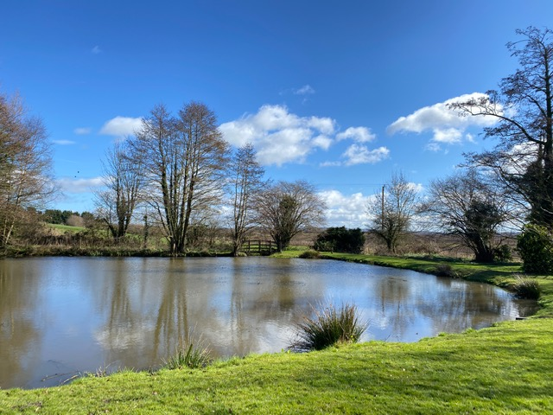
Figure 12: Moreton Say Millennium Pool

Objectives
Provision of Adequate Housing
- To allow future infill development in the Three Parishes which respects the variety of building styles and materials used in the area.
- Limited infill in each settlement which respects the rural outlook, maintaining gaps between settlements.
- To support the provision of an appropriate number and range of house types and tenures on appropriate sites meeting the needs of people living in the Three Parishes.
Employment Opportunities
- Encourage suitable employment opportunities through conversion of existing buildings or small well-designed buildings in appropriate locations.
Natural Environment
- To retain its largely rural character whilst having enhanced range of services and facilities offered to all age groups.
- To protect and enhance green areas, natural habitat, wildlife and biodiversity in and around the parishes and to encourage appropriate management.
- Reduce our carbon emissions, making sure development mitigates for and enables adaption to the effects of climate change.
Transport and Movement
- To work and improve public transport opportunities minimising the use of cars in and around the parishes, and reduce the associated problems of noise, pollution and parking.
- To provide a safe, accessible and well-maintained network of roads, cycle routes, footpaths, rights of way and pavements, whilst retaining rural character to support more sustainable modes of transport and offering healthier lifestyle options.
Built Environment and Heritage
- To respect the Norton in Hales conservation area and support sympathetic design to protect and enhance the conservation area to the benefit of the entire community.
- To protect the character and setting of the Three Parishes historic buildings, ensuring new development is in keeping with other buildings and their surroundings.
Community Facilities
- To protect existing facilities and services considered important for a vibrant community, supporting development of new ones which will benefit the community.
- Increase opportunities to access community facilities and to enhance the range of activities and facilities available for all.
- To encourage suitable employment opportunities and communications connectivity (broadband and mobile phone).

Policies
The following policies were devised to reflect the opinions of the Three Parishes and deliver the objectives and visions set out in the previous chapter, in being able to guide and influence new developments and maintain the Three Parishes attractive and historic character. These policies will look to help planning decisions to be made on new developments through the planning application process.
As set out in the policy context the planning system is set nationally by the National Planning Policy Framework (NPPF) and locally by the Shropshire Local Plan – in this case the Shropshire Core Strategy and SAMDev Plan. Policies in a Neighbourhood Plan must align with the framework both nationally and locally and not conflict or undermine it (NPPF paragraph 29).
However, the current Shropshire Development Plan is now out of date and therefore the existing Core Strategy and SAMDev policies are under review. Shropshire have now reached the examination stage, therefore an appropriate and sensible approach from this point is to proceed with the Neighbourhood Plan on the basis of the emerging strategy and policies, working closely with Shropshire Council during the preparation of both documents.
Housing and Design
This section of the Neighbourhood Plan focuses on both the design of housing as well as the desired housing mix for the Three Parishes. In previous consultations housing has been considered by a large amount of respondents, including the design of new housing which is to remain in keeping with their surroundings through to type and tenure.
The quality of housing is considered to be a major factor in what makes our neighbourhoods so enjoyable. Their influence can have a major impact on our health and well-being which is influenced by housing conditions, affordability, security and tenure. These are all considered factors that contribute to our life satisfaction.
Not only do our homes satisfy our daily needs but they also impact our surroundings and wider neighbourhood. It is therefore important that the design of housing is carefully considered as it is important to the Three Parishes that the visual characteristics of their villages are taken into account.
Key themes covered in previous consultations considered that it was important for new housing developments to consider the following:
- Scale of the surroundings;
- Character and positioning of surrounding buildings;
- Design of surrounding buildings;
- Materials of surrounding buildings; and
- Open space character of the villages and settlements within the Three Parishes.
Another important factor considered within this section and highlighted within previous consultation is the desired housing mix of the area, with national policy supporting the delivery of a wide choice of high quality homes, including opportunities for home ownership and the creation of socially mixed communities.

Evidence and Justification
H1 Housing Design
Development proposals which are consistent with wider development plan policies for the area, should demonstrate high quality design and contribute to the beauty and sustainability of the built environment, and have regard to the following:
- Do not adversely affect the local characteristics and setting of their surroundings, keeping with the scale, material and character of intrinsic buildings and the layout of the area;
- Maintain visual amenity of the Parishes providing high quality boundary treatment that is appropriate to maintaining the rural character;
- Minimise adverse impacts on the amenity of future or adjacent property by reason of overshadowing, overlooking, visual intrusion, noise and disturbance and odour;
- Complements the existing materials seen locally, with particular consideration given to window design, doorways and chimneys;
- Provide good pedestrian and cycle connections to existing travel routes;
- Provide adequate storage for bins and recycling;
- Incorporates Secured by Design standards where it is reasonable to do so;
- Support features beneficial to wildlife and biodiversity where appropriate;
- Delivers energy efficient and environmentally friendly measures such as the installation of solar panels or heat pumps; rainwater porous driveways and parking areas; including proactive measures to reduce CO2 emissions; and
- Parking does not have significant adverse impacts on existing road and pedestrian safety.
Consultation responses considered the impact that design can have on their surroundings as well as the impact on open spaces within the Three Parishes. This policy approach is seen as particularly important when dealing with proposals for infill applications to avoid complications relating to the inappropriate design of new developments. Further responses to the impact of new development in the area includes the following:
- Loss of identity (as villages);
- Impact on significant views;
- Inadequate parking;
- Loss of countryside;
- Increased traffic;
- Unsafe pedestrian routes; and
- Development not fitting with the current character of the area.
In addition to reflecting previous consultation responses, the policy advocates Secured by Design, looking to ensure that developers properly consider the measures involved in designing out crime to create and maintain a sustainable community.
This policy compliments SP5 High-Quality Development where Shropshire Council seeks to ensure the delivery of high-quality design in all development, stating that development will:
  - Ensure the creation of better places;
  - Promote individual and community well-being;
  - Promote healthy and active lifestyles; and
  - Enhance the way places are enjoyed and experienced by those who live, work or visit.
The NPPF further considers that the creation of high quality, beautiful and sustainable buildings and place is fundamental to what the planning and development process should achieve. Good design is considered to be a key aspect of sustainable development, creating better places in which to live and work helping to make development acceptable to communities.
This is in tandem with the aims of the Local Plan, which is concerned with ensuring that new development maintains and enhances the character, appearance and historic interests of the County’s settlements and countryside, including its distinctive landscape. This is also in line with the West Midlands Design Charter.
This policy complements the criteria set out within Policy SP5 of the Shropshire Local Plan Review and the requirements of the NPPF. This policy conforms to:
- NPPF paragraphs: 8b, 20, 28, 92, 97, 126, 127, 129, 130 and 134.
- Shropshire Local Plan: Policy SP1 The Shropshire Test; Policy SP4 Sustainable Development, Policy SP5 High-Quality Development, SP6 Health and Wellbeing, SP10 Managing Development in the Countryside, DP23 Conserving and Enhancing the Historic Environment and S11.3 Market Drayton Place Plan Area.
- Neighbourhood Plan Objectives: 5 and 8.
H2 Housing Mix and Tenure
Development proposals for housing should meet identified local housing needs, and provide appropriately for the sites, a mix of sizes, types and tenures, including homes for smaller households suited to sheltered accommodation and those who need support due to disabilities. Proposals for suitable small infill sites and appropriate affordable housing schemes on exception sites will need to comply with Policy DP1 Residential Mix of the Shropshire Local Plan.
Evidence and Justification
Achieving a suitable housing mix for the Three Parishes is an important consideration that plays a significant role in creating a sustainable, inclusive and mixed community. Respondents in previous consultation were asked ‘If new homes are to be built, what type/tenure of new housing do you want to see built within the Three Parishes?’ in which they were able to select as many options as needed. The sub elements included:
- Homes to be buy by anyone;
- Homes to rent by anyone;
- Affordable housing to buy or rent with preference for local people;
- Sheltered accommodation for older people to rent or buy with preference for local people;
- Homes for those with disabilities to live independently;
- Residential care; and
- Shared ownership homes.
From the number of respondents for each sub element of this question the highest response rate and subsequent vote was for ‘Homes to buy by anyone’ at 95% obtained a total of 133 votes for yes. Overwhelming support was also given for affordable housing (75.3% yes), sheltered accommodation (66% yes) and homes for those with disabilities (76.1% yes). Residential care (68.9% no) and shared ownership homes (61% no) did not receive support from respondents.
Moreover the Three Parishes Housing Needs Assessment (completed in March 2020) considers that new development provides an opportunity to build dwellings that would be appropriate to the needs and financial capabilities of both young households and older households who may wish to downsize.
In the context of the Three Parishes’ comparatively large stock overall, the evidence reviewed in the report considers the Neighbourhood Plan should prioritise the provision of modest sized homes with 2 and 3 bedroom homes. In terms of demographic change, new development might involve the following share of dwelling sizes: 22.7% as 1 bedroom, 38.5% as two bedrooms and 38.8% as three bedrooms.
The NPPF considers that the size, type and tenure of housing needed for different groups in the community should be assessed and reflected in planning policies. The aim of Policy H2 looks to establish the Three Parishes overall approach to promoting housing schemes that meet a range of housing needs, particularly sheltered accommodation, affordable homes and homes for those with disabilities. This is in line with Shropshire Council’s Strategic Housing Market Assessment (SHMA) as stated within Policy DP1 Residential Mix.
The purpose of the SHMA is to analyse different types and tenures of dwellings taking into account that households of different ages and different compositions will have differing needs. The SHMA illustrates the diversity of dwelling stock across the County, providing a breakdown of accommodation type for Place Plan Areas, including Market Drayton of which the Three Parishes falls within. These areas in turn encompass some of the most remote parts of the County and have the highest average house prices.
Further evidence through Market Drayton and Surrounding Area Placement Plan 2019/20 considers that Community Hubs (including Adderley) will provide additional dwellings over the period to 2026. This will be delivered through infilling, groups of houses and conversions which may be acceptable on suitable sites within the development boundaries, and delivery of development taking into account individual area requirements.
This policy conforms to the following policies and objectives:
- NPPF paragraphs: 8b, 50, 60, 62, 78
- Shropshire Local Plan: Policy SP1 The Shropshire Test; Policy SP4 Sustainable Development, Policy SP7 Managing Housing Development, SP9 Managing Development in Community Clusters, DP1 Residential Mix and S11.3 Market Drayton Place Plan Area.
- Neighbourhood Plan Objective 3.

Employment and Business
The importance of the landscape and setting of the Three Parishes is considered an important asset to their communities. Accordingly any development that is related to new businesses or small changes of use, need to ensure that there will not be a materially negative impact on neighbourhoods residential properties or the wider landscape.
It is however recognised that appropriate businesses can produce employment opportunities and subsequent wider economic gains through other means such as tourism. Historically in the rural area, agriculture has played a major role in shaping the character of neighbourhoods, this is further reflected in the overall profile for the Three Parishes which has the following industry sectors as the most populous for working residents in the area (15.5%):
- Agriculture;
- Forestry; and
- Fishing.
Other popular industry sectors included Wholesale and Retail Trade (14.4%) and Education (10.9%). This is in stark contrast to Shropshire with the three most populous industry sectors being Wholesale and Retail Trade (16.1%); Human Health and Social Work (13.7%) and Manufacturing (10.6%).
There is also an opportunity, through the dominance of agriculture, to promote farm diversification. Farms that can successfully diversify are often able to put their existing farm assets to use, whilst providing economic gain that may otherwise have been lost.
The policies below set out the ways in which employment opportunities can be boosted, whilst controlling the extent of new employment development in the Three Parishes, as well as improving opportunities for farm diversification.
EMP1 Small Scale Employment
Development proposals that provide suitable, appropriate, employment opportunities will be supported. This could be through one of the following:
- Conversion of existing buildings across the Neighbourhood Plan area, subject to heritage considerations and the impact of provision on neighbouring properties, the local environment, the highway network and parking, subject to it being an appropriate use. This could, where feasible, include the re-use of existing farm buildings or be a part of farm diversification; or
- Provision of small well-designed new buildings within the built-up areas of the Three Parishes, subject to it being an appropriate use and design.
Proposals for the re-use of land or buildings on existing employment sites for uses other than employment purposes should demonstrate:
- It can be demonstrated through a viability appraisal that the on-going use of the premises or land for employment purposes is no longer viable; and
- The alternative proposal would provide demonstrable benefits to the local community and contribute to its long-term sustainability.

Evidence and Justification
When asked the question in consultation ‘Should new business be encouraged within the Three Parishes Area?’ the overwhelming response were in favour totalling 81.5% of all votes cast (total 135 respondents). In relation to the most populous jobs in the Three Parishes, much support from respondents in terms of what kind of employment the plan should encourage were reflected as follows:
- Agriculture/Local Produce (91.6% yes);
- Pubs, Restaurants and Cafes (76.3% yes);
- Home Businesses (89.4% yes);
- Shops and Retail (60.7% yes);
- Tourism, Leisure and Crafts (76.2% yes); and
- Financial/Professional (71.9% yes).
Employment areas that were not supported with a majority vote included:
- Transport, Storage and Distribution (89.1% no); and
- Light Industrial (76.4% no).
The Neighbourhood Plan seeks to promote rural enterprise by supporting small scale employment uses which could in turn be provided by new buildings, conversions of agricultural buildings, or other changes of use. The economic benefits that new businesses may have on the Three Parishes would also be of great benefit to neighbourhoods within the area. The purpose of the policy is to provide guidance for how small-scale employment could be implemented into the neighbourhoods, whilst respecting the rural characteristics of the Three Parishes.
This policy conforms to the following policies and objectives:
- NPPF paragraphs: 8a, 20, 81, 84, 85
- Shropshire Local Plan: Policy SP1 The Shropshire Test; SP3 Climate Change, SP4 Sustainable Development, SP8 managing Development in Community Hubs, SP10 managing Development in the Countryside, SP12 Shropshire Economic Growth Strategy, SP13 Delivering Economic Growth and Enterprise and S11.3 Market Drayton Place Plan Area.
- Neighbourhood Plan Objective 4.
Evidence and Justification
EMP2 Farm Diversification
Development proposals for the diversification of farms will be supported where:
- Development proposals are directly related to the agricultural business;
- Development does not result in unacceptable effects on the landscape or ecological or heritage significance of buildings concerned;
- Development does not result in an unacceptable level of heavy goods vehicles on rural roads;
- Development demonstrates that there is no significant adverse impact on nearby properties by noise, dust, odour or light pollution; and
- New development would either sustain or increase local employment; and
- It can be demonstrated that the development proposal would make an ongoing contribution to sustaining the agricultural enterprise of the local area as a whole.
Where development proposals for the diversification of farms is not possible or the continued use of the business is unviable, proposals might consider rewilding opportunities
Farming has and always will be important to our economy, providing a secure food system and delivering a wide range of environmental and rural community benefits. Farms in the Three Parishes contribute to the maintenance of the surrounding landscape within which the villages reside whilst also having a major impact on the rural character and appeal of the area.
Hedges and hedgerow trees not only provide shelter for livestock, support for wildlife and reduce soil erosion, but they also make an important contribution to the landscape character of the Three Parishes, but like most areas of England, they have suffered from a reduction in agricultural workforce leading to many gaps and poor maintenance, and especially a lack of traditional hedge laying.
Previous consultation has raised a number of responses regarding the impact of farming in the area. Question 43 asks ‘Much of the land in the Three Parishes is graded for agricultural use. Do you wish there to be policies that control development of this land?’ the options identified were as follow:
- Change from traditional agricultural use to specialised agricultural use. E.g. poultry, exotic breeds, new crops etc.;
- Different use of the land that is not agricultural. E.g. stables, tourism, livery, tourism, leisure; and
- Different use of farm buildings for small business.
Support for different uses of land that is not agricultural, and different uses of farm buildings each received majority votes in favour with 65.6% (yes) and 66.2% (yes) respectively.
Further responses that were raised by consultees in relation to agricultural use considered the impact that agriculture has on the highway, air pollution as well as the natural environment. Reintroducing animal and plant species, through rewilding of sites, can greatly assist in strengthening ecosystems, as well as assist in reduced carbon emissions absorbed through natural landscaping.
Other responses also considered the potential for changes of use or diversification of farm land. Additionally, open comments taken in 2019 highlighted an openness for agricultural enterprise, tourism, homeworking and village shops.
Local Plan Policy SP10 considers that sustainable employment such as tourism, leisure, other business and community development proposals in the countryside will be positively considered, where they maintain or enhance countryside vitality and character. This includes small-scale new economic development which diversifies the rural economy, including farm diversification schemes.
This policy conforms to the following policies and objectives:
- NPPF paragraphs: 8a, 20, 81, 84, 85
- Shropshire Local Plan: Policy SP1 The Shropshire Test; SP3 Climate Change, SP4 Sustainable Development, SP8 Managing Development in Community Hubs, SP10 Managing Development in the Countryside, SP12 Shropshire Economic Growth Strategy, SP13 Delivering Economic Growth and Enterprise and S11.3 Market Drayton Place Plan Area.
- Neighbourhood Plan Objective 4.

Natural Environment
From providing space for physical activity to providing areas for biodiversity to thrive, the natural environment is vital to creating a healthy and sustainable community. The importance of our open spaces and natural environment not only provides communities with areas for recreation and amenity value but also contributes to the importance of the rural setting throughout the Three Parishes.
It is therefore important for the Neighbourhood Plan to ensure that local people have access to a range of high quality open spaces and environmental assets, and that development proposals can provide appropriate provision and support towards delivering or enabling access to such assets, and to enhance the rural character of the Three Parishes.
G1 Protecting Public Open Spaces in the Three Parishes
Areas of public open space will be protected and development on these sites should demonstrate:
- The proposal will provide a replacement facility to an equal or improved standard in a suitable alterative location; or
- The proposal will provide alternative areas of public open space to an equal or improved standard and replace that being lost; or
- The proposal can secure other wider benefits, which outweigh the loss of such open space; or
- Appropriate mitigation measures are provided to compensate for the impact upon existing provision.

Evidence and Justification
The policy looks to protect areas of public open space, helping to achieve the NPPFs aim of promoting healthy communities by maintaining areas or adequately replacing open spaces that are used for recreational activities.
Previous consultation responses also demonstrated strong support for protecting open space and the character of the villages and settlements with 98.6% of respondents considering open space to be an important factor for development to protect.
The NPPF further considers that access to a network of high quality open spaces and opportunities for sport and physical activity is important for the health and well-being of communities, and can deliver wider benefits for nature and support efforts to address climate change.
This policy conforms to the following policies and objectives:
- NPPF paragraphs: 8c, 84d, 93, 98, 99
- Shropshire Local Plan: Policy SP1 The Shropshire Test; SP4 Sustainable Development, SP8 Managing Development in Community Hubs, SP10 Managing Development in the Countryside, SP12 Shropshire Economic Growth Strategy, SP13 Delivering Economic Growth and Enterprise and DP15 Open Space and Recreation.
- Neighbourhood Plan Objective 4.

Evidence and Justification
G2 Protection and Enhancement of Biodiversity
Biodiversity within proposed developments should be planned and designed to protect and enhance local wildlife species and habitats, including those that are undesignated, demonstrating how they aim to achieve at least a 10% net gain for biodiversity. This includes:
- Preserving or creating wildlife habitats, including trees and hedgerows on their boundaries;
- Establishing and maximising wildlife corridors linking up to local green infrastructure assets through the use of native planting;
- Protecting and enhancing existing wildlife corridors such as the Shropshire Union Canal corridor, ensuring external lighting avoid adverse impacts to nocturnal species;
- Retain ancient, veteran, mature trees as well as trees that have amenity value. Where trees must be lost they should be replaced at a ratio of 2:1 with a preference for native trees/fruit or nut trees;
- Implement Sustainable Urban Drainage Systems (SUDS), using natural features such as drainage ditches and ponds;
- Provide wildlife friendly features in areas of open space; and
- Where on-site net gain for biodiversity is not feasible then other areas specified by the Parish Council may be appropriate to add such value to the local Nature Recovery Network.
In recent years there has been a radical change in attitude towards the need for biodiversity net gain at both national and local planning level. As a society it is now accepted that we need to conserve and enhance our biodiversity in the face of a global biodiversity crisis.
Nationally, the UK government is committed to building Nature Recovery Networks to “help us deal with 3 of the biggest challenges we face: biodiversity loss, climate change and wellbeing”.
The NPPF further backs the protection that planning should act as a way of minimising impacts on and providing net gains for biodiversity, this includes establishing coherent ecological networks that are more resilient to current and future pressures.
The NPPF also considers that plans should “promote the conservation, restoration, and enhancement of priority habitats, ecological networks and the protection and recovery of priority species pursue opportunities for securing measurable net gain for biodiversity.
The Three Parishes is covered by large areas of open countryside with a strong rural character comprised high scenic quality, with historical, natural and cultural qualities. Although natural diversity is typical in this rural landscape, there is good connectivity of hedgerows and trees to larger areas of woodland and open fields, this in turn supports an abundant and diverse range of wildlife. The range of species within the area can be found on Shropshire Council’s website through site based ecology reports.
Moreover, through consultation it is considered that there is an opportunity to further enhance the biodiversity of the Three Parishes through a wildlife corridor route that links the Tern valley, disused railways tracks, the Shropshire Union Canal and the Ducklow Brook. Opportunities such as this would be in line with aims of Policy G2 where the Three Parishes are looking to establish and maximise wildlife corridors.
The importance of protecting biodiversity in the Three Parishes is also reflected within the Neighbourhood Plan Questionnaire, with several respondents supporting the protection and enhancement of biodiversity within the Three Parishes with a particular focus on wildlife protection and maintenance of trees and hedgerows.
By protecting biodiversity in the area, this policy helps to deliver one of the key aims of the NPPF in conserving and enhancing the natural environment, and ensure that the valued wildlife characteristics of the Three Parishes are protected and enhanced.
Additionally, this also supports Shropshire Councils aim to ensure that all development delivers at least a 10% net gain for biodiversity, as well as avoiding harm to Shropshire’s natural assets and achieving their conservation, enhancement and restoration.
This policy conforms to the following policies and objectives:
- NPPF paragraphs: 8c, 15, 153, 174, 179
- Shropshire Local Plan: Policy SP1 The Shropshire Test; SP4 Sustainable Development, SP6 Health and Wellbeing, DP12 The Natural Environment, DP14 Green Infrastructure and DP16 Landscaping of New Development.
- Neighbourhood Plan Objectives: 5 and 6
G3 Local Carbon Reduction
Local development proposals should be designed to meet a high level of sustainability and be optimised for energy efficiency, targeting zero carbon emissions. Relevant development proposals should include a statement setting out how the development will achieve this, including where appropriate:
- Are as energy efficient as practicable with compliance of energy standards exceeding building regulations by at least 19%. (LA 4.100-4111); and
- Generate a proportion of its energy on-site from renewable and low carbon energy sources.
The installation of community renewable energy generation will be supported where the following criteria are met:
- Generation facilities will result in a significant reduction in community carbon emissions over their lifetime;
- Ownership of the renewable energy generation facilities are settled prior to agreement and approval;
- The businesses case for each facility is sound, and is reasonably required to meet community objectives;
- Where the noise, smell and visual appearance of the installations are minimised such that they do not cause unacceptable nuisance;
- Each facility is installed in such a way that land can be used and subsequently returned to its existing use over time, as more efficient technologies are developed; and
- The development of any such community renewable energy generation meets a majority approval from the community.
- All renewable energy developments must result in a significant reduction in community energy costs
- The development seeks to reduce carbon emissions during construction.

Where appropriate selection of suitable locations for such facilities is based on choosing sites:
- Of low ecological value and wildlife impact;
- Where land requirement can be minimised by adopting less space intensive technologies;
- Where the land can be shared by renewable energy facilities and some agricultural use as appropriate;
- Where on-site compensatory measures can be and are taken for any residual impact.

Evidence and Justification
The effect of climate change means temperatures are rising around the world and are leading to more extreme weather events and further danger to the population. However, unless further action is taken, the planet could still warm by more than 2C by the end of this century. If nothing is done, scientists think global warming could exceed 4C, leading to devastating heatwaves, millions losing their homes to rising sea levels and an irreversible loss of plant and animal species.
The document ‘Neighbourhood planning in a climate emergency’ (Centre for Sustainable Energy and TCPA, February 2020), notes that rural communities often have greater potential for renewable energy, and that ‘a requirement for 10% of energy to be provided from renewable energy isn’t that ambitious anymore’.
Public consultation also looked to highlight the public’s opinion on alternative energy sources either on a domestic or large scale, these included:
- Domestic Wind Turbines (56% yes)
- Commercial Wind Turbines (71.1% no)
- Solar Panels on Individual Homes (77.4% yes)
- Solar Farms (54.7% yes)
- Ground/Air/Water Heat Pumps (81.3% yes)
In addition to the options above (which were largely in favour) further comments covered a wide variety of issues in our climate, including a desire to reduce our carbon emissions and encourage further tree planting to increase carbon sequestration.
On a local level Shropshire Council also declared a climate emergency in 2019, with climate change representing a major challenge to people’s way of life, and alongside this the Council is looking to ensure that development meets today’s needs for future generations. Additionally, in 2008 the Climate Change Act required that the country reduce its greenhouse gas emissions by at least 80% by 2050.
In June 2019, the Government announced that the UK will ‘eradicate its net contribution to climate change by 2050’ by legislating for net zero emissions. As part of this, all buildings need to be net zero carbon by 2050. However, the Committee on Climate Change has reported that by 2030, current plans would at best deliver around half of the required reduction in emissions, 100-170 MtCO2e per year short of what is required by the carbon budgets. A 36% reduction in UK emissions is therefore required from 2016 to 2030, with approximately a 20% cut in emissions (89 MtCO2e) required from the buildings sector as a whole. The Committee has made clear that this will require “stronger new build standards for energy efficiency and low carbon heat”.

This policy conforms to the following policies and objectives:
- NPPF paragraphs: 8c, 152, 153, 154, 155
- Shropshire Local Plan: Policy SP1 The Shropshire Test; SP3 Climate Change, SP6 Health and Well-Being and DP11 Reducing Carbon Emissions.
- Neighbourhood Plan Objective 7.

Movement and Connection
Transport and movement plays an important role in supporting economic growth and enhancing community where people want to live, work and play. It is also essential in achieving sustainable development and ensuring safe accessibility at various levels for all individuals.
Transport is not just about functional journeys, but is also about recreation and opportunities for physical activities, such as walking and cycling. Transport options can have a big impact on social exclusion, especially for groups with less access to motor vehicles, such as the old and the young. This can limit access to employment and community facilities.
The following policies look to address the challenges faced in the Three Parishes where transport options are more limited and the dependency on private travel is far more prevalent.
T1 Linkages and Connections
Development proposals for the enhancement and improvement of the existing Public Rights of Way, including the Shropshire Union Canal towpath, will be supported where appropriate. All new planning applications should demonstrate safe and accessible routes for pedestrians and cyclists to local services, facilities and existing networks, particularly where they link with public transport. The addition of pavements or any other measures serving the same function should be in keeping with the rural nature of the Three Parishes and their local character.
Evidence and Justification
Consultation responses when asked ‘If the opportunity arose, what new facilities would you like to see in your Parish?’ considered several different options with the majority in favour of public footpaths; bridleways, public transport and road safety measures.
Traffic generation as a result of new developments should be mitigated by improved links to public transport in order to further minimise the additional carbon footprint generated by new housing. Although this is strictly not controlled by planning legislation this is certainly affected or influenced by new development and appropriate enhancements can be sought through the planning process.
According to the 2011 census 6.1% of households across the Three Parishes did not own a car or van. However, the proportion of households with 2 cars or vans was vastly higher at 42.4% and 3 cars or vans at 14%. These statistics suggest that households across the Three Parishes were more reliant on private vehicles for their day to day needs, given the lack of public transport options across the local area.
This policy is reflected in the Local Plan Review which seeks to improve communications and transport networks supporting the infrastructure and services to widen travel and transport choices and to improve connectivity and accessibility whilst moving towards reduced car dependency and managing the impacts of transport movements on communities and our environment.
This policy conforms to the following policies and objectives:
- NPPF paragraphs: 8b, 88, 92, 98, 100, 104, 105, 106, 112
- Shropshire Local Plan: Policy SP1 The Shropshire Test; SP3 Climate Change, SP4 Sustainable Development, SP6 Health and Wellbeing, DP11 Reducing Carbon Emissions and DP28 Communications and Transport
- Neighbourhood Plan Objectives: 9 and 10.
Evidence and Justification
T2 Parking
Development proposals that result in the loss of off-street public car parking will not be supported. Alternative schemes will be considered if equivalent or improved parking capacity is provided elsewhere.
Retail, commercial or business developments that provide appropriate parking facilities that avoid or minimise ‘on street’ parking will also be supported.
Opportunities, where possible, to provide electric charging facilities for both commercial and domestic development in line with requirements in the Shropshire Local Plan will be supported.
Provision of parking spaces can be beneficial to communities, helping to reduce traffic obstructions, increase road safety and provide convenience for householders, businesses and visitors in the area. In previous consultation Question 20 ‘What worries you most about further development within the Three Parishes?’ a large proportion of respondents considered inadequate parking to be an issue, of which the Three Parishes are looking to address through the implementation of this policy.
When asked what could be improved parking was regularly considered among written responses stating the need for adequate parking, school parking in Norton in Hales, and the issues of parking on main roads near schools and parking facilities.
Whilst there are no county standards for off street parking facilities on new builds. The NPPF states that if setting local parking standards for residential and non-residential development, policies should take into account:
- The accessibility of the development;
- The type, mix and use of development;
- The availability of and opportunities for public transport;
- Local car ownership levels; and
- The need to ensure an adequate provision of spaces for charging plug-in and other ultra-low emission vehicles.
The standards above are considered appropriate for the Three Parishes, due to car ownership levels and lower levels of public transport.
This policy conforms to the following policies and objectives:
- NPPF paragraphs: 104, 107, 108, 110
- Shropshire Local Plan: Policy SP1 The Shropshire Test and SP6 Health and Wellbeing
- Neighbourhood Plan Objective 9.

Evidence and Justification
T3 Broadband Connecting the Parishes
Development proposals that provide access to super-fast broadband network within villages and outlying properties in the countryside, as well as improving speed of existing services, will be supported, provided the location and design of any above-ground network installations have regard to the character of the local area.
Proposals must provide appropriate ducting suited to fibre connections technologies that is either connected to the public highway; through satellite broadband; a community led local access network; or to another location that can be justified.
Proposals should demonstrate how any development will contribute to and be compatible with local fibre or internet connectivity. This should be through a ‘Connectivity Statement’ provided with relevant planning applications. Such statements should include details of:
- The intended land use and the anticipated connectivity requirements of the development;
- Known nearby data networks and their anticipated speed (fixed copper, 3G, 4G, 5G, fibre, satellite, microwave etc.);
- Realistic viability and delivery assessments of connection potential or contribution to any such networks; and
- Measures taken by the applicants to work with Telecomm providers to ensure that Superfast Broadband is available at the point of occupation.
In the Government’s Planning Reforms published in August 2020 one of the key challenges highlighted was digital connectivity. Superfast broadband – defined as a service delivering more than 30Mbps – is available to 95% of homes and businesses in Britain. Yet more than half of those living in rural areas do not have access to even 10Mbps, despite it being a legal right in the “Rural Economy and Levelling Up” report.
The rollout of broadband across the UK is complicated by limitations imposed by financing and economies of scale, as well as existing infrastructure and difficult terrain. The report points out that rural areas are “beset” by these problems and lists improved access to land, and for planning reforms to facilitate infrastructure development as solutions.
Previous consultation responses indicate that when asked what could be improved, several responses consisted of the need for improved broadband. This continued to be a theme under Jobs and the Economy with some of the respondents stating a need to develop faster broadband.
Question 49 ‘How important is broadband access to your household?’ had a response rate of 97.5% with 93.5% of respondents considering broadband access to be very important. Furthermore when asked ‘Is the speed of your broadband a limiting factor in your household’s internet use?’ 53.2% of respondents considered broadband to be an issue, of which the policy is looking to address head on.
High speed broadband is a critical factor in securing the sustainability of the Three Parishes and unlocking untapped economic potential. This is further backed by the NPPF which considers advanced, high quality and reliable communications infrastructure essential for economic growth and social well-being.
Shropshire Council also considers broadband as an integral function for businesses and communities to support economic growth, social inclusion and community safety. This policy therefore conforms to the following policies and objectives:
- NPPF paragraphs: 8, 114
- Shropshire Local Plan: Policy SP1 The Shropshire Test; SP12 Shropshire Economic Growth Strategy, DP27 Broadband and Mobile Communications Infrastructure and DP28 Communications and Transport.
- Neighbourhood Plan Objective 13.

Built Environment and Heritage
Historic buildings and Conservation Areas within a community not only add to the aesthetics and cultural values of an area, but they also have a kinder impact on the environment and attract more people to the area. Therefore preserving these buildings is not only beneficial for a community’s culture and heritage, but also for the community’s local economy.
Within the Three Parishes there is one conservation area (shown in Appendix 4) at Norton in Hales village. This was designated on 1st March 2007 and covers most of the built-up area of the village. In addition there are several Grade II and II* listed buildings, with the greatest concentration of listed buildings being found around the main villages of Adderley and Norton In Hales, as well as a considerable number along the Shropshire Union Canal corridor. Historic halls such as Brand Hall, west of Norton In Hales, includes a Grade II* listed hall and several Grade II and II* structures within the grounds of the hall.
A scheduled monument is located north of Adderley village, approximately 75m North West of Pool House. The monument includes the earthwork and buried remains of a motte castle and an 18th century icehouse.
LE1 Conservation of the Three Parishes Historic Character
Development proposals will be supported that preserve and enhance the historic character of the Three Parishes including their listed buildings, scheduled ancient monuments and other heritage assets, whether designated or otherwise, considered to contribute to local or historic interest, together with their settings, including the Norton In Hales Conservation Area. In addition, development proposals should contribute to local character and make a positive contribution to the locally distinctive historic character of the Three Parishes.
Proposals will be supported that:
- Make a positive contribution to the Conservation Area through high quality design with buildings respecting the height, size, scale, materials and massing of adjacent buildings, plot width and form;
- Respect the local identity and pattern of development and built form, including the use of traditional materials;
- Retain locally important buildings, structures and open spaces that contribute to the Three Parishes rural character;
- Avoid substantial demolition, alteration, extension or other development that causes significant harm to a historic building’s significance, including its setting;
- Use the historic character of the Parishes to inform the design concepts of new developments, this includes development proposals for additional buildings within farmsteads;
- Protect or enhance the setting of listed buildings through appropriately sited and designed developments; and
- Retain and/or increase hedgerows, tree cover and historic sandstone boundary walls.
Development proposals likely to have a significant impact on local historic character and distinctiveness and/or on heritage assets should include should clearly demonstrate that there would be substantial public benefits that would outweigh any harm.
Evidence and Justification
Question 56 of the Neighbourhood Plan questionnaire asks ‘If anyone in your household has any further comments about the Neighbourhood Plan or if they wish to expand on any earlier comments then please do so below’, in response several respondent’s commented on the heritage values of the Three Parishes and protecting these values for the future.
The purpose of the policy is to draw upon the importance of the Three Parishes historic and rural character alongside the conservation area in Norton In Hales. The emphasis is where possible to preserve and enhance the heritage value of not only Listed Buildings and scheduled monuments but also buildings of historic interest of which there are many within the neighbourhood area.
The Local Plan considers that development proposals offer valuable opportunities to enhance the historic environment and that heritage assets make an important contribution to the County’s character and local distinctiveness.
This policy conforms to the following policies and objectives:
- NPP5 paragraphs:8c, 130c, 189, 190, 194, 199, 200, 201 and 202
- Policy SP1 The Shropshire Test; Policy SP4 Sustainable Development, Policy SP5 High-Quality Development, SP6 Health and Wellbeing, SP10 Managing Development in the Countryside, SP12 Shropshire Economic Growth Strategy, DP10 Tourism, Culture and Leisure and DP23 Conserving and Enhancing the Historic Environment.
- It will help deliver Neighbourhood Plan Objective 1.

Community Facilities
Community facilities contribute to the overall quality of life in the Neighbourhood Area and meet a wide variety of needs for the Three Parishes. These can provide for the health, welfare, social, educational, spiritual, recreational, leisure and cultural needs of the community, and play an important role in the development of vibrant neighbourhoods by creating a sense of place and providing opportunities for people to meet and interact socially.
COM1 Community Facilities
There will be a presumption in favour of the protection of existing community facilities.
The proposed re-use of local community facilities will only be supported for other similar uses. Any proposal that would result in the loss of community amenities will not be supported unless it satisfies the following criteria:
Changes of use or redevelopment of community amenities will be supported where:
- The proposed use will provide equal or greater benefits to the community, or
- Any replacement facilities are built in sites which are accessible by public transport, walking and cycling, and have adequate car parking, or
- Does not lead to the loss of community facilities.
Proposals for new community facilities in appropriate locations will be supported, where appropriate, if the development contributes to the health and wellbeing of the public.
New development proposals which impact adversely on the function of the community facilities or which would result in the loss or partial loss of existing community facilities, will be resisted unless it can be demonstrated that the facility is no longer in active use and has no prospect of being brought back into use, or is to be replaced by a new amenity in the village of at least an equivalent standard and in an equally accessible location
Evidence and Justification
In all consultations with the public in relation to both the Neighbourhood Plan and the Local Plan, there was significant concern that community facilities should be retained in order to keep the Three Parishes a viable and active community. The Shropshire Local Plan also recognises the importance of community facilities in the rural area and stresses that it is especially important that these facilities are protected. The Neighbourhood Plan seeks to build on this approach by protecting existing community facilities.
Question 52 ‘How often do members of your household use the following facilities in your Parish?’ the following options were presented:

- Playground
- Church
- Playing Field
- Public House
- Public Footpaths and Bridleways
- Cricket Club
- Tennis Club
- Bowls Club
- Village Hall
- Canal
- Village Shop

Each of those listed below had a number of options and varied greatly between with some uses such as public footpaths and the canal being used frequently and uses such as the Cricket and Tennis Clubs being more specific and varying to few times a year to rarely.
However, when asked ‘If the opportunity arose, what new facilities would you like to see in your Parish?’ the majority of respondents supported facilities for older (78.4%) and young people (76.4%) as well as leisure and recreational facilities (65.7%), this clearly shows support for the implementation of new community facilities in communities.
In addition, changes to the Permitted Development Rights laws concerning ‘Change of Use’ from one class of use to another, ranging from Business to Residential, subject to various restrictions and requirements, but not in Conservation Areas or Listed Buildings, albeit that there are limitations to the size of properties which can be converted without Planning Permission. The Three Parishes seeks to preserve and enhance all amenities in the area and will work closely with Shropshire Council and potential developers to achieve this goal.
This policy conforms to the following policies and objectives:
- NPPF Paragraphs 7, 9, 16, 20, 28, 70, 84d, 187
- Shropshire Local Plan: Policy SP1 The Shropshire Test; SP4 Presumption in Favour of Sustainable Development; SP10 Managing Development in the Countryside; SP12 Shropshire Economic Growth Strategy; SP13.7 Delivering Sustainable Growth and Enterprise; DP9 .8 and DP9.9 Managing and Supporting Town Centres; DP10 Tourism, Culture and Leisure; DP15 Open Space and Recreation
- It will help deliver Neighbourhood Plan Objectives: 11 and 12.

Monitoring and Review
It is expected that Shropshire Council, as the Planning Authority, will continue to monitor progress relating to the number of dwellings and number of affordable homes delivered during the Plan period, as part of the wider monitoring responsibilities for the Council area set out in their Annual Monitoring Report.
This Plan covers the period until 2038. For long term success it is essential that developments in the Plan area are reviewed against the Plan’s Objectives and Policies.
Three Parishes Council will monitor the delivery of its policies and work to ensure that benefits to the communities within the Parishes are achieved.
Each agenda for the Parish Council meetings will include a ‘Three Parishes Neighbourhood Plan’ which will ensure that the item is continually reviewed and reported upon during the Plans lifecycle.
On the anniversary of the adoption of the Plan, the Three Parishes will assess the impact of the Plan during the previous year and discuss the implementation of the Plan for the forthcoming year, taking into consideration any significant changes that may have come about as a result of the plans adoption. Any matters or problems will be raised by the Three Parishes and brought to the attention of the Borough Council, this will then be used as part of their contribution to the Annual Monitoring Report produced by Shropshire Council.
In 2027, 2032 and 2037, there will be thorough five year reviews of progress by a recruited community-based steering group. The purpose of these more comprehensive reviews will be to hold the Three Parishes to account by assessing how / whether the ‘Objectives’ are being achieved. Continued confidence in the Plan for the next Plan period will depend upon ensuring that all current and relevant information is taken into account. Each five year review will be assessed along with the combined Annual Monitoring Reports, and their results will inform any decision on the need for a ‘Full Formal Review’. If there is a need for a Full Formal Review, up-to-date data on Housing Needs Survey, Parish Profile, Census results etc. will be used.
In 2038, the Steering Group will be re-informed to undertake a Full Formal Review to decide on the need for a subsequent 15 year Plan, and to oversee the development of this new Plan if required. This should coincide with work at Shropshire Council.
In conjunction, Shropshire Council will undertake its statutory role and continue to monitor Neighbourhood Plans as part of its monitoring framework.
The Three Parishes may be best placed to monitor the progress of certain elements of the Neighbourhood Plan; the division of responsibility will be agreed with Shropshire Council. This might mean that Shropshire Council leads on monitoring the strategic delivery of housing while the Three Parishes monitors local delivery. Monitoring arrangements are to be recorded in a Memorandum of Understanding between the two authorities.
The Three Parishes monitoring could take the form of a spreadsheet listing all planning applications and decisions made on them. It should be possible to see the extent to which the Neighbourhood Plan has been successful in influencing planning and development decisions by recording which policies are being used in decision making and the outcomes. Hence, we should be able to access how well policies are providing the expected outcomes. Findings from this should be shared with other interested parties to inform future Plans.
Table XX Example of Policy Monitoring
Policy | No. of times used | Decision in accordance | Decision against policy | Commentary

Appendix 1 Neighbourhood Plan Boundary
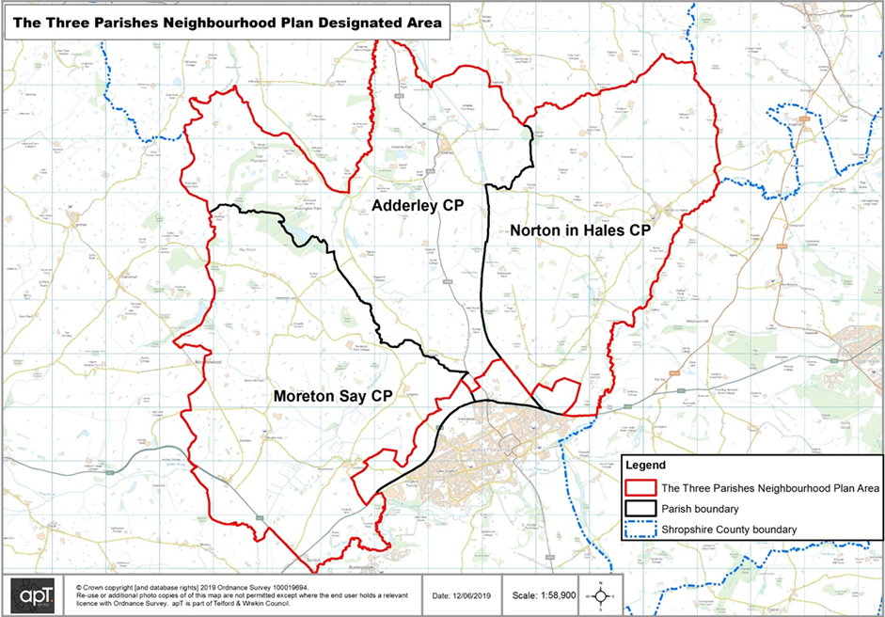

Appendix 2 Process of Preparing a Neighbourhood Plan
Neighbourhood Plans have to be prepared in a manner that is appropriate to the procedure set out by the Government. The table set out below briefly overviews these processes. Beginning from the designation of the Neighbourhood area as has been described above.
The Neighbourhood Plan Process

In accordance with Regulation 14, a six week consultation of the Neighbourhood Planning Regulations 2012 was carried out with the Three Parishes residents, businesses and consultative bodies. The point of this consultation period was to give people the opportunity to provide feedback on the first draft of the plan.
A further six-week consultation (Regulation 16) by Shropshire Council will take place once the revised plan is submitted under Regulation 15 (the current stage) where alongside the plan a Basic Conditions Statement, Consultation Statement, Strategic Environmental Assessment and Habitats Regulations Assessment will also be submitted.
The Shropshire Local Plan is currently under review and is undergoing Independent Examination. This will likely result in changes through required modifications by the Inspector. In this instance, the Three Parishes will consider the implications of these likely changes within this Regulation 15 submission, as well considering the representations received during the 6 week (Regulation 16) consultation stage. As a result of the Local Plan Examination the Neighbourhood Plan may need to be amended so that it complies with any relevant modifications to Shropshire Council’s Local Plan.
The Plan, its evidence base and consultation responses, will then be submitted by Shropshire Council for Independent Examination and the process will culminate in a local referendum on whether the plan should be made part of the Statutory Development Plan for Shropshire. If the result of the referendum is positive the Plan will pass through one final Cabinet Meeting to finalise the Plan as ‘made’.
At this point the Three Parishes Neighbourhood Plan will be part of the Shropshire Statutory Development Plan. Policies within this Neighbourhood Plan will reflect the aspirations of the majority of people in the Three Parishes who have all had an opportunity to play a part in shaping the future of their parishes.
Appendix 3 National Heritage List for the Three Parishes
Name and Location | Date | Notes | Grades
Adderley
Shavington Wood Farmhouse | 1536 | A farmhouse that has been altered and extended, the original part is timber framed with plastered and painted infill. The 18th and 19th-century extensions are in brick, and the house has a tiled roof, one storey and an attic. The entrance front has three gabled dormers, a doorway with a moulded architrave, and a timber framed porch. Most windows are casements, and the right gable is slightly jetted with a moulded bressumer. | II
Barn, Shavington Wood Farm | c.1600 | The barn is timber framed with weatherboarding, and it has been partly rebuilt with red brick nogging. The left wall has been rebuilt in brick, and the barn has a corrugated iron roof. It contains doors, loft doors and lozenge-shaped vents | II
St Peter’s Church | 1635 – 37 | The oldest part of the church is the north transept, the tower dates back to 1712, and the rest of the church was rebuilt in 1801. The church is built in sandstone and has slate roofs. It has a cruciform plan, consisting of a nave, north and south transepts, a chancel and a west tower. The chancel and south transept have apsidal ends. The tower has two stages, with Doric pilasters, a moulded cornice, and a plain parapet. The north transept has an embattled parapet with crocketed pinnacles. The church has been divided internally, the nave being used as a parish church, and the rest of the church being under the care of the Churches Conservation Trust. | I
Stable block, Shavington Gardens | c. 1685 | The stable block was extended at the rear in the 19th century, forming a courtyard plan. It is in red brick with grey sandstone dressings, chamfered quoins, a moulded eaves cornice, and a hipped slate roof. There are two storeys, and the east front has seven bays. In the centre is a round-arched carriageway with rusticated surround, flanked by segmental-arched openings. At the top is an open triangular pediment containing a clock face in the tympanum. On the roof is an octagonal wooden cupola with fluted Greek Doric columns, a moulded cornice, and a lead dome with a weathervane. | II
Ice House, Pool House | 18th century | The ice house is in the grounds of Pool House. It consists of an entrance passage in red brick with a barrel vaulted roof that leads to a domed central chamber. | II
Sundial | 18th century | The sundial stands in a triangle of grass to the north of St Peter's Church. It is in red sandstone, and has a base of two steps, a tapered square shaft with chamfered corners, a cubic dial block with wrought-iron gnomons, and a globe finial | II
Mounting block | 1774 | The mounting block is to the north of St Peter's Church. It is in sandstone and consists of four steps | II
Estate bridge | Late 18th century | The bridge is in Shavington Park, and carries an estate track over the River Duckow. It is in sandstone, and consists of two segmental arches with round-topped semicircular cutwaters and flanking pilaster buttresses. The parapet has a moulded string course and square end piers with globe finials. Approaching the bridge are quadrant wing walls. | II
Shavington Bridge (northwestern) | Late 18th century | One of a pair of bridges carrying a road over the River Duckow. It is in grey sandstone, and consists of two segmental arches with round-topped circular cutwaters and flanking pilaster buttresses. The parapet has a moulded string course and square end piers with globe finials. Approaching the bridge are quadrant wing walls. | II
Shavington Bridge (southeastern) | Late 18th century | One of a pair of bridges carrying a road over the River Duckow. It is in red sandstone, and consists of a single segmental arch with flanking pilaster buttresses. The parapet has a moulded string course and square end piers. Approaching the bridge are quadrant wing walls. | II
Former stable block,  Adderley Hall Farm | c.1787 – 88 | The former stable block is in red brick with dressings in grey sandstone and a hipped slate roof. It has two storeys and consists of four ranges around a square courtyard. The main front on the west has eleven bays. There is a central elliptical-headed carriageway above which is a pediment with a moulded cornice and a clock in the tympanum. On the roof is a square wooden bellcote with a lead cap, a globe finial and a weathervane. The windows are sashes, some of which have been blocked. | II
Church Farmhouse | c. 1790 | The farmhouse is in red brick on a plinth, with a dentil eaves cornice and a hipped tile roof. There are three storeys and a basement, and a symmetrical front of five bays, the central three bays projecting forward under a pediment. There is a central round-headed doorway with a fanlight, and the windows are casements. | II
Bridge No. 67  (Bettoncoppice Bridge) | c. 1830 | An accommodation and roving bridge crossing the Shropshire Union Canal, it is in sandstone, and consists of a single elliptical arch with a hump back deck. The bridge has voussoirs, a flush keystone, a chamfered string course, and a parapet with rounded coping and a square end pier to the north. The abutments are slightly battered and curved, and the towpath and accommodation part of the bridge are divided by a stone wall. | II
Bridge No. 68  (Adderley Lees Bridge) | c. 1830 | An accommodation bridge carrying a track over the Shropshire Union Canal, it is in sandstone, and consists of a single elliptical arch with a hump back deck. The bridge has voussoirs, a raised keystone, a chamfered string course, and a parapet with square end piers and rounded coping. The abutments are battered and curved, and there are cast iron corner posts. | II
Bridge No. 69  (Adderley Wharf Bridge) | c. 1830 | The bridge carries a road over the Shropshire Union Canal, it is in sandstone, and consists of a single elliptical arch. The bridge has voussoirs, a flush keystone, a chamfered string course, and a parapet with square end piers and rounded coping. The abutments are battered and curved, and there are cast iron corner posts. | II
Bridge No. 70  (Wems Bridge) | c. 1830 | An accommodation bridge carrying a track over the Shropshire Union Canal, it is in red brick with dressings in blue brick, and consists of a single elliptical arch with a hump back deck. The bridge has a chamfered string course, and a parapet with square end piers and rounded stone coping. The abutments are slightly battered and curved, and there are cast iron corner posts. | II
Bridge No. 71  (Massey's Bridge) | c. 1830 | An accommodation bridge carrying a track over the Shropshire Union Canal, it is in red brick with dressings in blue brick, and consists of a single elliptical arch with a hump back deck. The bridge has a chamfered string course, and a parapet with square end piers and rounded stone coping. The abutments are slightly battered and curved, and there are cast iron corner posts. | II
Bridge No. 72 (Hawksmoor Bridge) | c. 1830 | The bridge carries Rectory Lane over the Shropshire Union Canal, it is in red brick with dressings in blue brick, and consists of a single elliptical arch with a hump back deck. The bridge has a chamfered string course, and a parapet with square end piers and rounded stone coping. The abutments are slightly battered and curved, and there are cast iron corner posts. | II
Bridge No. 73  (Adderley Pool Bridge) | c. 1830 | An accommodation bridge carrying a track over the Shropshire Union Canal, it is in red brick with dressings in blue brick, and consists of a single elliptical arch with a hump back deck. The bridge has a chamfered string course, and a parapet with square end piers and rounded stone coping. The abutments are slightly battered and curved, and there are cast iron corner posts. | II
Milepost near Bridge No. 70 | c. 1830 | The milepost is on the towpath of the Shropshire Union Canal to the north of bridge no. 70. It is in cast iron, and consists of a cylindrical round-topped post carrying three convex plates indicating the distances in miles to Nantwich, Autherley Junction and Norbury Junction. | II
Milepost near Bridge No. 73 | c. 1830 | The milepost is on the towpath of the Shropshire Union Canal to the south of bridge no. 73. It is in cast iron, and consists of a cylindrical round-topped post carrying three convex plates indicating the distances in miles to Nantwich, Autherley Junction and Norbury Junction. | II
No. 1 Tittenley Lodge | 1885 | One of a pair of entrance lodges to Shavington Park designed by Norman Shaw. It is in orange brick with sandstone dressings, chamfered quoins, a moulded dentil eaves cornice, and a lead pyramidal roof. The chimney is in the centre of the roof, and has quoins, stone coping and globe finials on the corners. The lodge has a square plan and two storeys. Steps with low flanking walls lead up to the central doorway that has a porch on supports, and there is a square window to the right. In the returns are Venetian windows, and the upper floor contains a Diocletian window on each front. At the rear is a walled garden enclosure. | II
Retaining wall southeast of  No. 1 Tittenley Lodge | 1885 | The wall is in red brick with sandstone dressings and chamfered stone coping. It has a quadrant plan, and square end piers with recessed panels and moulded stone caps with globe finials. | II
No. 2 Tittenley Lodge | 1885 | One of a pair of entrance lodges to Shavington Park designed by Norman Shaw. It is in orange brick with sandstone dressings, chamfered quoins, a moulded dentil eaves cornice, and a lead pyramidal roof. The chimney is in the centre of the roof, and has quoins, stone coping and globe finials on the corners. The lodge has a square plan and two storeys. Steps with low flanking walls lead up to the central doorway that has a porch on supports, and there is a square window to the left. In the returns are Venetian windows, and the upper floor contains a Diocletian window on each front. At the rear is a walled garden enclosure. | II
Retaining wall southwest of  No. 2 Tittenley Lodge | 1885 | The wall is in red brick with sandstone dressings and chamfered stone coping. It has a quadrant plan, and square end piers with recessed panels and moulded stone caps with globe finials. | II
7 and 8 Shavington Park | c.1903 | A pair of estate cottages in red brick with tile-hung gables and attics, and a tiled roof, hipped at the rear. They have one storey and attics, a U-shaped plan with a front face of four bays, rear wings and a one-storey service block between them. The porches are pebbledashed, the gables have plain bargeboards, the windows are casements, and in the upper floor are dormers. | II
Norton In Hales
St Chad's Church and archway | 13th century | The oldest part of the church is the chancel, the tower dates from the late 14th century, most of the church was restored and rebuilt in 1864–65, and the north transept and archway were added in 1872. The church is built in sandstone with slate roofs, and consists of a nave with a clerestory, north and south aisles, a north baptistry, a north transept with an attached archway, a chancel with a north vestry, and a west tower. The tower has three stages, diagonal buttresses, a clock face on the south front, gargoyles, and an embattled parapet with crocketed corner pinnacles. | II*
Churchyard cross | 15th or 16th century | The cross is in the churchyard of St Chad's Church. It is in red sandstone, and has a square base and an octagonal shaft, surmounted by a 19th-century cast iron cross. | II
Betton Old Hall | Late 16th century | A timber framed house with plaster infill on a brick plinth with a tile roof, that has been extended in brick with applied timbers. The central bay is gabled and has two storeys and an attic, and is flanked by single-story wings. The upper floor of the central bay is jettied and has a moulded bressumer, the gable is also jettied and has plain bargeboards and a finial. The windows are casements. | II
Ridgwardine Manor | Late 16th or early 17th century | The farmhouse has been remodelled and extended. Originally timber framed, it has been largely encased and extended in red brick, and has a tile roof. There are two storeys and an attic, and the house consists of a one-bay range, with a one-bay gabled cross-wing on the left, a projecting two-bay gabled cross-wing on the right, and a further extension to the left. The gables have plain bargeboards and finials, the doorway has a moulded surround and a gabled porch, and the windows are casements. | II
Bellaport Old Hall | Early 17th century | Part of a large house on a moated site that was largely demolished in the 19th century. It is in stone and red brick, partly rendered, and with a tile roof. It has an L-shaped plan, with a two-storey range, and a single-storey wing. The doorway has a chamfered surround, and the windows are mullioned. | II
Old font | 17th century | The former font is in the churchyard of St Chad's Church. It is in grey sandstone, and has a circular stem, and a circular bowl with a moulded bottom edge. | II
Barn south of Brand Hall | Mid 17th century | The barn is timber framed with red brick nogging on a red brick plinth, partly rebuilt and extended in red brick and with a tile roof. It has three bays, with an extension of half a bay at each end, and there is a central cart entrance. | II
Brand Hall | c. 1700 | A country house with a 17th-century core, that was later extended. It is in red brick with grey sandstone dressings, and some timber framing with plaster infill at the rear, and with tile roofs. It is on a chamfered plinth,with chamfered quoins, a moulded cornice, and a coped parapet with sections of balustrading. The house has two storeys and an attic, with a front of seven bays, flanked by two-storey wings, and with a rear wing. In the middle three bays are unfluted Doric pilasters, and an entablature with a triangular pediment containing a coat of arms between loops of drapery. | II*
Archway southeast of Brand Hall (north) | c.1700 | The archway is in red brick with grey sandstone dressings. It consists of an elliptical arch that has piers with plinths, chamfered quoins, and impost bands, and on the arch is an open triangular pediment. | II*
Archway southeast of Brand Hall (south) | c. 1700 | The archway is in red brick with grey sandstone dressings. It consists of an elliptical arch that has piers with plinths, chamfered quoins, and impost bands, and on the arch is an open triangular pediment. | II*
Ha-ha southeast of Brand Hall | Early 18th century | The ha-ha is at the end of the lawn in front of the hall and is in red sandstone with coping blocks. It is about 60 metres (200 ft) long and 1 metre (3 ft 3 in) high, and is ramped down at the ends where there are globe finials. | II*
Stable block southeast of Brand Hall | Early 18th century | The stable block is in red brick with grey sandstone dressings on a brick plinth with a chamfered sandstone top. There is a string course, and a hipped tile roof with a triangular pediment and a clock face in the tympanum. The block has two storeys and three bays. In the centre is a blocked round-headed archway, and above is an octagonal wooden cupola with a moulded base, square piers, a moulded cornice, and an ogee lead cap with a globe finial and weathervane. | II
Tunstall Hall | c. 1732 | A country house in red brick with sandstone dressings on a chamfered stone plinth, with two string courses, a moulded cornice and parapet, and a two-span hipped tile roof. There are three storeys, a front of nine bays and sides of four bays. The central doorway in the west front has a moulded architrave, pilaster strips, a frieze, and a segmental pediment on consoles. The windows are sashes with moulded architraves, those in the ground floor with triangular pediments. In the east front is a doorway with a Gibbs surround and a triangular pediment, and in the south front is a full-height, five-sided bay window. | II*
Betton House | Mid to late 18th century | A red brick house with grey sandstone dressings on a stone plinth, with a moulded cornice and a hipped slate roof. There are three storeys and seven bays. The outer bays contain full-height bow windows with conical roofs. The central doorway has Ionic three-quarter columns, a radial fanlight, a fluted frieze, and an open triangular pediment. The windows are sashes; those in the middle bay have moulded architraves, and in the middle floor they have balustrading beneath, a frieze with paterae and a moulded cornice. | II
Chest tomb | Late 18th century | The chest tomb is in the churchyard of St Chad's Church. It is in sandstone, and has a moulded plinth, shaped corner balusters, and a moulded cornice to a flat top. There are recessed circular side and end panels, and the inscription is illegible. | II
Shifford's Bridge | Early 19th century | The bridge carries the A53 road over the River Tern. It is in sandstone, and consists of a single wide segmental arch. The bridge has a projecting keystone on the north side, a flat string course, and curved ends on the south side. | II
Victoria Bridge | 1827–30 | Bridge No. 65 carries Maer Lane over the Shropshire Union Canal. It is in stone with some brick, and consists of a single elliptical arch. The bridge has voussoirs, a keystone, a band, a slightly cambered parapet with coping, and square piers, also with coping. | II
Bettonwood Bridge | c. 1830 | Bridge No. 66 is an accommodation bridge over the Shropshire Union Canal. It is in sandstone, and consists of a single elliptical arch. The bridge is hump-backed, and has voussoirs, a flush keystone, a chamfered string course, a parapet with rounded coping, and square end piers. | II
Milepost south of Bridge No. 66 | c. 1830 | The milepost is on the towpath of the Shropshire Union Canal. It is in cast iron, and consists of a cylindrical round-topped post with curved rectangular plates. The plates are inscribed with the distances in miles to Autherley Junction, Nantwich, and Norbury Junction. | II
Milepost south of Bridge No. 67 | c. 1830 | The milepost is on the towpath of the Shropshire Union Canal. It is in cast iron, and consists of a cylindrical round-topped post with curved rectangular plates. The plates are inscribed with the distances in miles to Autherley Junction, Nantwich, and Norbury Junction. | II
Betton Hall Farmhouse and farm buildings | Mid 19th century | A model farm, it was extended in the 20th century. The farmhouse is in red brick on a stone plinth and has a dentilled eaves cornice, and a tile roof, two storeys, a double-depth plan, and four bays. Above the door is a fanlight, and the windows are sashes. The farm buildings are in red brick with dressings in blue brick and limestone, and most roofs are tiled. Adjoining the house is a single-storey range. The other buildings are separate and form a T-shaped plan; they include loose-box stables, cow houses and a milking parlour. | II
Moreton Say
Oldfields Farmhouse | Early 15th century | The farmhouse was altered and extended in the 17th and 19th centuries. It is timber framed with cruck construction, the rebuilding and extensions are in brick and the roof is tiled. The original part has one storey and an attic, and consists of a quasi-aisled hall with three bays, and there is a rebuilt cross-wing to the southeast and a later extension to the southwest, both with two storeys. The windows are casements, and there are two small gabled eaves dormers. Inside is a central base cruck truss. | II*
Glynde Cottage | 16th century | The house was later altered and extended. The original part is timber framed with cruck construction and brick nogging on a brick plinth, and with a tile roof. There are two storeys, two bays, and a single-storey extension to the right. The doorway has a gabled porch, and the windows are casements. | II
Bletchley Manor | Late 16th century | The farmhouse was altered and extended in the 19th century. The original part is timber framed and rendered, and the rebuilding and refacing are in brick, with applied timber and painting to resemble timber framing. The farmhouse has a three-span tile roof with three gables and three bays at the front. The original part has two storeys and an attic, and the extension has two storeys. There is a central doorway with a moulded architrave and a timber-framed gabled porch. The windows are cross-windows, and there is a sash window in the extension. | II
Holly Cottage | Late 16th century | The cottage was altered and extended in the 19th and 20th centuries. The original part is timber framed with plaster infill, it has been partly rebuilt and underbuilt in brick, and the roof is tiled. There is one storey and an attic, two bays, and a one-storey lean-to at each end. The windows are casements, and at the rear are a lean-to porch and gabled eaves dormers. | II
The Old Smithy | 1600 | Alterations and additions were made later to the cottage, which is timber framed with brick nogging on a rendered plinth, the extensions are in brick, and the roof is tiled. There are two storeys, originally with two bays and later extensions. There are two gabled porches, and the windows are casements | II
The Royal Oak Farmhouse | c. 1600 | The farmhouse, at one time an inn, was extended in the 19th century. It is timber framed with plaster infill on a sandstone plinth, the extension is in brick, and the roof is tiled. There is one storey and an attic, and an H-shaped plan, with a central range of one bay, cross-wings of two bays each, and a single bay in the angle at the rear. The cross-wings have jettied upper floors with moulded bressumers on scrolled brackets, and the gables are also jettied with decorative bressumers. The windows are casements, and in the middle range is a large gabled dormer. | II
Longford Old Hall | Early 17th century | The farmhouse is timber framed with brick infill, underbuilding in brick, and a tile roof. There are two storeys and an attic, and an H-shaped plan, consisting of a central single-bay range, two gabled cross-wings, each with two bays, and a single-storey lean-to at the rear. The doorway has a chamfered surround, the windows are casements, and there is a central gabled full dormer. | II
Rhiews Farmhouse | Early to mid 17th century | The farmhouse, later a private house, has been altered and extended. It is timber framed with brick nogging on a brick plinth, and extended in brick painted to resemble timber framing, one gable end is rendered, and the roof is tiled. There are two storeys, two bays, an extension to the southeast, and a rear wing. The windows are casements, and there is a lean-to porch. | II
New Street Lane Farmhouse | 17th century | The farmhouse was remodelled in the 18th century and extended in the 19th century. It is in red brick with a timber framed core, on a plinth, with quoins, a dentil eaves cornice, and a tile roof. The farmhouse is partly in one storey, and partly in two storeys with an attic, there are three bays, and a rear wing. The windows are casements, some with segmental heads, and some with Gothick arches, and there is a gabled porch. | II
Styche Hall | 1762–66 | A small country house designed by William Chambers, altered in 1796–98 by Joseph Bromfield, and altered again in about 1900. It is in brick with a hipped tile roof. There are three storeys and a basement, and a square plan with sides of seven and six bays. The central doorway has a moulded architrave, and a porch with fluted Corinthian pilasters, an entablature, and a triangular pedimented gable. This is flanked by full-height canted bay windows, and the other windows are sashes. | II
Stychefields Residential Home and The Coach House | 1763–66 | Originally the stables and coach house for Styche Hall designed by William Chambers, they are in red brick with grey sandstone dressings, and have hipped tile roofs. The stables from an L-shaped plan around a courtyard with fronts of seven and five bays, with the former coach house in the southeast corner. There are two storeys, the windows are casements, and in the centre of each block is a window with a moulded architrave, a pulvinated frieze, and a moulded cornice. The round-arched entrance has a moulded architrave, flanking Tuscan pilasters and a full entablature. On the roof is a wooden cupola with a clock, a tented lead cap, and a weathervane. | II
Nobridge Farmhouse | Mid to late 18th century | The farmhouse, which incorporates a 17th-century core, is in red brick with a plat band and a tile roof with coped and parapeted gable ends. There are three storeys and five bays, a kitchen wing, and attached coach house and stables. The windows are sashes, and the doorway has pilasters, a frieze, a cornice, and a bracketed hood. | II
St Margaret's Church | 1769 | The oldest substantial part of the church is the tower, and the nave and chancel were added in 1788, incorporating a 12th-century core. The church was restored and the porch was added in 1900. The church is built in red brick with grey sandstone dressings, the east end was rebuilt or refaced in red sandstone in 1900, and the roof is tiled. It consists of a nave and a chancel in one unit, a south porch, and a west tower. The tower has three stages and a low parapet with corner obelisks, Along the sides of the church are two tiers of round-headed windows, there is a string course, and quoins on the corners. The porch is gabled and has a Tudor arched entrance. | II*
Markham memorial | 1778 | The memorial is in the churchyard of St Margaret's Church, and is to the memory of John James Markham Bart. It is a pedestal tomb in grey sandstone with a large sandstone base. The tomb has a moulded plinth, square panels, a moulded cornice, a hollow chamfered top, and an ovoid finial. | II
Milepost near Fordhall Cottages | Early to mid 19th century | The milepost is on the southeast side of the A53 road. It is in cast iron, and has a triangular section with a chamfered top. The milepost is inscribed with the distances in miles to "SALOP" (Shrewsbury) and to "DRAYTON" (Market Drayton). | II
Granary, Oldfields Farm | Early to mid 19th century | The granary, which incorporates some 14th-century material, is timber framed with red brick nogging on a red sandstone plinth, the rear wall is rebuilt in brick, and the roof is tiled. There is one storey and a loft, three bays, and a one-storey brick extension to the left. The granary contains doorways and loft openings, and in the extension are a window and a stable door, both with segmental heads. | II
Pump, Oldfields Farmhouse | Mid to late 19th century | The pump is in cast iron, and has a circular shaft with moulded rings and spout, a fluted top, a fluted domed cap, and a handle with winding mechanism. There is also a stone trough. | II
Pool Cottage | 1872 | An estate cottage by William Eden Nesfield. It is timber framed with plaster infill on a red brick plinth, and in brick painted to resemble timber framing. The roof is tiled and partly hipped, the gables are tile-hung, and there are globe finials on the apices. There is one storey and an attic and an irregular T-shaped plan. The windows are mullioned and transomed, and other features include canted bay windows, jettied attics with moulded bressumers, a polygonal-arched entrance, and an attic oriel window. | II
Outbuilding, Pool Cottage | c. 1872 | The outbuilding is in red brick with a dentil eaves cornice and a hipped tile roof. It has one storey, a casement window, and a pair of segmental-headed doors. | II
Tern Hill House Farmhouse | Late 19th century | The farmhouse is in red brick with a plat band and a dentil eaves cornice, and a hipped slate roof. There are three storeys, three bays, and a single-storey rear wing. The central doorway has unfluted attached Doric columns and an entablature, and the windows are sashes. | II
The Haven | 1876 | An estate cottage by William Eden Nesfield. It is timber framed with plaster infill on a red brick plinth, and in brick painted to resemble timber framing. The roof is tiled and partly hipped, the gables are tile-hung, and there are globe finials on the apices. There is one storey and an attic and an irregular T-shaped plan. The windows are mullioned and transomed, and other features include canted bay windows, jettied attics with moulded bressumers, a polygonal-arched entrance, and an attic oriel window. | II

Appendix 4: Norton In Hales Conservation Area

These regulations will continue to apply unless new legislation is introduced to withdraw or amend them.
As set out by Regulation 4 of the SEA Regulations. The role of the statutory consultees within SEA is to bring their individual environmental expertise to the assessment process. Note: statutory consultees are not required to respond to screening requests. Limited resources mean they may need to prioritise the plans they engage with in detail based on an assessment of risk.
Shropshire Council Site Based Ecology Reports Map https://shropshire.gov.uk/environment/biodiversity-ecology-and-planning/site-based-reports-and-ecology-maps/
An agreement between two or more parties outlined in a formal document. It is not legally binding but signals the willingness of the parties to move forward with a contract.

