Shropshire Strengthening Families/Early Help

How do we collect information from you and for what purpose?

The purpose of this form is to ensure your family consent to multi-agency Early Help, involving services that will be able to support your family. Information may be shared with partner agencies to provide you with specific services (for example, health, housing, education, children’s services, police, early years providers). The information is held securely on a case management system to ensure your family receive the best support services available.
All information collected and shared will be done to provide you and your family with services that support and help your family.
We will treat information as confidential and we will not sell or rent your information to third parties. We will not share your information with third parties for marketing purposes.
Full details about how the Council will use your information can be found on our website at: www.shropshire.gov.uk/privacy and the Strengthening Families Privacy notice can be found on the Early Help Website strengthening-families-privacy-notice.pdf (shropshire.gov.uk)

Name of professional supporting the completion of this consent form
Family Address and postcode

Main family contact telephone number | Main family contact email address
Column Name (First name/family name)
Date of birth

Gender

Ethnicity (See codes below)
Additional needs and or disabilities
First language spoken

National Insurance number
Signature
Date
Relationships: Please complete for each family member or the Early Help Episode for the family cannot be created. For an example see page 5.
Name (First name/family name) Column name relationship to row name
Consent to the Early help and how your information will be used

It has been explained how our information will be used and a copy of the Privacy Notice has been provided?: strengthening-families-privacy-notice.pdf (shropshire.gov.uk)
We/I consent to my family taking part in the Early Help process and to receiving help and support and copies of our Early Help documentation being stored securely on Shropshire Council’s case management system, Liquidlogic
We/I understand that to provide us with Early Help support and services, information may be shared with partner agencies for example health, housing, children’s services, early years providers and police, and used for the sole purposes of providing our family with help and support.
Is there any individual person or agency that you do not wish information to be shared with? If so please provide details here:
We/I understand that agencies (for example, health, housing, education, children’s services, and police) may discuss our family’s needs and that we/I will be provided with feedback from these discussions.
We/I understand that by agreeing to Early Help some of our personal information may be collected and shared with The Department for Levelling Up, Housing and Communities and The Office of National Statistics for evaluation purposes and that all findings will be anonymised.
We/I understand we/I can withdraw my consent to Early Help at any time in writing to the Lead Professional.
We/I understand that a request to see our personal information can be made.

Parent/Carer Signature |  | Name |  | Date
Professional Name |  | Organisation |  | Date
Professionals Signature |  | Job Title
Professionals contact details | Phone Number |  | E-mail address

Please complete all sections of the form (guidance can be found on pages 4 and 5) and send to ShropshireStrengtheningFamilies@Shropshire.gov.uk using an encrypted email. A case will be created for you and access given to the Lead Professional identified on this form. You will then need to follow the workflow to complete the assessment and plan as appropriate.
If you do not have access to the Early Help Module of Liquidlogic a member of the Strengthening Families Team will be in contact to discuss next steps.
Guidance notes

- Please make sure every member of the household is included on this form even if they do not sign.
- Please ensure that the relationship section is completed for all members of the household. Example below. See relationships chart on page 5 for options
- If other members of the family need to sign please make a copy and ask for it to be signed and returned
- Please ask the family if they would like a copy of the completed form.
- Please clarify the family’s understanding of the form, including how their information will be shared.

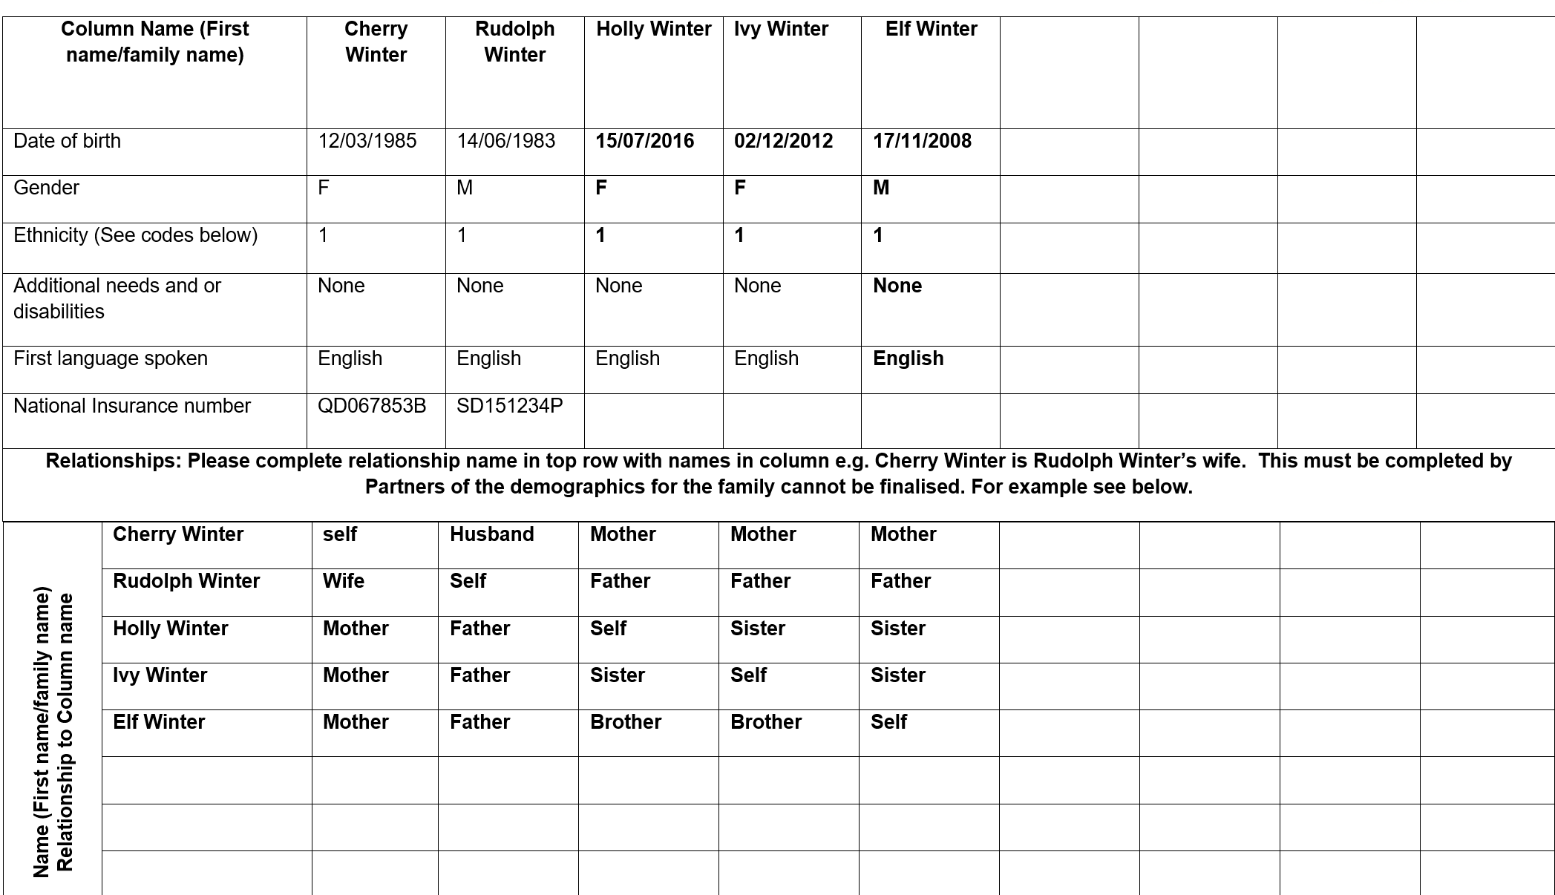
Cherry Winter
Cherry is the wife of Rudolph
Cherry is the mother of Holly
Cherry is the mother of Ivy
Cherry is the mother of Elf

Relationships:
Self | Mother |  | Father |  | Daughter |  | Son |  | Wife
Husband | Sister |  | Brother |  | Ex Wife |  | Ex Husband |  | Half Sister
Half Brother | Mother’s Partner |  | Father’s Partner |  | Partner’s daughter |  | Partner’s son |  | Step mother
Step Father | Step daughter |  | Step Son |  | Step sister |  | Step brother |  | Grandmother
Grandfather | Granddaughter |  | Grandson |  | Step Grandmother |  | Step Grandfather |  | Step Granddaughter
Step Grandson | Great grandmother |  | Great grandfather |  | Great granddaughter |  | Great Grandson |  | Aunty
Uncle | Niece |  | Nephew |  | Cousin |  | Mother in Law |  | Father in Law
Daughter in law | Son in Law |  | Sister in Law |  | Brother in Law |  | Carer |  | Cared for
Adoptive Mother | Adoptive Father |  | Adoptive daughter |  | Adoptive son |  | Friend |  | Foster carer
Foster child | Private Foster carer |  | Private Foster Daughter |  | Private Foster son |  | Other – please state
Ethnicity Codes:
White: |  | Mixed/Dual Background: |  | Asian or Asian British: |  | Black or Black British: |  | Chinese:
- White - British |  | - White and Black Caribbean |  | 10. Indian |  | 14. Black Caribbean |  | 17. Chinese
- White – Irish |  | - White and Black African |  | 11. Pakistani |  | 15. Black – African
- Traveller of Irish Heritage |  | - White and Asian |  | 12. Bangladeshi |  | 16. Any other Black background
- Gypsy/Roma |  | - Any other Mixed background |  | 13. Any other Asian background |  |  |  | 18. Any Other Ethnic Group
- Any other White background

