Highways & Transport
Road Traffic Regulations Act 1985 and the amendment of 1994, for special events and Section 16A of the Road Traffic Regulation Act 1984
Application to temporarily restrict parking on a public highway for a sporting event, social event or entertainment by the use of no waiting cones
Important: Please complete this form in full using block capitals – failure to complete all sections may result in unnecessary delays or refusal
Information about the latest roadworks and road closures in Shropshire can be found on: http://www.shropshire.gov.uk/hwmaint.nsf
Name of event:
Date and time of event:
Name of organiser (must be applicant):
Address:
Telephone numbers:  Office hours: …………..………………. |  | Outside office hours: ………….………………..…….
Email:
Numbers likely to attend event and likely takings
Location temporary parking restriction required
OS 12 number grid ref:
Section (description)
Enforcement of the parking  restriction | Enforcement required, and, therefore, temporary traffic regulation order Yes / No  It should be noted that the cost of enforcement:  Events run by charities and public sector organisations |  |  | Events run by private sector organisations
 | Placing temporary Free  traffic order and advertising and noticing |  |  | £1000 (or equivalent cost of road closure charge)
Enforcing the 0-50 cones £50.00 0-50 cones £60.00
cones per day per day
50- 100 cones 50- 100 cones
£100.00 per day £115.00 per day
100-500 cones 100-500 cones
£150.00 per day £175.00 per day
Number of no waiting cones required. | Number of cones required |  | Events run by Events run by charities and private sector  public sector organisations  organisations
 | Placing and removing the cones out. |  | Cost as invoiced by Cost as invoiced  Enterprise by Enterprise plus  15%
 | Replacing lost cones |  | £8.00 per lost cone £10.00 per lost cone
It should be noted that the cones can be collected from and returned to the nearest Shropshire Council Highways Depot by the event promoter. In this case there will be no charge for placing and removing the cones, but there will be a charge for replacing lost cones.
Note: In all cases cones can only be collected and returned by prior arrangement (telephone 03456 789006 and ask for your local Highways Depot), an appointment time must be obtained from your local depot before collecting or returning cones.

Public liability insurance details:
Name of insurer: .................................................................................................................……..
Policy number: ………………………..…………………Expiry Date : ………..…………………….… Cover (£5m minimum): ……………………………………………………………………………………
Can you please give the reasons why it is necessary for the event to be held on a road:
...........................................................................................................................................…….. ..........................................................................................................................................………
Views of Street Works Manager:
..........................................................................................................................................………
..........................................................................................................................................………

Page 3
This form must be sent to your local Street Works Manager, no later than 10 days before the event. Please see conditions below.
Conditions:
- The organisation shall nominate stewards who will be responsible for making suitable provision for the safety of persons attending the event and for ensuring that adequate access is available at all times for fire engines, ambulances, police cars or other vehicles that may be required in an emergency.
- If required to do so by the Street Works Manager, the organisers shall ensure that signs are in position to indicate to drivers that the road is closed.
The form below must be signed by Street Works Manager and then handed to the Enterprise Store person for issue of cones.
The Enterprise Store person should return the completed form to the SC Office
For official use and for proof of authorisation to Enterprise Store person
Application: Approved ………....................................... Refused ….……………………...……..
Signed: ................................................................ Date:
Street Works Manager
The above signatory has authorised the issue of the following number of cones:
Number of cones to be provided ………………………Number of cones returned…………………

Please return this form to the Streetworks Office as identified below:
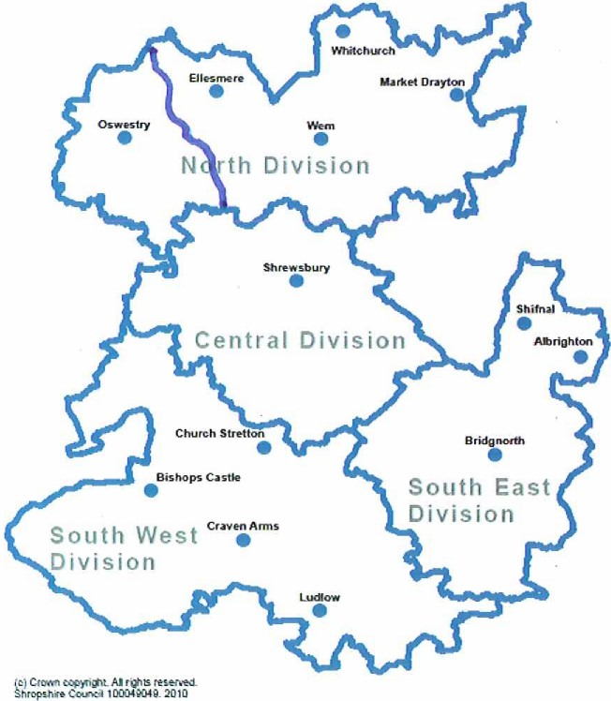
Streetworks
Highways & transport Team
Shropshire Council
107 Longden Road
Shrewsbury
Shropshire
SY3 9EL

If you are unsure of which office to return your form or you have any other queries please call our Customer Service
0345 678 9006

streetworks@shropshire.gov.uk

